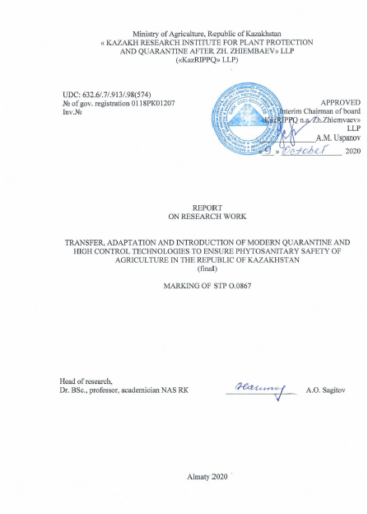

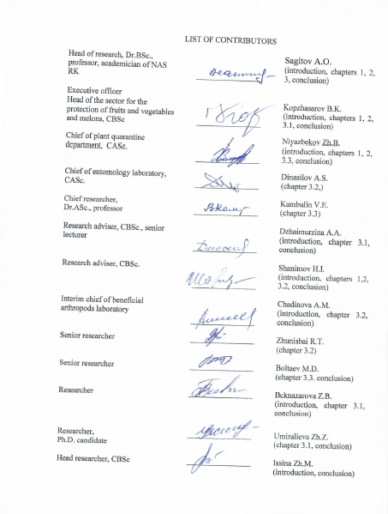

ABSRACT

Report 318 p., 14 tabl., 9 fig., 72 sour., 6 attachment.

FIRE BLIGHT, FUNGICIDES, BIOLOGICS, ENTOMOPHAGES, HERD ACRIDOIDEA, GEOINFORMATIONAL SYSTEM, DIGITAL MAP.
Research objects: Fire blight in fruit-bearing plants (Erwinia amylovora (Burrill.) Winslow et al), entomophages – macrophus (Macrolophus nubilus N.S.), Nesidiocoris (Nesidiocoris tenuis Reuter). Phytophages – tomato leafminer (Tuta absoluta Povolny, herd species of acridoidea.
Purpose of research: Providing phytosanitary safety through the realization of transfer and adaptation of progressive agricultural technologies to fight quarantine and particularly harmful pests (Fireblight of fruit-bearing plants(fire blight), South American tomato leafminer, herd species of Acridoidea) и introduction of those technologies at AIC, Republic of Kazakhstan.
Methods of research: conventional methods in entomology, in phytopathology, plant protection, field studies on the basis of UAVs, deciphering of aerial images.
Research results: Bacteriological analyzes were carried out. For demonstational experiments of complex protection system of apple tree from fire blight on demonstration plot on in the p/f Zhemis, Enbekshikazakh district of Almaty region. A transfer of colored glue traps with the Tuta absoluta pheromone was carried out. Production tests of a complex of protective measures in the fight against tomato moth were carried out using bioagents, pheromone traps and biological products in combination with a selective insecticide Koragen, c.s.
Remote sensing of the Moroccan, Asian and Italian locusts was carried out using a UAV. As a result of overlapping images from UAVs in the infrared and visible ranges of the electromagnetic spectrum with the calculated NDVI and VARI indices, respectively, the zones with damaged vegetation were identical. Thematic digital maps of distribution and abundance of gregarious locusts were created. A comparative analysis of the data on the distribution and abundance of gregarious locust species was carried out, and maps of the frequency of their detection were created.
During the research period (2018-2020), 20 articles were published, including 8 in the materials of international scientific and practical conferences, 2 in the symposium, in the domestic edition recommended by the KKSON MES RK – 8, foreign publications with an impact factor - 2, received: 1 patent, 4 certificates of state registration of copyright rights, held: seminars - 9, field day 3 and round table – 3.
Applications: plant protection and quarantine, agriculture.
CONTENT
 | p.
INTRODUCTION | 8
MAIN PART | 14
1 Choice of the research direction | 14
2 Research Methdology | 15
3 Research results | 18
3.1 Development of recommendations on comprehensive measures to combat bacterial burns of fruit crops | 18
3.1.1 Monitoring of fireblight in the conditions of Almaty, Turkestan Zhambyl regions | 18
3.1.2 Isolation and identification of the fire blight pathogen | 22
3.1.3 Molecular genetic study of local strains of the pathogen bacterium Erwinia amylovora | 23
3.1.4 Determination of pathogen ribotypes and interpopulation genetic diversity of the pathogen  3.1.5 The evaluation of bactericidal properties of drugs in laboratory conditions on local strains of Erwinia amylovora bacteria | 24  25
3.1.6 Testing chemical and biological preparations, trace elements and growth regulators against bacterial fire blight of fruit crops in the field | 26
3.1.7 Development of recommendations on comprehensive measures to combat bacterial fire blight in fruit crops and implementation on a 15 ha demonstration area | 28
3.2 Development of recommendations on the South American tomato moth сontrol (Tuta absoluta Povolny) in Almaty, Turkestan and Kyzylorda regions conditions | 31
3.2.1 Study of international experience in combating Tuta absoluta: efficiency of applied techniques and tomato protection means | 31
3.2.2 Monitoring of tomato moth spread in tomato plants in greenhouses in the country | 32
3.2.3 Brief morphological and biological characteristics of development features and harmfulness of tomato moth | 33
3.2.4 Transfer and study of development features of Macrolophus (Macrolophus nubilis), nezidiocoris (Nesidiocoris tenuis) and podisus (Podisus maculiventris) mass breeding technology | 36
3.2.4.1 Bioenvironmental assessment and some behavioural characteristics of entomophage development | 36
3.2.4.2 Technological regulations for mass breeding of entomophages | 38
3.2.5 Development of production testing and implementation of an integrated (biologized) tomato protection system against tomato moth | 42
3.2.5.1 Rationale and criteria for the production testing and the sequence of control measures in the integrated tomato protection system | 44
3.2.5.2 Biological and economic assessment based on the results of the implementation of an integrated tomato protection system against tomato moth | 47
3.3 Biological control of gregarious locust species using GIS technologies | 49
3.3.1 Development of technology for remote phytosanitary monitoring of foci of gregarious locusts using an unmanned aerial platform (Hexacopter, etc.) | 49
3.3.2 Field Studies | 49
3.3.3 Creation of thematic digital maps of gregarious locusts distribution and there numbers based on GIS  3.3.3.1 Comparative analysis of data for three years of research | 53  54
3.3.4 Selection of domestic and foreign methods for controlling the abundance of gregarious locusts | 54
CONCLUSION | 57
REFERENCES | 60
APPENDIX A Recommendations on comprehensive measures to combat fire blight of fruit crops  APPENDIX B Guidance on control measures for South American tomato moth | 69  96
APPENDIX C Biological control of gregarious locust species using GIS technologies | 106
APPENDIX D Time Schedule | 119
APPENDIX E Reprints of Published Articles | 121
APPENDIX F Patent Report | 280

DEFINITIONS AND MEANINGS

In this R&D report, the following terms are used with appropriate definitions:
Acclimatization – | adjustment of the organisms to new life conditions after territorial, artificial, and natural relocation with the formation of the stable reproducing groups of organisms (populations)
FB – | fire blight
Identification – | determining bacteria genus and species
Inoculum – | infectious start (virus, bacteria, fungi), which causes an infection when in contact with the plants
Inoculation – | introduction of causative agents into the plant
Infection (lat. infectio – contamination) – | set of biological processes originating and developing from pathogen introduction into the organism
Pathogen – | infectious agent of the plant
Exudate – | substance secreted by bacteria on the surface of the plants
Epiphytotics – | pant epidemic
Biological fight agent (bioagent) – | beneficial organism used in biological fight of the harmful organisms
Mass breeding (entamophage) – | reproduction of the vast number of entomophages in artificial conditions. Mass (as oppose to laboratory) should refer to insect breeding for an effective use in specific programs with the reasonable cost to income ratio in volume, exceeding the number of single female offspring by 10k to 1M times in one generation
Entomophage – | predator which feeds on insects, or parasite living off insects. Hymnoptera, Coleoptera, Hemiptera, Diptera, Neuroptera, as well as mites from orders Parasitoids and Acariformes possess greatest practical significance in biological protection of plants

LIST OF ABBREVIATIONS

In this R&D report, the following abbreviations apply:

UAV – | Unmanned Aerial Vehicle
GIS – | Geographic Information System
GPS – | Global Positioning System
REP – | Remote Earth Probing
IC – | Infrared camera
RGB – | Additive Color Model
VARI – | Vegetational index based on color proportion comparison
NDVI - | The normalized difference vegetation index
ENVI 5,1 – | software application used to process and analyze geospatial imagery
ISO DATA – | The International Organization for Standardization
IT – | Information Technology
e.c. – | emulsion concentrate
w.g. – | water-soluble granules
w.s.m. – | water soluble mixture
a.s.c. – | aqueous suspension concentrate
s.p. – | softening powder
a.d.g. – | aqueous-dispersing granules
SATM - | South American tomato moth
s.c. – | suspension concentrate
a.s. – | aqueous solution
w.s.c. – | water-soluble concentrate
a.e. – | aqueous emulsion
DNA – | deoxyribonucleic acid
PCR – | polymerase chain reaction
b.p. – | base pairs

INTRODUCTION

Relevance. In the State Program for the Development of the Agro-Industrial Complex of the Republic of Kazakhstan for 2017-2021, it is noted that the area of ​​distribution of quarantine objects and especially dangerous harmful organisms as of 2016 is 5085.4 thousand hectares. New types of quarantine objects have been identified, the centers of which are increasing annually.
To solve the problems of ensuring phytosanitary safety within the framework of the PCF, the transfer, adaptation and introduction of advanced technologies against quarantine and highly dangerous pests are envisaged using biological plant protection products, GIS and IT technologies, molecular genetic methods. It is planned to train young personal and participate in the implementation of the program by 38.8% of scientists under the age of 35.
Fire blight is one of the most harmful infectious diseases of fruit-bearing plants. It was recorded in over 50 countries at the moment [1]. Fire blight is considered a quarantine infection for the most of the countries, including Kazakhstan.
Economic harm of Fire blight is not only reflected on harvest and tree losses, but also in garden restoration and tree removal expenses. The pathogen can be in a latent state for a long time when favorable weather conditions occur, multiplies rapidly and causes the epiphytotic development of the disease [2, 3].
At the moment, numerous Fire blight hotbeds were found in South and Southeast Kazakhstan, which put domestic horticulture at risk Presence of Fire blight hotbeds may lead to mass spreading of the infection [4, 5]. The presence of foci of fire blight can lead to its massive spread.
Climate of the South and Southeast Kazakhstan, where main zones of horticulture are located. favorable for pathogen acclimatization and settlement [6].
Analysis of literature shows that effective control measures to suppress bacterial burn infection have not yet been developed. One of the radical methods of combating fire blight, as a quarantine disease, is uprooting trees, which leads to high economic costs and may not be effective.
On greenhouse vegetable crops in Kazakhstan, the greatest harm to cultivated plants is caused by the greenhouse whitefly (Trialeurodes vaporariorum), common spider mite (Tetranychus urticae), tobacco thrips (Thrips tabaci), melon aphid (Aphis gossypii), etc. regions of the republic revealed a previously unknown pest of tomatoes - the South American tomato moth (Tuta absoluta), which is widespread in many countries of the world [7].
According to survey data carried out by the plant quarantine services of the republic and employees of the Kazakh Research Institute for Plant Protection and Quarantine, the pest in 2015 - 2020. massively occupied the planting of tomatoes in Almaty, Turkestan, Kyzylorda, Aktobe and Zhambyl regions [8, 9]. For example, in the greenhouse farms "Koktem", "Zhana Konys" of the Turkestan region, the damage to tomatoes reached 78-100%. The pest was also found on tomato plantations in open ground. The foregoing shows that tomato moth is a serious hazard on tomatoes and therefore the development of effective protection measures is an extremely urgent problem for vegetable agrocenosis.
At the moment, the market for "agricultural" UAVs is at an early stage of development. However, experts believe that in the future, agriculture will become one of the largest market segments for UAVs. The American company "Markets and Markets" in 2016 estimated the market of "agricultural" UAVs at $ 864.4 million, predicting a steady annual growth of the industry by 30% (up to $ 4.2 billion) by 2022.
Currently, in the CIS countries, only chemical insecticides are used to control the number of locusts. This method guarantees only relative and temporary safety from the devastating invasion of the gregarious locust. Chemical preparations have a protective effect limited to 3-5 days (short period of exposure), which leads to the need for repeated treatments. [10].
There are strict requirements on the inadmissibility of the use of chemical treatment in water protection zones, during the processing of pastures and near settlements.
Entomopathogens are an important regulatory factor in the insect population. Many species of fungi are used as biological insect pest control agents of agricultural, veterinary and medical importance. They are safe for humans and animals [11].
The scientific novelty lies in the development of recommendations for comprehensive measures to combat bacterial burns using effective chemical and biological preparations and growth regulators, determining the optimal timing of treatments, molecular genetic diagnosis of the disease.
The South American tomato moth was detected for the first time in the republic and received the status of a quarantine pest. Therefore, the studies begun under this project will be carried out in Kazakhstan for the first time and are aimed at studying the biological characteristics of the development of moths, developing and mastering the regulations for mass breeding and the use of entomophages in the fight against the pest and introducing a comprehensive integrated (biologized) system of tomato protection based for using of biological control .
For this, there was envisaged to carry out the transfer of macrolophus (Macrolophus nubilus), nezidiocoris (Nesidiocoris tenuis) and podizus (Podisus maculiventris), effective against tomato moth entomophages, and to develop a bioconveyor for their mass reproduction. The complex integrated system provides for the inclusion in the program of protective measures of pheromone traps, as well as low-toxic (selective action) insecticides. The complex of measures developed for the first time for implementation will allow obtaining environmentally friendly products, eliminating the negative consequences of the pesticides using.
In various soil and climatic conditions of the republic, comprehensive studies will be carried out to study the methods of using promising foreign biological products against gregarious locust species. For the first time, a survey technology using GIS technologies and UAVs will be developed for operational and reliable monitoring of herd locust species.
Practical significance. Designed recommendation on complex combat measures will pave a way to control Fire blight, decrease its harmfulness to an economically reasonable level. Research results on tomato leafminer will also allow integrated complex of protection`s development and introduction to happen in the conditions of Alamty, Turkestan, and Kyzylorda regions.
Introduction of the biological control of the herd Acridoidea species with the use of GIS-technologies will allow RK to meet international ecological safety norms, which regulates the cooperative use and nature conservation. This chosen research mdirection favourable impact economic, social, and physical well-being of the citizens
Comparing with the existing models. Research on the Fire blight was conducted for the first time in RK by us in 2013-2015. Broad range of questions on Fire blight etiology, its morphological, cultural, and biochemical properties, infection sources and reserves, seasonal dynamics were addressed; in addition, system of protective activities were developed, which were based on copper containing fungicides – copper oxychloride and Bordeaux liquid [12-14]. Designed system will serve as a groundwork for future improvements
Project authors isolated and identified the Fire blight causative agents for the first time in RK in Almaty, Turkestan, and Zhambyl region conditions [15]. There were 28 strains, isolated by them in Kazakhstan and adjacent Kyrgyzstan territories, included in FGBI “VNIIKR” [16].
The difficulties of the protection of tomatoes from T. absoluta lie in invisibility and intratissue localization of larvae and rapid acquirement of insecticide resistance. This is why, according to studies, multiple applications are required, which goes against sanitary safety standards of horticultural production, since the latter accumulates toxic insecticide residues.
Modern GIS-technologies are widely used to solve agricultural problems in USA, Europe Brasil, Argentina, China. Among them, China possesses the leading position in UAV production and exploitation
It is worth noting that rapid development in remote probing results in the new recording techniques and various apparatuses for its use, emergence of modern UAV models and private satellites. Besides that, Software is being actively developed, which will allow rapid and quality processing of the received information and its use in pest control.
Biotechnological research on manufacturing is evolving in a rapid pace, 40% of biological preparations are manufactured in USA, 35% in Europe, and 25% in all other countries. In China use of biological constitutes 60%. Kazakhstan also has its own practices; however it lacks much needed manufacturing power to produce domestic biological substances.
Preliminary evaluation of competitiveness. Taking into account that Kazakhstan lacks an integrated combat system against Fire blight, practical recommendations with the use of effective biological and chemical preparations and plant growth regulators will be on demand by horticulture in South and Southeast of the Republic.
In Europe, applied research with the use of over 80 beneficial insects` species is implemented to fight pests. Distinctive feature of our research is that, within the framework of the real project, effectiveness of bioagents, domestic as well as introduced from other countries, for quarantine sites of the tomato leafminer, will be studied for the first time. Complex combat system will be designed which includes bioagents like macrolophus (Macrolophus nubilus), nesidiocoris (Nesidiocoris tenuis) and podisus (Podisus maculiventris)in combination with insecticides of selective action.
It should be noted that services provided on the basis of UAVs in agricultural disciplines are also markedly developing in Russia, even despite imperfect normative and legislative regulations. Among the most active participants of te market, companies like «Bespilotniye tekhnologii» (Novosibirsk), «Geoskan» (Saint-Peteresburg), «Avtonomniye aerokosmicheskie sistemy» — «GeoService» (Krasnoyarsk) and ZALA AERO (Izhevsk). Range of services presented by the companies above is quite broad, including phytosanitary observation of the plantation`s conditions.
In Kazakhstan, planning off the conservational activities are based on methods and results of the field route observations and studies: this had multiple drawbacks resulting in chemical treatment disruptions and delays. Use of GIS and UAVs will allow swift and valid live monitoring, up-to-date treatment, including biological in the fighting of locusts, and 90% decrease in locust monitoring time. Currently, «agricultural» UAVs market is on the initial stages of development. However, experts assume that agriculture would be one of the main segments for UAV market in the future. American company «Markets and Markets» in 2016 estimated the worth of Agricultural UAVs to be $ 864.4M, forecasting annual growth of 30% (up to $ 4,2 billions) until 2022.
Implementation of the project will allow employees of the plant protection and quarantine service of the State Inspection Committee (KGI) in AIC MA RK, SI «Republic Methodological Center for Phytosanitary Diagnostics and Forecasts», RSE “Phytosanitary” in AIC MA RK qualitatively use a high level recommendations, guidelines for information technologies, acquire and use satellite and unmanned platforms databases for herd locust species control in our republic.
The developing technologies will be demanded not only in the republic, but in countries with adjacent territories, common waterways, close economic and agricultural ties, where the problem of ecology and conservation of ecosystem biodiversity can only be solved together.
The purpose of research. Ensuring phytosanitary safety through the implementation of the transfer and adaptation of advanced agricultural technologies in the fight against quarantine and especially harmful organisms (fire blight, South American tomato leafminer, herd locust species) and the introduction of developments in the agricultural sector of the Republic of Kazakhstan
Research objectives on 2018-2020 years:
Monitoring of fireblight (Fire blight) in the conditions of Almaty, Turkestan (South Kazakhstan) and Zhambyl regions.
Isolation and identification of the FB pathogen.
Molecular and genetic study of local pathogen strains.
Determination of pathogen ribotypes and interpopulation genetic diversity of the pathogen.
Evaluation of bactericidal properties of drugs in laboratory conditions on local strains of bacteria E. amylovora.
Field testing of chemical and biological products, trace elements and growth regulators.
Development of recommendations on comprehensive measures to combat bacterial burns of fruit crops and implementation at the demonstration site.
Study and assessment of foreign experience in Tuta absoluta control, the effectiveness of the methods and means for tomato protection.
Brief morpho-biological characteristics of the development and harmfulness of tomato moth.
Monitoring the spread of tomato moth in tomato plantings in greenhouses of the republic.
Transfer and study of bioecological features of the development of entomophages of macrolophus (Macrolophus nubilus), nezidiocoris (Nesidiocoris tenuis) and podizus (Podisus maculiventris).
Technological regulations for mass breeding of entomophages.
Development, production verification and implementation of an integrated (biologized) protection system for tomato moth control using bioagents, pheromone traps, biological products and selective insecticides.
Development of technology for remote phytosanitary monitoring of herd locust hotbeds using an unmanned aerial platform (Hexacopter and others).
Selection and adaptation of domestic and foreign biological preparations based on entomopathogenic fungies and their using methods for herd locust control.
Creation of thematic digital maps of the distribution and number of herd locusts based on GIS.
Selection and adaptation of domestic and foreign biological preparations based on entomopathogenic fungi and methods of their use to control the number of gregarious locusts.
Creation of thematic digital maps of distribution and abundance of gregarious locusts based on GIS.
At the end of 2018 and 2019 presented reports, which were assigned the following inventory numbers No. 0218RK01406 (2018), No. 0219RK00785 (2019).

MAIN PART

1 Choice of the research direction

Currently, in all countries where a fire blight is detected, constant monitoring and control over the manifestation and disease spreading [17, 18]. At the same time, priority is given to fast and accurate diagnostic methods - serological, molecular genetic. In Europe and America, pathogen identification is carried out using molecular genetic methods, such as real-time PCR and sequencing [19, 20].
The fire blight control strategy in many countries provides for an integrated control system that includes sanitation, copper-based preparations and biological control agents [21-25].
According to EU scientists, a long-term program to eliminate the pathogen is needed to develop effective control of fire blight. At the local level, it is important to know the symptoms of the manifestation of the disease, to determine the optimal timing for protective measures and to choose more effective chemical and biological preventive measures. The goal of the program is to reduce the pathogen population and damage rate to an economically viable threshold. A locally appropriate control strategy should be developed for each country [26].
In this regard, based on a study during 2015-2017 years the strategy to combat it was developed, including a set of measures aimed at reducing the infectious load in gardens, curbing the intensity of pathogen reproduction, and increasing plant resistance to disease (Appendix A.1, Figure A.1.1).
The effectiveness of our strategy for controlling a fireblight (Fire blight) in the hotbeds of infection will depend on the correct selection of the treatment time, the use of effective chemical and biological preparations, plant growth regulators, and swift and accurate diagnosis.
Taking into account the high harmfulness of the South American tomato moth, which becomes a permanent quarantine object in the vegetable agrocenosis of the republic, regular monitoring of its distribution and the development of a pest control strategy is an urgent problem. If we take into account that already in the first year of its detection in some farms of Turkestan and other regions, tomato damage reached 80-100%, then there is no doubt that it is necessary to conduct research to study the phytophage and develop effective control measures [27]. The ultimate goal is to prevent the massive spread of the quarantine pest, and at the same time, in the light of modern requirements, it is necessary to develop a biologized system of tomato protection, ensuring the ecological purity of the grown products used by the population fresh. An attempt to solve these problems served as the basis for choosing the direction of research and writing this project with the implementation of a set of tasks set out above.
Today, all information that forms the basis for predicting pest threats is collected and processed almost manually. A promising direction for solving this problem is the use of the latest information technologies.
Thus, the German Center for Technical Cooperation (CTZ) to identify breeding areas and locust control in Africa, according to data obtained from the Landsat, SPOT and Meteosat satellites, created maps for the Tokar delta (Sudan) and some territories of Mali and Mauritania, which allowed specialists predict reliably nearly all locust breeding areas without costly ground surveys. In developed countries, drones are used to treat rice fields, soybeans and wheat against pests [28], to determine the health status of citrus trees [29], to establish the total biomass and rice yield [30], to combat weeds, pests and diseases [31,32 ].
In the republic, 800-900 tons of highly toxic insecticides are used per year to control locusts, which leads to significant environmental pollution, to the accumulation of both insecticides and their decay products in agricultural products.
In the USA, B. bassiana has been used as the basis for two experimental anti-locust drugs - Mycocide GH® and Mycotrol®. To date, the assortment of foreign mycoinsecticides for locust control includes 11 items [33,34].
Kazakh Research Institute of Plant Protection and Quarantine named by Zh. Zhiembaeva also developed and registered 2 biological products Mikolar-M and Mikolar-V based on entomopathogenic fungi of the genera Beauveria and Metarhizium. However, it should be recognized that, taking into account the registered drugs, their quantity does not meet the production needs.

2 Research Methodology

Monitoring of perennial fruit plantations in the farms of Almaty, Zhambyl and Turkestan regions in order to identify foci of fire blight was carried out by examining and establishing the spread and degree of development of the disease in accordance with the methodological instructions [35-36].
Isolation and identification of fire blight was carried out in laboratory conditions according to the guidelines [37,38].
Molecular genetic study of local strains of Erwinia amylovora was carried out according to the protocols of manufacturers and methods (Appendix A.2) [39-43].
Evaluation of the bactericidal properties of drugs (fungicides, biological products, growth regulators) was carried out in laboratory conditions on local strains of the bacterium E. amylovora, the causative agent of a bacterial burn, by the method of holes according to the guidelines [44].
The testing of chemical and biological preparations, microelements and growth regulators in gardens in the field was carried out according to the methodological instructions [45].
The introduction of comprehensive measures to combat bacterial burns of fruit crops at the demonstration site was carried out in accordance with the methodological guidelines for production tests [46].
The monitoring of tomato plantations population by tomato moth and other harmful organisms was carried out both in open and closed ground. To study the biological characteristics of the development of phytophage and bioagents, the technology of their breeding, we used the methods generally accepted in agricultural entomology and recommended by individual authors [47-49]. The laboratory population of the tomato moth was kept in cages at a temperature of 24-28 ° C, a humidity of 60-70%, and 16 hours of light. The biological characteristics of the development of the tomato moth were studied by placing male and female pests in cages. Under the conditions of an experimental greenhouse, the effectiveness of not only bioagents, but also biological products, insecticides and pheromone traps against tomato moth was studied. Biological efficiency was determined by Abbott formula [45].
The method of breeding predatory bugs in laboratory conditions consisted of the following technological (stages) processes: growing tobacco plants as a substrate for bedbugs laying eggs → breeding grain moth (Sitotroga cerealella) and collecting eggs → bio-conveyor for breeding bioagents (mother plant of a greenhouse whitefly, mother plant of predatory bugs) → storage of biomaterial → release of predatory bugs into greenhouses. Inventories of damage to plants in greenhouses were carried out using the methods specified in the reference book “Biological method of pest and disease control in greenhouses. The inventories of damage to plants in greenhouses were carried out using the methods specified in the reference book “Biological method of pest and disease control in greenhouses. In each greenhouse, 5 plants (50 plants in total) were examined at 10 counting sites. The sites were located along the perimeter of the greenhouse and along the central aisle. The method for identifying Tuta absoluta consisted in examining the apical part of the bush, where the buds, flowers are damaged, the fruits on which an abundance of dark excrement is visible. To carry out experiments to determine the developmental characteristics of moths, phytophages were kept in cages at a temperature of 24 - 28°C, humidity - 60% and a 16-hour lighting period. Tomato seedlings were grown in plastic vessels 15 cm in diameter on soil mixtures (1: 1 soil + peat). Traps for monitoring were hung in the upper part of the plant in an amount of 20 pieces. per 1 hectare.
As a basis for laboratory breeding of entomophages of macrolophus and nesidiocoris, methodological instructions were used [47-48].
The technological process of mass breeding of podizus was carried out according to the regulations of Zh.A. Shirinyan [49], which includes: rearing larvae and pupae of a large flour beetle → breeding a brood culture of a podizus → collecting eggs or larvae of a predator → rearing podizus larvae to an imago.
Surveys of locust habitats to determine the timing of development, abundance, density, area of ​​populations and morphometric analysis of the phase state were carried out on the recommendation of Nurmuratov and others. [50].
Evaluation of the quality of the biological substances— spore titer record was conducted by Koch method [51].
Assessment of the biological effectiveness of biological preparations in the field conditions was carried out according to Weiser [52].
A spring-autumn survey for locust egg pods was carried out according to generally accepted methods in entomology [13, 53]. The surveyed egg-pod deposits were recorded with a GPS device.
The development of technology for monitoring herd species of locusts using UAVs was based on the recommendations of A.A. Lyubimov and others and Nikiforov A.V [54, 55].
The methodology for conducting research using GIS technologies was based on standard approaches of remote probing data processing, subsatellite observations described in the scientific work of Chandra A.M. et al. [56].

3 Research results
3.1 Development of recommendations on comprehensive measures to combat bacterial burns of fruit crops
3.1.1 Monitoring of fireblight in the conditions of Almaty, Turkestan and Zhambyl regions
Monitoring of perennial fruit plantations in the farms of Almaty, Zhambyl and Turkestan regions was carried out to identify foci of fireblight of fruit. The most favorable regions for natural and climatic conditions for acclimatization and justification of fireblight according to PRA are the South-East and South of the Republic. These regions include Almaty, Zhambyl and Turkestan regions, the main areas of industrial gardening.
In 2018, in the Almaty region, monitoring was carried out in the fruit-growing farms of the Enbekshikazakh, Talgar and Karasai districts (Appendix A.3, tables A.3.1-3).
A survey of apple orchards in the Enbekshikazakh region showed that out of 15 farms on an area of ​​167 hectares, foci of fire blight were detected in 8. In three farms, a weak manifestation of the disease was noted, in the form of single dried branches on individual shoots. The prevalence ranged from 2.2 to 8%, with a developmental degree of 0.5-2%. The greatest distribution among the surveyed farms was found in the peasant farm "Zharyk" on the Zailiyskoye variety, where the distribution was 25%, with a development rate of 18.7%. In the remaining 3 farms, the distribution varied from 9 to 15%, with a development level of 5.5-7.5%.
In Talgar region, from 9 surveyed gardens with an area of ​​72.5 hectares, the disease was detected in seven farns. In three farms "Bayserke-Agro", "Badalov" and "Dursunov", the distribution on the Aport variety reached 27-29%, with a development rate of 20.2-21.7%, respectively. In the remaining four, it varied from 5 till 14%, with development from 2.5 till 7%.
From 9 surveyed farms in the Karasai region with a total area of ​​73.5 hectares, foci of fire blight were identified in 8 farms. The prevalence of the disease ranged from 2.4 to 28%, the degree of development from 0.8 to 21%. In this area, fire blight mainly affected the Aport variety.
In Zhambyl oblast, monitoring was carried out in Kordai, Merke and Baizak districts (Appendix A.3, Table A.3.4). The outbreaks of the quarantine object were identified in all nine farms, with a total area of ​​97.2 hectares. In 6 farms, fire blight had weak foci of spread, 1-7%, with a degree of development of 0.6-3.7%, a stronger spread was in two farms from 10.0 to 29.0%, with a degree of development of 5.0 -14.5%. A large focus of a bacterial blight was found on a pear in K.-Kh. "Astana", where the spread of the disease reached 77.0% with a degree of development of 57.7%.
In the Turkestan region, monitoring was carried out in 3 districts: Kazygurt, Saryagash and Tolebi (Appendix A.3, Table A.3.5). In all surveyed three farms with a total area of ​​174 hectares, foci of fire blight were identified. On apple trees in the surveyed farms, the spread of the disease was from 3 to 8%, with a degree of development from 0.3 to 2%, except for the Gala variety, where the spread reached 10% with a degree of development of 2.5%. In the Kazygurt region in the "Amankeldi" LLP in the pear orchard, the spread of fire blight reached 30% with a development level of 15%.
In 2019, the monitoring of perennial Almaty region apple plantations in Enbekshikazakh, Talgar and Karasai districts was carried out (Appendix A.3. table A.3. 6-8).
A survey of apple orchards in Enbekshikazakh district showed that out of 18 surveyed farms on an area of ​​471.8 hectares, foci of fire blight were identified in 11 of them. However, under the conditions of this year, the spread and degree of development of the disease were insignificant. Thus, the spread of fire blight on households varied from 2 to 14%, with a developmental rate of 0.4 to 6.8%. Only in the farm "Akkazy", the distribution was 62%, and the degree of development was 6.8%.
In Talgar district, 6 peasant farms were surveyed on an area of 64.5 hectares. The foci of a fireblight were identified in three households. The spread of the disease ranged from 8 to 26.2%, with a degree of development of 0.5-11.6%. The largest spread of fire blight is in the Tairova farm which made up 26.2%, with a development rate of 11.6%.
In the Karasai region, 6 households were surveyed on an area of 59 hectares; in all, foci of a fireblight were revealed. The spread of fireblight in 4 households ranged from 8 to 18%, with a degree of development of 0.2-0.7%. The greatest spread of fireblight was noted in the “Olzhas” farm on the “Aport” cultivar, the spread was 64%, with a development rate of 10.8%.
In the Zhambyl region, monitoring was carried out in the Korday, Merken, Turar Ryskulov, Zhambyl and Baizak regions (Appendix A.3 table A.3.9). In this region, 42 farms were surveyed, the total area of which was 663.45 hectares, of which fireblight foci were detected in 13 farms/ In 9 farms, the quarantine disease had weak foci of distribution, 1-7%, with a degree of development of 0.2-6.0%. A large focus of fireblight was detected on the pear varieties Forest beauty in "Astana" peasant farm, where the spread of the disease reached 81.0% with a degree of development of 54.0%.
In Turkestan region, monitoring was carried out in 6 districts: Tulkubas, Abay (Shymkent city), Kazygurt, Saryagash, Tolebi and Keless (Appendix A.3, table A.3.10). The survey conducted in the Turkestan region showed that out of 9 farms with a total area of 314 hectares, fireblight was detected in 5 farms. On Apple trees in the surveyed farms, the spread of the disease was from 1 to 7.1%, with a degree of development from 0.2 to 1%, except for the gala variety, where the spread reached 7.1% with a degree of development of 1.0%. In Kazygurt district in LLP "Amankeldi" in the pear orchard, the spread of fireblight reached 9.0% with a degree of development of 4.5%.
In 2020, the survey of apple orchards in the main fruit-growing regions of the Almaty region was continued in individual farms of the Enbekshikazakh, Talgar, Karasai regions on a total area of ​​810.7 hectares (Appendix A.3, tables A.3. 11-13). In the Enbekshikazakh region, out of 21 surveyed farms on an area of ​​693.2 hectares, foci of fire blight on an apple tree were found in 13, where the prevalence varies from 2.0% to 28.0%, the degree of development from 0.28% to 4.8%. Among the surveyed peasant farms, the most severe manifestation of a bacterial burn was noted in 3 - "Suzdalieva O.V.", "Akkazy" and "Raushan", where the distribution ranged from 23.8% to 28.0%, and the degree of development 4.54%, 1.33% and 4.8% respectively.
The monitoring showed that in the Talgar district of the Almaty region, a bacterial burn was detected in all 9 surveyed gardens with a total area of ​​72.5 hectares. The spread of the disease ranged from 1.6 to 16.0%, with a degree of development from 0.06 to 8.0%.
In the Karasai region, out of 12 surveyed farms with a total area of ​​99.0 hectares, foci of fire blight were identified in 7 farms. The spread of the disease varied from 1.0 to 80.0%, the degree of development from 0.14 to 48.0%.
It should be noted that in many farms where a complex of preventive measures was carried out according to our recommendations - sanitary and hygienic, agrotechnical and chemical, a bacterial burn under the conditions of this year was not observed or manifested itself to a weak degree.
In Zhambyl oblast, monitoring was carried out in Kordai, Merke, Baizak, Zhambyl, Turar, Ryskulov and Zhualinsky districts (Appendix A.3, TableA.3. 14). In the Zhambyl region, 40 households with a total area of ​​676.6 hectares were surveyed, foci of fire blight were identified in seven. In 3 farms, the quarantine disease had weak foci of spread, 4.7-30%, with a degree of development of 0.1-19%. Stronger distribution was in the farms "Tan", "Birlik-Kamenka" and "Astana" from 75.0 to 91.0%, with a degree of development of 32.0-54.6%. A large focus of a bacterial burn was identified in K.-H. "Astana" located in the Bayzak region, where the spread of the disease reached 91.0% with a development level of 54.6%, it is planned to completely uproot it.
In Turkestan region, monitoring was carried out in 7 districts: Tyulkubassky, Abay (Shymkent), Sairam, Tolebi, Kazygurt, Saryagash and Keles districts, with a total area of ​​1083 ha (Appendix A.3, Table A.15).
From all surveyed 20 farms with a total area of ​​1083 hectares, foci of fire blight were identified in five. The spread of the disease ranged from 5.0% to 18%, with a degree of 0.45-7.5%. Severe damage by a bacterial burn in the Turkestan region was not found.
During the survey period (2018-2020), the largest number of outbreaks in the surveyed farms was found in Almaty region 69.04%. Their number is much less in Zhambyl region - 17.5% and in the Turkestan region - in 25.0% of the region (Appendix A.3, Figures A.3.1-3).
The weak development of bacterial burns in the surveyed farms is associated with a low infectious background due to the prevailing meteorological conditions during the growing season, as well as the implementation of preventive measures in many farms - sanitary and hygienic trimmings, spraying with copper-containing fungicides according to our recommendations.
The symptoms of the disease manifested themselves in the form of individual shriveled branches. More often, the disease was observed on the skeletal branches and bark of a tree in the form of ulcers along the trunk, weeping spots, cracking with the release of exudate (Figure 1). In this regard, the autumn whitewashing of the tree trunk with the addition of copper sulfate is included in the comprehensive protection.
Observations of the dynamics in the foci of bacterial burn infection in 2018-2020 showed that during the flowering period in April and May, due to the prevailing weather conditions (prolonged cool spring), the manifestation of a bacterial burn was not observed, the temperature was within 7-16 ° C, the air humidity was 60% and higher. For intensive reproduction of the pathogen, a temperature of 20-28°C is required. However, the temperature parameters in these years did not correspond to these indicators. The first signs of a fire blight appeared only in the third decade of May. The prevalence of the disease during this period did not exceed 2-6%.
In June and the first ten days of July, during the period of regrowth of young shoots, unstable weather with a predominance of elevated temperatures persisted, the average daily temperature was in the range of 23-25^{о}С and humidity was 50-60%. During this period, the development of the disease increased slightly, the spread of the disease reached 16-22%. In the second half of July and in August, steady dry and hot weather (temperature above 30°C, humidity in the range of 30-40°C) restrained the further spread and development of fire blight.
Thus, the analysis of the seasonal dynamics of the fire blight showed that the dangerous phases of the disease affecting the apple tree are the periods of flowering and regrowth of young shoots. The epiphytotic development of a fire blight during this period is associated with factors such as temperature and humidity. According to the literature, during this period there is an intensive reproduction of the pathogen and the rapid spread of the disease [57].

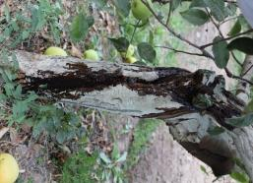 | 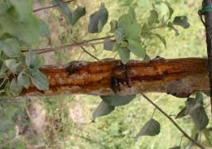
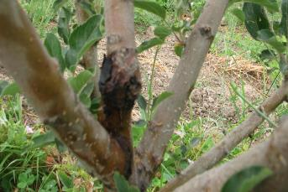
a, b, c - symptoms of burns on the trunk

Figure 1 - Symptoms of a fire blight on a tree trunk

It is important to prevent the accumulation of infection during the flowering period, since nectar is a favorable environment for the reproduction of bacteria [58].

3.1.2 Isolation and identification of the fire blight pathogen
When monitoring fruit plantations in peasant farms in Almaty, Zhambyl and Turkestan regions, samples with typical symptoms of a fire blight were taken for laboratory tests. 3-4 samples were taken from each tree affected by the disease, while all antiseptic requirements were observed. Affected tree organs were selected - leaves, ovary, fruits, shoots, bark. The collected samples were kept in the refrigerator in filter paper for several weeks until the etiology of the disease was precisely established.
For diagnostics, bacteriological analyzes were carried out in order to isolate the causative agent of the disease in a pure culture and study the morphological and cultural signs and pathogenic properties.
Over the three years of the study, bacteriological analyzes of 692 samples taken from the affected apple and pear trees from the Almaty, Zhambyl and Turkestan regions were carried out. 453 isolates were isolated. Many of which are identified as related.
Isolation of a pure culture of bacterial blight pathogens was carried out according to generally accepted methods, on media of potato agar, Levanov and King B. The bacteria grown on the nutrient medium were observed for 7-10 days. During this period, they clearly developed the main cultural features (size, shape, profile, consistency, structure, edges, color, etc.). After describing the colonies, the types characteristic of E. amylovora bacteria were selected. Colonies are off-white or slightly creamy, round with even edges, shiny, translucent, domed with a denser center, ranging in size from 2 mm to 5 mm (Appendix A.5, Figure A.5. 1). Selected colonies were seeded into tubes with slant agar (potato agar) and then plated on plates with King B's nutrient medium. When similar colonies grew, they were again seeded into slant agar tubes for further studies.
The pathogenicity was tested by the Klement infectious infiltration method on an indicator plant of room geranium (Pelargonium Zonala L.). Most of the isolates we isolated, similar to E. amylovora, caused chlorosis with necrosis on the leaves. The pathogenicity test by the White method was carried out on immature pear fruits. At the same time, bacteria similar to E. amylovora caused tissue necrosis with the release of an off-white exudate after 16-24 hours. This is one of the main diagnostic features of the bacterium E. amylovora, the causative agent of fire blight (Appendix A.5, Figure A.5.2).
To confirm the diagnosis, identification of isolated bacteria was carried out using PCR analysis. The results of bacteriological analyzes, as well as PCR diagnostics, confirmed the presence of a bacterial burn in the surveyed farms. The bacteria selected and identified by classical bacteriological methods and PCR analysis are included in the collection.
After confirming the pathogenicity of the studied bacteria, identification was carried out by molecular genetic analysis in FLASH format.

3.1.3 Molecular genetic study of local strains of the pathogen bacterium Erwinia amylovora
During molecular genetic analyzes, DNA was extracted from 91 samples of apple and pear (leaves and ovary) collected during monitoring from farms in Almaty, Zhambyl and Turkestan regions. The quality and quantity of isolated DNA was assessed by electrophoresis on a 1.5% agarose gel. FLASH-PCR was performed according to the manufacturer's protocol. The results were displayed in the form of a diagram (Appendix A.5, Figure A.5.1). According to the results of FLASH-PCR, all tested samples showed the presence of a pathogen.
Molecular genetic identification of local strains of the pathogen was also carried out by PCR. PCR amplification was performed with the primers FER1-F: 5'-AGC AGC AAT TAA TGG CAA GTA TAG TCA-3'rgER2-R: 5'-AAA AGA GAC ATC TGG ATT CAG ACA AT-3 '. PCR product 458 bp (Appendix A.6, Figure A.6. 2). Of the 283 isolates tested, 152 were not confirmed, the remaining 131 were identified as E. amylovora.

3.1.4 Determination of pathogen ribotypes and interpopulation genetic diversity of the pathogen
The next stage of research was devoted to PCR-ribotyping of bacteria identified as E. amylovora. PCR ribotyping exploits the size polymorphism of the 16S-23S rRNA spacer region among various bacteria and is used to identify bacteria at the species level and differentiate strains within a species. PCR - ribotyping was performed using the Rib F primers: 5 '- TTG TAC ACA CCG CCC GTCA-3'; Rib R: 5'-CGT ACT TAG ATG TTT CAG TTC-3 '. Amplification yielded PCR products (Appendix A.6, Figure A.6. 3), the size of which varied from about 700 bp to about 700 bp. up to 1100 bp. Based on the results obtained, all strains isolated from three regions were assigned to the third ribotype according to the authors, Patricia S. et al. [40].
A region of the 16S rRNA gene was used as a genetic marker.
PCR fragments obtained during amplification of DNA isolated from E. amylovora were run in 1% agarose gel with the addition of ethidium bromide in a horizontal electrophoresis chamber (Appendix A.6, Figure A.6. 4). The sequencing results showed that the nucleotide sequences in all studied samples were homogeneous and included mutations (Appendix A6, Figure A.6.5).
The computerized table (BLAST-NCBI) showing the species identification of Erwinia amylovora showed that the percentage of homology with the studied samples ranges from 97.58% to 99.72%.
Since the evolutionary discrepancy between the studied samples was not significant, only two representative sequences were selected. As can be seen from the phylogeny (Appendix A.6, Figure A.6.6), the isolated strains are very close in origin to the strains isolated from pears in Korea (E. amylovora BC2280 AF140341 ​​and E. amylovora BC229 AF140340). Other populations such as Italy, USA, Iran, Egypt and China are also similar to our samples. More distant populations are strains from Slovakia, Japan and Ukraine. The populations of Canada and Ecuador were the most distant. High genetic distances were found between samples from Kazakhstan and a strain from Canada (0.0204).
The studying samples were then compared with other Erwinia species ((Appendix A.6, Figure A.6. 7). The nucleotide sequences of the 16S rDNA reference strains were obtained from the Bacterio.net database. Pectobacterium carotovorum (AB242908) was used as an outgroup. According to the phylogenetic structure, the strains studied (3 pear and 37 apple) form a monofolytic group with the reference strain E. amylovora and E. pyrifoliae The evolutionary relationship for E. amylovora confirms that Pantoea Stewartii and Pectobacterium carotovorum are more distant.According to the studies of Takayuki of Matsuura et al. 2012 [44] showed a similar topology according to phylogenetic analysis of 16 S rDNA, where E. pyrifoliae, E. uzenensis, E. piriflorinigrans, and other species in the structure occupied similar positions.
The value of the genetic distance, the 16S rDNA sequences of the Erwinia amylovora gene and related species of Erwinia, ranged from 0.000 to 0.0454 (Appendix A6, Figure 1). The smallest genetic distance was found between the E. amylovora reference strain and Kazakhstani isolates. Also, low values ​​of the genetic distance were found for the E. amylovora and E. pyrifoliae strains (0.0009). The greatest genetic distance was found between (0.0454) strains of Pectobacterium carotovorum_AB242908 and Erwinia uzenensis_AB546198.

3.1.5 The evaluation of bactericidal properties of drugs in laboratory conditions on local strains of Erwinia amylovora bacteria
For the selection of effective means of protection against bacterial burns of fruit crops in laboratory conditions, the bactericidal properties of chemical and biological preparations, as well as plant growth regulators, were assessed by the method of holes according to the methodological instructions. At the same time, various doses of drugs were tested. The list of tested drugs, their active ingredient, countries of origin and recommended concentrations are presented in appendix (Appendix A.7, Table A.7. 1, Figures A.7. 1-4).
As shown by the results of the experiments, all tested fungicides showed bactericidal properties against the bacterium E. amylovora. The zone of inhibition at various concentrations ranged from 8.3 to 28.7 mm. The best performance in the variants Best Bakir, Microgranulat Cu, Fosiram, Curamin Foliar, Kosayd, Kurzat, Agri Gent Plus.
From testing biological preparations, phytolavin and kasumin showed bactericidal properties. The zones of inhibition of the growth of E. amylovora bacteria ranged from 4 to 7 mm, depending on the concentration.
Despite the fact that some growth regulators and biological products did not show bactericidal properties, Fitop, Bioduks, Immunocytophyt, Vaciplant, Novosil and Biostat) they will be tested on model trees as immunomodulators - activating the plant's immune system in order to induce plant resistance to fire bright.
Thus, when assessing the bactericidal properties of the preparations, fungicides Kurzat, Koside, Best Bakir, Curamin Foliar, Fosiram, Agri Gent Plus, biological products Kasumin, Fitolavin, Fitolavin, as well as growth regulators (Fitop 8.67-9, Bioduks, Immunocytofit, Novoslantosil , Biostat) for field trials in the garden in 2019.

3.1.6 Testing chemical and biological preparations, trace elements and growth regulators against bacterial fire blight of fruit crops in the field
Chemical and biological preparations, trace elements and growth regulators were tested in gardens in the field at two stationary sites in foci of bacterial fire blight. The first stationary is in Karasai district of Almaty region in the industrial garden of "Alatau" peasant farm on "Aport" grade susceptible to bacterial fire blight, planting year 2003, planting scheme 7×5, altitude 896.15 m above sea level. The second stationary is in Yenbekshikazakh region, Almaty Oblast, in the industrial garden of “Dikhan” peasant farm on the “Stark Erliest” variety of 2011 planting, planting scheme 5×3, altitude 636.92 m.
Based on the developed strategy to combat bacterial fire blight, 7 schemes have been drawn up, including preparations selected in laboratory conditions that have bactericidal properties in relation to E. amylovora bacteria. To reduce the infectious load in the garden, copper-containing fungicides are included in the schemes: Bordeaux Liquid, Koside 2000, Curamin Foliar, Allett, Kurzat P, Fosiram, Best Bakir, Contolfit Cu, Kuproxat 34.5%, Aliet Super 80. To contain the propagation of the bacterial fire blight pathogen, biologics (antagonists and competitors) are included: Fitolavin RMC, Kasumin, Agroflora, Fitop 8.67 and Extrasol. To activate the immune system, growth regulators are included in the schemes: VacciPlant, Potassium Humophosphate (GUPOS), Phoskraft MKP, Novosil, Regalis Plus and Extrasol. Autumn and spring agro-technical and preventive measures were carried out at two hospitals selected by us, including trimming of branches contaminated with bacterial fire blight with the capture of 20 cm of healthy tissue in compliance with phytosanitary and quarantine requirements, cleaning of wounds and ulcers on stamped branches and trunk, whitewashing of their lime with the addition of copper sulfate. Experiments on model trees have been laid down in accordance with the methodology. Prophylactic fungicide spraying was carried out over the green cone and before flowering; biological spraying during flowering and by growth regulators after flowering. Schemes and timing of treatment for bacterial fire blight are presented in Appendix A.8. ( Appendix A.8, table A.8.1). The performance results effectiveness of 7 apple tree fire blight protection schemes in two stations are presented in Table 1.

Table 1 – Efficiency of various apple tree treatment schemes against bacterial fire blight in two stations. (p.f. «Alatau», Variety Aport), 2019 y.
Variants | Level of development, % | Biological effectiveness, % | Harvest , tonne ha | Crop gain
 |  |  |  | tonne ha | %
Control | 21,2 | - | 16,9 | - | -
Scheme №1 | 2,8 | 86,7 | 22,1 | 5,2 | 30,7
Scheme №2 | 0,8 | 96,2 | 24,8 | 7,7 | 45,5
Scheme №3 | 1,0 | 96,9 | 25,2 | 8,3 | 49,1
Scheme №4 | 0,8 | 95,3 | 23,0 | 6,1 | 36,1
Scheme №5 | 2,5 | 89,1 | 21,9 | 5,0 | 29,6
Scheme №6 | 1,8 | 91,5 | 23,2 | 6,35 | 37,5
Scheme №7 | 0,9 | 95,7 | 23,2 | 6,3 | 37,3
 |  |  |  | НСР=2,9

As can be seen from Table 1, all of the apple tree experience schemes for protecting apple trees from bacterial fire blight at the "Alatau" gardening station have shown a significant reduction in the degree of disease development compared to control. The degree of bacterial fire blight development in the pilot versions varies from 0.8-2.8%, while in the control version 21.2%, biological efficiency ranges from 86.7% to 96.9%. The highest biological efficiency of this plant farming in schemes 2, 3, 4 and 7 is 96.2%, 95.3%, 96.9% and 95.7% respectively. Yield gains in all experience schemes compared to controls ranging from 29.6 to 49.7%. The highest increase in schemes №2 and №3 was 46.7% and 49.1%, respectively. (Appendix A.8, Table A.8.2 and 3).
A similar picture emerges from the experiments on the "Dikhan" plant farm. There is also a significant reduction in bacterial fire blight compared to control. The degree of disease development for all experience schemes is from 0.9% to 2.8%, and biological efficiency is 84.8% to 96.2%. The best options are 2,3,4 and 7, and biological efficiency is 91,5-96,2%.

Table 2 – Efficiency of various apple tree treatment schemes against bacterial fire blight in two stations (p.f., «Dikhan», variety Stark Erliest), 2019 y.
Variants | Level of development, % | Biological effectiveness, % | Harvest , tonne ha | Crop gain
 |  |  |  | tonne ha | %
Control | 18,5 | - | 19,8 | - | -
Scheme №1 | 2,8 | 84,8 | 27,5 | 7,7 | 38,9
Scheme №2 | 0,9 | 95,1 | 28,8 | 8,7 | 43,9
Scheme №3 | 0,9 | 95,1 | 28,7 | 9,0 | 44,4
Scheme №4 | 0,7 | 96,2 | 28,2 | 8,4 | 42,4
Scheme №5 | 2,0 | 89,2 | 26,4 | 6,6 | 33,3
Scheme №6 | 1,2 | 93,5 | 27,6 | 7,8 | 39,3
Scheme №7 | 0,9 | 95,1 | 28,0 | 8,3 | 41,9
 |  |  |  | НСР = 2,0
Yield data at this station is slightly higher than at the «Alatau» station. This was probably due to the variety features and the planting scheme. According to data from the weather station (Table 2), the «Alatau» peasant farm had higher air humidity during the growing season than the «Dikhan» peasant farm. Harvest increase for all experience schemes is in the range of 33.3%-44.4%. The largest yield increases in schemes No. 2, 3, 4 and 7 were 43.9%, 44.4%, 42.4% and 41.9%.
Experimental studies of bacterial fire blight development have shown that the most effective fungicides are: Kurzat R, Cosaid, Curamin Foliar + Phoscraft (macro- and microelements), Fosiram, Agrigent Plus, Allett; biopreparations: Kasumin, Phytop and Phytolavin VRK; and growth regulators: Regalis Plus, Novosil and Extrasol.
Thus, the results of 7 tests on apple tree protection schemes against bacterial fire blight showed the effectiveness of the comprehensive protection system we have developed and the possibility of reducing the harmfulness of disease to an economically insensible level. The biological efficiency in the 3 schemes at two stations was in the range of 95.1-96.9%, with yield increases of 42.4% to 49.1%.
Scheme 3 was selected for the demonstration of the integrated system of apple tree protection against bacterial fire blight, including Kosaid fungicide, which is part of the "Directory of Pesticides (Poisonous Chemicals) Approved for Use in the Republic of Kazakhstan", against bacterial fire blight, as well as Phytolavin bio-preparation and Novosil growth stimulant. In this scheme, the biological efficiency of the two stations was 95.3 % and 95.1 %, while the yield increase compared to control was 49.1 % and 44.4 %.

3.1.7 Development of recommendations on comprehensive measures to combat bacterial fire blight in fruit crops and implementation on a 15 ha demonstration area
Copper-containing preparations, biofungicides, antibiotics, in particular streptomycin and immunomodulators, are widely used worldwide against bacterial fire blight. Only effective preparations must not be used to combat fire blight, and a suitable strategy must be developed. In this regard, we have developed a strategy to combat this, which includes a set of measures aimed at reducing the infectious load in gardens, curbing the intensity of pathogen reproduction and increasing the resistance of plants to disease.
The results of our research and literature sources show that all apple tree organs affected by bacterial fire blight (ovaries, leaves, fruits, shoots, ulcers, cracks in the bark) contain a bacterial infection that persists until the end of the growing season and winters in the specified places. Consequently, the main source of infection is the tree itself. Bacteria can tolerate low temperatures well and can remain in a latent state for a long time.
In 2019, the effectiveness of 7 schemes of complex measures for combating bacterial fire blight was assessed, including sanitary measures, chemical and biological preparations, trace elements and growth regulators.
In order to implement comprehensive measures against bacterial fire blight, the demonstration area selected Scheme 3, which includes copper fungicide Kosaid and biopreparation Casumin, which are included in the list of approved preparations against bacterial fire blight of fruits in the territory of the Republic of Kazakhstan, as well as immunomodulator Regalis plus (calcium progesaxadione). In this scheme, the biological effectiveness against bacterial fire blight at two stations was 95 and 96.2%, with yield increases of 45.4% and 49.0%.
Demonstration experiments on the introduction of integrated control measures were laid in the Yenbekshikazakh region of Almaty Oblast in the infestation centre in the plant peasant farm "Zhemis" on an area of 15 ha, on two varieties of "Stark Erliest" and "Golden Delicious" according to the methodological guidelines on conducting industrial testing of pesticides in the Republic of Kazakhstan.
Sanitary pruning of diseased tree organs in the apple orchard was performed at the demonstration site in late autumn (third decade of October) 2019 during the period of cessation of saplinging and quarantine requirements were met: whitewashing of the tree trunk and skeletal branches with lime with the addition of 4% copper sulfate against infection in ulcers and cracks, then spraying the tree crown with 0.5% copper Cosaid fungicide against mummified organs containing infection. These measures prevent the transmission of infection for the next season.
In the early spring (April 3), before buds were blown out, 0.5% Kosaid was re-sprayed to suppress overwintering infection.
During the flowering and outgrowth period of young shoots (susceptible phases of apple tree development), Kasumin (2-3 l/ha) was sprayed twice with bio-preparation, the first at the beginning of flowering and the second at the end to saturate the tree with antagonists and competitors restraining the reproduction of the infection. In order to increase the disease resistance of apple trees, an immunomodulator - Regalis plus (d. V. calcium progexadion) (1.25 kg/ha) was sprayed, the first at the beginning of petals fall and the second at the end.
Given that copper-containing fungicides may exhibit phytotoxicity, they have been used at the end of the growing season, during the period when the falconry ceases, and at the beginning of the growing season before the buds blossom.
Measurements and observations at the demonstration site have shown that comprehensive control measures have been effective in containing the bacterial fire blight development intensity of the two varieties. Sanitary measures and 4-fold spraying with copper-containing fungicides were taken in the standard. The results of biological and economic efficiency are presented in Tables 3 and 4.

Тable 3 – Biological efficiency of integrated measures to combat bacterial fire blight on an apple tree at a demonstration site (Enbekshikazakh region., p.f. «Zhemis»), 2020 y.

Variety | Implementation area, ha | Spread of fire blight, % |  | Degree of development, % |  | Biological effectiveness  , %
 |  | template | experiment | template | experiment
Starkrimson | 7,5 | 9,8 | 2,2 | 5,8 | 0,2 | 96,5
Golden delicious | 7,5 | 11,2 | 2,6 | 6,2 | 0,3 | 95,2

As can be seen from Table 3, there was no significant difference between the two varieties in terms of bacterial fire blight. Both schemes in the conditions of this year have constrained the intensive development of bacterial fire blight. Complex control measures showed high biological efficiency compared to the standart in the Starkrimson 96.5% and Golden Delicious 95.6%.

Таble 4 – Cost-effectiveness of integrated measures to combat bacterial fire blight on an apple tree at a demonstration site (Enbekshikazakh region., p.f. «Zhemis»), 2020y.
Parameters | Apple-tree variety
 | Starkrimson |  | Golden Delicious
 | template | experiment | template | experiment
Harvest, t\hа. | 35,5 | 49,9 | 25,4 | 32,2
Retained crop, t\hа | - | 14,4 | - | 6,8
Cost of retained crop, thousand. tg. | - | 2 880 000 | - | 1360000
Costs of plant protection, collection and transportation of additional products | - | 358506 | - | 206506
Net income compared to the benchmark | - | 2 521 494 | - | 1 153 494

A cost-benefit calculation has shown that the application of comprehensive measures to combat bacterial fire blight has contributed to the production of additional products compared to the standart. On the Starkrimson variety, the yield increase was 14.4 t/ha (28.8%), and on the Golden delicious variety, 6.8 t/ha (21.1%), with the cost of 1 ton of apples 200 thousand tenge. Net income compared to the standart on Star Crimson 2521 thousand tg, on Golden Delicious 1 153 thousand tg.
Similar results were obtained for Scheme №2. (Appendix A.9, tables A.9.1-2). The act of implementation is attached (Appendix A.10).
3.2 Development of recommendations on the South American tomato moth сontrol (Tuta absoluta Povolny) in Almaty, Turkestan and Kyzylorda regions conditions
3.2.1 Study of international experience in combating Tuta absoluta: efficiency of applied techniques and tomato protection means
An analysis of literature on the distribution and harmfulness of tomato moth in foreign countries shows that tomato crop losses often reach as much as 100% and therefore production becomes unprofitable [59]. In the early years of the pest, organophosphorus compounds were used to protect tomatoes, but due to the rapid appearance of resistance in the moth they were replaced by pyrethroids [60]. However, after some time, the effectiveness of insecticides became extremely low again. In this regard, the researchers, based on the results of the practical use of various preparations, concluded that the solution to the issue of Tuta absoluta lies in the use of a comprehensive protection system: these include the colonisation of bioagents, the capture of moth for pheromone traps, the treatment of plants with biopreparations and, in exceptional cases, the treatment of tomatoes with insecticides of selective (low-hazard) action [61]. This approach to solving the problem of protecting tomatoes from moth is justified: firstly, pesticides are practically not used and secondly, environmentally friendly products can be obtained.
Biopreparations application. Entomopathogenic biologics have been successfully used against pests in some countries. In particular, high lethality was observed among the Tuta absoluta caterpillars after spraying tomato plants with a suspension of a biopreparation based on the Bacillus thuringiensis var. kurstaki bacteria [62].
The use of pheromone traps. Worldwide, instead of insecticides, useful insects and pheromone traps are additionally used to biologise protective measures. Pheromone traps are used both for monitoring and for mass catching insects. For example, pheromone QT TuaLd traps were used to catch moth males, which were hung in the greenhouse 2 weeks before the planting of seedlings at a height of 40 cm above the ground surface [63]. The largest number of butterflies were caught in traps located at a height of 2 m, where 398 individuals were caught, at a height of 1 m - 236 and on the soil surface - 152 individuals. This is explained by the fact that the lower leaves age and become unsuitable for caterpillar nutrition and development, which is why butterflies lay eggs on young plant parts. Based on the practice of tomato protection, the authors conclude that the use of pheromone traps to integrate them into the integrated system significantly reduces the moth population.
The use of chemicals against Tuta absoluta. Despite the negative consequences of their use, they remain in many countries the main means of controlling the number of harmful stages of the phytophage, i.e. an important component in a comprehensive tomato protection system. As moth, after insecticide use, forms resistant races, researchers note the need for systemic insecticides, which have certain restrictions on their use in vegetable crops [64]. It is noted that in recent years there have been preparations that are highly effective, have a longer duration of action and are less toxic to enterophages and that such insecticides will remain an important component of integrated pest protection for tomatoes in the foreseeable future. Studies have shown that Koragen, Proclamation and Antorio have been the most effective anti-moth preparations in the fight against moths [65].

3.2.2 Monitoring of tomato moth spread in tomato plants in greenhouses in the country
The homeland of Tuta absoluta is considered to be South America, where the phytophage has spread virtually throughout the tomato growing area. The species was first described in Peru [67], although cases of damage to tomatoes was recorded even earlier [67]. In Europe, moth was identifi in 2007 and now inhabits the entire continent, including the countries of the former USSR [68]. In 2015, tomato moth was also detected in Kazakhstan and in the first few years it caused serious losses in the tomato harvest in some plant farms of the republic. Surveys of tomato plantations, both open and closed, conducted between 2015 and 2020 by the Institute's staff confirmed the mass spread of the pest in the conditions of Turkestan, Kyzylorda and Almaty regions. Table 5 shows the data obtained during the survey by employees of the Kazakh Research Institute of Plant Protection and Quarantine.

Table 5 – Range of tomato moth spread by region of Kazakhstan (2019-2020 years)

№ | Name of the greenhouse farms | Surveyed area, ha | Tomato Extension and Population Index, %
 |  |  | spread |  | settlement
 |  |  | 2019 y. | 2020 y. | 2019 y. | 2020 y.
Turkestan region
1 | p/f «Ayanat» | 3,0 | 20,0 | 12,0 | 7,3 | 6,0
2 | p/f «Adeliya» | 5,0 | 5,5 | 18,0 | 2,0 | 5,0
3 | p/f «Naiymbekov» | 2,0 | 15,0 | 22,0 | 4,0 | 5,0
4 | p/f «Koktem» | 1,0 | 44,1 | 100,0 | 7,0 | 55,0
5 | p/f «Rahmon» | 2,0 | 18,9 | 23,0 | 6,5 | 7,0
6 | p/f «Bibol» | 1,3 | - | 54,0 | - | 2,3
Almaty region
1 | p/f «Otan» | 3,0 | 8,0 | 22,0 | 18,0 | 18,4
2 | JPC «Chilica Farmers» | 2,0 | 9,0 | 18,0 | 7,8 | 3,0
3 | p/f «Iliyas» | 1,2 | - | 38,0 | - | 46,0
4 | p/f «Masak» | 1,0 | 40,0 | 9,0 | 50,5 | 4,0
5 | p/f «Aldeke» | 0,13 | - | 55,5 | - | 21,0
6 | p/f «Tomatik» | 5,0 | 17,0 | 12,0 | 3,8 | 4,0
Kyzylorda region
1 | p/f «Natysheva» | 2,0 | 94,2 | 44,0 | 50,2 | 12,0
2 | p/f «Bereke» | 4,0 | 88,0 | 15,0 | 24,6 | 5,0
3 | p/f «Shakh» | 0,3 | - | 24,0 | - | 15,0
4 | p/f «Ak-Nur» | 2,0 | - | 12,0 | - | 8,0

The data in the table shows that tomato moth has been widely spread to varying degrees in the country's greenhouses. However, the mass and repeated use of chemical agents against quarantine pests contributed to a slight decrease in the prevalence of the pest in 2020. Sufficient mass distribution of tomato moth was noted in 2019 in the greenhouse farms "Koktem" in Turkestan region, "Natischeva" and "Bereke" in Kyzylorda region. The high prevalence of moth in these plant farms continued in 2020, which indicates that the chemical agents used are not effective enough as a result of resistance development, due to the habituation of moth to drugs. There is therefore no doubt that the need for protective measures using bioagents, pheromone traps, biopreparations and selective insecticides is essential.

3.2.3 Brief morphological and biological characteristics of development features and harmfulness of tomato moth
Imago (butterfly) of silver-gray tomato moth with black dots on the front wings. The antennae are long and bristle-shaped. The body size of 5-7 mm. Wings in a span of up to 10-12 mm. Cylindrical shaped butterfly eggs laid, small white and yellow in colour, passing to a cream colour length of 0.3-0.5 mm. Hatching caterpillars are 0.5 mm in size, initially in yellow, and as they grow, they acquire a yellow-green colour. A black stripe appears at the back of the head. An adult caterpillar, having reached a length of 9 mm, acquires a pink colouring in the back part. The pupa is up to 6 mm in size, usually light brown in color. The phases of moth development are shown in Figure 2.

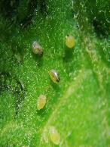 | 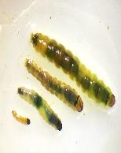 | 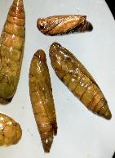 | 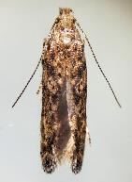
Egg | caterpillar | pupa | imago

Figure 2 - Tomato moth growth phases (Tuta absoluta)

Tomato moth is a pest with high reproductive potential. Females lay eggs on plant leaves for 2-5 eggs in total, their number reaches an average of 160-260 eggs. The temperature regime affects the timing of embryonic development and is at +30℃ 4-5 days. When the temperature drops to +15℃, the egg development period increases to 10-14 days. Hatching caterpillars pass through 4 ages in their development. Caterpillars of the 1st age mainly mine leaves, the last stages are introduced into stems, pedicels, ovary and green fruits. The data obtained from laboratory tests on temperature settings for the development periods of individual phases are shown in Table 6.

Table 6 – Duration of development of different stages of tomato moth development depending on temperature conditions, 2018-2019 years

Air temperature, ⁰С | Duration of development, day |  |  |  | Total, days
 | egg | larva | pupa | imago
8-9 | 15,34±0,44 | 46,9±0,90 | 31,2±0,41 | 32,8±1,08 | 126,24±0,71
10-13 | 8,375±0,37 | 39,8±0,74 | 18±0,57 | 22±1,6 | 79,57±0,82
15-18 | 7,8±0,13 | 28,6±0,57 | 12,5±0,25 | 23±0,5 | 71,9±0,36
20-23 | 5,4±0,20 | 11,1±0,20 | 7,6±0,27 | 17,2±0,65 | 41,3±0,33
25-28 | 4,6±0,20 | 10,9±0,20 | 6,3±0,22 | 16,9±0,41 | 38,7±0,26
30-33 | 1,8±0,13 | 7,14±0,17 | 5,04±0,10 | 16,2±0,41 | 30,18±0,41
35-38 | 3,2±0,13 | 8,8±0,41 | 5,44±0,27 | 16,4±0,27 | 33,84±0,27

Of the data presented in the table, the highest life expectancy for all stages of tomato moth was between 8 and 9°C and was 126 days. As the temperature regime increased, life expectancy decreased, and with an increase to 38 °C, there was again an increase in duration. Knowledge of this indicator is necessary when conducting laboratory work on the maintenance and reproduction of the pest as a victim of bioagent breeding.
The lower development temperature threshold is +6 C. Caterpillars pupate in soil, on leaf surfaces and even in mines. Tomato moth butterflies appear after 12-14 days. They are active at dusk and early hours in the morning, and during the day they hide from sunlight on hidden parts of plants. Butterflies live for 35-40 days. Knowledge of the influence of temperature conditions on the viability of eggs and the life period of males and females is also of great practical importance. Experiments to establish the viability of eggs have shown that they are most stable at temperatures of 25-28°C and 30-33°C. This indicator is of great practical importance when reproducing a pest that is a victim of the bioagents used. The table with egg viability indicators is given in Appendix B.1.
Harmfulness of tomato moth. Tuta absoluta damages tomato plants at any stage of development, from seedling to the end of vegetation. For the phytophage, the most important thing is the presence of green mass, damaging all parts of the plant above ground - stems, leaves, apical buds, flowers and fruits. The development of the harmful phase - caterpillars - takes place in plant tissue, where mines are ejected in the parenchyma of leaf, stem and fruit. In this way, the plant's photosynthetic system is destroyed when feeding on mesophyll leaves, which leads to deformations.
The most attractive plant for moth is tomato, which is damaged at any age. You can see an abundance of black excrement on the damaged parts of the plant. The characteristic signs of damage on leaves are spotted mines (Figure 3).

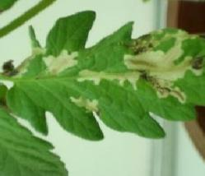 | 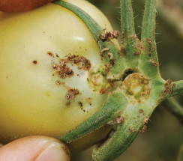
а | б

Figure 3 – Tomato moth damage, a – leaves; b – fruits

On the fruit of tomatoes and eggplant caterpillars form deep tunnels, and they almost completely lose their commercial appearance and are not even suitable for processing.
In addition to tomatoes, Tuta absoluta also damages eggplants (Solanum melongena), potatoes (Solanum tuberosum), pepper (Capsicum annuum) and other Solanaceous plants.
According to observations, tomato moth develops in 10-12 generations when feed is available. In the first years of tomato moth appearance, quarantine services of the republic gave recommendations to economic entities to process tomatoes with Confidor and Actellic preparations, which proved to be ineffective. Therefore, the laboratory of the Institute was tasked to develop a set of preliminary preventive measures against moths on the basis of literature data. Taking into account the need of the biological function of the protective measures was organized effective transfer of biological agents macrolophus, nesidiocoris and pheromone traps. Technologies for breeding entomophages were mastered, pheromone traps and insecticides with prolonged action Koragen, K. s and Proclaim fit, which are not dangerous for useful fauna, were tested. Preliminary tests of the insecticide Koragen, pheromone traps, the biological product Actofit, and the bioagents macrolophus and nezidiocoris have shown high efficiency in their combined use.

3.2.4 Transfer and study of development features of Macrolophus (Macrolophus nubilis), nezidiocoris (Nesidiocoris tenuis) and podisus (Podisus maculiventris) mass breeding technology.
In order to develop an integrated tomato moth protection system, the laboratory of useful arthropods of the Institute has transferred effective macrolophage and nesidiocoris entomophages from other countries (Figure 4).

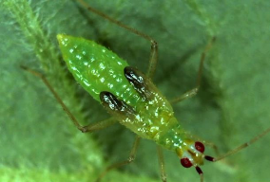 | 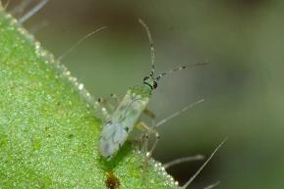
а | б
а – predatory bedbugs: а – macrolophus; б – macrolophus; в - podisus
Figure 4 – Carnivorous bugs

3.2.4.1 Bioenvironmental assessment and some behavioural characteristics of entomophage development
Bedbugs belong to the horseflies Miridae family, a group of semi-rigid wings (Hemiptera). The bugs' life cycle consists of several phases: embryo, nymph (5 ages) and imago. Despite external similarities in life cycles and behavioural patterns, there are significant differences between the bioecology of macrolophus and nesidiocoris predators. Table 7 provides a brief bioecological description of the development of entomophages.

Table 7 – Bioecological characteristics of macrolophus and nesidiocoris development (2019-2020 years)

Name of development indicators |  | Macrolophus | Nesidiocoris
Body measurements, mm |  | 2,7 – 3,7 | 3,0 – 4,0
Imago colour |  | green | Green, with striped antennas and a black and white wing pattern
Development stages |  | egg →5 nymphal stages →imago | egg →5 nymphal stages →imago
Duration of development from egg to imago, 24 hours |  | 42 – 50 | 21
Colour of eggs |  | grayish-yellow or yellowish-green | white
Optimal conditions for growth | Temperature: | 25 – 27°С | 27°С
 | Humidity: | 75 – 80% | 75 – 80%
Number of eggs laid by female, pcs. |  | up to 140 | 60 – 80
Place of egg-laying |  | on the leaves near the veins | in the top of the plant, in the leaf axils
The data in the table shows that the development of macrolophus can last up to 50 days, while nezidiocoris is more intensive and takes only 21 days. The characteristic almost significant difference is considered to be the egg-laying places. The authors [48] also note differences in the pest nutrition of bedbugs, depending on the density of the victim. Thus, at a low density of the phytophage (5-10 eggs per 1 leaf), macrolophus, unlike nesidiochoris, did not eat them. Moreover, when the density increased to 25 eggs/sheet, macrolophus consumed significantly less than nesidiocoris, which ate 99% of the eggs. In addition, it has been found that when daylight hours are less than 16 hours, macrolophus shows a decrease in egg-laying females compared to nesidiocoris. Observations of the use of nesidiocoris revealed another feature, which is that 12 weeks after bug release, the biological efficiency against the whitefly was 97%, while for leaves with ring-shaped damage on petioles it was almost 30%. Observations of bug development have shown that macrolophus can develop at temperatures of 16-18°C, nesidiochoris +20°C. Predators also show that their own population only increases 3 weeks after release. During this period they prefer only moth eggs, and only when their own population increases do they actively destroy the pest caterpillars. Characterising the voracity of predators, it should be emphasised that the efficiency of nesidiochoris is significantly higher than that of macrolophus. Thus, females of nesidiocoris were eaten by 210.5 whitefly larvae per day, while macrolophus was only 134.8. It should be noted that nesidiochoris, with a high pest density (200 eggs/list), ate 99% of the victim. In protected ground conditions, predatory bedbugs are used to destroy almost the entire complex of greenhouse pests: aphids, thrips, spider mites, greenhouse whiteflies, tomato moth. Studies conducted in this regard [47,48] showed a high efficiency of the macrolophus bug against the greenhouse whitefly, which was 90%. The release of the bioagent in the norm of 5 individuals/m2 contributed to almost 100% aphids destruction on pelargonium plants and roses, although the pest population was high, amounting to 27 individuals/m2. The laboratory tests carried out in this regard have shown that bug breeding is highly dependent on the type of dressing. In bug breeding technology, after laying macrolophus eggs, plant pots were transferred to other boxes. Bedbug larvae hatched in all the boxes were fed eggs by sithotrogs and the larvae of bugworms with sithotrogs. Biomaterial yield data from all 6 pots are shown in Table 8.

Table 8 – The average number of bedbugs from 6 pots depending on the type of feed, 2018-2019 years

Experience options | Average | Average amount of macrolophus, pcs. | Received only on average, pcs | Average amount of macrolophus in one pot, individuals
Feeding bedbugs with sitotroga | 2018 – 2019 years. | 240 | 956,5±9,7 | 159±3,5
Feeding bedbugs with whitefly larvae with a sithotrope | 2018 – 2019 years. | 240 | 1052±8,9 | 175,3±5,2
The data presented in table 8 shows that when feeding bedbugs both with sitotroga and in combination with whitefly larvae, they provided a fairly high yield of bedbugs from 6 pots.
The predator Podisus (Podisus maculiventris) is intended for biological control of the Colorado potato beetle, however, we have tested releases against tomato moth on tomatoes in protected ground conditions. A bug is widespread in North America, Canada and other countries (69). There are 5 nymphal stages in its development, with development time from egg to adult phase being 28-30 days. The egg stage lasts 5-9 days. The authors note that bedbugs feed on 75 species of harmful pests, including corn moth, cabbage moth, Colorado potato beetle, etc. [70]. As podizus trials did not yield a positive result against tomato moth, work on the entomophage was completed in 2019, but some research has been done on bioecology and the development of bug breeding technology.

3.2.4.2 Technological regulations for mass breeding of entomophages
Following the recommendations [47, 48] methods of maintenance, breeding and application of bioagents obtained from the transfer were mastered in order to use them in a comprehensive program of protection of tomatoes and other vegetable crops. Mass bug breeding in the laboratory consists of sequential technological processes, which include: tobacco fodder plant cultivation → macrolophus and nesidiocoris content → whitefly falcon → grain moth (sithotrogs) breeding → macrolophus and nesidiocoris breeding. The main technological stages of cultivation of macrolophus and nesidiocoris are shown in Appendix B.2 figures.
Breeding bedbugs can be carried out in two ways: the first is the use of whitefly as a prey for a predator and the second is the use of grain moth eggs (sithotrogs). Оба направления разведения клопов осуществлялись в трех отдельных боксах: первый-для выращивания кормового табака; второй-для разведения парниковой белокрылки (маточных клопов); третий-для разведения хищных клопов (маточных клопов). To improve bug breeding technology, a feed additive consisting of a mixture of eggs and whitefly larvae in a mixture of grain moth eggs was tested.
Breeding bugs on a greenhouse whitefly. The technology of bug breeding on a whitefly greenhouse presupposes the cultivation of a tobacco plant in a separate room free from pests and predators. In the room, the duration of the light day should be 16-18 hours. After diving, the plants are planted one by one in plastic pots. The schematic technology for laboratory breeding of macrolophus and nesidiocoris bugs on greenhouse whiteflies is shown in Appendix B3. Tobacco plants grown in a separate box in plastic pots 15 cm in diameter when reaching 6-8 leaves are transferred to the whitefly queen cell. Then the leaves infected with the whitefly with a high density of larvae and pest imago are placed on the tobacco plants at the rate of 200 individuals per plant. The moment when tobacco leaves infected with whitefly are prepared for placement in the uterus is shown in Appendix B4. The temperature in the box was kept at 25-26°C, humidity 65-70% and daylight length 16 hours. The plants inhabited by whiteflies are transported to the bug womb box, where the temperature is set at 23-24°C, humidity 70-80% and daylight length is 18 hours. 6 pots with plants inhabited by different phases of whitefly development were put into cages. As the number of whiteflies decreased as a result of bedbug feeding, plants infected with whitefly were added to the cages using the conveyor method. Plants that were already without a whitefly were removed, and bug surveys were carried out regularly.
Breeding macrolophus and nesidiochoris on grain moth eggs. The laboratory breeding of bedbugs on grain moth eggs differs from the above scheme in that the plants are not populated by whiteflies, but sitotroga is offered as food to predators. For this reason, tobacco plants grown in a separate room were introduced into the uterine macrolophus and nesidiocoris culture box. Six pots of plants were also placed in each nursery and the bioagents were launched on the basis of 200 individuals, once every two days. A general view of bedbug infested mothers is shown in Appendix B5. Bedbugs in this breeding technology were fed only eggs of grain moth. Hatching larvae from eggs laid by bedbugs were raised to adults. The box was kept at 22-23°C and 70% humidity. Bedbug breeding is technologically linked to the breeding of sitotroga, which was also breeded in a separate room. The order of grain moth breeding is as follows: grain preparation (barley) → grain infestation → butterfly collection → butterfly content → egg collection → egg cleaning → bedbugs breeding. The technology of bug breeding on grain moth eggs is schematically shown in Appendix B6. Surveys conducted over 30 days showed that an average of 1,000 bed bugs can be obtained from a single 60 x 90 cm cage using this breeding technology.
Breeding macrolophus and nesidiocoris using a mixture of whitefly larvae eggs and sithotroga as feed. In the course of bioconveyor breeding of macrolophus and nesidiocoris, parallel experiments were conducted to establish the dependence of the impact of different bug feed species on the quantitative yield of predators. For this purpose, in the first experiment, 240 individuals of macrolophus and nesidiocoris were launched on tobacco plants populated with whitefly larvae and eggs, placing each of them in different boxes. In the second experiment, plants that were not infected with whitefly were introduced into the seedlings and the same amount of macrolophus and nesidiochoris was started separately, but they were only fed with grain moth eggs. In the third experiment, plants infected with greenhouse whitefly were introduced into the seedlings and 240 bedbugs were also launched, while the entomophage was only additionally fed with grain moth eggs. The experience data obtained is shown in Table 9.
Analysis of the data presented in the table shows the positive impact of feeding bedbugs with a mixture of eggs and whitefly larvae with the addition of grain moth eggs. The yield of bedbugs in this variant, in particular macrolophus, was higher in comparison with feeding on whitefly larvae by 33.3%, and nesidiocoris by 36.2. Feeding with a mixture of eggs and larvae of whitefly and grain moth is also advantageous in comparison with additional feeding only with whitefly larvae, since the yield of macrolophus and nesidiocoris was also higher here, by 10.5% and 15.2%, respectively. On the basis of the data obtained, it can be concluded that it is preferable to feed bedbugs when a mixture of eggs and whitefly larvae and grain moth eggs is diluted, as this provides a much higher yield of bedbugs from a unit of laboratory area. The technology of bedbug breeding using whitefly eggs and larvae mixed with grain moth eggs as feed is shown in Appendix B7.

Table 9 – The number of bedbugs output depending on the type of additional feed (2018-2019 years)

Experience options | Entomophage | Bug emergence from the 1st cage on average, individuals | Average number of bedbugs per 1 pot, individuals
Feeding eggs and whitefly larvae | Macrolophus | 790,5 | 131,5
 | Nesidiocoris | 860,5 | 143,4
Feeding eggs of grain moth | Macrolophus | 956,5 | 159,4
 | Nesidiocoris | 1017,0 | 169,5
Feeding whitefly eggs and larvae in a mixture with grain moth eggs | Macrolophus | 1052,5 | 175,0
 | Nesidiocoris | 1172,5 | 195,4

Although the podizus is not intended to combat tomato moth, we have nevertheless carried out research into certain biological features of the development and developed breeding technology. In 2018-2019, experiments were conducted on the selection of food for the castaneum , which is a victim of podizus. As food castaneum experienced grain waste, corn, wheat and barley. The development time and weight of the larvae of the castaneum were taken into account (table 10).
According to the data in the table, the castaneum larvae react equally to different types of feed in terms of development time and average larval weight. The materials of additional experiments to determine the effect of the type of feed on some biological indicators of podizus development are shown in Appendix B.8.

Table 10 – Influence of feed species on development time and weight of crunch larvae (2018-2019 years)

Parameter | Average | Development of a castaneum on different types of forage
 |  | corn | wheat | barley
Development time, days | 2018 – 2019 гг. | 154,5±0,2 | 158,5±0,6 | 159,5±0,7
Average weight of larvae, mg | 2018 – 2019 гг. | 108,5±0,6 | 108,0±0,4 | 109,0±0,6

The podisus larvae development took place at 24-26°C, 60-70% relative humidity and a 16-hour light day. Observations carried out on the development of the bug with various types of food showed that the duration of development when feeding wax moth is 24.8 days, when feeding large flour castaneum 22.3 days, which has a certain practical value in favor of the latter when breeding podizus. Determination of the number of winged adults showed that when feeding large flour crustaceans, the indicator was 77.5 individuals, when feeding wax moth 35.1 individuals. The fecundity of one female bug when fed with wax moth was 45.3 eggs, and 69.5 eggs per female when fed with large flour castaneum. There are also certain regularities in determining the weight of adult predators. These experiments were carried out to determine which of the victims should be used in breeding the podisus. Based on the analysis of the data, preference on all counts when breeding podisus given large flour castaneum. The technological process of mass-rearing podisus includes the following cycles (stages): breeding uterine culture podisus → farming of victims (larvae and pupae large flour castaneum) for feeding of the entomophage → quality control biomaterial. The sequence of the process of breeding podisus for the production of a uterine culture should be maintained permanently. The larvae of the predator are raised in Petri dishes, the bottom of which is covered with circles of filter paper. Larvae of the 1st age contained 50 individuals each, and of the 2nd age 5 individuals each. Food for podisus larvae were older castaneum larvae, which were fed into Petri dishes of 7 larvae each. At 24-26°C, 70% relative humidity and 18 hours of light, bedbugs were winged for 23 days. Then the bedbugs were placed one pair (female and male) in Petri dishes and fed with large flour castaneum pupae every 3 days. After mating, the eggs begin to be laid, which are collected daily and kept in separate Petri dishes. Hatching larvae of the first age are transferred from a Petri dish to containers with a capacity of 0.5 litres. The containers are covered with a napkin from mesh. Larvae are grown to adults under such conditions. Bedbugs are given a flour pupae flour castaneum as food. In the future, the bedbugs are transplanted into other containers to collect eggs. In such conditions, the output (eggs podisus) make up for 4 collections of 15 thousand pieces per container.
3.2.5 Development of production testing and implementation of an integrated (biologized) tomato protection system against tomato moth
According to the literature data, existing systems of protecting tomato from tomato leafminer and methods for suppressing its number and reducing product losses are often not sufficiently effective. Difficulties in protecting the culture from Tuta absoluta appear to be due to the hidden interstitial localization of caterpillars, as well as the rapid emergence of adaptation to the applied insecticides, as result of the development of resistance in the phytophage [72]. Due to the decrease in the effectiveness of insecticides, olericulturists have to increase the consumption rates of chemicals, or use ones with higher toxicity. Repeated chemical treatments undoubtedly lead to the accumulation of toxic residues of insecticides in products, which, with the lack of proper control, are sold to the population. There were cases found by the toxicological laboratory of the Institute when the residues of pesticides in the fruits and vegetables sold in supermarkets in Almaty exceeded the permissible limits tenfold [73]. Despite such extremely negative consequences, vegetable producers have not yet adopted the usage of a biological method of plant protection, where the use of entomophages, pheromone traps and biological products in the system of protective measures can significantly reduce the number of pest populations and, most importantly, contribute to the greening of the applied measures and obtaining products that are safe to consume. Table 11 shows the data of capture of butterflies with different types of traps.

Table 11 – Attraction of Tuta absoluta towards the different types of pheromone traps (2019-2020)

Type and color of the trap | The number of captured imagos of tomato moth on the day of documenting |  |  | Total of captured species
 | Day 1 | Day 3 | Day 5
Deltoid yellow | 22.1/14,.5 | 33.4/37,0 | 28.5/33.7 | 84.0/85.2
Deltoid red | 27.5/9.2 | 38.0/11.5 | 32.4/18.5 | 98.4/39.2
Rectangular blue | 25.4/11.0 | 21.7/19.0 | 25.3/23.2 | 75.4/53.2
Floor aqueous, red | 40.1/22.7 | 50.4/48.6 | 48.3/38.7 | 138.8/98.0

The data presented in the table show that the largest number of butterflies was caught in the red floor trap. Trap testing carried out on these farms is shown in Figure 5.
Based on the results of tests of the effectiveness of pheromone traps, it was found that they play an essential role in monitoring and reducing the pest population. In 2019-2020, introduction of an integrated set of protective measures against tomato moth in the peasant farm (p/f) “Naimbekov” and the p/f “Zaure” showed that the mass capture of males contributed to a significant decrease in the moth population, since the use of pheromone traps removed mating of moths.

 |  | 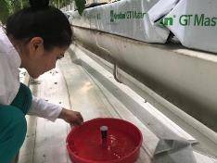
a- deltoid | b - blue | C - floor

Figure 5 - Testing of traps

Evaluation of the effectiveness of biopreparations in the combat against tomato moth: In 2019-2020, testing of biopreparations against tomato moth was continued, in particular, production testing of the effectiveness of biological products were carried out (ak kobelek, bitoxibacillin and lepidocide) in the greenhouse of the p/f “Naimbekov” on an area of ​​1 hectare. The results of tests of biological products carried out in 2019-2020 are shown on the table in Appendix B.9. Treatments were done during the period of flowering of the third raceme and the formation of fruits against the eggs of the tomato moth to be performed before the emergence of young larvae (darkened embryonic phase). The biological effectiveness of the biopreparations were shown to be ak kobelek - 56.5%, bitoxybacillin - 44 3% and lepidocide 44.5% in 2019 and 50.5, 40.3 and 39.8 respectively in 2020. These drugs yielded in low efficiency: while leaving the eggs, the larvae are implanted into the leaves within a short time and lack enough time to swallow the required amount of the drug. According to the results of two-year tests, it can be concluded that these biological products are not advisable to use as a means of protection against tomato leafminer.
Testing insecticides of selective action: The control of tomato leafminer is difficult due to some features of the biology of the pest underlying the hidden lifestyle of caterpillars inside the leaves and fruits, and, therefore, this makes them susceptible only for systemic insecticides. In this regard, there are cases of using bioagents when, as a result of a sharp increase in the number of moth, entomophages and other non-chemical agents cannot provide the desired effect, and it becomes necessary to use insecticides. In order to test the effectiveness, we carried out treatments with Coragen SC and Proclame Fit in different concentrations in the greenhouse of the p/f "Rakhmon", Saryagash district, Turkestan region. The obtained testing data are shown in Table 12.

Table 12 - Biological effectiveness of Coragen SC and Proclaim Fit preparations against tomato moth in tomato plantings in the greenhouse of the "Rakhmon" farm, Saryagash district, Turkestan region (2018 -2020)

Groups in the experiment | The number of mines on one plant with live caterpillars, in species |  |  |  | Percent decrease in the number of mines with live caterpillars on the day of documenting
 | Before the treatment | The day of documenting after treatment
 |  | 3 | 7 | 14 | 3 | 7 | 14
Control (no treatment) | 155.2 | 161.0 | 175.0 | 179.0 | - | - | -
Coragen SC 0.140 L/ha | 154.2 | 12.0 | 10.0 | 11.2 | 92.5 | 94.1 | 92.9
Coragen SC, 0.315 L/ha | 150.7 | 7.0 | 6.0 | 9.2 | 95.6 | 96.4 | 94.1
Proclaim Fit 450, in grams – 0.15 L/ha | 154.5 | 15.0 | 17.7 | 25.2 | 90.7 | 89.5 | 84.1

The results of insecticide tests showed that Coragen SC, in contrast to Proclaim Fit, provided high biological efficiency both at a rate of 0.140 L/ha and at a rate of 0.315 L/ha with a single treatment, which amounted to 93.1% and 95.3% respectively. Thus, the drug Coragen SC, which is safe for beneficial insects, has low toxicity for humans, and possesses both ovicidal and larvicidal effects, can be safely included in the complex tomato protection system. Moreover, the positive qualities of the insecticide include the fact that it has a systemic effect and permeates all plant tissues, while maintaining a protective effect for 3 weeks.

3.2.5.1 Rationale and criteria for the production testing and the sequence of control measures in the integrated tomato protection system
Vegetable crops, including in protected ground conditions that are consumed by the population in a fresh state, must be environmentally friendly and without pesticide toxic residues: therefore, the development of a system for protecting tomatoes from tomato moth based on the use of safe means is a very relevant problem. In this regard, the improved system of protection of tomatoes from tomato moth should be maximally biologized, and as a result the developed set of measures taken for production testing should guarantee the fulfillment of the main task to prevent the mass development of moths through the maximum use of biological agents and thus obtaining products not contaminated with pesticide residues. Along with the inclusion of mainly biological agents in the tested integrated system, at first, in the case of a high extent of moth infestation, it is necessary to use low-danger insecticides. We used insecticide Coragen SC in our experiment, which, along with the aforementioned positive characteristics, has a systemic effect of penetrating and saturating all plant tissues, which in its turn ensures its high efficiency. Armed by the information above and on the basis of the data obtained during testing of the effectiveness of biological agents (entomophages, pheromone traps, and the drug Coragen SC), in the greenhouse farms “Naimbekova” (Shymkent) and “Otan” (Almaty region) and p/f "Shakh" (Kyzylorda region), a production testing of the integrated tomato protection system was carried out on an area of ​​2 hectares, 1 hectares and 0.3 hectares respectively, which in the technological plan consisted of the protection measures mentioned above.
The sequence of implementation of measures of protection against Tuta absoluta: After planting the seedlings to a permanent place in the greenhouse, pheromone traps were hung at the ratio of 20 pcs/ha. At the same time, a careful monitoring of plants is carried out by visual inspection in order to determine the possible infestation of plants even in the seedling period. Since the plants were infested with tomato moth during this period in the greenhouse in previous years, and despite the absence of the pest, macrolophus was released at a ratio of 0.5-1 individuals/m2. The early release of the entomophage, despite the absence of prey, is due to the need to create an opportunity for the bug to increase its population by the time of mass egg-laying and hatching of moth caterpillars. When the first egg-laying species of the pest is detected, the plants are treated with the drug Coragen SC, and it is applied via drip irrigation under the root of the plant, ensuring the complete absorption of the introduced insecticidal solution by the tomatoes. After 10-12 days after the application of the insecticide, during the egg-laying and hatching period of caterpillars at a temperature of 20°C, entomophages ass macrolophus or nesidiocoris are additionally released at a ratio of 1 individual/m2. With a low degree of moth population of plants, additional treatment with biological preparations of Bitoxibacillin, Aktofit, Ak kobelek, Lepidocide is possible. The effectiveness of biopreparations, as a rule, is low; nevertheless, a certain decrease in the number of caterpillars still occurs.
Later, until the end of the culture (crop) turnover, insecticide treatments and the release of entomophages were not required. Capture of male moths with pheromone traps by creating a male vacuum also led to a decrease in the moth population. The sequence of protective measures carried out using a set of measures with a biological focus is given in the calendar (Table 13).

Table 13 - Calendar of the complex of protective measures against tomato leafminer and other associated pests

Measures taken | Goal and date of the measure | Rationale of the applied methods and of means of protection and technology of implementation
1 | 2 | 3
Collection of plants damaged by pests in the greenhouse, destruction of wild-growing Solanaceae crops outside the greenhouse | Carrying out preventive measures immediately after the end of the crop circulation | Plant residues (leaves, stems, fruits) to collect and burn;  Plants outside the greenhouses of cultivated and wild-growing Solanaceae families to destroy or replace with other crops
Hang mosquito nets on the windows and ventilation openings of the greenhouse; the entrance doors should be double. Nets are also fixed on the transom | To constantly ensure phytosanitary and safety to prevent infestation of the greenhouse with pests | Mandatory measures to ensure the exclusion of harmful insects from outside the greenhouse
Preventive work to decontaminate the inner surfaces of the greenhouse from harmful organisms | At the end of the crop circulation (vegetation) of plants and the previous activities | Spraying with a 2% formalin solution (40% w.r.) at a rate of 1 L/m2 with one of the insecticides: Aktelik 500 (5.0 L/ha) or Confidor, 20% w.c. (2 L/ha)
Disinfection of greenhouses by steaming the substrate or replacing it | 3 - 4 days after disinfection of the greenhouse to destroy pests and diseases | Disinfection of the greenhouse by burning sulfur (50g / m2) for 1 - 2 days at a temperature of 18 ° C. Steam or replace the substrate
Monitoring the spread (detection) of tomato moth and other pests | After planting tomato seedlings in the ground in a permanent place, to timely identify the pest | Inspection of at least 50 tomato plants to identify egg-laying and moth larvae that may have already been in the seedling department. During this period, the examination is carried out daily, further during the growing season, every 5 - 7 days
Placing or hanging pheromone traps for the timely detection of tomato moths | Immediately after disembarking the seedlings to a permanent place, to catch and destroy male moths | Place red floor traps or delta traps at the rate of 20 traps per hectare. Catching males significantly reduces the number of pests, since mating and reproduction of moths does not occur
Colonization of the macrolophus bioagent and feeding the predator with eggs of a grain moth, to intensively increase the population of the entomophage by the time of the start of egg-laying by the tomato moth | After transplanting the seedlings to a permanent place, before the start of egg-laying of the tomato moth, since the entomophage begins to work in the 3rd generation | Colonization of macrolofus is carried out at the beginning at a rate of 0.5 individuals / m2 after planting seedlings in the ground. When conducting surveys, it must be remembered that the entomophage lays eggs on leaves near the veins, therefore, leaves with egg-laying are plucked and laid out under the heating pipe, where the predator will intensively develop in order to increase the number by the period of mass egg-laying of moths

Table continuation 13
1 | 2 | 3
Treatment of plants with insecticide Coragen SC under the root after missed watering so that the mats (substrate) or soil are slightly dry | The insecticide is applied to the egg-laying of the moth at the beginning of the hatching of the moth caterpillars, in the morning or evening, when it is not hot in the greenhouse | The insecticide is applied under the root of the plant in 0.03% concentration with drip irrigation or direct spraying 1 time per crop circulation. The next watering is carried out as usual in 4 - 5 hours after the introduction of the insecticide, when the plant absorbs the introduced insecticidal solution. The effect of the drug will last 2 - 3 weeks, the introduction should be carried out on the laying, considering that the insecticide has both ovicidal and larvicidal action
The next colonization of the entomophage macrolophus or nesidiocoris when the average daily temperature of + 20 ° С is established in the greenhouse | The release is carried out during the period of mass summer of moth butterflies and mass egg-laying and hatching of caterpillars after 10 days after treatment with an insecticide | Release rates 1 - 2 individuals / m2. With a high number, the release rate increases to 2 - 3 individuals / m2
Spraying plants with biological products (Bitoxibacillin, Aktofit, Ak kobelek, Lepidocide.) To suppress hatching caterpillars before their introduction into the leaves | During egg-laying and the beginning of hatching of caterpillars | Treatment is carried out with a knapsack sprayer at a flow rate of 400 L / ha. Normally, Bitoxibacillin and Ak kobelek are used - 2 L / ha, Aktofit - 5 L / ha, Lepidocide - 1.5 L / ha. Young, newly hatched caterpillars swallow particles of a biological product, which leads to their death
Colonization of entomophages of macrolophus or nesidiocoris. If necessary, issue additional issues twice within a month | If necessary, it is advisable to release bugs every 2 weeks for a month. After that, they acquire the ability to independently maintain their population, ensuring the suppression of moth development. | Releases of bioagents are required when the number of butterflies exceeds 10 individuals during the first viewing of pheromone traps

3.2.5.2 Biological and economic assessment based on the results of the implementation of an integrated tomato protection system against tomato moth
A biological assessment of the effectiveness of the integrated system was determined by the establishment of a decrease in tomato damage because of the use of various methods and means of protection. A complex of biological agents (bioagents, pheromone traps) was carried out immediately after planting the seedlings in a permanent place. Techniques and means of protection, timing of events considering the development of moths were shown in the calendar. The degree of moth infestation of tomatoes was established a month after the detection of tomato moth and application of the drug Coragen SC under the root of the plant. At the same time, pheromone traps were set up. The release of the macrolophus was carried out even before the appearance of the moth to accumulate the predator population by the time the phytophage appeared. The efficiency of using the integrated system was established at the end of the crop circulation by determining the number of plants with mines on 50 bushes in the experiment and in the control. Calculations of the biological effectiveness of the application of the integrated system of protection of tomatoes against tomato moth were carried out according to formula I and the results are shown in the table in Appendix B.10. The data given in the table, obtained due to the use of entomophages, pheromone traps and a low-toxic preparation Coragen SC showed high efficiency. Such an integrated system, along with a high efficiency against tomato moth of 95%, allows obtaining environmentally friendly products. In parallel, a set of measures, consisting of 5-6 times spraying directly on plants with Actellik and Confidor showed an efficiency of 91%.
The calculation of the economic efficiency of using an integrated system against Tuta absoluta is presented in Table 14.

Table 14 – Economic efficiency of using an integrated complex for protecting tomatoes from South American tomato moth in the p/f «Naimbekov», Sairam district, Shymkent, Turkestan region

Index | Integrated protection | Chemical protection | The control
Yield, kg/sq.m. | 2 | 3 | 4
Yield increase, kg/sq.m | 9,0 | 8,5 | 7,0
Selling price for 1 kg of tomatoes | 2,0 | 1,5 | -
Released entomophages, specimen/Sq.m. | 300 | 280 | 200
Cost of 1 thousand entomophages, thousand tenge | 1
Cost of using entomophages, tg/sq.m | 30,0
The cost of using pheromone traps, tg/sq.m | 15
Cost of pesticides used, thousand tenge/sq.m | 2.5 | With 5x treatment: 6.9
Costs for protective measures, thousand tenge/sq.m | 25,38 | 16,8
Total costs, tg/sq.m | 25,4 | 16,9
Proceeds from additional harvest, sq.m/tg | 600 | 450
Net income, tg/sq.m | 574,6 | 433,1

The economic efficiency was assessed on the basis of comparing the application of a set of measures using entomophages, pheromone traps and a single use of the Coragen SC preparation in comparison with the damage of tomatoes in the treated variant and in the control group. The costs of plant protection consisted of: costs of entomophages, insecticide, cost of work, overhead costs, costs of selling additional crops. The proceeds from the sale of additional products were calculated by multiplying the estimated value of the yield increase by the average selling price of 1 kg of tomatoes. Net income was calculated by subtracting the total cost of protection from the proceeds from the sale of additional products.

3.3 Biological control of gregarious locust species using GIS technologies
3.3.1 Development of technology for remote phytosanitary monitoring of foci of gregarious locusts using an unmanned aerial platform (Hexacopter, etc.)
Instruments and equipment: After analyzing the characteristics of various types of drones, the choice was made on the design of a helicopter-type UAV. In this connection, a DJI Phantom 4 PRO + drone with two sets of spare batteries and a remote control with a screen on Android was purchased to conduct the research. A portable inverter was used to recharge the UAV batteries in the field. A GPS receiver was used to position the terrain. For the aerial spraying behavior, a Foxtech Gaia 160HY UAV equipped with spraying equipment was used. Ground spraying with biological products was put into action with a backpack motor sprayer "Solo 450".

3.3.2 Field Studies
In 2018, the optimal meteorological, flight-navigation, and optical parameters of aerial photography were established as a result of the studies for the research of gregarious locust species on basis of the UAV, which expects the observance of the following parameters: wind speed up to 5 m/s, cloud cover up to 5 units, aircraft speed 6 m/s, the transverse overlap of images is 40-50%, and the longitudinal overlap of the adjacent strip is 15-20%.
Aerial surveys were carried out in three stages:
Preparatory stage - in the course of preparatory work, the coordinates of the corners of the surveyed polygon were determined, the placement and coordination of characteristic points on the terrain were carried out, which, during further processing of the images, served as reference points for binding the photographic plan to geographical coordinates. To ensure the continuity of the newly received data with the old maps, the reference points were linked to the existing triangulation points of the State Geographic Network. Cameras were also calibrated.
The stage of flight-survey work consisted in the calculation of aerial survey elements, the designing of UAV flight routes, and conducting planned aerial survey with the UAV in the visible range of the electromagnetic spectrum.
During the aerial survey from the UAV, a planned method of the survey performance was selected. Planned shooting expects and helps with the deviation of the optical axis of the aerial camera from the specified vertical position by no more than 30.
Testing of transverse and longitudinal overlap of aerial photographs was carried out according to measurements of aerial photographs of linear and adjacent routes when overlapping parts of aerial photographs were combined.
As a result of test flights, it was found that transverse overlap of images of 15-20% and longitudinal of 40-50% were sufficient for aerial photography in flat terrain conditions.
In the course of the study, a test scan of the area with younger species of the Moroccan locust was carried out.
As a result, several hundred images were obtained from a height of about 100 m.
After viewing individual images in the field, it was clear that locust patches could be easily spotted — even from video. Geo-tagged images with exact GPS location and time where they were taken were present.
The stage of the office work consisted of performing a cycle of work aimed at the study of the distinctive signs of the Moroccan locust larvae on pastures and preparing cartographic materials.
A free open source software product QGIS (Quantum Geographic Information System) was used to process the data obtained from the UAV, QGIS allowed to calculate the VARI (Visible Atmospherically Resistant Index) $\frac{Green -Red}{Green+Red -Blue}$.
The use of this index made it possible to determine that the red areas are heavily damaged by locusts, but the area from green to blue is an intact area.
However, the process of classification of images from UAVs used in this particular case involves the use of specialized GIS software products and requires a certain level of qualification from the operator of the UAV complex.
In this connection, facilitation of the process of image classification was attempted for the identification of gregarious locust species based on ready-made automated solutions of the DroneDeploy project (a cloud service and application for processing aerial photography data from UAVs, building high-resolution 2D maps, 3D terrain models).
In 2019, aerial photography from a UAV was performed in the habitats of the Moroccan locust, and orthophotgraphs of the surveyed area were created in the DroneDeploy cloud software. Each image was geo-referenced based on data from the UAV on the coordinates of the central points of the images: an example is shown in Figure 6.

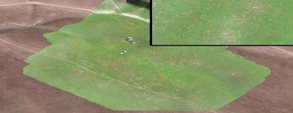

Figure 6 –An orthophotograph of the test site for the Moroccan locust habitats.
The results of the expert interpretation made it possible to reveal the distribution of the Moroccan locust within the test range with the use of configuration and size of areas with destroyed pasture vegetation.
However, it should be noted that the results of last year's studies proved that at a higher density (1000 pcs/m2 and whiter), the swaths with locust accumulations are easily distinguishable in the images.
The established parameters of aerial photography were also tested in the conditions of Almaty on two species of locust (Asian, Italian). The number of locust population of both species also did not exceed 500 / m2.
By similar methods used in the images obtained in the Turkestan region, primary processing and interpretation of the images were carried out (Appendix B.1).
During the expert interpretation of the aerial photographs, it was found that the Asian and Italian locusts in the images had similar visual distinctive signs as in the images with the Moroccan locust – areas of destroyed vegetation and their configuration.
In the cloud software service DroneDeploy, orthophotographs were processed and the vegetation indices of test sites were calculated. Example is shown in Figure 7 (Appendix B.2).
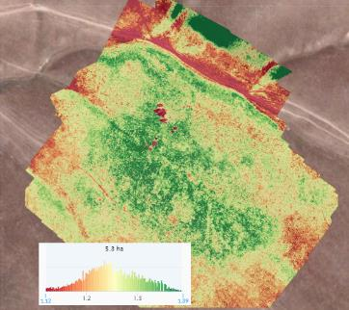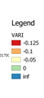

Figure 7 - Orthophotograph of the test site of the Moroccan locust habitats
with the calculated VARI index

A plant health algorithm such as VARI (Visible Atmospherically Resistant Index) compares the proportions of light captured in different portions of spectrum (red, green, blue) to compute numerical values ​​for each pixel or area of ​​a given drone map. It has been established that healthy plants reflect light differently than damaged plants. Healthier plants tend to reflect more green light than red.
Thus, the use of this index makes it possible to detect locusts by indirect signs: red areas are heavily damaged by locusts, and green to blue marks an intact area.
Images taken in the infrared range by a camera installed on an unmanned aerial vehicle during field trips to the territory of the Kurkeles district in the Turkestan region were processed in the ENVI 5.1 software product
According to the data of the infrared channel, the classification was carried out using the IsoData method and areas with different conditions of the vegetation cover were identified.
During the survey, locust swaths were found in the area, which affected the state of the vegetation. Figure 8 shows images divided into classes according to the density of vegetation in relative units.
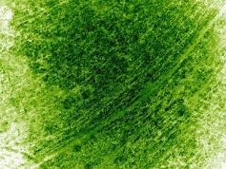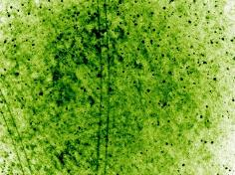

Figure 8 - Processed images in the IR range from UAVs with division into classes according to the density of vegetation

As a result of overlapping the images of the surveyed area from the UAV in the visible and infrared ranges of the electromagnetic spectrum, the zones with damaged vegetation happened to be identical.

3.3.3 Creation of thematic digital maps of gregarious locusts distribution and there numbers based on GIS
Satellite images of medium spatial resolution for the vegetational season of 2019 served as the basis for thematic soil and vegetation maps.
In the course of the research, cloudless images from the Landsat-8 satellite were selected from the space database at the website https://earthexplorer.usgs.gov/, where they can be downloaded for free. Space images were pre-processed and had preliminary calculated spectral indices. As a result, maps were obtained for monitoring the soil and vegetation cover of the two study areas for the growing season 2018-2020.
During the research, a geographic information system (GIS) of the project was created. Topographic vector data (district boundaries, road network, hydrographic network, and human settlements), field survey data (locust detection points) and raster satellite imagery data (initial and processed images (Appendix B.3) were loaded as layers in the GIS.
In 2018-2020, field surveys were carried out to detect gregarious locust species on agricultural lands of Almaty and South Kazakhstan regions. As a result of combining the processed remote sensing data, layers of the geographic information system and ground data, thematic digital maps of the distribution and abundance of gregarious locusts were obtained. An example of a map is shown in Figure 9 (Appendix В.4).
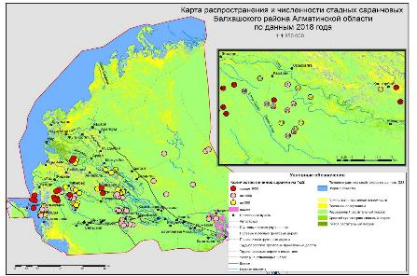

Figure 9 – Map of distribution and abundance of the Asian locust in Balkhash district of Almaty region in 2018

3.3.3.1 Comparative analysis of data for three years of research
For three years (2018-2020), studies were carried out to identify areas of distribution and to count the number of gregarious locust species in two regions of Kazakhstan: Turkestan and Almaty. The studies were realized using a unified methodology with data from the exact same source. These areas are the most dangerous and require special attention from the quarantine services (Appendix B.5).

3.3.4 Selection of domestic and foreign methods for controlling the abundance of gregarious locusts
In 2018, experiments with the Moroccan locust (Dociostaurus maroccanus Thunb.) were carried out on the territory of Turar Ryskulbekov district, Zhambyl oblast. Of all the tested concentrations, only 1% gave good results: on day 2, 96% mortality, and then (day 3) - 100%.
A similar experiment was done on June 4 near the city of Kyzylorda (Abay village, p/f “Ak Zhol”) with the Asian migratory locust (Locusta migratoria migratoria L.).
On June 4, 1% Aktofit was used. Water consumption is 300 L/ha, drug concentration - 1%, sprayer - Solo 450. If no mortality in the control group, the effectiveness of Aktofit was 62.5% on the second day, and 74.3% on the third and 92.7% on the fifth.
A similar experiment, but with some manuals changes, was carried out in 2018 against the Asian migratory locust in the Zheltoranginsky rural district in the Balkhash, Almaty region.
In this case, the 2 and 3 instar larvae treated in the same way were harvested by mowing with a net the next morning after spraying and were taken to the laboratory for further observations, where they were kept in cages and fed with untreated food, which probably influenced the results. Out of 97 larvae of the experimental group, the mortality was: 3rd day - 8.2%; 4th day - 29.9%; 5th day - 57.7%; 6th day - 89.7%; 7th day - 97.9% and 8th day - 100%.
Experiments on the effectiveness of a biological preparations based on the fungus Metarhizium were carried out on the territory of the Birlik rural district, Saryagash region, Turkestan region. The biological effectiveness of a drug based on the fungus Metarhizium on the 12th, 14th and 16th days after treatment was 26.7, 84.5 and 91.2%, respectively.
In 2019, the experiments were continued with the use of other drugs, and the Gaia 160 AG UAV was first used for aerial spraying. The tests were carried out on all 3 species of the gregarious locust.
Moroccan Locust (Dociostaurus maroccanus Thunb.): The experiments were conducted in the Yubileinyi rural district, Turar Ryskulbekov district, Zhambyl region. The coordinates of the base camp, located near the cultivated plots is N41, 150, E 68.3.9. The number of larvae in the places of planned treatments is about 10-15 indiv./m2, maily of age 2 and 3
Italian locust (Calliptamus italicus L): The experiments were carried out on the territory of the Ile district, Almaty region (the rural district of Karoi). The coordinates of the base camp are N43.580, E76.670. The population number is in the range of 10-20 individuals / m².
Asian locust (Locusta migratoria migratoria L.): Testing drugs against the Asian locust was carried out in the Koktal rural district 15 km away from village, Balkhash district, Almaty region. Camp coordinates is N45.420; E 75.110. The number in the swaths often reached 1000 ind./m2.
The larvae from the experimental plots were collected in cages and delivered to the place of further observation.
It should be noted that when working with UAVs, the use of vegetable oil as the main component of the fuel is impossible. Therefore, diesel fuel was used as a filler for Mikolar B and M, and this had never been done before. The results of the technical efficiency of biological treatments for all three locust species using Gaia 160 AG and Sоlo 450 are given in Appendix B.6.
In general, all tested agents have shown some effectiveness in the control of locust larvae.
The fastest and strongest toxic effect was shown by the drug avermectins-based Aktofit - up to 100% mortality on day 10.
Good results were also shown by the fungal drug Novacrid by “Elephant Vert” and the Russian drug Green Barrier.
The last places in the analyzed six are occupied by Mikolar V and Mikolar M, which, as already mentioned, were made in the laboratory of biotechnology manually.
Analysis of data on two types of treatment equipment showed their complete similarity in the context of preparations, which makes it possible, in further tests, to use only one method of spraying.
Measurement of the parameters of body parts was carried out using a vernier caliper (scale: 0.1 mm). The results of biometric parameters are given in Appendix B.7.
In 2020, three biological preparations of various origins were used in the process, and some of them have already been tested for entomopathogenicity in relation to locusts (Appendix B.8).
In general, all tested agents have shown some effectiveness in the control of locust larvae. The fastest and strongest toxic effect was shown by the avermectin-based drug Aktofit - up to 90-99% mortality on days one-to-three.
Good results were also shown by the fungal drug Novocrid by "Elephant Vert". The analysis of indicators for two types of treatment equipment revealed their complete identity in the context of preparations, which makes it possible, in further tests, to focus on only one method of spraying. At the same time, any type of sprayer can be used for practical purposes.

CONCLUSION

During monitoring in fruit-growing farms of Almaty, Zhambyl and Turkestan regions, foci of fire blight (bacterial disease) were discovered. The largest number of foci is in the Almaty region. During the examination, it was noted that apple varieties Aport, Gala, Idared and Pink Lady, as well as pears, were strongly affected by the disease. In many farms, the apple orchards of the Aport variety and pears are being eradicated. Therefore, it is necessary to abide by spatial isolation from pear orchards as reservoirs of infection.
During three-year studies of the seasonal dynamics of a fire blight, a close relationship between the disease and the meteorological conditions of the growing season was established. The limiting factors for the development of fire blight are low temperatures (7-13) during the flowering period, as well as dry and hot weather in July and August. The most dangerous periods for reproduction and accumulation of infection are periods of flowering and regrowth of young shoots. The established dates for carrying out protective measures are scheduled during this period.
Over the three years of the study, bacteriological analyzes of 692 samples taken from the apple trees affected by the disease in Almaty, Zhambyl and Turkestan regions were carried out. 453 isolates were isolated. Many of the isolated bacteria are identified as concomitant.
The studies conducted to diagnose the causative agent of a fire blight using molecular genetic methods confirmed the presence of the pathogen in all samples of fruit crops of apple and pear (leaves and ovary) selected from three regions of Kazakhstan (Almaty, Zhambyl and Turkestan). As a result of the test identification, 131 isolates were identified as E. amylovora bacteria, the causative agent of fire blight. All isolates confirmed as E. amylovora were assigned to the third ribotype. A phylogenetic tree was constructed relative to the NCBI database samples, and interpopulation genetic diversity was determined.
The bactericidal properties of chemical and biological preparations were studied in laboratory conditions on a pure culture of the bacterium Erwinia amylovora, the causative agent of bacterial burn. Fungicides Kocide, Curzate, Curamin Foliar, Allette, Fosiram, AgriGentPlus, Best Bakir, from biological preparations Kasumin, Fitop and Fitolavin, growth regulators Regalis Plus, Novosil and Extrasol were selected for field testing on model plants.
As shown by the development of fire blight on 7 schemes of field experiments, the most effective fungicides are Kocide, Curzate, Curamin Foliar + Foskraft MKP (micro and macroelements), from biopreparations - Kasumin and Fitolavin, from the growth regulators Regalis plus (calcium prohexadione), Novosil and Fitop. For the implementation of comprehensive control measures at the demonstration site from a fire blight on an apple tree, scheme No. 3 was selected, including the copper-containing fungicide Kocide 2000 and the biopreparation Kasumin 2L, which are included in the "Directory of pesticides (toxic chemicals) permitted for use in the Republic of Kazakhstan", as well as a stimulant Regalis plus.
Comprehensive measures were introduced to combat this bacterial disease on a 15 hectare demonstration plot on two varieties - Starkrimson and Golden Delicious, in the p/f “Zhemis”, Enbekshikazakh district, Almaty region. The biological efficiency of the measures developed totaled 96.5% for the Starkrimson variety and 95.2% for the Golden Delicious variety. The yield increase in comparison with the standard for the Starkrimson variety is 28.8%, for the Golden Delicious variety 21.1%.
There was a transfer of pheromone traps from the Plant Quarantine Center (Moscow), of the entomophages of macrolophus (Macrolophus nubilus N.S.), nesidiocoris (Nesidiocoris tenuis Reuter) from the All-Russian Institute of Plant Protection (Pushkino) and the podisus (Podisus maculiventris Say) from the All-Russian Institute of Biological Plant Protection(Krasnodar). Red floor traps with pheromone showed high efficiency when capturing male tomato moths.
For the first time, the biological features of the development of tomato moths were studied; also, the optimal life span of all age stages of the development of tomato moths was established, which is 126 days at +8 ° C and 30 days at +30 ° C.
The highest fecundity of the tomato moth was established at a temperature of 30 ° C, while the viability of eggs reaches 95.9%, and the number of eggs from one female was 219.8 eggs.
The average fecundity of entomophages macrolophus and nesidiocoris was 58.2 and 66.1 eggs, respectively, when fed with whitefly eggs and 55.3 and 55.9 when fed with a sitotrogas.
The “gluttony” of macrolophus and nesidiocoris when feeding on eggs and larvae of whitefly was 137.7 and 177.7 individuals, respectively, and 70 and 79 individuals when feeding on sitotrogas.
The technological regulations for mass cultivation of macrolophus and nesidiocoris have been developed, which allows introducing a bioconveyor for the cultivation of entomophages in the production biolaboratory of greenhouse farms.
When entomophages were bred in cages with 6 pots, the quantitative yield of macrolophus and nesidiocoris bugs when feeding the sitotrogas and when combining the sitotroga with whitefly larvae was 1007 and 1085 individuals respectively.
The podisus bug is not preferred to use against tomato moths due to the lack of a positive effect, especially against eggs and younger ages of tomato moths.
For the first time, a biologized integrated complex of protective measures for tomatoes against tomato moth in protected ground conditions was developed and tested based on the use of pheromone traps, bioagents of macrolophus, nesidiocoris and insecticide of the selective iaction Coragen, its effectiveness was 95%.
In 2018-2020, monitoring of the spread of tomato moth was carried out in 16 greenhouse farms of Almaty, Turkestan and Kyzylorda regions where the pest became widespread.
The calculation of the economic efficiency of the applied protection of tomatoes from tomato moth showed that the net venue from the additionally obtained harvest amounted to 574.6 tenge per square meter. At the same time, environmentally friendly products were obtained.
Optimal meteorological, flight-navigation and optical parameters have been developed for aerial surveys for surveying gregarious locust species based on UAVs, providing for the following parameters: wind speed up to 5 m/s, cloud cover up to 5 units, aircraft speed 6 m/s, overlap of transverse images to be 40-50% and the longitudinal lines with the adjacent strips to be 15-20%. The use of the VARI vegetation index made it possible to detect locusts by indirect features: the red areas are heavily damaged by locusts, but green to blue denotes the intact area. As a result of overlapping of images from UAVs in the infrared and visible ranges of the electromagnetic spectrum with the calculated NDVI and VARI indices, respectively, the zones with damaged vegetation were identical. Thematic digital maps of distribution and abundance of gregarious locusts were created. A comparative analysis of the data on the distribution and number of gregarious locust species in the Turkestan and Almaty regions was carried out, and maps of the frequency of their detection were created.
It was found that the drug Aktofit showed the fastest effect in the combat against locust larvae. The highest effect in testing entomopathogenic-fungi-based preparations was obtained from Novacrid by “Elephant Vert”. In experiments on the use of the Sоlo 450 sprayer and a UAV with Gaia 160 AG as a technique for treating locust larvae, identical results were obtained in all experiments.

REFERENCES

1 Zhao Yu-qiang, Tian Yan-li, Wang Li-min, Geng Guo-min, Zhao Wen-jun, Hu Bai-shi, Zhao You-fu. Fire blight disease, a fast-approaching threat to apple and pear production in China // Journal of Integrative Agriculture. - 18(4). – 2019. – P. 815-820.
2 Bonn W. G., Zwet T. Distribution and economic importance of fire blight //Fire blight: the disease and its causative agent, Erwinia amylovora. – 2000. – С. 37-53.
3 Smetanik A.I. Bacterial blight of fruit trees // Plant protection and quarantine. – М., 2003. ‒ № 10. – С. 38-39. (Сметаник А.И. Бактериальный ожог плодовых // Защита и карантин растений. – М., 2003. ‒ №10. – С. 38-39.)
4 Drenova N.V., Isin M.M., Dzhaimurzina A.A., Aitkulov A.K. et al. Bacterial blight of fruit crops in the Republic of Kazakhstan // Plant Quarantine. Science and practice. Russian-English magazine. – М., 2013, ‒ № 1. – P. 39-43. (Дренова Н.В., Исин М.М., Джаймурзина А.А., Айткулов А.К. и др. Бактериальный ожог плодовых культур в Республике Казахстан //Карантин растений. Наука и практика. Русско-английский журнал. – М., 2013. ‒ №1. – С.39-43.)
5 Sagitov A.O., Isin M.M., Dzhaimurzina A.A. Bacterial burn of fruit crops in Kazakhstan // Plant protection and quarantine. – М., 2015. ‒ P. 13-15. (Сагитов А.О., Исин М.М., Джаймурзина А.А. Бактериальный ожог плодовых культур в Казахстане // Защита и карантин растений. – М., 2015. ‒ С. 13-15.)
6 Zharmukhamedova G.A., Dzhumanova Zh.K., Aitkulov A.K., Khusnutdinova R.A. Analysis of the ways of penetration and acclimatization of the causative agent of bacterial blight of fruit crops in the territory of Kazakhstan, 2016. (Жармухамедова Г.А., Джуманова Ж.К., Айткулов А.К., Хуснутдинова Р.А. Анализ путей проникновения и акклиматизации возбудителя бактериального ожога плодовых культур на территории Казахстана. - Алматы, 2016.)
7 Izhevsky S.S., Akhatov A.K. Sinev S.Yu. The tomato mining moth has already been identified in Russia. G. Plant protection and quarantine. -2011, No. 3, P. 40 - 44. (Ижевский С.С., Ахатов А.К. Синев С.Ю. Томатная минирующая моль выявлена уже в России // Защита и карантина растений. -2011. - № 3 – С.40 – 44.)
8 Zhunisbai R.T., Dinasilov A.S. South American tomato moth in Kazakhstan. J. Agrodom. - 2016. - No. 7. - P. 42-44. (Жунисбай Р.Т., Динасилов А.С. Южноамериканская томатная моль в Казахстане // Агродом. – 2016. - №7. - С. 42-44.)
9 Duysembekov B.A., Chadinova A.M. South American tomato moth (Tuta absoluta Povolny) is a serious danger for growing tomatoes in greenhouses // Agribusiness Kazakhstan, June, 2018 .-- P. 36-38. (Дуйсембеков Б.А., Чадинова А.М. Южноамериканская томатная моль (Tuta absoluta Povolny) – серьезная опасность для выращивания томатов в условиях закрытого грунта //Агробизнес Казахстан. - 2018. - С. 36-38.)
10 Vasilyeva A.V., Zyuzkevich S.K., Markevich N.S. Biological product of regulatory action against locusts based on the entomopathogenic fungus Metarhizium anisopliae. In chemistry and chemical technology. - Moscow, Russia. - Volume XXIII. - 2009. - No. 3 (98). - P.215-227. (Васильева А.В., Зюзькевич С.К., Маркевич Н.С. Биопрепарат регулирующего действия против саранчовых на основе энтомопатогенного гриба Мetarhizium anisopliae. В химии и химической технологии. – М., 2009. -Т.XXIII. – 2009, № 3 (98). - С.215-227)
11 Kryukov V.Yu., Lednev G.R., Khodyrev V.P., Levchenko M.A., Duysembekov B.A., Sagitov A.O., Glupov V.V. Influence of entomopathogenic fungi (Metarhizium anisoplae, Beauveria bassiana) and bacteria Pseudomonas sp. for migratory locusts // Entomological research in northern Asia. VII Interregional – Novosibirsc, 2006. – P. 353-354 (Крюков В.Ю., Леднев Г.Р., Ходырев В.П., Левченко М.А., Дуйсембеков Б.А., Сагитов А.О., Глупов В.В. Влияние энтомопатогенных грибов (Metarhizium anisoplae, Beauveria bassiana) и бактерии Pseudomonas sp. на перелётную саранчу // Энтомологические исследования в северной Азии: Материалы VII Межрегионального совещания энтомологов Сибири. – Новосибирск, 2006. – С.353-354)
12 Dzhaimurzina A.A., Isin M.M., Umiralieva Zh.Z. Isolation and identification of the causative agent of bacterial blight of fruit crops in the south and southeast of Kazakhstan // Plant protection and environmental sustainability of agrobiocenoses, materials of the International Scientific Conference. - Almaty. – 2014. ‒ P. 389-391.
13 Dzhaimurzina A.A., Isin M.M., Kopzhasarov B.K., Umiralieva Zh.Z. Sensitivity of phytopathogenic bacteria Erwinia amylovora and Pseudomonas syringae to copper-containing fungicides // International scientific-practical conference "Bacterial and phytoplasmic diseases of agricultural crops: scientific and practical aspects". – М., 2014. ‒ P. 33-35. (Джаймурзина А.А., Исин М.М., Умиралиева Ж.З. Изоляция и идентификация возбудителя бактериального ожога плодовых культур на юге и юго-востоке Казахстана // Защита растений и экологическая устойчивость агробиоценозов, материалы Международной научной конференции. – Алматы, 2014. ‒ С. 389-391.)
14 Kopzhasarov B.K., Isin M.M., Duysembekov B.A., Dzhumanova Zh.K., Umiralieva Zh.Z., Soltanbekov S.S, Sarbasova A.M. The effectiveness of treatment schemes with copper-containing fungicides against bacterial blight // Mat. Int. scientific and practical seminar "Bacterial blight of fruit crops: environmental aspects and control measures." - Almaty. - 2016 - P. 174-178. (Копжасаров Б.К., Исин М.М., Дуйсембеков Б.А., Джуманова Ж.К., Умиралиева Ж.З., Солтанбеков С.С, Сарбасова А.М. Эффективность схем обработок медьсодержащими фунгицидами против бактериального ожога // Мат. Межд. научно-практического семинара «Бактериальный ожог плодовых культур: экологические аспекты и меры контроля». – Алматы, 2016. – С. 174-178.)
15 Djaimurzina A., Umiralieva Zh., Zharmuhamedova G., Born Y., Buhlmann A., Rezzonico F., Detection of causative agent of fire blight – E. amylovora (Burrill) Winslow et. al. – in the Southeast of Kazakhstan / Proc. XIIIth Int. Workshop on Fire blight // Actahorticulturae. - 1056, ISHS. - 2014.
16 Drenova N.V., Matiashova G.N., Belkin D.L., Kondratyev M.O. Morphological and genetic characteristics of E. amylovora strains from Kazakhstan and Kyrgyzstan // Mat. Int. scientific-practical seminar "Bacterial blight of fruit crops: environmental aspects and control measures." - Almaty. - 2016 .-- P. 100-107. (Дренова Н.В., Матиашова Г.Н., Белкин Д.Л., Кондратьев М.О. Морфологические и генетические характеристики штаммов E. amylovora из Казахстана и Кыргызстана // Мат. Межд. науч.-практ. семинара «Бактериальный ожог плодовых культур: экологические аспекты и меры контроля». – Алматы, 2016. – С.100-107.)
17 Bobev S.G., Maes M., Crepel C., Van J.V., Llop P., Lopez M. Fire blight in bulgaria: an overview//Proceedings of the Int. Workshop «Fire blight: with special reference to ecological aspects and control measures». – Almaty. – 2016. – P. 22-23.
18 Babadoost M. Fire blight of apple: occurrence and management // Proceedings of the Int. Workshop «Fire blight: with special reference to ecological aspects and control measures». – Almaty. – 2016. – P. 114-120.
19 Wojciech R. Selection of Primers for Polymerase Chain Reaction in BA White, Ed., - 1993 - Methods in Molecular Biology. Vol. 15: PCR Protocols: Current Methods and Applications". P. 31-40. Humana Press, Totowa NJ.
20 Khlestkina E. K. Molecular markers in genetic studies and breeding // Russian Journal of Genetics: Applied Research, 2014. – Vol. 4. – Is.3. – P. 236–244.
21 Komardina V.S. The spread of bacterial blight in Belarus and measures to limit it // Mat. Int. scientific and practical seminar "Bacterial blight of fruit crops: environmental aspects and control measures." - Almaty. - 2016 .-- P. 66-71. (Комардина В.С. Распространение бактериального ожога в Беларуси и мероприятия по его ограничению // Мат. Межд. научно-практического семинара «Бактериальный ожог плодовых культур: экологические аспекты и меры контроля». – Алматы, 2016. – С.66-71.)
22 Doolotkeldieva T, Bobusheva S. 2016. Fire blight disease caused by E. amylovora on Rosaceae plants in Kyrgyzstan and biological agents to control this disease // Advances in Microbiology. – 6. – Р. 831–851.
23 Raafat, K.H., Hanan, S.A. and Rabab, A.M. Antibacterial activity of antagonistic bacteria and plant extract on E. amylovora the Pathogen of Fire Blight Disease in Egypt. International Journal of Phytopathology, 4, 2015. – Р. 73-79.
24 Sundin, G.W., Werner, N.A., Yoder, K.S., Aldwinckle, H.S. Field evaluation of biological control of fire blight in the Eastern United States // Plant Disease. – 93. – 2009. Р. 386-394 (http://dx.doi.org/10.1094/PDIS-93-4-0386).
25 Mager M. G., Voloshchuk L. F., Lemanova N. B., Mager M. K., Application of chemical and biological preparations in the fight against bacterial blight of seed crops // Microbiology biotechnology-a science-intensive direction of modern knowledge// Intl. scientific Conf. – Kishinev, 2011. – 184 p. (Магер М.Г., Волощук Л.Ф., Леманова Н.Б., Магер М.К. Применение химических и биологических препаратов в борьбе с бактериальным ожогом семечковых культур // Микроб-я биотехнология-наукаёмкое направление современных знаний: Матер. Межд. науч. конф. – Кишинев, 2011. – 184 с.)
26 Shtienberg D., Manulis-Sasson S., Zilberstaine M., Oppenheim D., Shwartz H. The incessant battle against fire blight in pears: 30 years of challenges and successes in managing the disease in Israel // Plant Disease. – No. 99, 1048-1058. – 2015.
27 Chadinova A.M., Alimbekova A.K., Shanimov Kh.I., Duysembekov B.A. // Harmfulness of South American tomato moth (Tuta absoluta Povolny) in tomato crops in Kazakhstan and protection measures against it. - Collection of abstracts of the IV All-Russian Congress on Plant Protection. - St. Petersburg, 2019 . P. 150. (Чадинова А.М., Алимбекова А.К., Шанимов Х.И., Дуйсембеков Б.А. Вредоносность южноамериканской томатной моли (Tuta absoluta Povolny) в посевах томатов Казахстана и меры защиты от нее: Сборник тезисов докладов IV Всероссийский съезд по защите растений. – Санкт-Петербург, 2019. – С. 150.)
28 Johnson L F, Bosch D F, Williams D C, Lobitz B M. Remote sensing of vineyard management zones: implications for wine quality. Applied Engineering in Agriculture, 2001; 17(4): 557-560.
29 Macarthur D, Schueller J K, Lee W S, Crane C D, MacArthur E Z, Parsons L R. Schueller J. K. et al. Remotely-Piloted Helicopter Citrus Yield Map Estimation / Schueller, J. K., Lee, W. S., Crane, C. D., & Parsons, L. R. //Proceedings of ASABE Annual International Meeting. – Portland, OR: ASABE, 2006. – С. 1-11.
30 Swain K. C.,Jayasuriya H.P.W, Thomson S.J. Adoption of an unmanned helicopter for low-altitude remote sensing to estimate yield and total biomass of a rice crop. Transactions of the ASABE, 2010; 53(1): 21-27.
31 Peña-Barragána J M, Kelly M, de-Castroa A I, López-Granadosa F. Object-based approach for crop row characterization in UAV images for site-specific weed management. Proceedings of the 4th GEOBIA, Rio de Janeiro, Brazil, 7-9 May 2012; pp.426-430.
32 Torres-Sanchez J, Lopez-Granados F, De Castro A I, Pena-Barragan J M. Configuration and specifications of an unmanned aerial vehicle (UAV) for early site specific weed management. Plos One, 2013; 8(3): 1-15.
33 Lord J.С. From Metchnikoff to Monsanto and beyond: The path of microbial control / J.С. Lord // J. Invertebr. Pathol. – 2005. Vol. 89. – P. 19-29.
34 Lomer C.J. Biological control of locusts and grasshoppers / C.J. Lomer, R.P. Bateman, D.L. Johnson, J. Langewald, M. Thomas // Annu. Rev, Ento-mol. – 2001. – Vol. 46. – P. 667–702.
35 Methodological guides for bacterial blight of E. amylovora (Burrill.) Winslow et al. – М.,2009. p. 21 ( Методическое указание по бактериальному ожогу плодовых культур E. amylovora (Burrill.) Winslow et al. – М., 2009. – 21 с.)
36 Handbook on quarantine inspection and distribution of quarantine objects and alien species around the world. - Astana. - 2009. P. 66. (Справочник по проведению карантинного досмотра и распространению карантинных объектов и чужеродных видов по странам мира. – Астана, 2009. – С.66.)
37 Gvozdyak R. I., Matveeva E. V., Chumaevskaya M. A., etc. Guidelines for the diagnosis and control of bacterial blight and necrosis of fruit crops. – М., 1987. P.31 (Гвоздяк Р.И., Матвеева Е.В., Чумаевская М.А. и др. Методические указания по диагностике и мерам борьбы с бактериальным ожогом и некрозом плодовых культур. – М., 1987. ‒ 31 с.)
38 STO VNIIKR 4.001. Bacterial blight of fruit crops Erwinia amylovora (Burrill.) Winslow et al. Detection and identification methods. - M., 2009. P. 35-42. (СТО ВНИИКР 4.001. Бактериальный ожог плодовых культур Erwinia amylovora (Burrill.) Winslow et al. Методы выявления и идентификации. – М., 2009. – С. 35-42.)
39 Dardouri S., Chehimi S., Murillo J. and Hajlaoui M.R. Molecular characterization of Tunisian strains of E. amylovora // Journal of Plant Pathology. – 2017. - 99 (2). - Р. 331-337.
40 Patricia S., McManus, Alan L. Jones. Genetic Fingerprinting of E. amylovora strains Isolated from Tree-Fruit Crops and Rubus spp // The American Phytopatological Society. – 1995. – Vol. 85. - №12. – С. 1547-1553.
41 Tamura K., Nei M. Estimation of the number of nucleotide substitutions in the control region of mitochondrial DNA in humans and chimpanzees// Molecular Biology and Evolution. – 1993. – 10. – С. 512-526.
42 Kumar S., Stecher G., Li M., Knyaz C., Tamura K. MEGA X: Molecular Evolutionary Genetics Analysis across computing platforms // Molecular Biology and Evolution. – 2018. – 35. – C.1547-1549.
43 Takayuki Matsuura, Akifumi Mizuno, Takanori Tsukamoto, Yoshiaki Shimizu, Norihiko Saito, Shigeyoshi Sato, Shigemi Kikuchi, Tsuneyasu Uzuki, Koji Azegami, Hiroyuki Sawada. E. uzenensis sp. nov., a novel pathogen that affects European pear trees (Pyrus communis L.) // Int. Jour. of Systematic and Evolutionary Microbiology. – 2012. – 62. – Р.1799–1803.
44 Egorov N.S. Guide to practical training in microbiology M. 1995.22 p. (Егоров Н.С. Руководство к практическим занятиям по микробиологии. - М., 1995. -22 с.)
45 Methodical instructions for conducting registration tests of pesticides (pesticides) in the Republic of Kazakhstan. - Astana. - 2005. (Методические указания по проведению регистрационных испытаний пестицидов (ядохимикатов) в Республике Казахстан. – Астана, 2005.)
46 Methodical instructions for conducting productional tests of pesticides (pesticides) in the Republic of Kazakhstan. - Astana. - 2005. (Методические указания по проведению производственных испытаний пестицидов (ядохимикатов) в Республике Казахстан. – Астана, 2005.)
47 Krasavina L.P. New technology for breeding and application of the macrolophus predatory bug / Information bulletin of the UPPS MOBB 42 // St. Petersburg, 2011. - P. 115-119. (Красавина Л.П. Новая технология разведения и применения хищного клопа макролофуса // Информационный бюллетень ВППС МОББ 42. - Спб, 2011. – С. 115-119.)
48 Pazyuk I.M. Biological rationales for the use of Nesidiocoris tenuis (Reuter) (Hemiptera: Miridae) as an entomophage of vegetable pests in greenhouses. Abstract of dissertation for the degree of candidate of biological sciences. SPb., 2010. P. 19. (Пазюк И.М. Биологическое обоснование применения Nesidiocoris tenuis (Reuter) (Hemiptera: Miridae) в качестве энтомофага вредителей овощных культур в защищенном грунте. Автореферат диссертации на соискание ученой степени кандидата биологических наук. - Спб., 2010. - 19 с.)
49 Shirinyan Zh.A., Ismailov V.Ya. Technological regulations for the production of posidus Podisus maculiventris Say. - Krasnodar, 2007. P. 12.
50 Nurmuratov T.N., Azhbenov V.K., Kambulin V.E., Childebaev M.K., Komissarova I.A., Zhumagalieva G. Locust pests of agricultural plants in Kazakhstan and recommendations for limiting their numbers. - Almaty: Asia Publishing, 2000. P.56. (Нурмуратов Т.Н., Ажбенов В.К., Камбулин В.Е., Чильдебаев М.К., Комиссарова И.А., Жумагалиева Г. Саранчовые вредители сельскохозяйственных растений Казахстана и рекомендации по ограничению их численности. – Алматы: Asia Publishing, 2000. – 56 с.)
51 Seliger G.L. Large laboratorial manuals on microbiology. - 1962. P. 491. Селигера Г.Л. Большой практикум по микробиологии. – 1962. – 491 с. (Селигера Г.Л. Большой практикум по микробиологии. – 1962. – 491 с.)
52 Weiser J. Microbiological methods of control of harmful insects. - M .: Kolos, 1972. P. 314. (Вейзер Я. Микробиологические методы борьбы с вредными насекомыми. - М.: Колос, 1972. – 314 с.)
53 Langewald J., Kooyman C., Douro-Kpindou O.K., Lomer C. Field treatment of Desert Locust (Schistocerca gregaria Forskel) hoppers in the field in Mauritania with an oil formulation of the entomopathogenic fungus Metarhizium flavoviride // Biocontrol Sci. Technol. - 1997. - V. 7. - P. 603-611.
54 Lyubimov A.V., Vavilov S.V. Forest aerial photography and aviation. Assessment of the quality of aerial photography: Methodological instructions for laboratory studies. L.: LTA, 1985. P. 44. (Любимов А.В., Вавилов С.В. Лесная аэрофотосъемка и авиация. Оценка качества аэрофотосъемки: Методические указания к лабораторным занятиям. -Л.: ЛТА, 1985 - 44 с.)
55 Nikiforov A.A. Digital cameras used for aerial photography by unmanned aerial vehicles in forestry // Forests of Russia in the XXI century. Materials of the first international scientific and practical Internet conference. - SPb.: GLTA, 2010. - No. 4. - P. 65-70. (Никифоров А.А. Цифровые фотоаппараты, применяемые для аэрофотосъемки беспилотными летательными аппаратами в лесном хозяйстве//Леса России в XXI веке. Материалы первой международной научно-практической интернет-конференции. - СПб.: СПбГЛТА, 2010. – № 4. – С. 65-70.)
56 Chandra A.M., Ghosh S.K. Remote sensing and geographic information system. - Moscow, 2008 . P. 308. (Чандра A.M., Гош С.К. Дистанционное зондирование и географические информационные системы. – М., 2008. – 308 с.)
57 Dafny Yelin M., Mairesse O., Moy J., Silberstein M., Manulis-Sasson S., Shtienberg D. Epidemiology of fire blight (caused by Erwinia amylovora) in the Pink Lady apple cultivar in Israel. 2016
58 Braun P.C., Hildebrand P.D. Epidemiologi of fire blight of floricane red raspberry caused by Erwinia amylovora // Can. J. Plant Pathol, 2006. – Vol.28. -№1. – P .95-99.
59 Salazar E.R., Araya J.E. Deteccion de resistencia a insecticidas en la polilla del tomate // Simiente. – N67. – 1997. – P. 8-22. (Spanish)
60 Benvenga S.R., Fernandes O.A., Gravena S. Decision making
forintegrated pest management of the South American tomato pinwormbased on
sexual pheromone traps // Hortic. Bras. – № 25. – 2007. – P. 164–169.
61 Torres Gregorio, J.J. Argente, M. Angel Diaz and A. Yuste. 2009. Application of Beauveria bassiana in the biological control of Tuta absoluta Aplicacion de Beauveria bassiana en la lucha biologica contra Tuta absoluta. Agricola Vergel: Fruticultura, Horticultura, Floricultura, Citricultura, Vid, Arroz 28(326):129-132
62 Rawashdeh Sh.Kh. Tomato leaf mining moth - a dangerous quarantine pest of tomato // Plant Protection and Quarantine, 2011, No. 12, P. 35-37. (Равашдех Ш.Х. Томатная минирующая моль – опасный карантинный вредитель томата // Защита и карантин растений. – 2011. - №12. - С. 35-37.)
63 Lietti M., Botto E., Alzogaray R. Insecticide resistance in Argentine populations of Tuta absoluta (Meyrick) (Lepidpoptera, Gelechiidae) //Neotropical Entomology.- V. 34.-N1 .-2005. – P. 113-119.
64 Bielza P. 2010. La Resistencia en Tuta absoluta// Phytoma Espana. - № 217. – Р.103-106.
65 Mohamed Braham and Lobna Hajji (February 15th 2012). Management of Tuta absoluta (Lepidoptera, Gelechiidae) with Insecticides on Tomatoes, Insecticides - Pest Engineering, Farzana Perveen, IntechOpen, DOI: 10.5772/27812.
66 Luna, M. G., N. E. Sanchez, and P. C. Pereyra. 2007. Parasitism of Tuta absoluta (Lepidoptera, Gelechiidae) by Pseudapanteles dignus (Hymenoptera, Braconidae) under laboratory conditions. Environmental Entomology 36:887-893.
67 Bahamondes L.A., Mallea A.R. Biologia en Mendoza de Scrobipalpula absoluta (Meyrick) Povoln (Lepidoptera:Gelechiidae), especie nueva Parala Republica Argentina //Revistade la Holling CS. 1959. Some characteristics of simple types of predation and parasitism. Canadian Entomologist 91: 385-398.
68 Sinev A. K., Izhevsky S. S., Akhatov S. Yu. Tomato mining moth detected in Russia//Plant protection and quarantine, 2011, no. 3, P. 40-44 (Синев А.К., Ижевский С.С., Ахатов С.Ю. Томатная минирующая моль выявлена уже в России//Защита и карантин растений. – 2011. - №3. - С. 40-44)
69 De Clercg P. Predation by Podisus maculiventris on different life stages of Nezara viridula. // Florida Entomologist 85 – 2020. P. 197-202
70 Hoffmann, M.P. and Frodsham, A.C. (1993) Natural Enemies of Vegetable Insect Pests. Cooperative Extension, Cornell University, Ithica, P. 63. (Хоффман М.П., Фродшам А.С. Природные враги вредителей растительного насекомого// Корнельский университет. - Итака, Нью-Йорк, 1993. -63 с.)
71 Signeira Y.F., Yuedes R.N. Insecticide resistance in populations of Tuta absoluta (Lepidoptera)// Agric for Entomol. - №2-2000. Р. -147-153
72 Kazakhstan: Almaty residents eat foods that cause cancer and affect potency. "Karavan" newspaper from 21.06.2016 y. (Казахстан: Алматинцы едят продукты, вызывающие онкозаболевания и влияющие на потенцию // Газета «Караван» от 21.06.2016 г.)

APPENDIX A
Recommendations on comprehensive measures to combat fire blight of fruit crops
APPENDIX А.1
Control strategy for bacterial blight

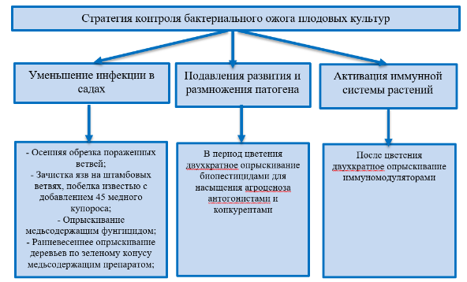

APPENDIX А.2
Genomic DNA

DNA isolation from plant samples was carried out using the GeneJET Plant Genomic DNA Purification Mini Kit # K0792 (ThermoFisher, USA), and from bacteria using the GeneJET Genomic DNA Purification Mini Kit # K0722 (ThermoFisher, USA) according to the instructions provided by the manufacturer of these reagents. To determine the quality and quantity of the isolated DNA, electrophoresis was performed on an agarose gel. The results of electrophoresis were analyzed using a Doc-VX5 gel documenting system (Vilbert Lourmat).
FLASH – PCR. Diagnostics of E. amylovora was carried out using reagent kits for identification of bacterial blight of the company "AgroDiagnostika" LLC (Moscow, Russia) according to the manufacturer's protocol. During FLASH PCR, the results were detected using a Genie fluorometer (DNA technology). At the stage of detection, the level of fluorescence of the sample with the level of background fluorescence is determined and the result is given in relative units (as a particular value of the sample fluorescence to the background value). The background was a reaction mixture without polymerase and DNA, but with a PCR buffer. The results were displayed in the form of a table and a diagram.
Identification of E. amylovora by PCR. PCR amplification was performed with primers FER1-F: 5'-AGC AGC AAT TAA TGG CAA GTA TAG TCA-3' rgER2-R: 5'-AAA AGA GAC ATC TGG ATT CAG ACA AT-3'. The reaction mixture (25 µl) contained 4 µl HF Buffer (Thermo scientific), 0.5 µl 2 mm deoxyribonucleoside triphosphate (dNTP) mix, 10 pmol of each of the primers, 0.5 µl Phusion High-Fidelity DNA Polymerase (Thermo scientific) , and 2 µl DNA as a matrix. PCR was performed in a SimpliAmpTM (Life Technologies Corporation) thermal cycler. The reaction was started by incubating the mixture at 94 ° C for 3 minutes, followed by 35 cycles, consisting of incubations: 94 ° C -10 seconds, 60 ° C -10 seconds and 72 ° C- 30 seconds. The final elongation was carried out at 72 ° C for 5 minutes. After PCR, all samples were run in 1% agarose gel with the addition of ethidium bromide in a horizontal electrophoresis chamber. As a marker of molecular weights DNA Ladder Gene Ruler 1 kb (Thermo Fisher, USA)
PCR ribotyping was performed using primers Rib F: 5’ - TTG TAC ACA CCG CCC GTCA- 3’; Rib R: 5’-CGT ACT TAG ATG TTT CAG TTC-3’.( According to the protocol of Patricia S. et al. Authors.
E. amylovora identification by 16S rRNA gene sequencing. PCR - amplification of 16S RNA genes was performed using a MicroSEQ ™ Full Gene 16S rDNA PCR Kit (Thermo Fisher, USA) in accordance with the standard kit protocol. Before sequencing, the amplified products were purified using the ExoSAP-IT ™ Express PCR Product Cleanup Reagent (Thermo Fisher, USA) according to the manufacturer's instructions. After PCR, all samples were run in 1% agarose gel with the addition of ethidium bromide in a horizontal electrophoresis chamber. For samples and positive controls, three fragments should be detected: one range from 460 to 560 bp, and two bands from 700 to 800 bp. The actual fragment size depends on the type of bacteria. The electrophoresis results were analyzed using a Doc-VX5 gel documenting system (Vilbert Lourmat).
Sequencing of the amplified fragments of the 16S DNA gene was carried out using a MicroSEQ ™ Full Gene 16S rDNA Sequencing Kit (Thermo Fisher, USA) using a SimpliAmp thermal cycler (Applied Biosystems, USA). Terminating amplification (Seq-PCR) was carried out according to the following parameters: 96 ° C -10 sec., 50 ° C- 5 sec., 60 ° C- 4 min., 25 cycles in total. Performa DTR Gel Filtration Cartridges (Edge Bio) were used to purify samples after Seq-PCR. After cleaning, 10 µl are taken from the tubes and sequentially transferred to a plate for sequencing (Applied Biosystems, USA). If, when filling the plate, empty wells remain, then 10 μl of Hi-Di Formamide (Applied Biosystems, USA) are added to them. Then the plate is closed with a rubber septum (Applied Biosystems, USA) and placed in a container for sequencing. Then, the 3500xL genetic analyzer (Applied Biosystems, USA) was launched.
The analysis and interpretation of the sequencing data was performed using Sequence Scanner v. 2 and Chromas Pro v. 2.1.8. The search for homologous nucleotide sequences of the 16S rRNA genes was carried out using the BLAST program (Basic Local Alignment Search Tool) in the International Gene Bank database of the US National Center for Biotechnology Information (htpp: //www.ncbi.nlm.nih.gov). Then, multiple alignment was performed using the MUSCLE v.3.8 program. A phylogenetic tree (Neighbor-joining tree) was constructed using the Mega X program. The statistical significance of phylogeny was assessed using the bootstrap method (1000 repeats). The "complete delete" option was used to exclude all items containing spaces and missing data.

APPENDIX А.3

Identified hotbed of bacterial blight

Table А.3. 1 - Identified hotbed of bacterial blight in the Enbekshikazakh district of the Almaty region, 2018

Farm | Area, ha | Cultivar | Disease Index, %
 |  |  | P | R
«Ayazhan» | 18,0 | Golden Delicious, | 8 | 2,0
«Samal» | 20,0 | Montet, Idared, Golden Delicious, | -  - | -
«Khusainova G.» | 5,5 | Golden Delicious, Starkrimson | 9  - | 6,7
«Zhemis» | 22,0 | Americanka,  Golden superior | -  - | -  -
«Suzdaleva O.V» | 14,0 | Voshod, Maksat, Aport | - | -
"Almagrinfield" | 186 | Golden Delicious | - | -
«Apple world» | 38,0 | Gala | 15 | 7,5
«Aqqazy» | 30,0 | Golden Delicious, | 11 | 5,5
«Agrosad» | 30,0 | Gala, Red Delicious | - | -
«Dikhan» | 20,0 | Idared,  Starkrimson,  Golden Delicious, | 12  -  - | 6,0  -  -
«Mahsat» | 8,0 | Golden Delicious, Red John Prince, Gala | -  - | -  -
«Zhalgasbayev» | 39,0 | Star Crimson, Ainur, Golden Delicious | 2,2  - | 0,5  -
«Zharyk» | 15,0 | Ziliyskoe,  Golden Delicious, Starkrimson,  Voshod | 25  -  -  - | 18,7  -  -  -
«Raushan» | 5,0 | Aport, Voshod, Golden Delicious, Starkrimson | -  - | -  -
RNE "Issyk State Dendrological Park" | 1,5 | Zailiyskoe | 3 | 0,7
Note: P - spread, R - degree of development.

Table А.3. 2 - Identified hotbed of bacterial blight in Talgar district, Almaty region, 2018

Farm | Area, ha | Cultivar | Disease Index, %
 |  |  | P | R
«Badenko Yu.A..» | 25,0 | Golden Delicious, Starkrimson | -  - | -  -
«Badenko M.G.» | 6,5 | Golden Delicious, Starkrimson | -  - | -  -
«Bayserke Agro» | 7,0 | Aport | 27 | 20,2
«Darhan» | 3,0 | Aport | 11 | 8,2
«Badalov» | 3,0 | Aport  Golden excellent, American | 29  -  - | 21,7  -  -
«Dursunov» | 5,0 | Aport,  Golden Delicious, Star Crimson, Idared | 28  -  - | 14,0  -  -
«Dzhulfayev» | 4,0 | Idared,  Star Crimson | 14  - | 7,0  -
«Tairova, D.» | 21,0 | Aport  Star Crimson, Golden Delicious, | 10  -  - | 5,0  -  -
«Semirechye» | 1,0 | Talgar beauty | 5 | 2,5
Note: P - spread, R - degree of development.

Table А.3. 3 – Identified hotbed of bacterial blight in in Karasay district of Almaty region, 2018

Farm | Area, ha | Cultivar | Disease Index, %
 |  |  | P | R
«Alatau» | 8,0 | Aport,  Star crimson,  Golden Delicious | 15,0  -  - | 15,0  -  -
«Israfil» | 1,5 | Collectible | 5,4 | 1,9
«Olzhas» | 3,0 | Aport | 12,0 | 6,0
«Dauren» | 10,0 | Aport | - | -
«Tan» | 12,0 | Aport | 28 | 21
c/d «Kainar» | 5,0 | Aport | 16,1 | 8,05
«Ruslan» | 3 | Idared,  Golden superior | 2,4  - | 0,8  -
«Altay» | 3 | Aport | 9,6 | 3,2
«Agrokeruen» | 28 | Zarya Alatau  American | 3,0  - | 1,1  -
Note: P - spread, R - degree of development.

Table А.3. 4 – Identified hotbed of bacterial blight in Zhambyl region, 2018

Farm | Area, ha | Cultivar | Disease Index, %
 |  |  | P | R
Korday region
«Kungey» | 5,2 | Idared,  Golden Delicious,  Red Delicious | 15  -  - | 3,7  -  -
«Zhemis» | 15,0 | Idared,  Golden Delicious | 5  - | 0,6  -
«Aruzhan» | 15,0 | Idared  American,  Golden Delicious, | 6  -  - | 0,7  -  -
Merke district
«Sovet» | 20,0 | Starkrimson Golden Delicious,  Red Delicious | 3  -  - | 0,8  -  -
«Balabek» | 17,0 | Idared,  Starkrimson  Golden Delicious | 10  -  - | 5  -  -
Bayzak district
«Astana» | 1 | Talgar beauty (pear) | 77,0  - | 57,7  -
«Bayzhanova N.» | 10 | Idared,  Golden Delicious,  Starkrimson | 29,0  -  - | 14,5  -  -
«Karlygash» | 4 | Idared,  Golden Delicious | 5,0  - | 0,6  -
«Zhanat» | 10,0 | Golden Delicious, Golden Red,  Lemonka | 7,0  - | 1,7  -
Note: P - spread, R - degree of development.

Table А.3. 5 – Identified hotbed of bacterial blight in the Turkestan region, 2018

Farm | Area, ha | Cultivar | Disease Index, %
 |  |  | P | R
1 | 2 | 3 | 4 | 5
Kazygurt district
«Amankeldi» | 18,0 | Santa Maria,  Williams,  Early maturing | 30,0  -  - | 15,0  -  -
 | 70,0 | Golden Delicious,  Gala,  Idared,  Granny Smid | -  10,0  3,0  - | -  2,5  0,3  -
Saryagash district
«Yntymak-Bekarys» | 36,0 | Golden Delicious,  Red Delicious,  Gala,  Granny Smead,  Pink Lady,  Saltanat | -  -  -  -  8,0  - | -  -  -  -  2,0  -

Table continuation А.3. 5
1 | 2 | 3 | 4 | 5
Tolebi district
«Zhana kush» | 50,0 | Golden Delicious,  Starkrimson,  Renet simirenko | -  3,0  - | -  0,75  -
Note: P - spread, R - degree of development

Table А.3. 6 - Identified hotbed of bacterial blight in the farms of the Enbekshikazakh district of the Almaty region, 2019

Farm | Area, ha | Culture | Cultivar | Disease Index, %
 |  |  |  | P | R
1 | 2 | 3 | 4 | 5 | 6
«Ayazhan» | 18,0 | Apple tree | Golden Delicious | 2,9 | 0,06
«Samal» | 20,0 | Apple tree | Montet  Idared  Golden Delicious | -  5  - | -  0,3  -
«Khusainova G.» | 5,5 | Apple tree | Golden Delicious  Starkrimson | 7  - | 0,14  -
«Zhemis» | 22,0 | Apple tree | Golden superior | - | -
«Suzdaleva O.V» | 14,0 | Apple tree | Voshod  Maksat  Aport | -  -  9 | -  -  0,2
"Almagrinfield" | 18,6 | Apple tree | Golden Delicious | - | -
«Apple world» | 38,0 | Apple tree | Gala | - | -
«Aqqazy» | 30,0 | Apple tree | Golden Delicious | 62 | 6,8
«Agrosad» | 30,0 | Apple tree | Gala  Red Delicious | -  - | -  -
«Dikhan» | 20,0 | Apple tree | Idared  Starkrimson  Golden Delicious | 12  -  - | 0,2  -  -
«Mahsat» | 8,0 | Apple tree | Golden Delicious  Red john prince  Gala | 3  -  - | 0,2  -  -
«Zharyk» | 15,0 | Apple tree | Zaiiliskoe  Golden Delicious Starkrimson  Voshod | 14  -  -  - | 0,5  -  -  -
«Raushan» | 5,0 | Apple tree | Aport  Voshod  Golden Delicious  Starkrimson | -  -  -  - | -  -  -  -
«Asyl tukym» | 95 | Apple tree | Aport  Starkrimson  Golden Delicious | 3,3  -  - | 0,9  -  -
«Daniyar» | 3,5 | Apple tree | Idaret | 2 | 0,4
«Bahus Global» | 79 | Apple tree | Golden superior  Zarya Alatau  Starkrimson  Qandil Sinap | 6  -  -  - | 0,5  -  -  -

Table continuation А.3. 6
1 | 2 | 3 | 4 | 5 | 6
«Zhalgasbayev» | 47,5 | Apple tree | Starkrimson  Ainur  Golden Delicious  Idared | -  -  -  - | -  -  -  -
«Sad» | 2,7 | Apple tree | Collection, summer varieties | - | -
Total: | 471,8
Note: P - spread, R - degree of development

Table А.3. 7 - Identified hotbed of bacterial blight in the farms of Talgar district, Almaty region, 2019.

Farm | Area, ha | Culture | Cultivar | Disease Index, %
 |  |  |  | P | R
«Badenko Yu.A..» | 25,0 | Apple tree | Golden Delicious  Starkrimson | - | -
«Badenko M.G.» | 6,5 | Apple tree | Golden Delicious  Starkrimson | - | -
«Badalov» | 3,0 | Apple tree | Aport  Golden superb  Americanka | -  -  - | -  -  -
«Dursunov» | 5,0 | Apple tree | Aport  Golden Delicious Starkrimson  Idared | 8  -  -  - | 0,5  -  -  -
«Dzhulfayev» | 4,0 | Apple tree | Idared Starkrimson | 10 | 0,5
«Tairova D.» | 21,0 | Apple tree | Aport  Starkrimson  Golden Delicious | 26,2  -  - | 11,6  -  -
Total: | 64,5
Note: P - spread, R - degree of development.

Table А.3. 8 – Identified hotbed of bacterial blight in the farms of Karasay district of Almaty region, 2019

Farm | Area, ha | Culture | Cultivar | Disease Index, %
 |  |  |  | P | R
«Olzhas» | 3,0 | Apple tree | Aport | 64 | 10,8
«Tan» | 12,0 | Apple tree | Aport | 18 | 0,7
«Ruslan» | 3 | Apple tree | Idared  Golden superior | 1  - | 0,2  -
«Alatau» | 8,0 | Apple tree | Aport  Starkrimson  Golden Delicious | 17,5  -  - | 0,5  -  -
«Agrokeruen» | 28 | Apple tree | Zarya Alatau  American | 2  - | 0,2  -
«Rassvet» | 5 | Pear | Forest beauty | 8 | 0,3
Total: | 95
Note: P - spread, R - degree of development.

Table А.3. 9 – Identified hotbed of bacterial blight in Zhambyl region, 2019

Farm | Area, ha | Culture | Cultivar | Disease Index, %
 |  |  |  | P | R
1 | 2 | 3 | 4 | 5 | 6
Korday region
«Kungey» | 5,0 | Apple tree | Idared  Golden Delicious  Red Delicious | -  -  - | -  -  -
«Zhemis» | 13,8 | Apple tree | Idared,  Golden Delicious | -  - | -  -
 | 1,2 | Pear | Talgar beauty | 18,0 | 6,0
«Aruzhan» | 9,8 | Apple tree | Idared  American  Golden Delicious | -  -  - | -  -  -
«Sovet» | 20,0 | Apple tree | Starkrimson  Golden Delicious | -  -  - | -  -  -
«Karim» | 6,0 | Apple tree | Idared | - | -
«Baigobek» | 5,6 | Apple tree | Idared  American | -  - | -  -
«Bakytzhan» | 10,0 | Apple tree | Starkrimson | 1,0 | 0,2
JCS «Tlemis Batyr» | 12,0 | Apple tree | Red Delicious  Golden superior | -  - | -  -
«Mamay» | 12,0 | Apple tree | Golden superior  Lemon | -  - | -  -
«Altyn kalam» | 17,0 | Apple tree | Idared  Starkrimson | -  - | -  -
«Balabek» | 17,0 | Apple tree | Idared  Starkrimson  Golden Delicious | 10,0  -  - | 5,0  -  -
«Nur-Sham» | 12,0 | Apple tree | Starkrimson  Golden Delicious  Lemon | -  -  - | -  -  -
«Maksat-Tore» | 7,5 | Apple tree | Idared  Starkrimson | -  - | -  -
 | 2,5 | Pear | Talgar beauty | - | -
«Orazaly auleti» | 3,0 | Apple tree | Red Delicious  Golden Delicious | -  - | -  -
«Merke experimental farm» | 22,0 | Apple tree | Idared  Starkrimson  Golden Delicious  Red Delicious  Babushkino | -  -  -  -  4,2 | -  -  -  -  0,8
«Tatti» | 2,0 | Apple tree | Golden superior  Red Delicious | -  - | -  -
«Azimkhan» | 2,0 | Apple tree | Amerikanka | - | -
«Oser-Sai» | 5,0 | Apple tree | Starkrimson  Americanka | -  - | -  -
«Maulen» | 5,0 | Apple tree | Starkrimson | - | -
«Zhar-Uiyk» | 15,65 | Apple tree | Idared  Starkrimson  Golden Delicious | -  -  - | -  -  -
 | 1,35 | Pear | Klapp's favorite | 3,2 | 0,6
«Zhasyl-Beles» | 15,0 | Apple tree | Golden Delicious  Golden superior | -  1,0 | -  0,4
«Altyn bidai 2» | 10,0 | Apple tree | Starkrimson  Gala | -  - | -  -

Table continuation А.3. 9
1 | 2 | 3 |  | 4 | 5 | 6
«Tabys» | 15,0 | Apple tree |  | Renet simirenko  Granny Smead  Gala | -  - | -  -
«Gulder» | 23,0 | Apple tree |  | Golden Delicious  Red Delicious  American  Starkrimson  Gala  Granny Smith | -  -  -  -  -  - | -  -  -  -  -  -
«B-Akzhol» | 11,0 | Apple tree |  | American  Gala  Pink Lady | -  -  - | -  -  -
NC «Akaral» | 165,0 | Apple tree |  | Golden Delicious  Red Delicious  American  Starkrimson | -  -  -  - | -  -  -  -
«Zhasyl Beles» | 15,0 | Apple tree |  | Golden Delicious  Red Delicious  American | -  -  - | -  -  -
«Boribay M» | 3,0 | Apple tree |  | American  Starkrimson | -  - | -  -
«Kaska Su» | 11,0 | Apple tree |  | Golden Delicious  Red Delicious | -  - | -  -
«Alzhan auleti» | 15,7 | Apple tree |  | Pink Lady  Golden Delicious  Red Delicious  Renet simirenko | 5,0  -  -  - | 1,8  -  -  -
 | 2,3 | Pear |  | Williams summer | 1,5 | 0,3
«Ravshan» | 5,0 | Apple tree |  | Golden Delicious  Red Delicious | -  - | -  -
«Granitogorsk» | 34,0 | Apple tree |  | Renet simirenko  American  Starkrimson  Idared | -  -  -  - | -  -  -  -
«Shamil» | 20,0 | Apple tree |  | Idared | - | -
«At zhailau» | 6,6 | Apple tree |  | Starkrimson | - | -
«Zhylybulak Merke» | 15,4 | Apple tree |  | Golden Delicious | - | -
 | 1,6 | Pear |  | Honey summer | 2,0 | 1,5
«Botabay» | 11,0 | Apple tree |  | Starkrimson  Red Delicious | -  - | -  -
Turar Ryskulov district
«Bakdaulet» | 3,0 | Apple tree |  | Starkrimson  Granny Smith | 27,0 | 4,5
Zhambyl district
АТК «Altyn Alma» | 50,0 | Apple tree |  | Breborn  Golden Delicious  Red Jonah Gold | 5 | 0,83
Bayzak district
«Astana» | 1 | Pear |  | Forest beauty | 81,0 | 54,0
«Baizhanova N.» | 10 | Apple tree |  | Idared,  Golden Delicious  Starkrimson | 16,0  -  - | 5,3  -  -
«Karlygash» | 5 | Apple tree |  | Idared  Golden Delicious | -  - | -  -
«Zhanat» | 10,0 | Apple tree |  | Golden Delicious Golden Red  Lemon | 7,0  - | 1,7  -
Total: | 666
Note: P - spread, R - degree of development.
Table А.3. 10 – Identified hotbed of bacterial blight in the Turkestan region, 2019

Farm | Area, ha | Culture | Cultivar | Disease Index, %
 |  |  |  | P |  | R
Tulkubas district
«Kemerbastau» | 30,0 | Apple tree | Starkrimson | - |  | -
«Shukyrbulak» | 3,0 | Apple tree | Golden superior | - |  | -
Abay district, Shymkent
«Zhuldyz» | 40,0 | Apple tree | Golden Delicious  Starkrimson  Fuji  Semerenko | -  -  -  - |  | -  -  -  -
 | 2,0 | Pear | Forest beauty | 18 |  | 6
«Keremet sapa» | 5,0 | Apple tree | Granny smith  Gala  Golden Delicious | -  -  - |  | -  -  -
Kazygurt district
IAPC «Ontustik bau bakshalary» | 50,0 | Apple tree | Breborn  Golden Delicious  Red Jonah Gold | 1  1  1 |  | 0,2  0,3  0,3
JCS «Amankeldi» | 18,0 | Pear | Santa maria  Williams  Early maturing | 9,0  -  - |  | 4,5  -  -
 | 70,0 | Apple tree | Golden Delicious  Gala  Idared  Granny Smid | -  7,1  2,1  - |  | -  1,0  0,3  -
Saryagash district
«Yntymak-Bekarys» | 36,0 | Apple tree | Golden Delicious  Red Delicious  Gala  Granny Smead  Pink Lady  Saltanat | -  -  -  -  -  - |  | -  -  -  -  -  -
Tolebi district
«Zhana kush» | 50,0 | Apple tree | Golden Delicious  Starkrimson  Renet simirenko | -  3,0  - |  | -  0,75  -
Keles district
«Tenel» | 9,5 | Apple tree | Golden superior |  | - |  | -
 |  | 0,5 | Pear |  | Forest beauty |  |  | - | -
Total: |  | 314
Note: P - spread, R - degree of development..

APPENDIX А.4

Distribution of bacterial blight of fruit crops

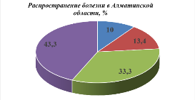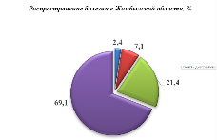

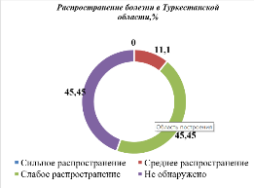

Figure А.4. 1 - Distribution of bacterial blight of fruit crops in the south and southeast of Kazakhstan, 2018

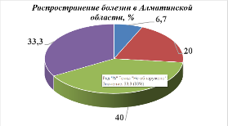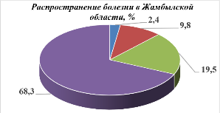

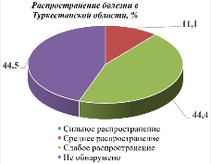

Figure А.4. 2 - Distribution of bacterial blight of fruit crops in the south and southeast of Kazakhstan, 2019

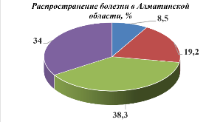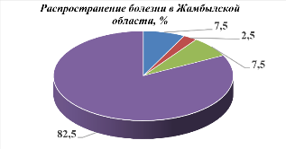

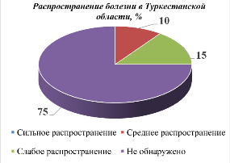

Figure А.4. 3 - Distribution of bacterial blight of fruit crops in the south and southeast of Kazakhstan, 2020

APPENDIX А.5

Colonies of a pure culture

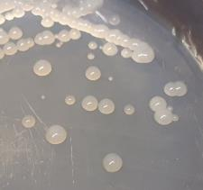 | 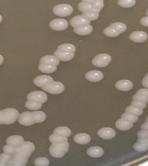
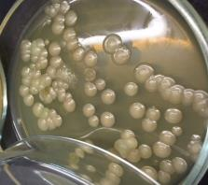 | 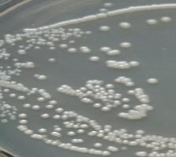
Figure A.5. 1 - Colonies of a pure culture of Erwinia amylovora bacteria

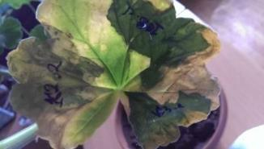 | 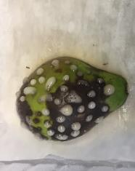
А – Geranium | B – pear
Figure A.5. 2 - Test for pathogenicity on geranium leaves and immature pear fruits

APPENDIX А.6

FLASH PCR

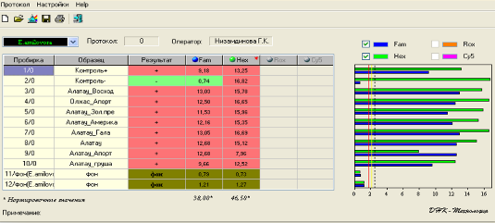

Figure A.6. 1 - The results of the analysis of samples of fruit crops for the presence
E. amylovora pathogen by FLASH PCR
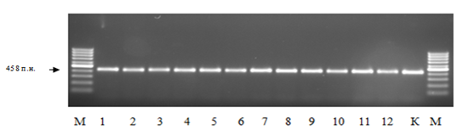

Figure A.6. 2 - PCR fragments obtained by amplification of DNA with primers FER1-F and rgER2. 1-12- investigated isolates, K- reference strain M- DNA Ladder Gene Ruler 1 kb (Thermo Fisher, USA)

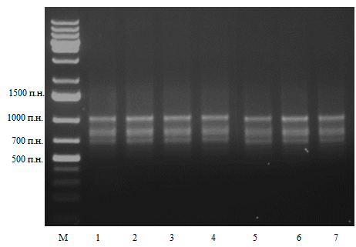
Figure A.6. 3 - PCR-ribotyping. PCR products separated in 1% agarose gel. М- DNA Ladder Gene Ruler 1 kb (Fermentas), 1-7 strains of E. amylovora
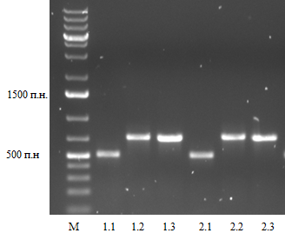

Figure A.6. 4 - PCR fragments obtained by amplification of DNA isolated from E. amylovora M-DNA Ladder Gene Ruler 1 kb Plus (Fermentas)

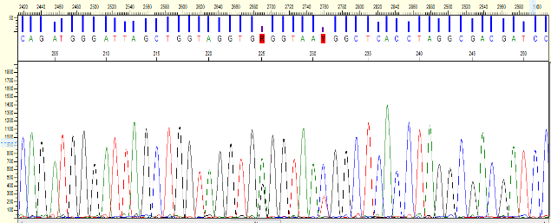
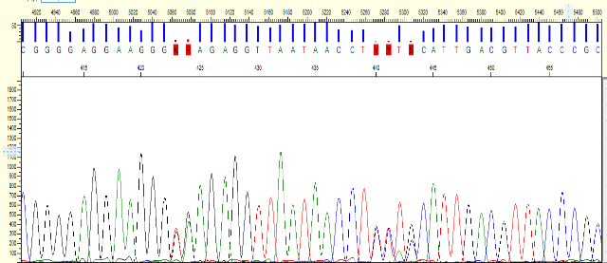

Figure A.6. 5 - Sequencing of the 16S rRNA region with mutations in the studied samples
Figure A.6. 6 - Phylogenetic tree built on the alignment of 16 S rDNA gene sequences between isolates from Kazakhstan with other populations of Erwinia amylovora, using the Neighbor-Joining (NJ) method. The scale bar represents 2 nucleotide substitutions per 1000 positions.

Figure A.6. 7 - Evolutionary relationship between Erwinia amylovora and related species Erwinia. A phylogenetic tree was constructed on the alignment of the 16 S rDNA gene sequences using the Neighbor-Joining (NJ) method. The scale bar represents 5 nucleotide substitutions per 1000 positions.

Table A.6. 1 - The value of the genetic distance, 16S rDNA sequences of the Erwinia amylovora gene and related species of Erwinia

 | E.amylovora_3_pear_16S_ribosomal_RNA_Kazakhstan | E.amylovora_37_apple_16S_ribosomal_RNA_Kazakhstan | Pectobacterium_carotovorum_strain_ATCC_15713_AB242908 | Erwinia_tasmaniensis_Et1/99_AM055716 | Erwinia_pyrifoliae_DSM_12163_AB242880 | Erwinia_piriflorinigrans_CECT_7348_GQ405202 | Erwinia_amylovora_NCPPB_683_AB242877 | Erwinia_uzenensis_YPPS_951_AB546198 | Erwinia_persicina_NBRC_102418_AB681774 | Pantoea_stewartii_ICMP_257_MT759984
E.amylovora_3_pear_16S_ribosomal_RNA_Kazakhstan
E.amylovora_37_apple_16S_ribosomal_RNA_Kazakhstan | 0,0000
Pectobacterium_carotovorum_strain_ATCC_15713_AB242908 | 0,0435 | 0,0435
Erwinia_tasmaniensis_Et1/99_AM055716 | 0,0120 | 0,0120 | 0,0368
Erwinia_pyrifoliae_DSM_12163_AB242880 | 0,0009 | 0,0009 | 0,0425 | 0,0129
Erwinia_piriflorinigrans_CECT_7348_GQ405202 | 0,0083 | 0,0083 | 0,0425 | 0,0092 | 0,0092
Erwinia_amylovora_NCPPB_683_AB242877 | 0,0000 | 0,0000 | 0,0435 | 0,0120 | 0,0009 | 0,0083
Erwinia_uzenensis_YPPS_951_AB546198 | 0,0055 | 0,0055 | 0,0454 | 0,0120 | 0,0064 | 0,0064 | 0,0055
Erwinia_persicina_NBRC_102418_AB681774 | 0,0223 | 0,0223 | 0,0426 | 0,0157 | 0,0233 | 0,0195 | 0,0223 | 0,0223
Pantoea_stewartii_ICMP_257_MT759984 | 0,0300 | 0,0300 | 0,0358 | 0,0291 | 0,0309 | 0,0329 | 0,0300 | 0,0329 | 0,0368

APPENDIX А.7

List of tested products and their concentrations,2019
Product name | Active substance | Producing country | Recommended concentration, %
Fungicides
Best Bakir, s.p. | 50% copper oxide (metallic copper) | AgroBestGrup, Turkey | 0,4-0,8
Fosiram, v.r.s. | P₂O₅ – 35%, K₂O – 20%, MgO – 3%, Cu – 12% | SWISSGROW, Switzerland | 0,15
Curamin Foliar, v.s., organically chelated liquid copper | N-3%, water-soluble phosphorus pentoxide,  Cu - 6.2%, amino acids 37% | SWISSGROW, Zurich, Switzerland | 0,15-0,2
Cosside 2000, v.d. | Copper hydroxide, 350 g / kg | CJSC "DuPont Khimprom", RF | 3
Kurzat P, s.p | Cymoxanil 4.2%, Copper oxychloride 39.8% | CJSC "DuPont Khimprom", RF | 3
Cuproxat 34.5%, T.P.C. | Copper sulfate, 345 g / l, fruit 600-1200 l / ha | LLC "Vassma", Ukraine | 0,5
Bordeaux liquid | copper sulfate + calcium hydroxide | Technoeskport, Russia | 3
Alieta Super 80 S.p. | Fosetyl aluminum (800 g / kg), treatment 0.25-0.3% w.c. | BayerGroop, Germany | 3
Allett | Fosetyl aluminum (800 g / kg), working solution consumption (norm) 600-1000 l / ha | BayerGroop, Germany | 3
ControlFit Cu | Copper gluconate (C12H22CuO14) associated with gluconic (aldonic) acid | Kazakhstan, A.S.K. Technik | 3
𝐶𝑢𝑆𝑂4+ PAN | Copper sulfate (copper sulfate) + Polyacrylonitrite | Kazakhstan, KazSRIPQ | 3
Zerox | 500 mg / l colloidal silver + 100 mg / l polyhexamethylenebiguanide hydrochloride | "AgroChemProm", Russia | 2
Biologicals
Fitolavin, VRK | Phytobacteriomycin, BA-120,000 EA / ml, 32 g / l. | LLC "Pharmbiomedservice", RF | 0,2
Kasumin 2L, v.r. | Kasugamycin 20g / l  (fermentation product of the fungus Streptomyces kasugaensis, 20 g / l) | Hokko Chemical Industry Co., Ltd, Japan | 0,2-0,4
Extrasol | Bacillus subtilis, strain Ch-13 + metabolites. not less than 100 million CFU / ml | Russia | 0,2
Fitop 8.67, liquid | Spore biomass of bacteria Bacillus subtilis strain VKPM B-10641, Bacillus amyloliquefaciens strain VKPM B-10642 and Bacillus amyloliquefaciens strain VKPM B-10643 | LLC NPF "Research Center - 17", RF | 0,01
Growth stimulator
Vacciplant | Laminarin algae, 45 g / l | Great Britain, arista | 0,5-0, 8l / ha
Novosil, liquid | Triterpene acids obtained from the needles of Siberian fir | JSC "PO" Electrochemical Plant ", RF | 5
Potassium humophosphate (POPHOS) | Humate phosphate + potassium | Kazakhstan, KazNU them. Al-Farabi | 0,5
Agroflorin | proteins (polypeptides, enzymes), carbohydrates (polysaccharides), amino acids, organic acids, vitamins, macro and microelements | LLC Universal RTO, RF | 2
Phoskraft MKP | $P_{2}O_{5}$-35%, $K_{2}$O-23% | Turkey | 3

Figure A.7. 1 - Zones of suppression of the growth of bacteria E. amylovora with various doses of copper-containing preparations, mm

Figure A.7. 2 - Zones of suppression of the growth of bacteria E. amylovora with various doses of other fungicides, mm

Figure A.7. 3 - Accounts of the zone of suppression of the growth of bacteria E. amylovora with various doses of biological products, mm

APPENDIX А.8

Scheme of the conducted field tests of fungicides

Table A.8. 1 - Scheme of the conducted field tests of fungicides, biological products and growth regulators against bacterial blight in the hotbed of infection at 2 stations (k.-kh. "Alatau" and "Dikhan") and processing time, 2019

Experience scheme | Processing time and development phase
 | 20-21.11.2018  in the fall  during dormancy | 3-4.04.2019  before bud break | 17-18.04.2019  before flowering | 17-18.05.2019  during flowering | 7-8.06.2019  after flowering
№ 1 | Bordeaux liquid,3% | Bordeaux liquid,, 3% | Bordeaux liquid,, 1% | Best Bakir,  0,4 l/ha | Vacciplant,  0,8 l/ha
№ 2 | Kurzat R,  3% | Kurzat R,  3% | Kurzat R,  3% | ControlFit Cu, 3 l/ha | Alieta super, 3kg/ha
№ 3 | Cosside 2000,  3% | Cosside 2000,  3% | Cosside 2000,  1% | Fitolavin,  2,0 l/ha | Novosil,  5 l/ha
№ 4 | Curamin Foliar, 3% +  Phoskraft MKP, 3% | Curamin Foliar, 3% +  Phoskraft MKP, 3% | Curamin Foliar, 3% +  Phoskraft MKP, 3% | Kasumin,  2,0 l/ha | Allett,  3 kg/ga
№ 5 | Fosiram, 3% | Fosiram, 3% | Fosiram, 1% | Agroflorin,  2 l/ha | Potassium humophosphate, 0,5 l/ha
№ 6 | Cuproxat 34,5%, 3% | Cuproxat 34,5%, 3% | Cuproxat 34,5%, 1% | Phytop 8.67 0,01 l/ha | Zerox 2 l/ha
№ 7 | 𝐶𝑢𝑆𝑂4+ PAN,  3% | 𝐶𝑢𝑆𝑂4+ PAN,  3% | 𝐶𝑢𝑆𝑂4+ PAN,  1% | Extrasol,  0,3l/ha | Extrasol,  0,3 l/ha

Mathematical model of yield data processing

Table A.8. 2 - Mathematical model of yield data for various Apple tree treatment schemes against bacterial blight at the Alatau station, Aport, 2019

Variants | Yield in replications, t / ha |  |  |  | Average yield, t\ha
 | I | II | III | IV
Control | 16 | 18,6 | 18,25 | 14,75 | 16,9 ± 1,8
Scheme №1 | 22,75 | 21,4 | 25,1 | 19,4 | 22,1 ± 2,3
Scheme №2 | 25,6 | 24,4 | 26,25 | 23,1 | 24,8 ± 1,3
Scheme №3 | 24,1 | 25,7 | 27,8 | 23,2 | 25,2 ± 2,0
Scheme №4 | 24,2 | 22,4 | 25,25 | 20,25 | 23,0 ± 2,1
Scheme №5 | 22,25 | 25,3 | 20,75 | 19,45 | 21,9 ± 2,5
Scheme №6 | 23,55 | 25,75 | 22,4 | 21,4 | 23,2 ± 1,8
Scheme №7 | 25,3 | 20,9 | 24,25 | 22,4 | 23,2 ± 1,9
 |  |  |  |  | LSD = 2,989

Table A.8. 3 - Mathematical model of yield data for various Apple tree treatment schemes against bacterial blight at farm Dikhan, Stark Erliest, 2019

Variants | Yield in replications, t / ha |  |  |  | Average yield, t\ha
 | I | II | III | IV
Control | 23,2 | 16,1 | 21,4 | 18,5 | 19,8 ±1,5
Scheme №1 | 28,9 | 31,5 | 26,9 | 22,9 | 27,5 ± 1,8
Scheme №2 | 29,5 | 23,5 | 36,3 | 26,2 | 28,8 ± 2,7
Scheme №3 | 29,4 | 35,8 | 26,1 | 23,8 | 28,7 ± 2,6
Scheme №4 | 32,4 | 23,6 | 30,3 | 26,6 | 28,2 ± 1,9
Scheme №5 | 28,2 | 29,1 | 23 | 25,4 | 26,4 ± 1,3
Scheme №6 | 28,5 | 31,6 | 25,6 | 24,9 | 27,6 ± 1,5
Scheme №7 | 28,7 | 35,1 | 25 | 23,5 | 28,0 ± 2,5
 |  |  |  |  | LSD = 2,034

APPENDIX А.9

Measures against bacterial blight

Table A.9. 1 - Diagram No. 1. The system of protective measures in the farm “Zhemis” against bacterial blight on an area of ​​7.5 hectares in 2020

Approximate  calendar dates | Phase of development of Apple trees | Pests, diseases, weeds | Preparations, consumption rate of 1000 liters of water per 1 ha | Note
25 March | Before bud break | Bacterial blight of fruit crops | Fosiram 2 kg / ha | Copper-containing trace element
10 April | After budbreak | Bacterial blight of fruit crops | Cosside - 2.0 kg / ha  Gemmastim (boron, zinc) | Copper fungicide
20 April | Before flowering | Bacterial blight of fruit crops | Kuramin Foliar - 1.5 l / ha  Foskraft MKP - 2.0 l / ha | Trace element with copper and phosphites
1 May | During flowering | Bacterial blight of fruit crops | Kasumin - 2 l / ha | Biological product
10 May | After flowering | Bacterial blight of fruit crops | Kuramin Foliar - 1.5 l / ha  Foskraft MKP - 2.0 l / ha | Trace element with copper and phosphites
25 May | Fruit inception with the size of cobnut | Bacterial blight of fruit crops | Allett 3 kg / ha | Systemic fungicide
10 June | Walnut-sized fruit | Bacterial blight of fruit crops | Novosil 0.2 l / ha | Immunomodulator
20 June | Fruit growth and development | Bacterial blight of fruit crops | Baktofit 3 l / ha | Biological product
15 October | When the leaves begin to fall | Destruction of fungal and bacterial diseases accumulated over the season | Koside 2 kg / ha | Copper fungicide
30 October | After the leaves fall | Whitewashing the trunk to skeletal branches with the addition of 4% copper sulfate.

Table A.9. 2 - Diagram No. 1. The system of protective measures in the farm “Zhemis” against bacterial blight on an area of ​​7.5 hectares in 2020

Approximate  calendar dates | Phase of development of Apple trees | Pests, diseases, weeds | Preparations, consumption rate of 1000 liters of water per 1 ha | Note
25 March | Before bud break | Bacterial blight of fruit crops | Fosiram 2 kg / ha | Copper-containing trace element
10 April | After budbreak | Bacterial blight of fruit crops | Kurzat - 2.0 kg / ha  Gemmastim (boracium, zinc) | Copper fungicide
20 April | Before flowering | Bacterial blight of fruit crops | Contolphite Kuprum - 2 kg / ha | Copper-containing trace element
1 May | During flowering | Bacterial blight of fruit crops | Fitolavin - 2 l / ha | Biological product
10 May | After flowering | Bacterial blight of fruit crops | Contolphite Kuprum - 2 kg / ha | Copper-containing trace element
25 May | Fruit inception with the size of cobnut | Bacterial blight of fruit crops | Prohexadione Calcium | Growth regulator
10 June | Walnut-sized fruit | Bacterial blight of fruit crops | Novosil 0.2 l / ha in a tank mixture with other preparations | Immunomodulator
20 June | Fruit growth and development | Bacterial blight of fruit crops | Extrasol 3 l / ha | Biological product
15 October | When the leaves begin to fall | Destruction of fungal and bacterial diseases accumulated over the season | Kurzat - 2 kg / ha | Copper fungicide
30 October | After the leaves fall | Whitewashing the trunk to skeletal branches with the addition of 4% copper sulfate.

APPENDIX A.10

Implementation report 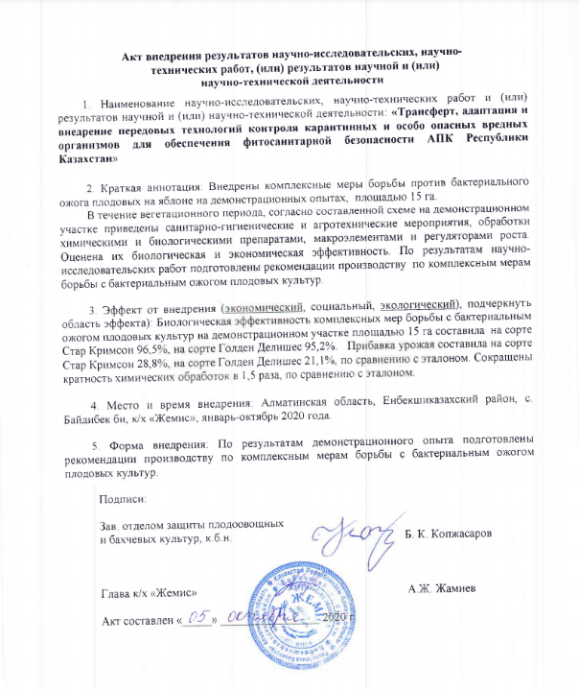

APPENDIX B
Guidance on control measures for South American tomato moth
APPENDIX B.1
Biological parameters of tomato moth

Influence of temperature on biological parameters of tomato moth (Laboratory of beneficial arthropods, 2019)

Temperature, ⁰С | Viable eggs, % | Received number of eggs from 1 female, pieces | Adult development period, days
 |  |  | males | females
15-18 | 48,7 | 70±3,2 | 12,06±0,28 | 23±0,5
20-23 | 67,00 | 165,4±5,69 | 7,10±0,37 | 17,2±0,65
25-28 | 75,50 | 183,4±2,63 | 6,1±0,44 | 16,9±0,41
30-33 | 95,2 | 219,8±7,16 | 5,30±0,28 | 16,2±0,41

APPENDIX B.2
Technological stages
The main technological stages of cultivation of macrolophus and nesidiocoris:
a - growing tobacco plants; b – keeping in a cage; c - larvae of predators, d - collection of predators
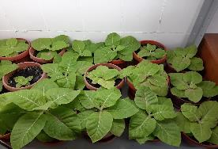 | 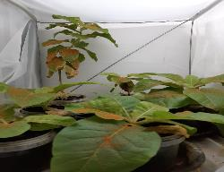
a | b
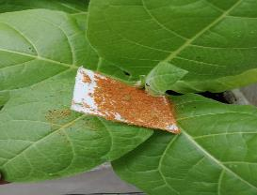 | 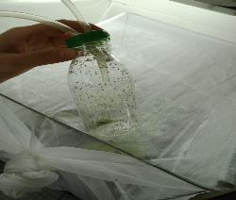
c | d

APPENDIX B.3
Mass breeding of bedbugs
Scheme of mass breeding of bedbugs on a greenhouse whitefly

Box with tobacco plants |  | Mother culture of whiteflies
Sump |  | Mother culture of bedbugs |  | Implementation of bedbugs in greenhouses

APPENDIX B.4
Whitefly
Tobacco leaf populated by whitefly

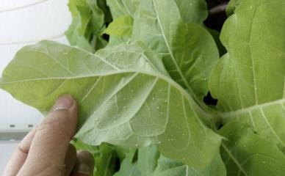

APPENDIX B.5
Moth culture
General view of mother culture, infected by a - nesidiocoris и b - macrolophus

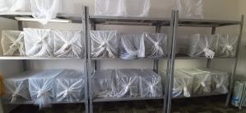 | 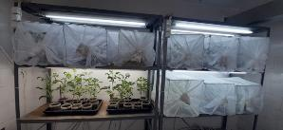
a – Nesidiocoris mother culture box | b - Macrolofus mother culture box

APPENDIX B.6

Scheme of bedbug breeding technology using sitotrog as feed

APPENDIX B.7
Breeding technology

Bedbug breeding technology under feeding predators with eggs and whitefly larvae mixed with eggs of a grain moth

APPENDIX B.8
Biological indicators of podizus
Biological indicators of podizus development under feeding with wax moth and flour beetle, 2019
Feed | Duration of development of larvae, days | Number of winged adults | Adult mass, mg | Fertility, the number of eggs per female
Wax moth | 24,8±0,32 | 35,1 | 87±2,3 | 45,3±6,2
Large flour beetle | 22,3±0,59 | 77,5 | 99±1,8 | 69,5±5,3

APPENDIX B.9
Biological products

The death of larvae after the use of biological products, 2019
Product | Consumption rate | Active substance | Biological effectiveness, %
 |  |  | 2019 | 2020
Aq kobelek | 2 kg / ha | B. thuringiensis | 56,5 | 20,5
Bitoxibacillin | 2 kg / ha | B. thuringiensis | 44,3 | 40,3
Lepidocide | 1,5 kg / ha | B. thuringiensis | 44,5 | 39,8
Control (water) | - | - | - | -

APPENDIX B.10
Integrated protection system

The effectiveness of the integrated tomato protection system (2019)

Experiment options | A total of 50 leaves were examined, pc. | Revealed the number of leaves with mines, pc. | Reduced leaf damage compared to control, %
Integrated system | 500 | 22 | 95,0
Chemical system | 500 | 40 | 91,0
Control | 500 | 448 | -

APPENDIX C
Biological control of gregarious locust species using GIS technologies
APPENDIX C.1
Orthophotomaps

Orthophotomaps of the test range of the Italian locust habitats

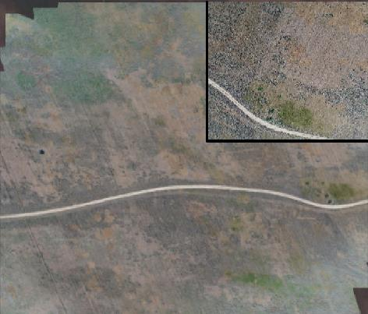

Orthophotomaps of the test site for the Asian locust habitats

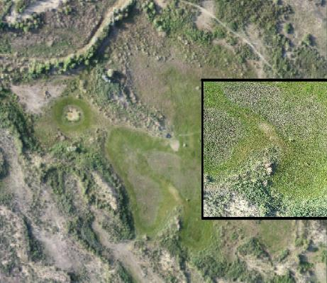
APPENDIX C.2
The Italian, Asian locust habitats

Orthophotomaps of the test range of the Italian locust habitats
with calculated VARI index

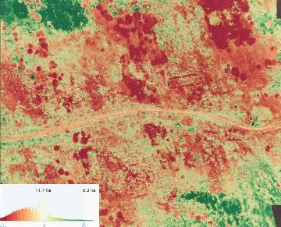

Orthophotomaps of the test site for the Asian locust habitats
with the calculated VARI index.

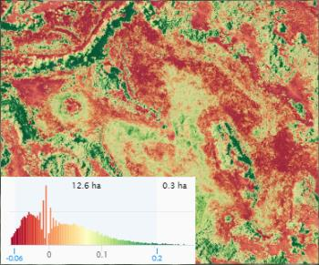

APPENDIX C.3
GIS layers

Example of overlay of digital GIS layers

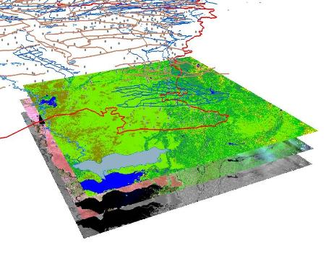

APPENDIX C.4
Distribution and abundance map of Asian locust
Distribution and abundance map of Asian locust in Balkhash district of
Almaty region in 2019

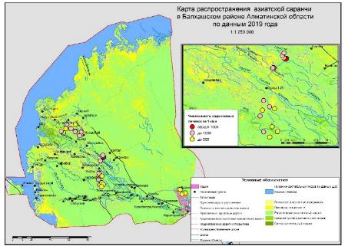

Distribution and abundance map of Asian locust in Balkhash district of
Almaty region in 2020
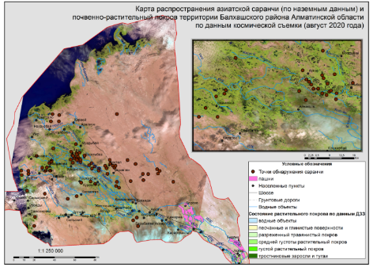

Distribution and abundance map of the Italian locust
in Almaty region in 2019

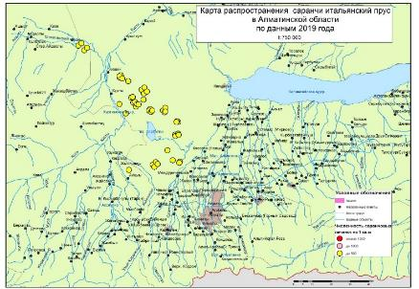

Distribution and abundance map of the Italian locust
in Almaty region in 2020

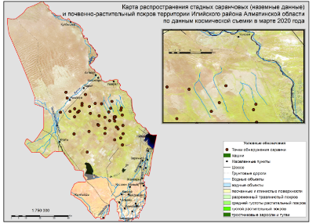

Distribution and abundance map of the Moroccan locust in the Saryagash district
of the Turkestan region in 2018

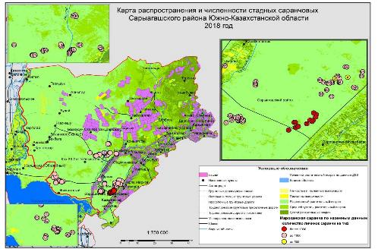

Distribution and abundance map of the Moroccan locust in
Turkestan region in 2019

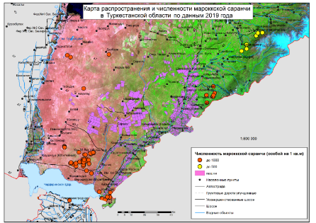

Distribution and abundance map of the Moroccan locust
in Turkestan region in 2020

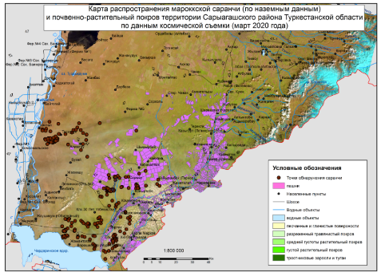

APPENDIX C.5
Frequency map of distribution of the Moroccan locust

Frequency map of distribution of the Moroccan locust in
Saryagash district of Turkestan region

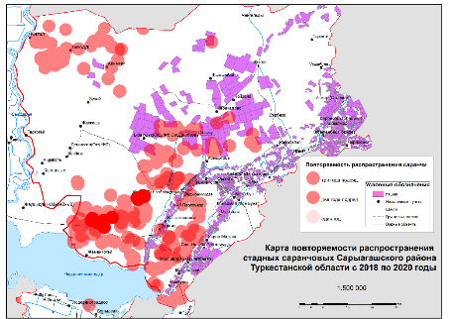

Map of frequency of distribution of Asian and Italian locusts in Almaty region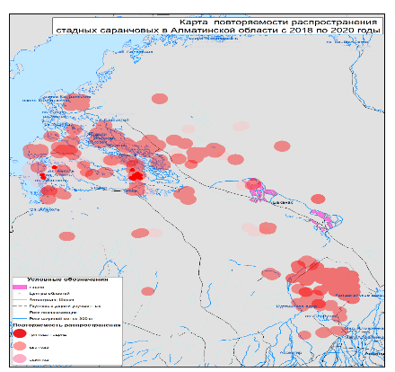

APPENDIX C.6
Biological effectiveness of the use of biological products

Table A.6. 1 - Biological effectiveness of the use of biological products in the control of locust larvae (UAV Gaia 160 AG)

Moroccan locust
Strain | Mortality %, day
 | 7 | 10 | 14 | 17
Novacrid | 40±4,08 | 52,5±10,3 | 65,0±5,00 | 97,5±2,50
Mikolar V | 15±2,88 | 42,5±6,29 | 62,5±6,29 | 70,0±5,77
Mikolar M | 22,5±2,5 | 50,0±4,08 | 67,5±7,5 | 82,5±2,5
Green barrier | 17,5±4,78 | 42,5±6,29 | 62,5±2,5 | 87,5±4,78
Actarophyte (1,0) | 90,0±2,0 | 98,0±2,0 | 100 | 100
Actarophyte (2,0) | 92,5±1,0 | 100 | 100 | 100
control | 0,0 | 0,0 | 15,0±6,45 | 20,0±7,07
LSD | 13,3 | 16,9 | 18,6 | 14,6
Italian locust
Novacrid | 25±2,88 | 50,0±4,08 | 67,5±2,5 | 89,5±2,50
Mikolar V | 15,0±2,88 | 35,0±6,45 | 57,5±2,5 | 65,0±5,0
Mikolar M | 22,5±2,5 | 42,5±6,26 | 55,0±8,66 | 68,0±5,00
Green barrier | 17,5±4,78 | 42,5±6,29 | 62,5±2,50 | 87,5±4,78
Actarophyte (1,0) | 82,0±8,16 | 85,0±5,77 | 87,5±4,21 | 95,0±7,07
Actarophyte (2,0) | 85,2±8,21 | 87,2±21,6 | 92,0±5,77 | 100
control | 0,0 | 0,0 | 10,0±4,08 | 12,5±4,78
LSD | 12,8 | 16,5 | 14,2 | 16,8
Asian locust
Novacrid | 25,0±2,88 | 42,5±6,29 | 65,0±9,57 | 80,0±4,08
Mikolar V | 15,0±2,88 | 40,0±4,08 | 50,0±5,77 | 60,0±8,16
Mikolar M | 20,5±2,5 | 42,5±6,29 | 60,0±0,0 | 67,5±7,5
Green barrier | 22,5±4,78 | 37,5±7,50 | 55,0±8,66 | 75,0±6,45
Actarophyte (1,0) | 81,0±4,65 | 82,2±6,3 | 85,0±7,1 | 95,5±2,5
Actarophyte (2,0) | 82,0±8,16 | 85,0±9,57 | 87,0±9,6 | 97,0±4,2
control | 0,0 | 0,0 | 12,5±4,78 | 15,0±6,45
LSD | 12,5 | 19,8 | 18,2 | 15,7

Table A.6. 2 - Biological effectiveness of the use of biological products in the control of locust larvae (Solo 450).
Moroccan locust
Strain | Mortality %, day
 | 7 | 10 | 14 | 17
Novacrid | 35±6,45 | 50,0±5,77 | 68,0±5,77 | 92,5±2,5
Mikolar V | 15±2,88 | 40,0±4,08 | 60,5±2,5 | 68,0±5,77
Mikolar M | 17,5±4,78 | 47,5±6,26 | 52,5±4,78 | 70,0±5,77
Green barrier | 17,5±2,5 | 40,0±11,5 | 60,0±8,16 | 82,5±2,87
Actarophyte (1,0) | 85,0±8,16 | 97,5±2,5 | 100 | 100
Actarophyte (2,0) | 93,0±8,10 | 100 | 100 | 100
control | 0,0 | 0,0 | 10,0±4,08 | 10,0±4,08
LSD | 13,7 | 21,2 | 20,1 | 13,5
Italian locust
Novacrid | 25±2,88 | 47,5±7,50 | 65,0±5,00 | 88,0±5,0
Mikolar V | 12,5±2,5 | 32,5±4,78 | 42,5±4,78 | 59,0±2,88
Mikolar M | 15,0±2,8 | 37,5±2,5 | 52,5±4,78 | 72,5±7,5
Green barrier | 17,5±4,78 | 38,0±4,08 | 58,5±2,5 | 85,0±5,0
Actarophyte (1,0) | 83,5±6,29 | 92,5±4,78 | 95,5±6,29 | 100
Actarophyte (2,0) | 88,2±6,21 | 95,0±5,01 | 98,5±6,21 | 100
control | 0,0 | 0,0 | 10,0±4,08 | 12,5±4,78
LSD | 11,2 | 11,2 | 15,2 | 16,3
Asian locust
Novacrid | 22,5±4,78 | 35,0±6,45 | 60,0±8,16 | 77,8±6,29
Mikolar V | 12,5±2,5 | 30,0±7,07 | 45,5±2,5 | 62,5±2,5
Mikolar M | 20,0±4,08 | 40,0±7,07 | 57,5±2,5 | 70,0±5,77
Green barrier | 20,0±3,21 | 40,0±4,08 | 52,5±4,78 | 72,5±4,78
Actarophyte (1,0) | 82,5±6,29 | 87,5±7,5 | 92,5±6,29 | 97,5±7,5
Actarophyte (2,0) | 85,0±5,21 | 89,0±8,45 | 92,5,0±4,73 | 100
control | 0,0 | 0,0 | 5,0±2,88 | 10,0±4,08
LSD | 11,6 | 17,7 | 16,0 | 16,8

APPENDIX C.7
Morphometric indicators

APPENDIX C.8
Biological effectiveness of the use of biological products

Table A.8. 1 - Biological effectiveness of the use of biological products in the control of locust larvae (UAV Gaia 160 AG)

Biological products | Moroccan locust
 | Mortality %, day
 | 3 | 5 | 7 | 9
Novacrid | 0,0 | 45,0±2,8 | 65,0±2,8 | 77,5±2,5
Actarophyte | 95,0±2,8 | 100 | 100 | 100
Green Gold | 45,0±2,8 | 70,0±7,0 | 85,0±2,8 | 92,5±2,5
Control | 5,0±2,8 | 5,0±2,8 | 7,5±2,5 | 7,5±2,5
LSD | 8,8 | 12,5 | 7,3 | 6,6
Italian locust
Biological products | Mortality %, day
 | 3 | 5 | 7 | 9
Novacrid | 0,0 | 47,5±2,5 | 70,0±4,08 | 75,0±2,8
Actarophyte | 95,0±2,8 | 100 | 100 | 100
Green Gold | 47,5±2,5 | 67,5±2,5 | 82,5±62,5 | 90,0±0,0
Control | 0,0 | 5,0±2,8 | 5,0±2,8 | 10,0±5,7
LSD | 9,7 | 7,0 | 8,6 | 9,9
Asian locust
Biological products | Mortality %, day
 | 3 | 5 | 7 | 9
Novacrid | 0,0 | 47,5±2,5 | 65,0±2,8 | 77,5±4,7
Actarophyte | 92,5±2,5 | 100 | 100 | 100
Green Gold | 42,5±4,7 | 67,5±4,7 | 80,0±4,08 | 92,5±2,5
Control | 0,0 | 5,0±2,8 | 7,5±2,5 | 7,5±2,5
LSD | 9,4 | 9,4 | 8,6 | 9,1

Table A.8. 2 - Biological effectiveness of the use of biological products in the control of locust larvae (Solo 450)

Biological products | Moroccan locust
 | Mortality %, day
 | 3 | 5 | 7 | 9
Novacrid | 0,0 | 45,0±2,8 | 60,0±4,0 | 77,5±2,5
Actarophyte | 92,5±2,5 | 100 | 100 | 100
Green Gold | 45,0±5,0 | 62,5±6,2 | 80,0±4,08 | 95,0±2,8
Control | 2,5±2,5 | 5,0±5,0 | 7,5±2,5 | 7,5±2,5
LSD | 13,5 | 11,5 | 9,6 | 7,0
Italian locust
Biological products | Mortality %, day
 | 3 | 5 | 7 | 9
Novacrid | 0,0 | 37,5±4,7 | 60,0±4,0 | 75,0±2,8
Actarophyte | 95,0±2,8 | 100 | 100 | 100
Green Gold | 50,0±4,0 | 62,5±2,5 | 72,5±4,7 | 97,5±2,5
Control | 0,0 | 5,0±2,8 | 5,0±2,8 | 10,0±5,7
LSD | 8,8 | 9,4 | 10,6 | 10,6
Asian locust
Biological products | Mortality %, day
 | 3 | 5 | 7 | 9
Novacrid | 0,0 | 47,5±2,5 | 65,0±2,8 | 75,0±2,8
Actarophyte | 95,0±2,8 | 100 | 100 | 100
Green Gold | 42,5±6,2 | 62,5±2,5 | 80,0±4,0 | 95,0±2,8
Control | 0,0 | 2,5±2,5 | 5,0±2,8 | 10,0±4,0
LSD | 11,5 | 6,6 | 8,8 | 8,8

APPENDIX D
Calendar Work Plan

Приложение № 2
к Договору № 24 от «20» сентября 2018 года

Календарный план работ ТОО «Казахский научно-исследовательский институт защиты и карантина растений
имени Жазкена Жиембаева» по бюджетной программе 267 «Повышение доступности знаний и научных исследований»
подпрограмма 101 «Программно-целевое финансирование научных исследований и мероприятий»
по специфике 156 «Оплата консалтинговых услуг и исследований» на 2018-2020 годы

№  п/п | Наименование  работ | Срок исполнения, год | Ожидаемые результаты | Сумма,  тенге
1 | Трансферт, адаптация и внедрение передовых технологий контроля карантинных и особо опасных вредных организмов для обеспечения фитосанитарной безопасности АПК Республики Казахстан | 2018-2020 гг. | Будут оценены бактерицидные свойства препаратов в лабораторных условиях с штаммами бактерий Erwinia amylovora. Будет проведено молекулярно-генетическое изучение местных штаммов патогена. Будет проведен мониторинг бактериального ожога в условиях Алматинской, Южно-Казахстанской и Жамбылской областей. Будут испытаны химические и биологические препараты, микроэлементы и регуляторы роста в садах в полевых условиях. Будет проведена изоляция и идентификация возбудителя БОП. Будет разработана рекомендация по комплексным мерам борьбы с бактериальным ожогом плодовых культур. Будет внедрена система защиты против бактериального ожога на демонстрационном участке на площади 15 га в садах Алматинской области. Будет определены риботипы патогена и межпопуляционные генетические разнообразия патогена.  Будут изучены зарубежные опыты борьбы с южно-американской томатной молью, выявлены наиболее эффективные биологические и химические инсектициды для борьбы с южно-американской томатной молью. Будут оценены технологии разведения биоагентов зарубежные и отечественные биосредства и инсектициды. Будут проведены эксперименты по усовершенствованию методов разведения макролофуса (Macrolophus nubilus), незидиокориса (Nesidiocoris tenuis) и подизуса (Podisus maculiventris). Будет освоена методика биоконвеера размножения биоагентов. Будет осуществлен трансферт феромонных ловушек, черных клеевых ловушек. Будут оценены технологии разведения биоагентов макролофуса, незидиокориса, подизуса. Будет осуществлен трансферт и оценка метода дезориентации самцов южноамериканской томатной моли на зараженном участке теплицы. Будут проведены производственные испытания эффективности феромонных ловушек, черных клеевых ловушек, биопрепаратов (ак кобелек, биотоксибациллин, лепидоцид и др.). Будет оценена эффективность дезориентации и снижения популяции южноамериканской томатной моли при применении феромонных ловушек. Будет осуществлен подбор тепличных хозяйств для внедрения интегрированной системы защиты томатов, мониторинг, степени заселения вредителями и производственная проверка интегрированной системы. Будут внедрены рекомендации по интегрированной системе защиты от южноамериканской томатной моли при обнаружении в закрытом грунте в условиях Алматинской, Кызылординской, Южно-Казахстанской областей.  Будут разработаны технологии проведения дистанционного фитосанитарного мониторинга очагов стадных саранчовых с использованием беспилотной летательной платформы (Гексакоптер и др.). Созданы тематические цифровые карты распространения и численности стадных саранчовых на основе ГИС. Будет отобраны отечественные и зарубежные методики для контроля численности стадных саранчовых, отобраны и адаптированы отечественные и зарубежные биологические препараты на основе энтомопатогенных грибов и способов их применения для контроля численности стадных саранчовых. Будет разработана рекомендация по применению ГИС и беспилотных летательных аппаратов для мониторинга стадных саранчовых. Будут внедрены отечественные и зарубежные методики, биологические препараты и способы для контроля численности стадных саранчовых.  При реализации программы будут подготовлены 8 магистрантов, 4 докторанта, опубликованы 14 статей, в том числе: 2 в зарубежном издании с импакт-фактором и 12 статей в отечественных изданиях, 3 рекомендации, 1 регламент, 1 заявка на авторское право. Будут проведены 3 дней поля, 3 семинара, 3 круглых стола, выпуск 1 каталога услуг института с целью маркетинга и коммерциализации.  Будет представлен заключительный отчет согласно ГОСТ-у 7.32-2001 | 360 000 000

Appendix № 2
to the Contract № 24 as of «20 » September 2018

Calendar Work Plan of "Kazakh Research Institute for Plant Protection and Quarantine
named after Zhazken Zhiembaev" LLP on budget programme 267 "Increasing accessibility of knowledge and scientific research".
Subprogramme 101 "Programme and targeted funding for research and activities".
on specifics 156 "Payment for Consulting Services and Research" for 2018-2020

№ | Work description | Term of contract, year | Expected results | Total,  tenge
1 | Transfer, adaptation and implementation of advanced control technologies for quarantine and highly hazardous pests to ensure phytosanitary safety in the agro-industrial complex of the Republic of Kazakhstan | 2018-2020 years | The bactericidal properties of the preparations in laboratory conditions with Erwinia amylovora bacterial strains will be assessed. Molecular and genetic studies of local strains of the pathogen will be conducted. Bacterial fire blight will be monitored in Almaty, South Kazakhstan and Zhambyl regions. Chemical and biological preparations, microelements and growth regulators will be tested in orchards in field conditions. The BOP pathogen will be isolated and identified. A recommendation will be developed on comprehensive measures to combat bacterial fire blight in fruit crops. A system of protection against bacterial fire blight will be implemented on a 15-hectare demonstration site in the gardens of the Almaty Region. Ribotypes of the pathogen and inter-population genetic diversity of the pathogen will be identified.  Foreign experience in combating South American tomato moth will be studied and the most effective biological and chemical insecticides to combat South American tomato moth will be identified. Foreign and domestic bioagent breeding technologies and insecticides will be evaluated. Experiments will be carried out to improve the breeding methods of Macrolophus (Macrolophus nubilus), Nesidiocoris (Nesidiocoris tenuis) and podisus (Podisus maculiventris). The methodology of the bio-conveyor of bioagents will be mastered. Pheromone traps and black glue traps will be transferred. Bioagent breeding technologies will be assessed for macrolophus, nesidiocoris and podisus. A transfer and assessment of the disorientation method of male South American tomato moth in an infected section of a greenhouse will be carried out. Production tests will be carried out on the effectiveness of pheromone traps, black glue traps and biopreparations (ak kobelek, biotoxybacillin, lepidocid, etc.). The effectiveness of disorienting and reducing the population of South American tomato moth in applying pheromone traps will be assessed. Greenhouse farms will be selected for the implementation of an integrated tomato protection system, monitoring, pest infestation rates and production testing of the integrated system will be carried out. Recommendations will be implemented on an integrated system of protection against South American tomato moth when detected indoors in Almaty, Kyzylorda and South Kazakhstan regions.  Technologies will be developed for remote phytosanitary monitoring of locust breeding areas using an unmanned aerial platform (Hexacopter, etc.). Digital thematic maps of locust distribution and number of herd locusts based on GIS have been created. Domestic and foreign methods for controlling the number of locust infestations will be selected, and domestic and foreign biological preparations based on entomopathogenic fungi and their application for controlling the number of locust infestations will be selected and adapted. A recommendation will be developed on the use of GIS and unmanned aerial vehicles to monitor herd locust species. Domestic and foreign methods, biological preparations and methods to control locust populations will be introduced.  In the process of implementation of the programme 8 Master's students, 4 Doctoral students will be trained and 14 articles will be published, including: 2 in a foreign publication with impact factor and 12 articles in domestic publications, 3 recommendations, 1 regulation, 1 copyright application. There will be 3 field days, 3 seminars, 3 round tables and 1 catalogue of the Institute's services for marketing and commercialisation purposes.  The final report will be presented in accordance with GOST -7.32-2001 | 360 000 000

APPENDIX E
List of published scientific works
and events held

LIST OF PUBLISHED SCIENTIFIC WORKS,
MEDIA AND EVENTS HELD in 2018

1 Duisembekov B.A., Chadinova A.M. Study and development of technology of mass breeding and application of entomophages against pests of vegetable crops of protected soil in Kazakhstan // Materials of international scientific conf. "Biological protection of plants is the basis of agroecosystem stabilization", Krasnodar, 11-13 September, 2018. (Дуйсембеков Б.А., Чадинова А.М. Изучение и разработка технологиии массового разведения и применения энтомофагов против вредителей овощных культур защищенного грунта в Казахстане // Материалы меж. научн. конф. «Биологическая защита растений основа стабилизации агроэкосистем». - Краснодар, 11-13 сентября, 2018.)
2 Dinasilov A.S., Zhunisbai R.T., Dinasilova G.A., Nizamdinova G.K. Collection of experimental material of quarantine pests in the republic of Kazakhstan // National Conference on Innovative Technological Interventions for Doubling Farmer`s Income. – 2018. (Dinasilov A.S., Zhunisbai R.T., Dinasilova G.A., Nizamdinova G.K. Collection of experimental material of quarantine pests in the republic of Kazakhstan // National Conference on Innovative Technological Interventions for Doubling Farmer`s Income. – 2018.)
3 Duisembekov, B.A.; Alimbekova, A.K.; Agibaev, A.J. Makrolofus biological agent against the pests of the protected ground vegetable crops in South-Eastern Kazakhstan. International Scientific and Practical Conference "Organic Agriculture - the Basis for Production of Ecologically Clean Products". Almalybak. 2018. p. 301-303. (Дуйсембеков Б.А., Алимбекова А.К., Агибаев А.Ж. Макролофус биологический агент против вредителей овощных культур защищенного грунта на юго-восточном Казахстане // Сбор. матер. Международной научно-практической конференции «Органическое сельское хозяйство – основа производства экологически чистой продукции». – Алмалыбак, 2018. – С. 301-303.)

Certificates of state registration of copyright rights:
1 Certificate of State Registration of Copyright rights No. 2125 of 25 June 2018 "Localization and Elimination of Bacterial Fire blight of Fruit Crops in Foci of Infection", No. 2125 of 25 June 2018. Authors: A.O. Sagitov, B.K. Kopzhasarov, A.A. Dzhaimurzina, A.A. Darubaev, G. Kaldybekkyzy, D.M. Jumahan, A.B. Zhanarbekova (Свидетельство о государственной регистрации прав на авторское право № 2125. Локализация и ликвидация бактериального ожога плодовых культур в очагах заражения №2125 от 25 июня 2018 г. / Сагитов А.О., Копжасаров Б.К., Джаймурзина А.А., Дарубаев А.А., Калдыбеккызы Г., Джумахан Д.М., Жанарбекова А.Б.: опбл. 25.06.2018)
2 Certificate of State Registration of Copyright rights No. 3028 of 8 October 2018, "Strategy for Combating Bacterial Fire blight". Authors: A.O. Sagitov, B.K. Kopzhasarov, A.A. Djaimurzina, A.A. Darubaev, G. Kaldybekkyzy. (Свидетельство о государственной регистрации прав на авторское право №3028. Стратегия борьбы с бактериальным ожогом / Сагитов А.О., Копжасаров Б.К., Джаймурзина А.А., Дарубаев А.А., Калдыбеккызы Г.: опубл. 08.10. 2018.)
3 Certificate of State Registration of Copyright rights No. 2756 of 24 August 2018, "Quarantine Object Identification Methods - South American Tomato Moth". Authors: A.S. Dinasilov, A.O. Sagitov, R.T. Zhunisbai, D.A. Gritsenko, O.H. Duisembekov, R.A. Islamova, A.B. Zhanarbekova, A.B. Nizamdinova, G.A. Dinasilov (Свидетельство о государственной регистрации прав на авторское право № 2756. Методы идентификации карантинного объекта – Южноамериканской томатной моли / Динасилов А.С., Сагитов А.О., Жунисбай Р.Т., Гриценко Д.А., Хамдиева О.Х., Дуйсембеков Б.А., Исламова Р.А., Жанарбекова А.Б., Низамдинова Г.К., Динасилова Г.А.: опубл. 24.08. 2018.)
Seminars and round tables:
1 Seminar "Application technology of macro- and micro-fertilisers in gardens and integrated pest and disease control measures, including bacterial fire blight of fruit" dated 10 August 2018. Location: Almaty Oblast, Uyghur region, Bahar village, «Alma Prodex» LLP. (Семинар «Технология применения макро- и микроудобрений в садах и комплексные меры борьбы с вредителями, болезнями, в том числе с бактериальным ожогом плодовых» от 10 августа 2018 г. Место: Алматинская область, Уйгурский район, с/о Бахар, ТОО «Alma Prodex»)
2 Round table "Technology for application of macro and micro-fertilisers in gardens and complex measures for pest and disease control, including bacterial fire blight of fruit" dated 22 August 2018. Location: Almaty Oblast, Uyghur region, Bahar village, «Alma Prodex» LLP. (Круглый стол «Технология применения макро- и микроудобрений в садах и комплексные меры борьбы с вредителями, болезнями, в том числе с бактериальным ожогом плодовых» от 22 августа 2018 г. Место: Алматинская область, Уйгурский район, с/о Бахар, ТОО «Alma Prodex»)
3 International round table with German specialists on locust problems using information technologies dated 23-24 October 2018. Location: 85 Kabanbai Batyr Street, Almaty. (Международный круглый стол совместно с немецкими специалистами по проблемам саранчовых с применением информационных технологий от 23-24 октября 2018 года. Место: г. Алматы, ул. Кабанбай батыра, 85)
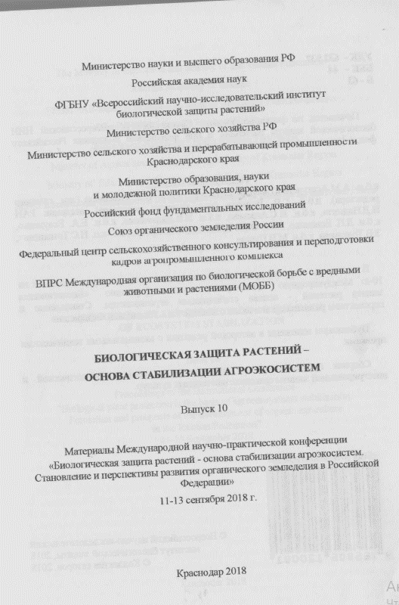

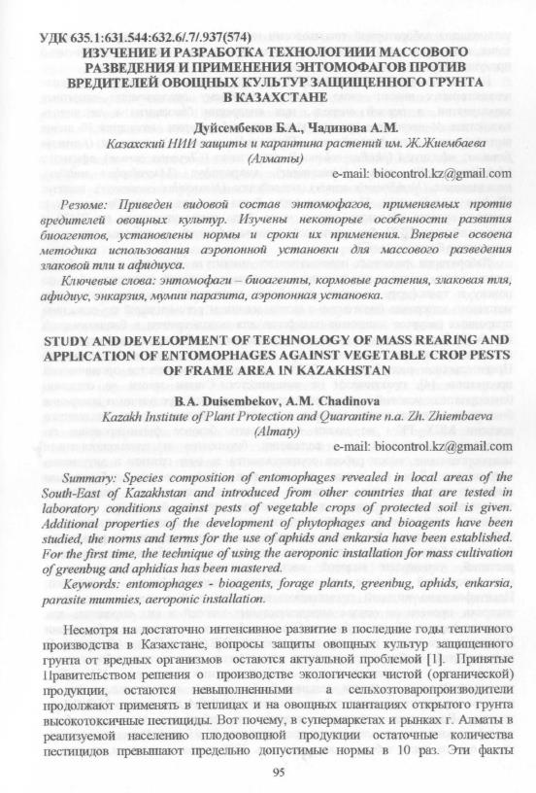

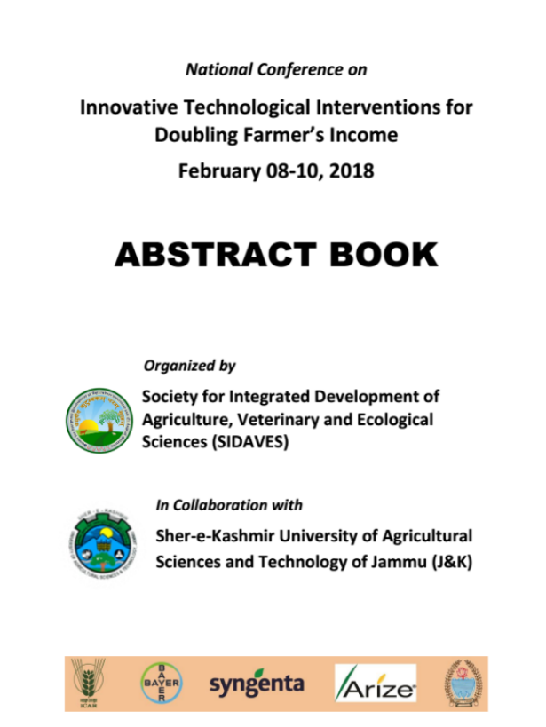

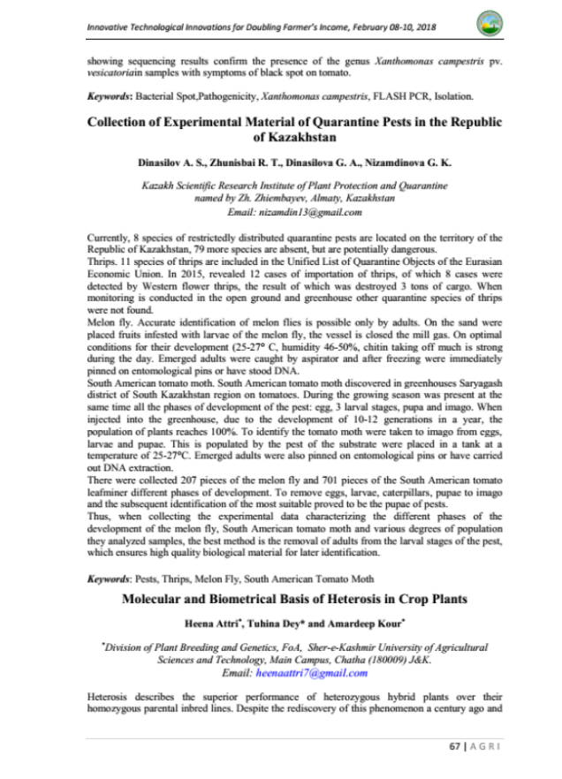
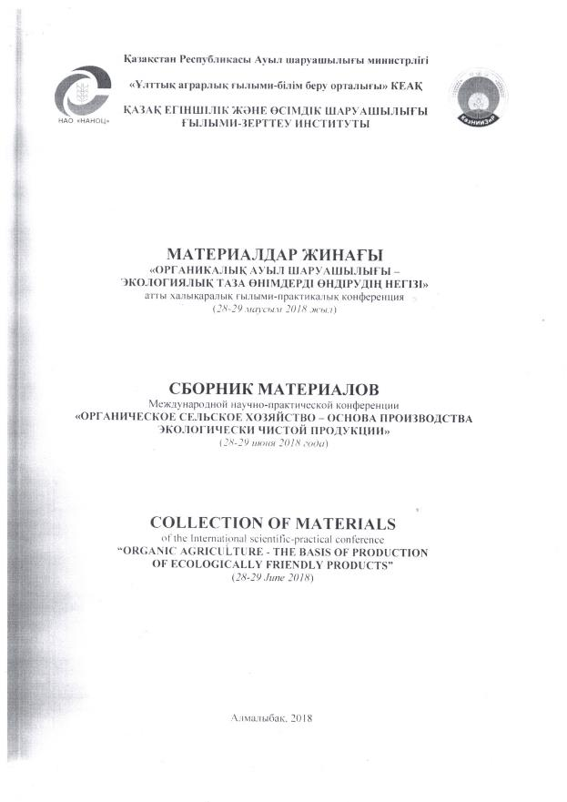
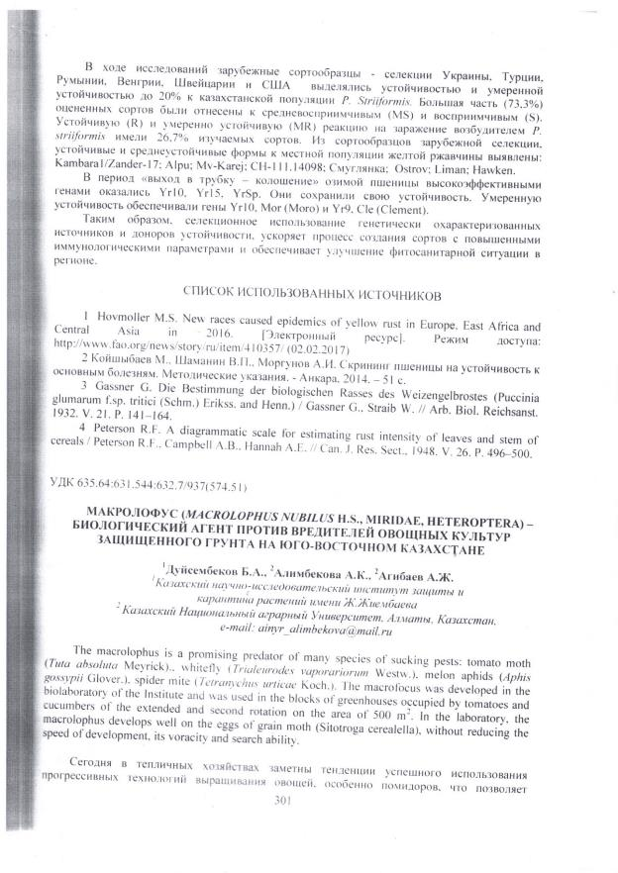

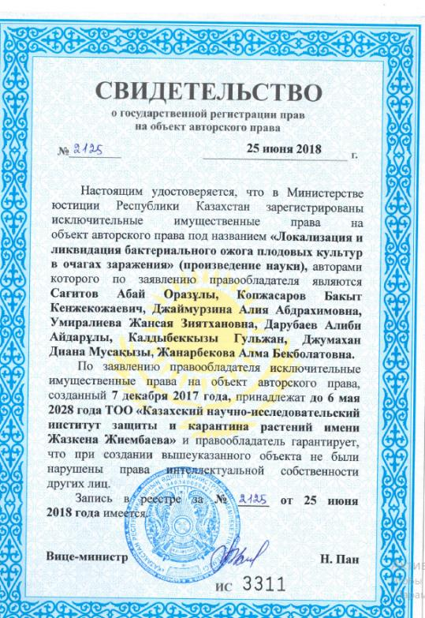

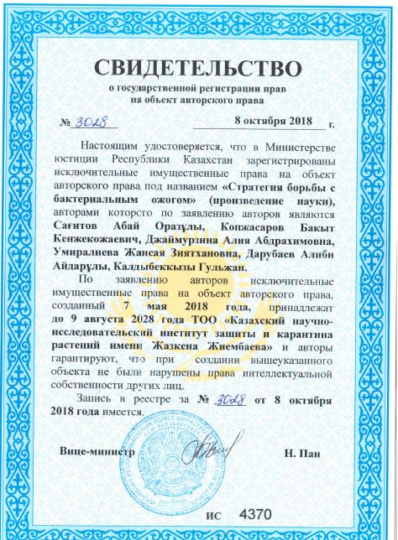



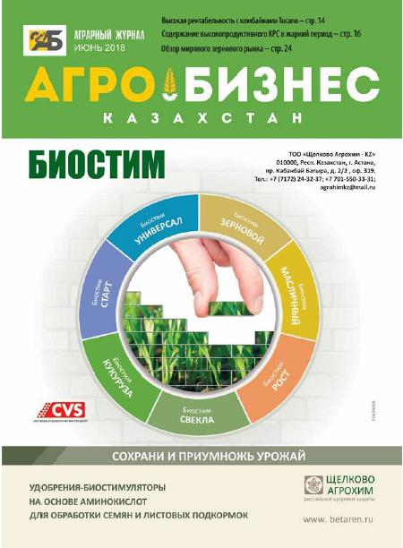

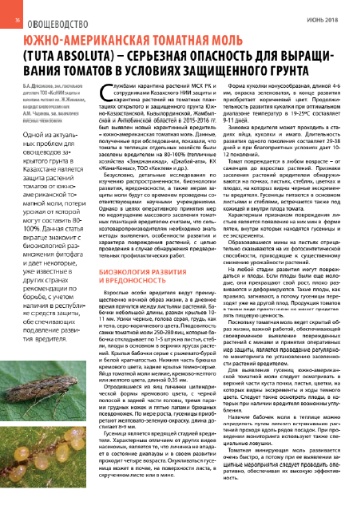

КОПИИ ДОКУМЕНТОВ, ПРОВЕДЕННЫХ СЕМИНАРОВ, КРУГЛЫХ СТОЛОВ

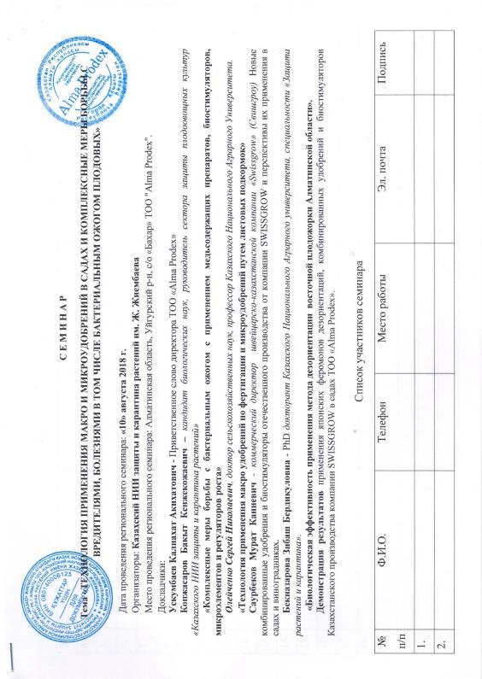

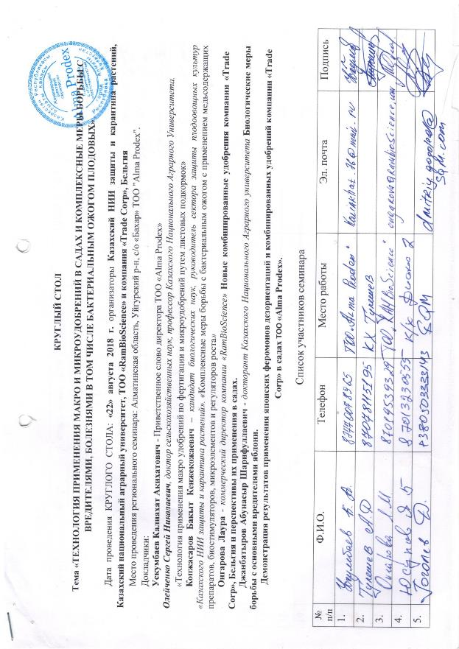

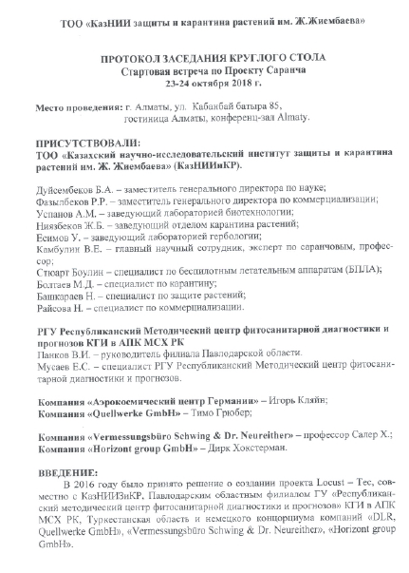

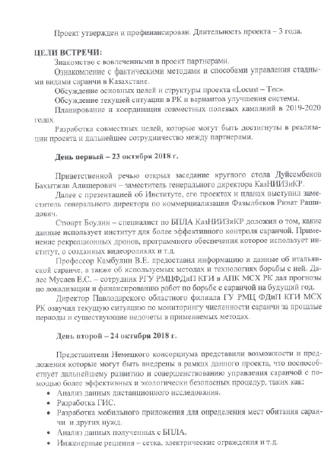

List of published scientific works in 2019

1 A.A. Darubaev, B.K. Kopzhasarov, A.A. Seisenova, G. Kaldybekkyzy, Z.B. Beknazarova, D.E. Kaldybek. Biological effectiveness of Cupromax preparation against bacterial fire blight of apples in Almaty conditions // International departmental scientific-practical conference "Science, production, business: current status and ways of innovative development of the agricultural sector on the example of Agroholding "Baiserke-Agro", dedicated to the 70th anniversary of Dosmukhambetov Temirkhan Minaidarovich. Almaty, 2019. p. 249-251. (Дарубаев А.А., Копжасаров Б.К., Сейсенова А.А., Калдыбеккызы Г., Бекназарова З.Б., Калдыбек Д.Е. Алматы жағдайында алманың бактериалық күйік ауруына қарсы купромакс препаратының биологиялық тиімділігі // Мат. межд. науч.-практич.конф. «Наука, производство, бизнес: современное состояние и пути инновационного развития аграрного сектора на примере Агрохолдинга «Байсерке-Агро», посвященной 70-летию Досмухамбетова Темирхана Мынайдаровича». – Алматы, 2019. -С. 249-251.)
2 Christina Schuster, Saikal Bobushova, Zhansaya Umiralieva, Mahabat Konurbaeva, Alia A. Dzhajmurzina, Bakyt Kopzhasarov, Alibek M. Uspanov, Bakhytzhan A. Duisembekov, Tinatin Doolotkeldieva, Andreas Leclerque. Isolation and molecular identification of Erwinia amylovora bacteria from Central Asia/VAAM (Association for General and Applied Microbiology) Annual Conference in Mainz. – Germany, 2019.
3 Umiralieva Zh., Dzhajmurzina A., Kopzhasarov B. The effectiveness of copper-containing fungicides against the pfthogen of bacterial fire blight Ervinia amylovora. - 2nd International Symposium on Fire Blight of Rosaceous Plants.- Traverse City, Michigan, USA.- 2019.- P.67-69.
4 Ismailova E., Sadanov A., Alimzhanova M., Shemshura O., Molzhigitova A., Kebekbaeva K., Zhanarbekova A. Lactobacillus biocontrol strains active against fire blight in Kazakhstan. - 2nd International Symposium on Fire Blight of Rosaceous Plants.- Traverse City, Michigan, USA.- 2019.- P.70-73.
5 Chadinova, A.M.; Alimbekova, A.K.; Shanimov, H.I.; Duisembekov, B.A. Harmfulness of the South American tomato moth (Tuta absoluta Polovny) in the tomatoes of Kazakhstan and protection measures against it // Collection of abstracts of the IV All-Russian Congress on Plant Protection. St. Petersburg, Russia, 2019. p.150. (Чадинова А.М., Алимбекова А.К., Шанимов Х.И., Дуйсембеков Б.А. Вредоносность южноамериканской томатной моли (Tuta absoluta) в посевах томатов Казахстана и меры защиты от нее // Сборник тезисов докладов IV Всероссийский съезд по защите растений. – Санкт-Петербург, Россия, 2019. – 150 С.

6 A.M. Uspanov, A.S. Dinasilov Plant quarantine in Kazakhstan // Reports of the International Scientific and Practical Conference "Actual problems of plant quarantine and protection". - Bykovo, Russia, 2019. p. 27-30. (Успанов А.М., Динасилов А.С. Карантин растений в Казахстане //Тезисы докладов Международной научно-практической конференции «Актуальные проблемы карантина и защиты растений». – Быково, Россия, 2019. – С. 27-30.)
7 Duisembekov B.A., Alimbekova A.K., Agibaev A.J., Alpysbaeva K.A. // Macrolophos nubilus H.S. (Heteroptera: Miridae) determination of optimal mass cultivation parameters // Surveys, Results, № 3 (83). Almaty, 2019, pp. 321-326. (Дуйсембеков Б.А., Алимбекова А.К., Агибаев А.Ж., Алпысбаева К.А. // Macrolophos nubilus H.S. (Heteroptera: Miridae) жаппай өсіруге оңтайлы параметрлерін анықтау // Ізденістер, Нәтижелер.– Алматы, 2019. -№ 3 (83). - Б. 321-326.)
8 Alimbekova A. K. / / Macrolophos nubilus H.S. (Heteroptera: Miridae) technology of mass reproduction/ / searches, results, No. 4 (84). Almaty, 2019, pp. 265-273. (Алимбекова А.К. // Macrolophos nubilus H.S. (Heteroptera: Miridae) жаппай өсіру технологиясы// Ізденістер, Нәтижелер.– Алматы, 2019. - № 4 (84). – Б.265-273.)
9 O.Kh. Khamdieva, G.T. Zhamanbaeva, G.E. Berganaeva Identification of bacterial fire blight Erwinia amylovora by Real-Time PCR. Collection of materials from the International Scientific and Practical Conference "Science, Production, Business: Modern state and ways of innovative development of agrarian sector on the example of "Baiserke-Agro" Agro Holding. Almaty. 2019. p. 188-191. (Хамдиева О.Х., Жаманбаева Г.Т., Берганаева Г.Е. Идентификация бактериального ожога Erwinia amylovora методом Real-Time ПЦР. Сборник материалов Международной научно-практической конференции «Наука, производство, бизнес: Современное состояние и пути инновационного развития аграрного сектора на примере Агрохолдинга «Байсерке-Агро». – Алматы, 2019. - С. 188-191.)

List of seminars and field days held
1 Pests and diseases of fruit-bearing orchards and nurseries and measures to control them. Suzdalev Agricultural Centre, Almaty. 05.02.2019 (Вредители и болезни плодоносящих садов и питомников и меры борьбы с ними. к/х Суздалева. - Алматы. 05.02.2019)
2 Fruit and vegetable growing and new technologies. Green Technology Centre, Akchi Secondary School, Almaty Oblast. USAID. 28.02-1.03.2019 (Плодоовощеводство и новые технологии. Центр зеленых технологий, Средняя школа п. Акчи, Алматинская область. USAID. 28.02-1.03.2019)
3 Fruit and vegetable growing and new technologies. Taraz, 27 Akbozova St., Aisha Deluxe Hotel. USAID. 4-5.03.2019. (Плодоовощеводство и новые технологии. г. Тараз, ул. Акбозова, 27, гостиница Айша делюкс. USAID. 4-5.03.2019.)
4 Fruit and vegetable growing and new technologies. Shymkent, 17 Adirbekova St., Dostyk Hotel. USAID. 6-7.03.2019 (Плодоовощеводство и новые технологии. г. Шымкент, ул. Адирбекова 17, гостиница Достык. USAID. 6-7.03.2019)
5 Agrotechnical maps for orchards, vineyards and vegetables: new trends, cultures and organics. Almaty, Shymkent, Taraz. USAID, Social Farm, KazRIACP and KR. 18-19 March, 2019. (Агротехкарты для садов, виноградников и овощей: новые тренды, культуры и органика. Алматы, Шымкент, Тараз. USAID, Social Farm, КазНИИЗ и КР. 18-19 Март, 2019.)
6 New trends, protection technologies in gardens and comprehensive pest and disease control measures, including bacterial fire blight of fruit. Almaty oblast, Uigur region, Chunzha. USAID, Social Farm, KazRIACP and RK. 18-19.03.2019 (Новые тренды, технологии защиты в садах и комплексные меры борьбы с вредителями, болезнями в том числе с бактериальным ожогом плодовых. Алматинская область, Уйгурский р.-н, г.Чунжа. USAID, Social Farm, КазНИИЗ и КР. 18-19.03.2019)
7 The use of insectopathogenic bacteria, bacterial entomotoxins and bacteriphages for more environmentally friendly and sustainable protection. Аlmaty. KazRIACP and RK. 2.04.2019 (Применение инсектопатогенных бактерий бактериальных энтомотоксинов и бактерифагов для более экологичной и устойчивой защиты. Алматы. КазНИИЗ и КР. 2.04.2019)
8 Identification and control of pests and diseases in fruit crops, including bacterial fire blight. Almaty Oblast, Enbekshikazakh region, Turgeny village, Bolek. KazRIACP and RK, firm BASF. 29-30.05.2019 (Определение вредителей и болезней плодовых культур и меры борьбы с ними, в том числе с бактериальным ожогом. Алматинская область, Енбекшиказахский район, поселок Тургень, Болек. КазНИИЗ и КР и фирма БАСФ. 29-30.05.2019)
9 Original technology for creating intensive, scale-free gardens on medium-sized stockings and comprehensive pest and disease control measures in gardens, including bacterial fire blight of fruit. Almaty Oblast, Uyghur region, Bahar village. ТОО Alma Prodex. КаzNAU, KazRIACP and RK, NPP RK Atameken. 23.08.2019 (Оригинальная технология создания интенсивных, без шпалерных садов на среднерослых подвоях и комплексные меры борьбы с вредителями, болезнями в садах в том числе с бактериальным ожогом плодовых. Алматинская область, Уйгурский район, п.Бахар ТОО Alma Prodex. КазНИИЗиКР, НПП РК Атамекен. 23.08.2019)

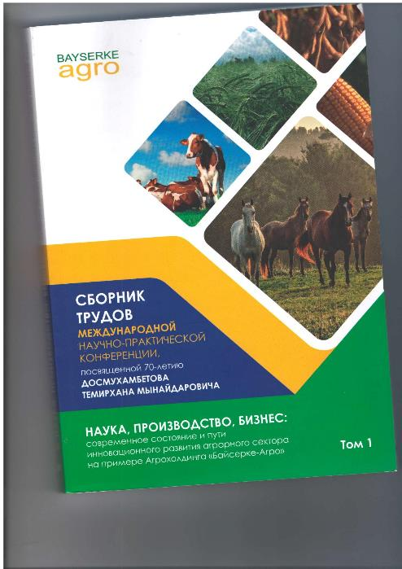

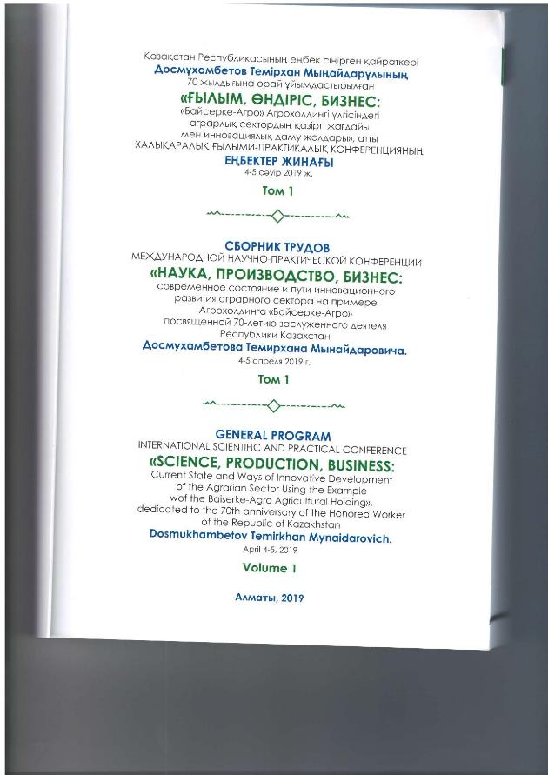

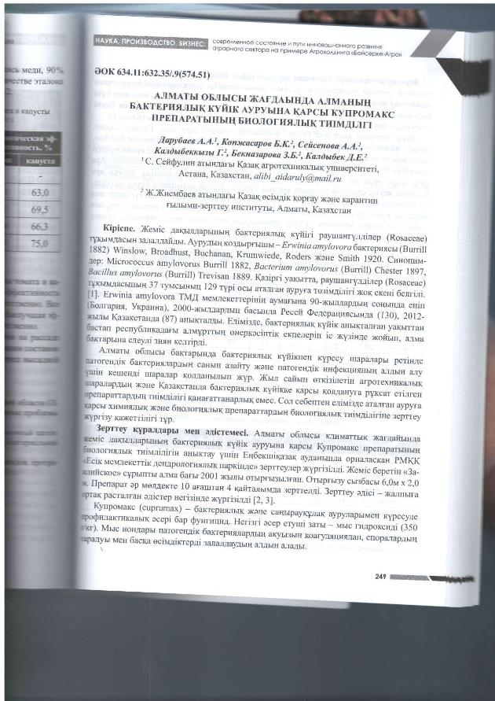

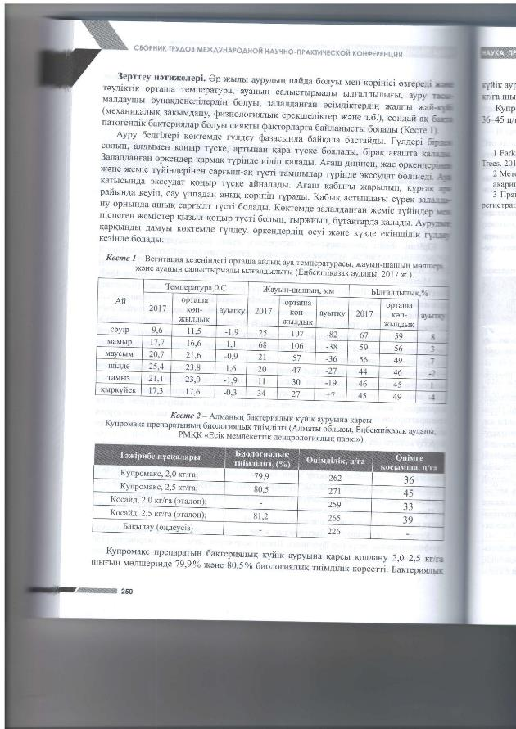

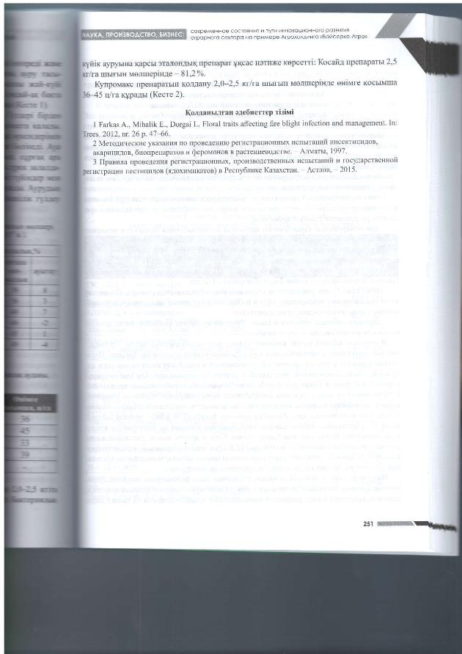

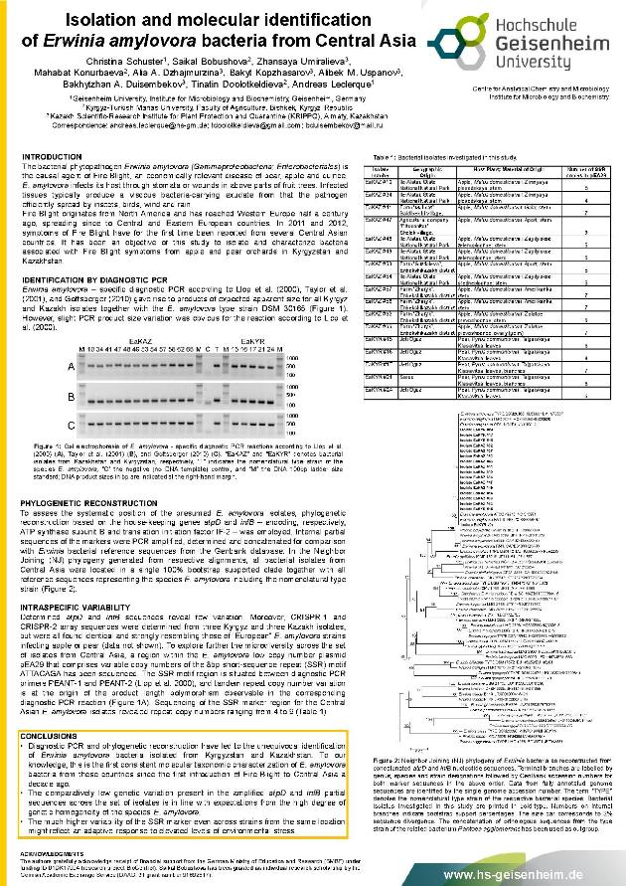

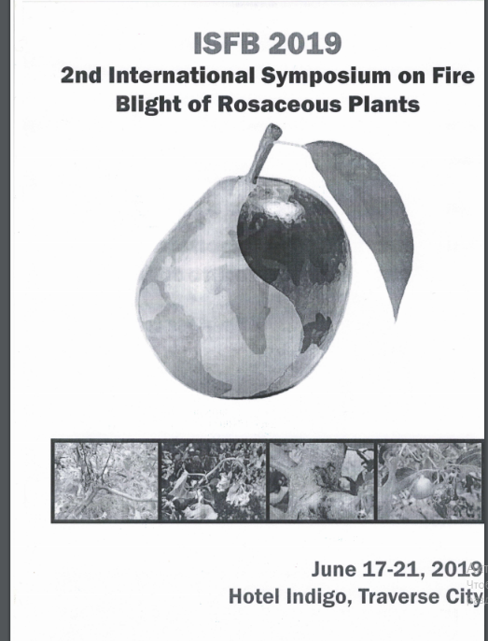

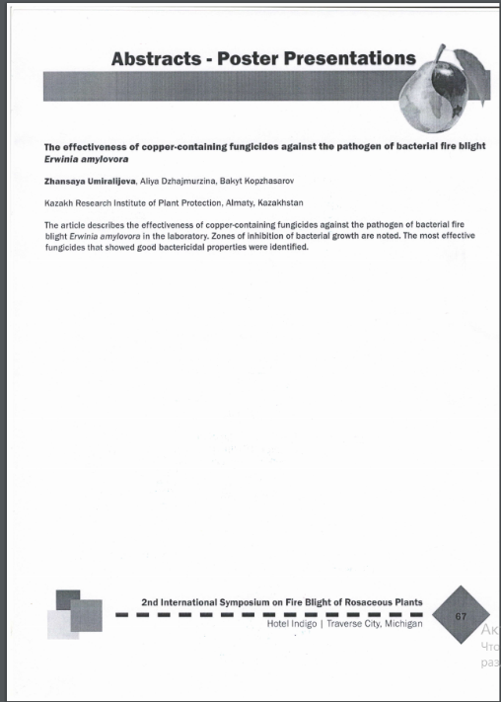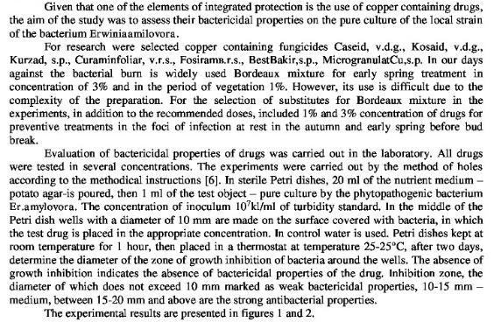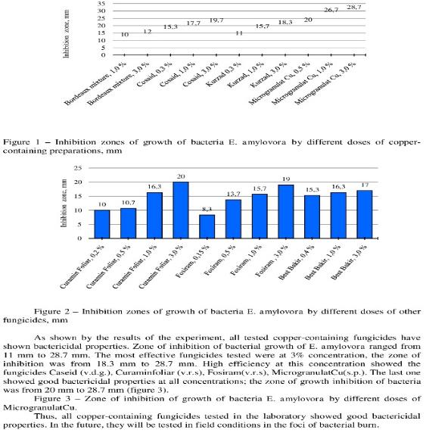

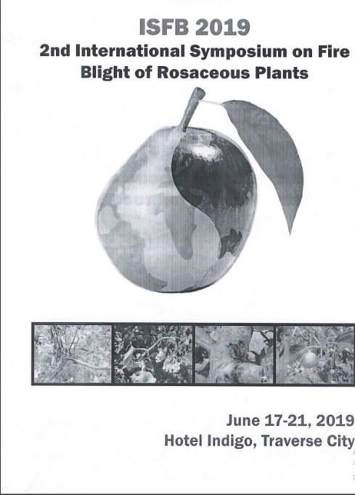

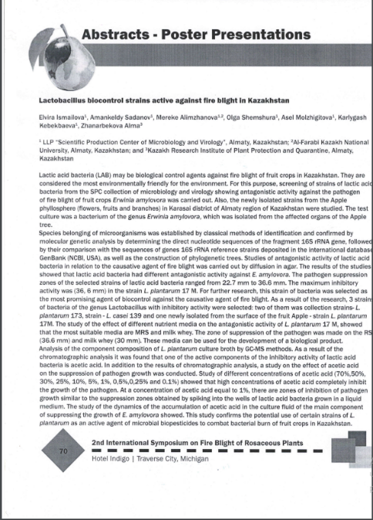
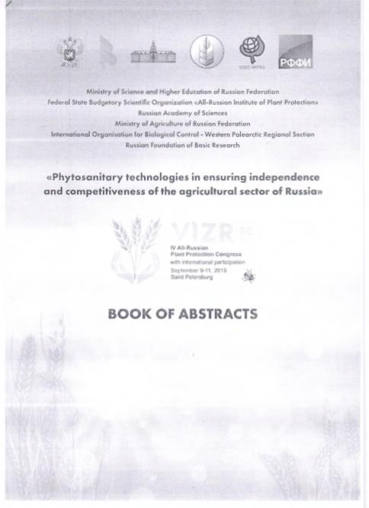
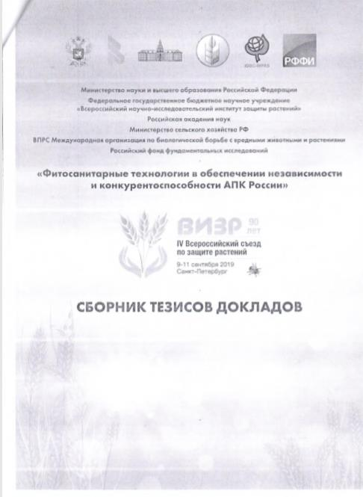

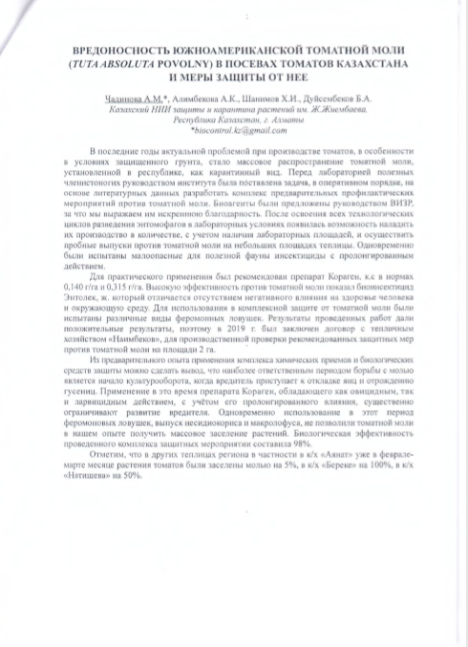

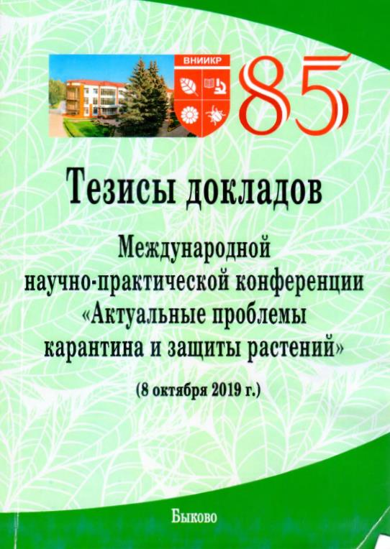
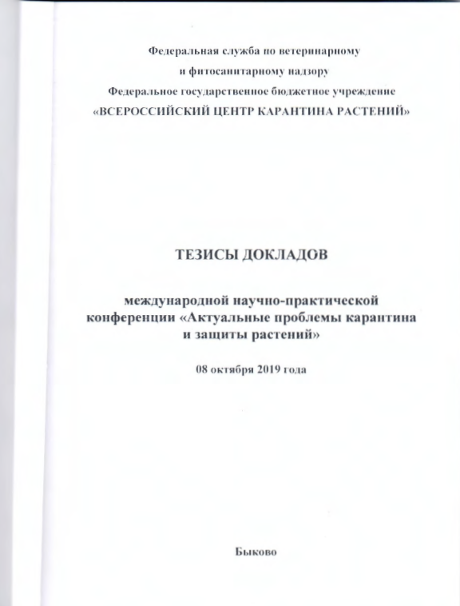
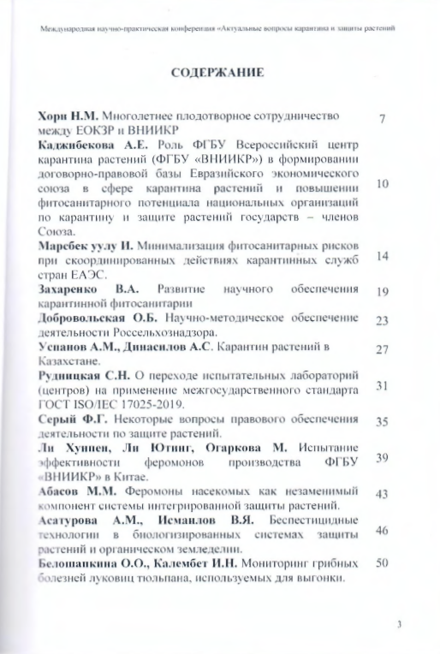
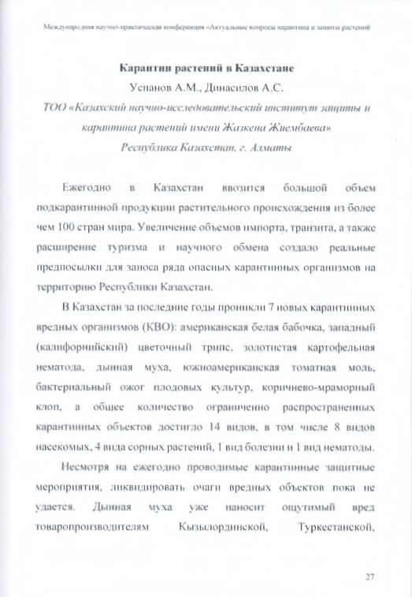
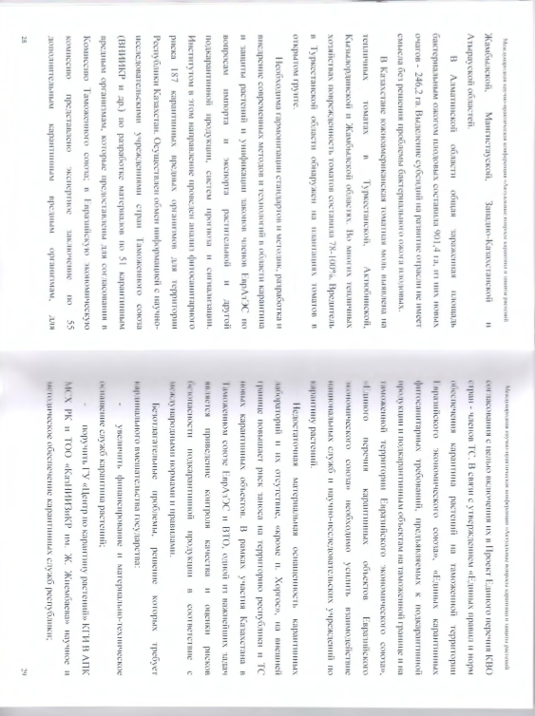
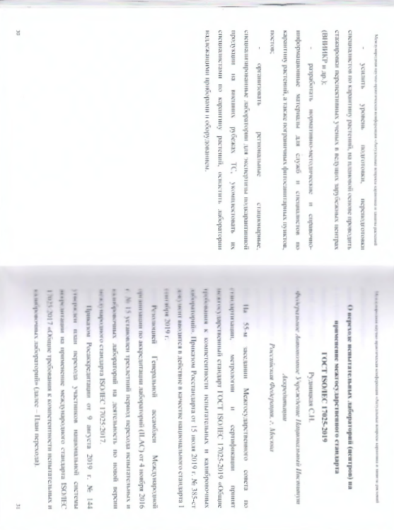

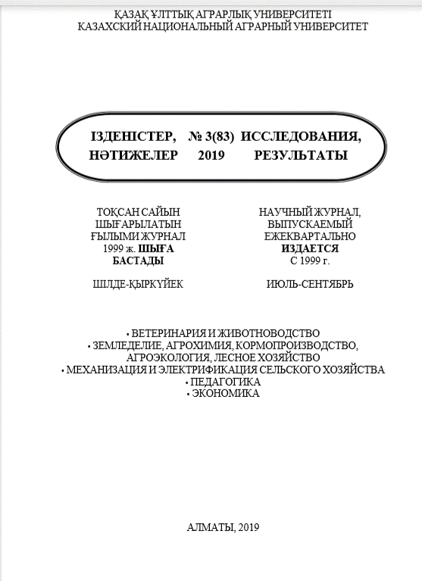

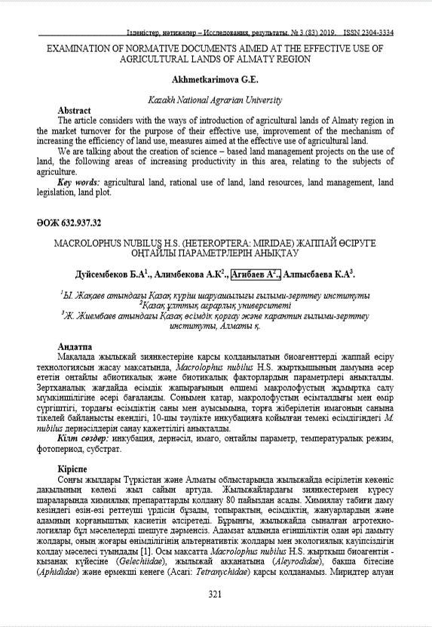
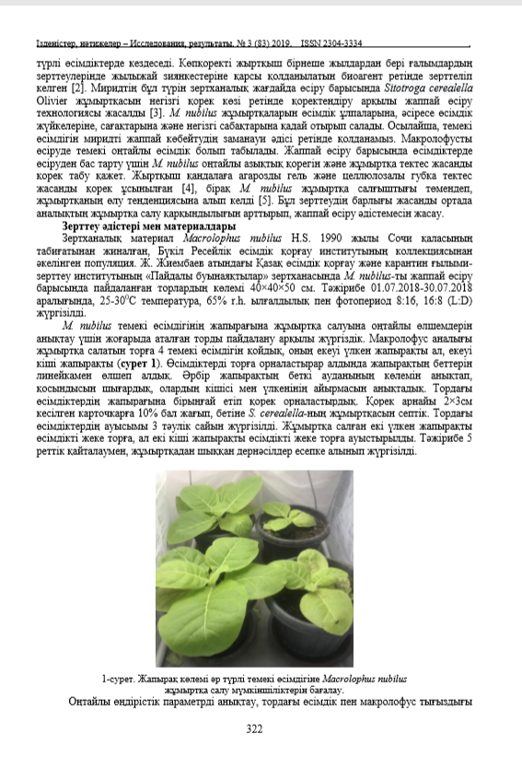
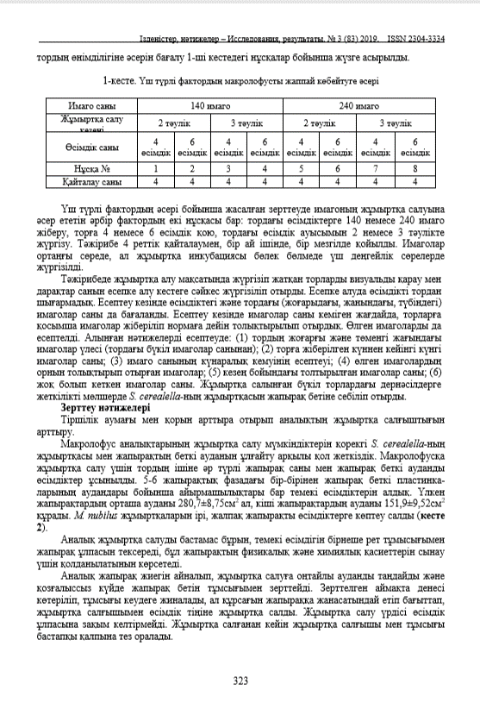
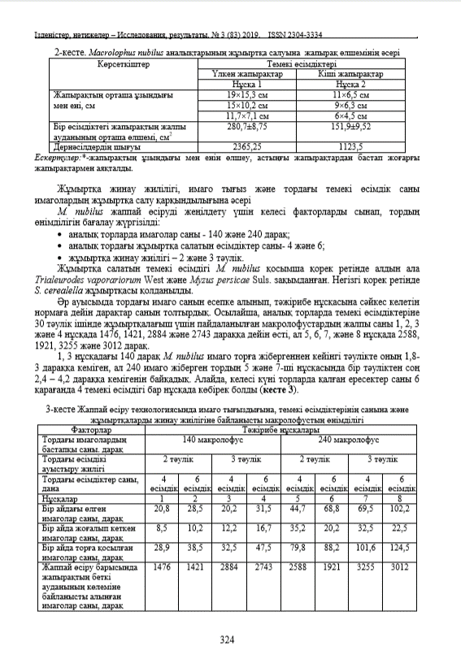
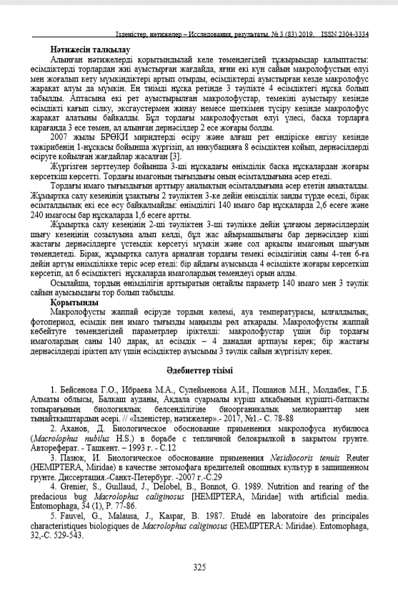
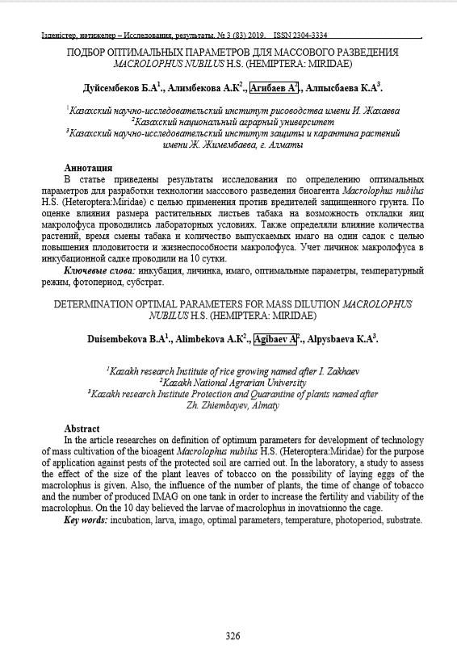

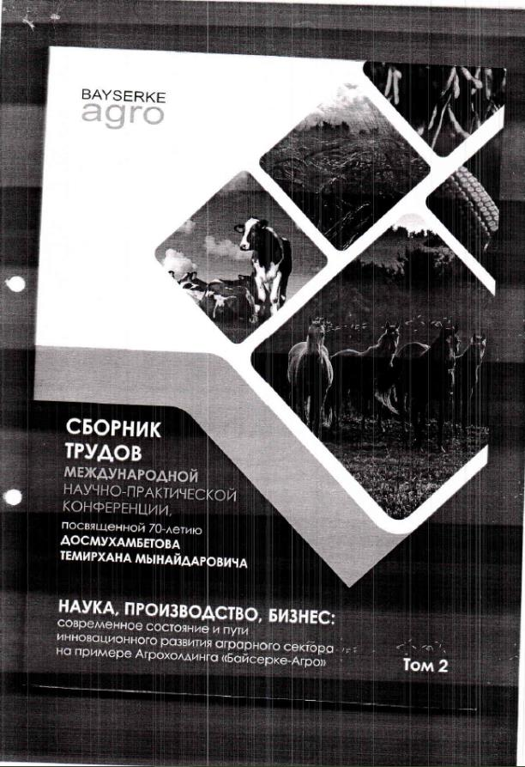
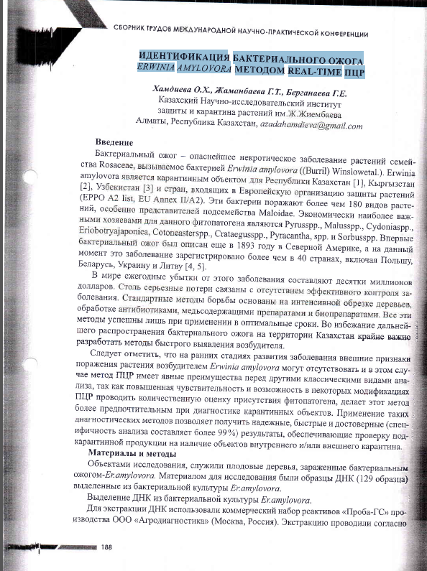

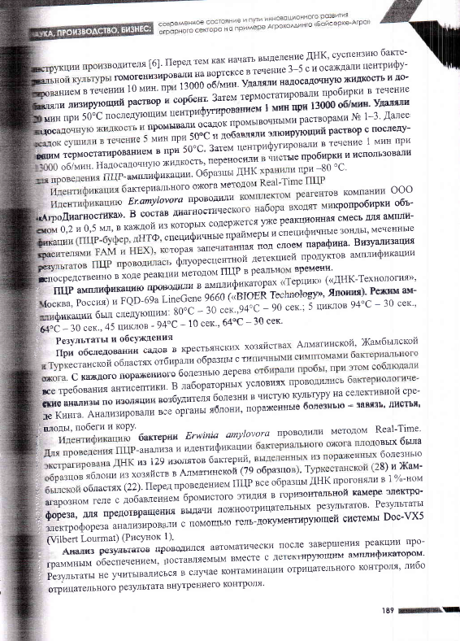

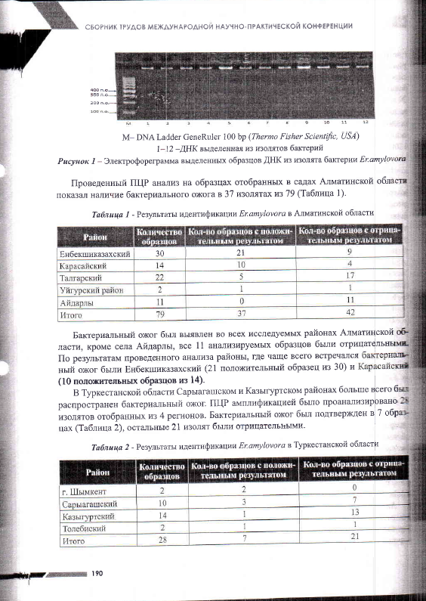

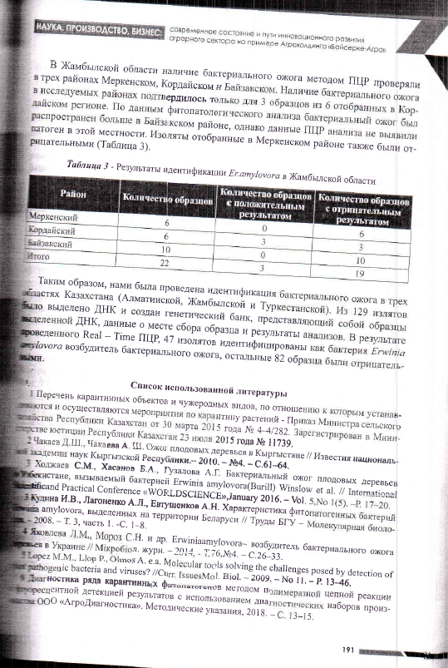

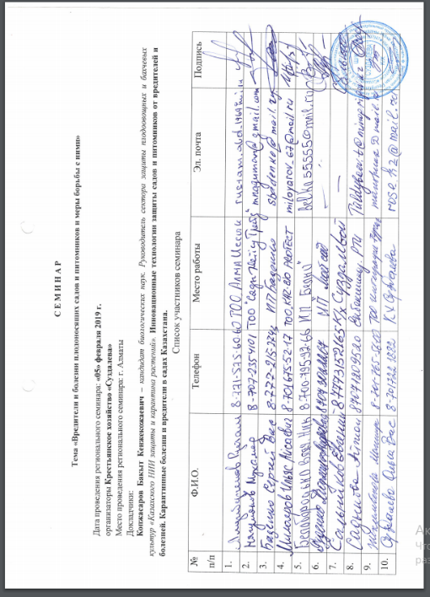

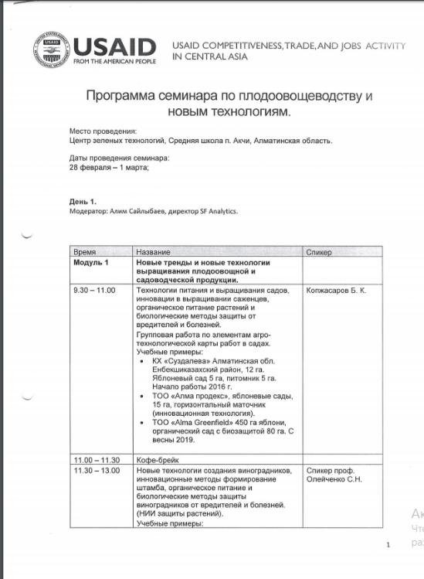


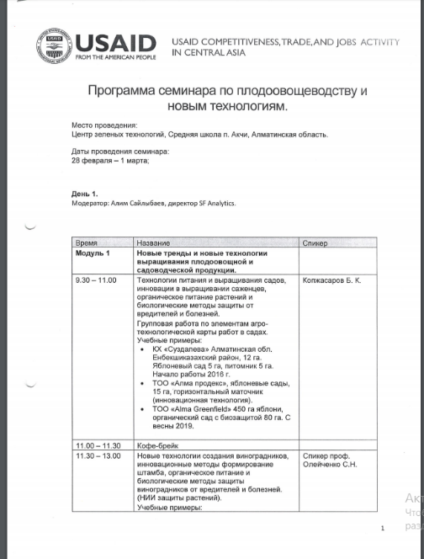
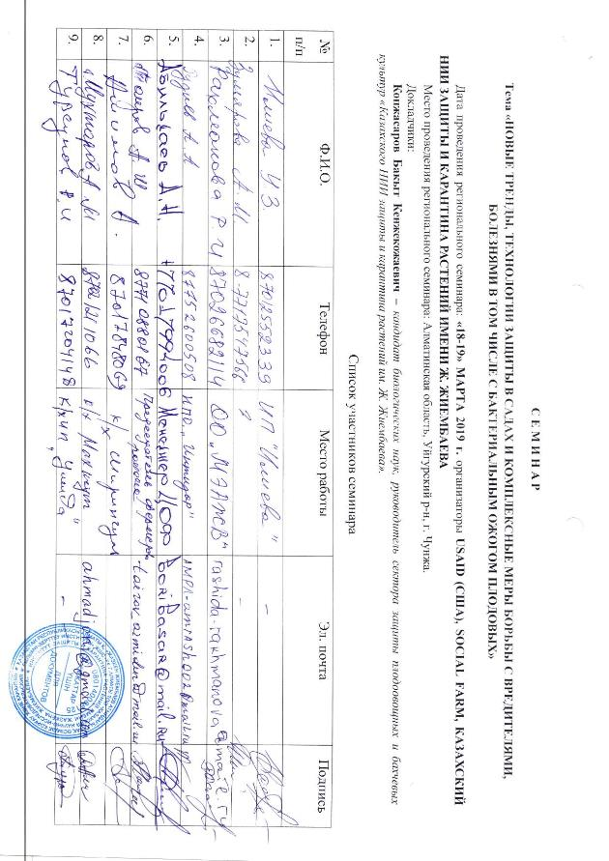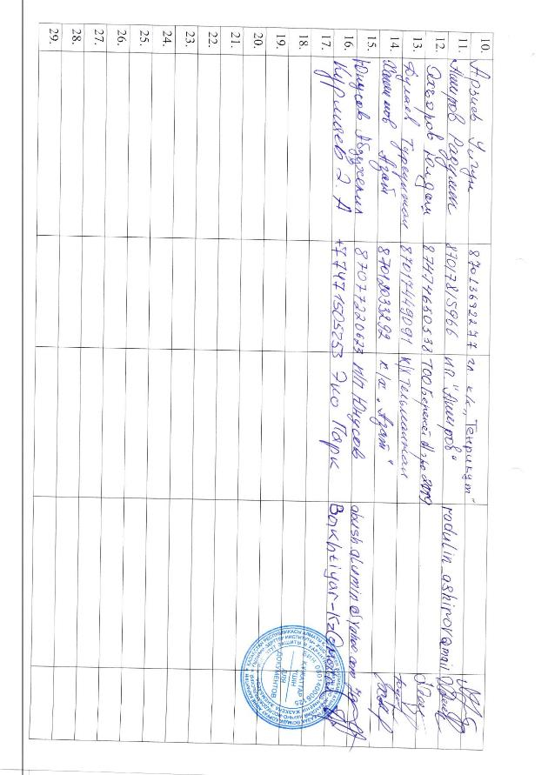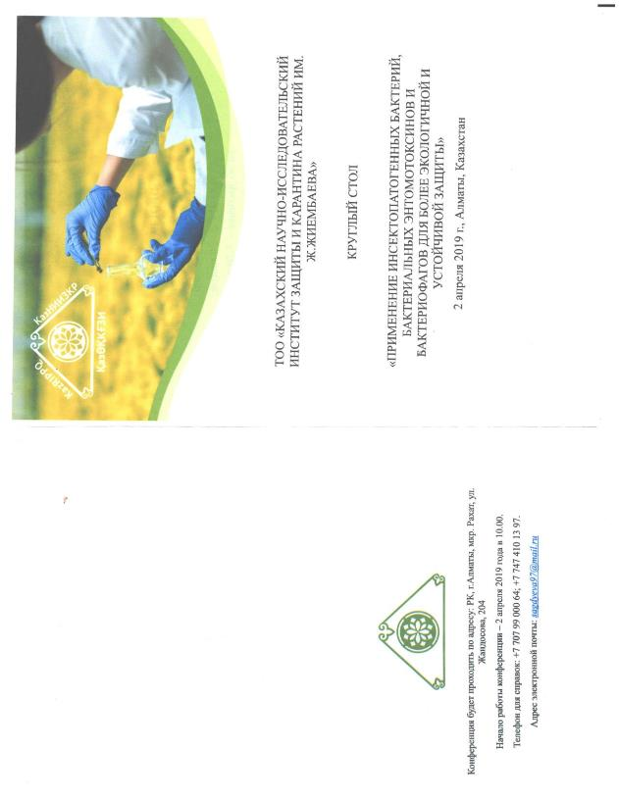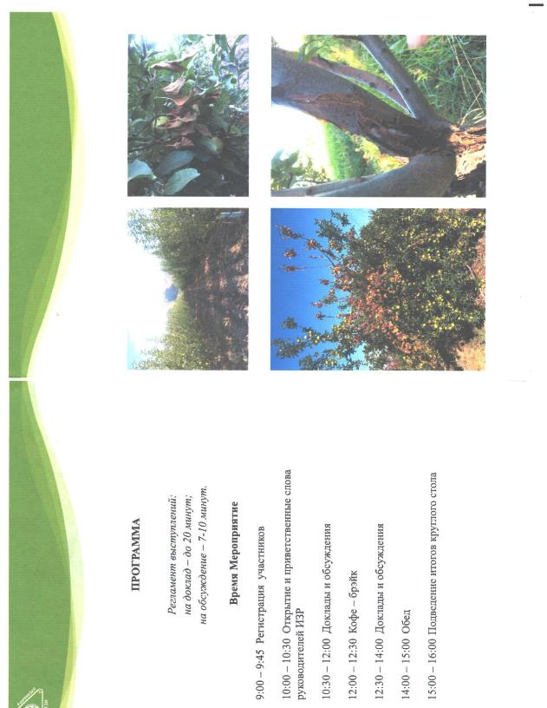

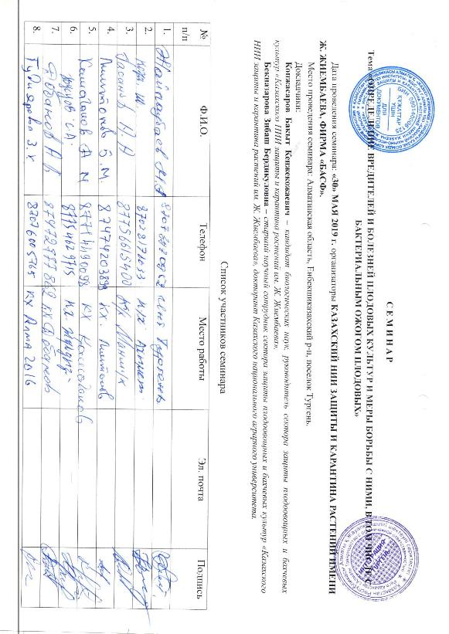 . 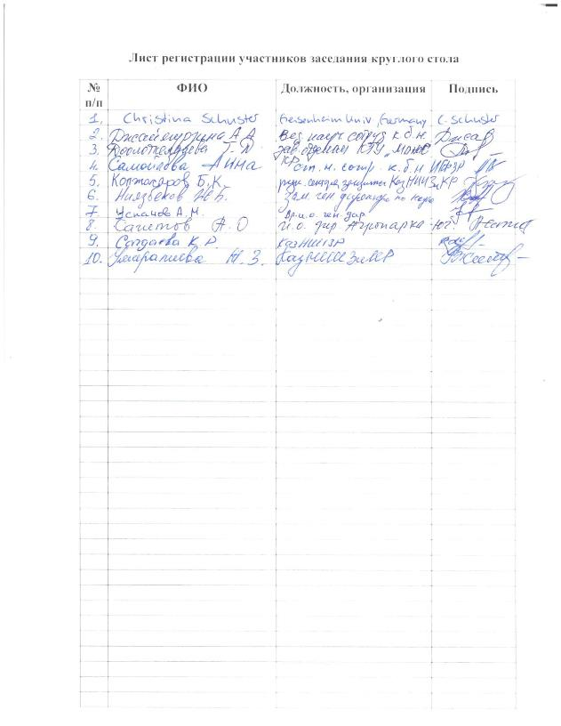

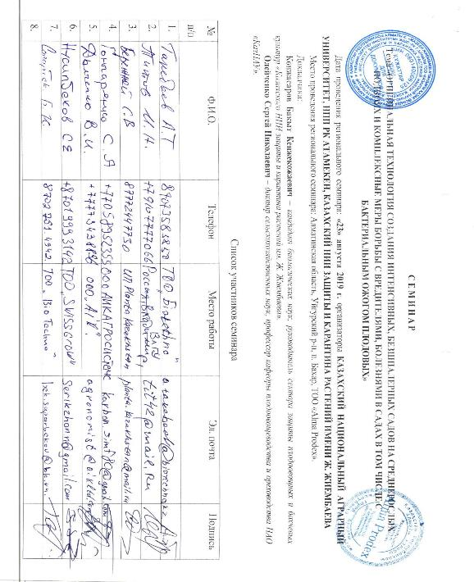
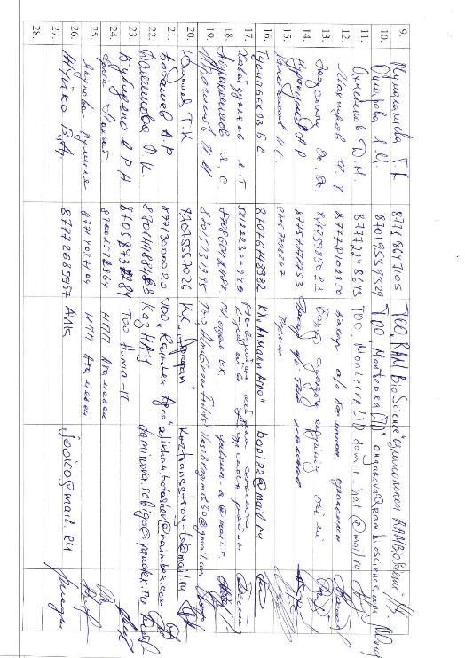

List of published scientific works, media and events held in 2020

1 А.К. Alimbekova, B.А. Duisembekov, L.K. Esengeldieva, A.M. Chadinova, K.T. Kurmanova Monitoring and assessment the efficiency of traps for mass capture Tuta absoluta (Povolny) (Lepidoptera: Gelecheiidae) pest of tomato culture breeding in out of bounds area (Solanum lycopersicum) // Izvestia NAS RK. Series of Agrarian Sciences. № 2 (56), 2020. p. 5-13.
2 Boltaev M.D., Kambulin V.E., Khidirov K.R, Esimov U.O., Bashkaraev N.A. To the Moroccan locust survey technique by unmanned aerial vehicle. // Serarch / POISK Almaty. № 2. 2020. p. 217-221. (Болтаев М.Д., Камбулин В.Е., Хидиров К.Р., Есимов У.О., Башкараев Н.А. К методике обследования мароккской саранчи беспилотным летательным аппаратом // ІЗДЕНІС / ПОИСК. – Алматы, 2020. – № 2. – С. 217-221.)
3 Boltaev M.D., Kambulin V.E., Khidirov K.R, Esimov U.O., Bashkaraev N.A. Results of Application of Geoinformation Technologies and Unmanned Aircraft for Identification of Moroccan Locust Larvae // Search / POISK – Almaty. № 2. 2020. p. 222-228. (Болтаев М.Д., Камбулин В.Е., Хидиров К.Р., Есимов У.О., Башкараев Н.А. Результаты применения геоинформационных технологий и беспилотного летательного аппарата для выявления личинок мароккской саранчи // ІЗДЕНІС / ПОИСК – Алматы, 2020. – № 2. – С. 222-228.)
4 Eszhanov T.K., Chadinova A.M, Zhamalbekova A.A. Zhunusova A.S. Efficiency of application of chemical means of protection of plants in struggle against the South American tomato moth (Тuta absoluta Рovolny) // International scientific-practical conference devoted to the 90th anniversary of the Department of "Fruit and Vegetable Growing and Nut Cultivation" of the Agrobiological Faculty of the Kazakh National Agrarian University, Almaty // "Modern condition and prospects of development of branches of fruit and vegetable growing", 2020 p. 136-140. (Есжанов Т.К., Чадинова А.М., Жамалбекова А.А. Жунусова А.С. Эффективность применения химических средств защиты растений в борьбе с южноамериканской томатной молью (Тuta absoluta Рovolny) // Международная научно-практическая конференция, посвященной 90-летию кафедры «Плодоовощеводства и ореховодства» Агробиологического факультета Казахского национального аграрного университета» «Современное состояние и перспективы развития отраслей плодоводства и овощеводства». - Алматы, 2020 - С. 136-140.)
5 Beknazarova Z. B., Kopzhasarov B. K., Zhunusova A. S.,Alimkulova M. K., on the topic: «Indicators of the amount of heat and the set of optimal temperatures required for the development stages of the initial fruits» // Researches, Results. – Almaty. 2020. №1. – p.273-278 (Бекназарова З.Б., Копжасаров Б.К., Жунусова А.С.,Алимкулова М.К., на тему: «Шығыс жеміс жемірінің даму кезеңдеріне қажетті тиімді температуралар жиынтығы мен жылу мөлшері көрсеткіштері» // Исследования, Результаты. – Алматы. – 2020, №1. – С.273-278)
6 Beknazarova Z.B., Kopzhasarov B.K., Iskendirova R.A., Esirkepov U.S., Kanatova M.K. New method of protecting apple orchards from eastern fruit pests // Researches, results. Almaty. 2020. №2. p. 229-236. (Бекназарова З.Б., Копжасаров Б.К., Искендирова Р.А., Есіркепов У.Ш., Қанатова М.Қ. Алма бақтарын карантинді зиянкес шығыс жеміс жемірінен қорғаудың жаңа әдісі // Исследования, результаты. – Алматы, 2020. - №2. - С. 229-236.)
7 Beknazarova Z.B., Kopzhasarov B.K., Dinasilov A.S. Californian shield dangerous quarantine pest of a fruit garden in the south-east of Kazakhstan // Izvestia NAS RK, series of biological and medical sciences. Almaty. 2020. №4. p. 5-10. (Бекназарова З.Б., Копжасаров Б.К., Динасилов А.С. Калифорнийская щитовка опасный карантинный вредитель плодового сада на юго-востоке Казахстана // Известия НАН РК, серия биологических и медицинских наук. - Алматы. – 2020, №4. - С. 5-10.)
in international publications:
Scientific articles with impact factor
1. Afonin, A.N., Kopzhassarov B.K., Sarbassova A.M., Seisenova A.A. Spatial predictive system of pest development in real time in Kazakhstan // Applied Ecology and Environmental Research // Hellenic Plant Protection Journal. - 2020. - №13. DOI 10.2478/hppj-2020-00. IF – 0.4, процентил – 46,67%.
2. Bożena Łozowickaa, Piotr Kaczyńskia,*, Patrycja Mojsaka, Julia Rusiłowskaa, Zibash Beknazarovab, Gulzhakhan Ilyasovac, Damira Absatarovad. Systemic and non-systemic pesticides in apples from Kazakhstan and their impact on human health. Journal of Food Composition and Analysis journal (www.elsevier.com/locate/jfca). - 2020 г. 90(103494) (IF – 3.721, percentage 86%).
3. An article was presented with the impact factor, Umiralieva Zh.Z.1, Kopzhasarov B.K.1, Dzhaimurzina A.A.1, Niyazbekov Zh.B.1, Isenova G.D.1, Tursunova A.K.1, Berganaeva G.E, "Epidemiology of bacterial blight in Kazakhstan" (Подана статья с импакт-фактором, Умиралиева Ж.З.¹, Копжасаров Б.К.¹, Джаймурзина А.А.¹, Ниязбеков Ж.Б.¹, Исенова Г.Д.¹, Турсунова А.К.¹, Берганаева Г.Е, «Эпидемиология бактериального ожога в Казахстане»)
Recommendations, laboratory regulations:
1 ISBN 978-601-7181-11-6 Kopzhasarov B.K., Dzhaimurzina A.A., Umiralieva Z.Z., Beknazarova Z.B. Complex measures against bacterial fire blight. Recommendation. Almaty 2020. p.21. (ISBN 978-601-7181-11-6 Копжасаров Б.К., Джаймурзина А.А., Умиралиева Ж.З., Бекназарова З.Б. Комплесные меры борьбы с бактериальным ожогом. Рекомендация. – Алматы, 2020. – 21с.)
2 ISBN 978-601-7181-10-9 A.O. Sagitov, B.A. Duisembekov, A.M. Chadinova, H.I. Shanimov, and A.K. Alimbekova, A.S. Dinasilov. Recommendations on Measures to Combat South American Tomato Moth (Tuta absoluta Povolny) on Protected Ground Tomatoes and Mass Breeding and Application of (Macrolophus Nubilis H.S.) and (Nesidiocoris Tenuis Reuter) Entomophages. Recommendation. - Almaty. 2020. 34p. (ISBN 978-601-7181-10-9 Сагитов А.О., Дуйсембеков Б.А., Чадинова А.М., Шанимов Х.И., Алимбекова А.К., Динасилов А.С. Рекомендации по мерам борьбы с южноамериканской томатной молью (Tuta absoluta Povolny) на томатах защищенного грунта и массовому разведению и применению энтомофагов макролофуса (Macrolophus nubilis H.S.) и несидиокориса (Nesidiocoris tenuis Reuter). Рекомендация. – Алматы, 2020. – 34с.)
3 ISBN 978-601-7181-12-3 Kambulin V.E., Yskak S., Uspanov A.M., Niyazbekov J.B., Esimov U.O., Boltaev M.D., Yermekbaev B.U., Bashkarayev N.A., Nurmanov J.Ғ. Recommendations for use of unmanned aerial vehicles (UAVs) for phytosanitary monitoring of locust herd larvae / Almaty, 2020. p. 22. (3 ISBN 978-601-7181-12-3 Камбулин В.Е., Ыскак С., Успанов А.М., Ниязбеков Ж.Б., Есимов У.О., Болтаев М.Д., Ермекбаев Б.У., Башкараев Н.А., Нурманов Ж.Ғ. Рекомендации по применению беспилотных летательных аппаратов (БПЛА) для фитосанитарного мониторинга личинок стадных саранчовых.- Алматы, 2020. – 22 с.)
Patents:
1 A method to protect seed gardens from apple (Laspeyresia Pomonella l.) and Eastern (Grapholita molesta Busck.) fruit. 2019/1030.2. of 25 November 2020. (1 Пат.Ресрублика Казахстан 5375. Способ защиты семечковых садов от яблонной (Laspeyresia Pomonella l.) и восточной (Grapholita molesta Busck.) плодожорки / Копжасаров Б.К., Джаймурзина А.А., Умиралиева Ж. З., Бекназарова З.; заявлено 2019/1030.2. от 25 ноября 2020)
Application for a patent of the Republic of Kazakhstan for a utility model:
1 Application No. 2020/0828.2, .2020 "Method of complex measures to combat quarantine disease of bacterial fire blight in fruit crops" was submitted. Authors: Dzhaimurzina A.A., Kopzhasarov B.K., Uspanov A.M., Umiralieva Zh. Z., Eszhanov T.K., Beknazarova Z.B. (Подана заявка «Способ комплексных мер борьбы с карантинным заболеванием бактериальным ожогом плодовых культур» № 2020/0828.2, .2020 г.. Авторы: Джаймурзина А.А., Копжасаров Б. К., Успанов А. М., Умиралиева Ж. З., Есжанов Т. К., Бекназарова З. Б.)
Certificates of state registration of rights to copyright:
1 Certificates of state registration of rights to copyright "Recommendation on the Criteria of Bioagents (Entomophages) for Control of Major Fruit and Berry Crops Pests", No 8299 of 20 February 2020. Authors: Kopzhasarov B.K., Dzhanbatyrov A.Sh. (Свидетельство о государственной регистрации прав на авторское право №8299. Рекомендация по критериям биоагентов (энтомофагов) для борьбы с основными вредителями плодово-ягодных культур / Копжасаров Б.К., Джанбатыров А.Ш: опубл. 20.02.2020.)
Regional seminars, round tables, field day:
1 "Measures to combat bacterial fire blight of fruit crops in Kazakhstan" dated 11.03.2020. Location: Almaty Oblast, Yenbekshikazakh region, Baidibekby farm "Zhemis". (Меры борьбы с бактериальным ожогом плодовых культур в Казахстане от 11.03.2020 г. Место: Алматинская область, Енбекшиказахский р.-н, с/о Байдибек би к/х «Жемис»)
2 "Integrated protection of vegetable crops from pests, including the dangerous quarantine object of South American tomato moth. 29 September 2020. Location: Almaty oblast, Yenbekshikazakhskiy region, Shelek SPC "Chilic Farmers" farm. (Интегрированная защита овощных культур от вредных организмов, в том числе от опасного карантинного объекта южноамериканской томатной моли. от 29.09.2020 г. Место: Алматинская область, Енбекшиказахский р.-н, с/о Шелек СПК «Фермеры Чилика»)
Introduction of scientific innovations into production
Act of implementation. Bacterial fire blight protection systems have been implemented on a 15 ha demonstration area in the Zhemis farm in the Yenbekshikazakh district of Almaty Oblast. (Акт внедрения. Внедрены системы защиты против бактериального ожога на демонстрационном участке на площади 15 га в к/х «Жемис» Енбекшиказахского района Алматинской области)
Act of implementation. Integrated complex of protection of tomatoes from South American tomato moth on the area of 1 ha in the farm "Otan" of Talgarsky region of Almaty oblast. (Акт внедрения. Внедрение интегрированного комплекса защиты томатов от южноамериканской томатной моли на площади 1 га в к/х «Отан» Талгарского района Алматинской области)
Act of implementation. Integrated complex of protection of tomatoes from South American tomato moth on the area of 1 ha in the farm "Naimbekov" of the Sairam region of Shymkent (Акт внедрения. Внедрение интегрированного комплекса защиты томатов от южноамериканской томатной моли на площади 1 га в ИП «Наимбеков» Сайрамского района г. Шымкент)
Act of implementation. Integrated complex of protection of tomatoes from South American tomato moth on the area of 0,3 ha in the farm " Shah", Shieli district, Kyzylorda region (Акт внедрения. Внедрение интегрированного комплекса защиты томатов от южноамериканской томатной моли на площади 0,3 га в к/х «Шах» Шиелийского района Кызылординской области
Act of implementation. Implementation act. A method for controlling the number of locusts using UAVs on an area of ​​10 hectares Balkhash district, Almaty region.
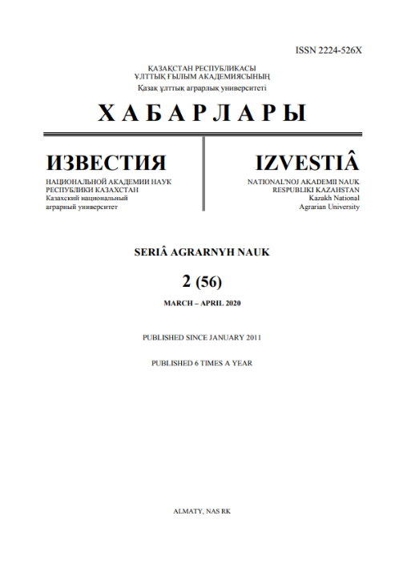

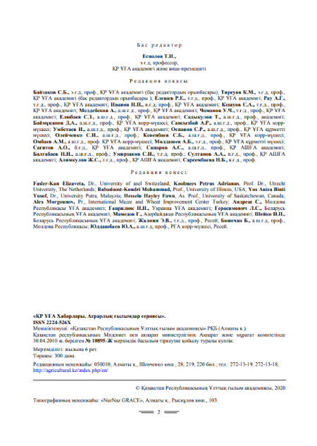
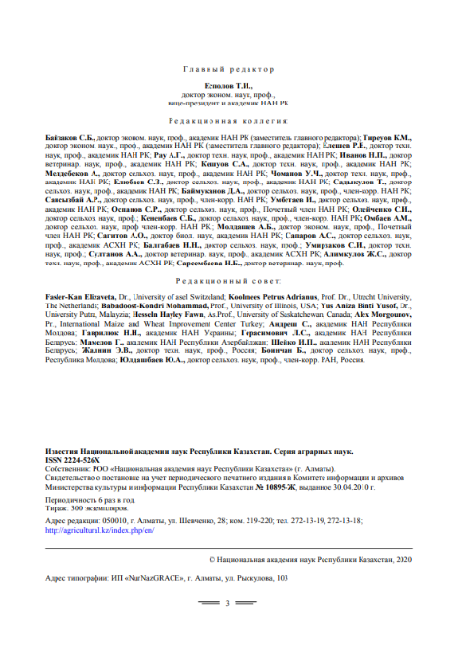
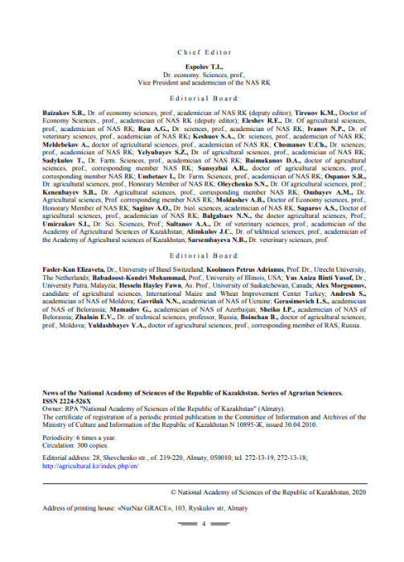
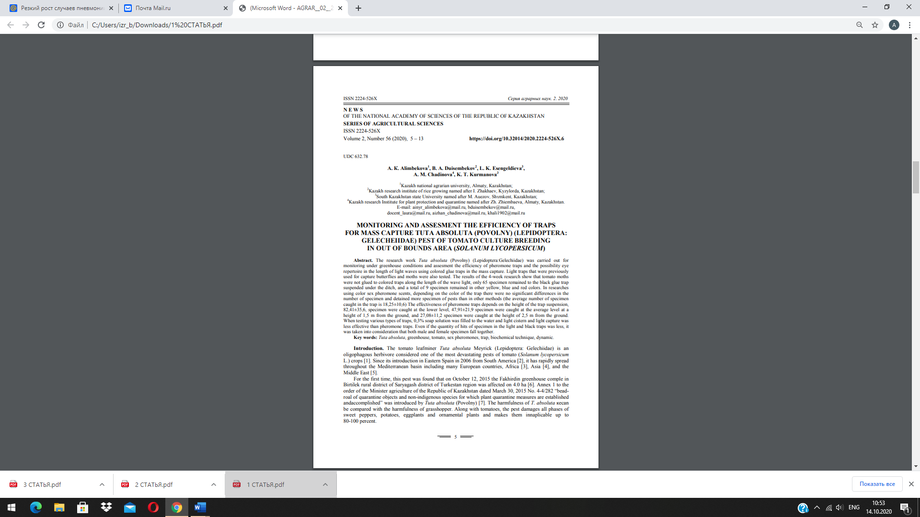
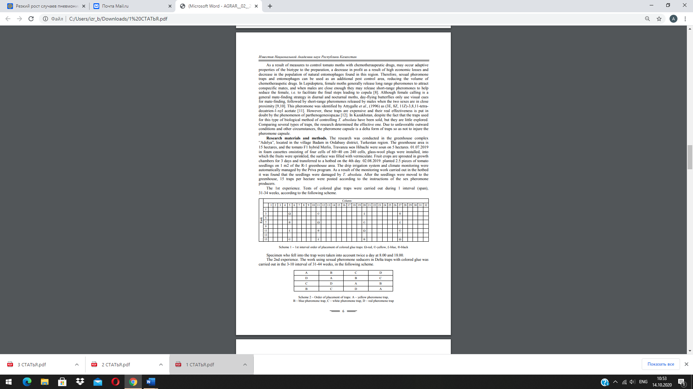

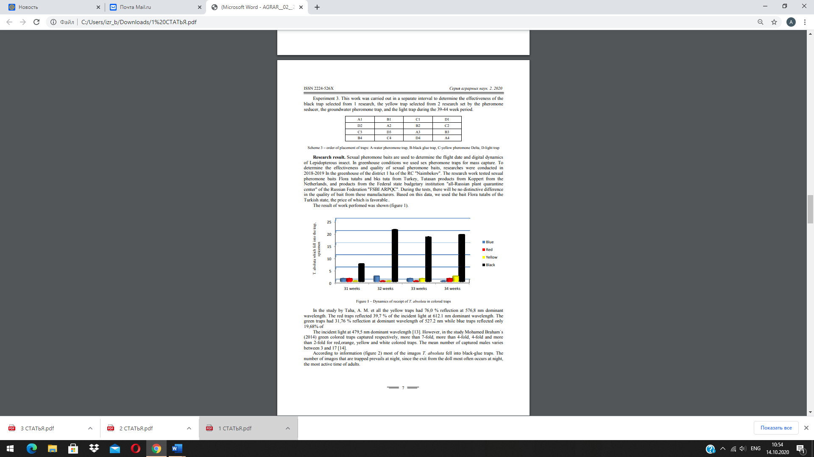
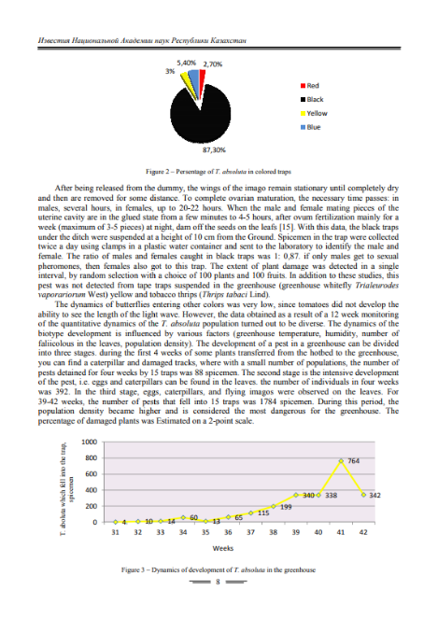
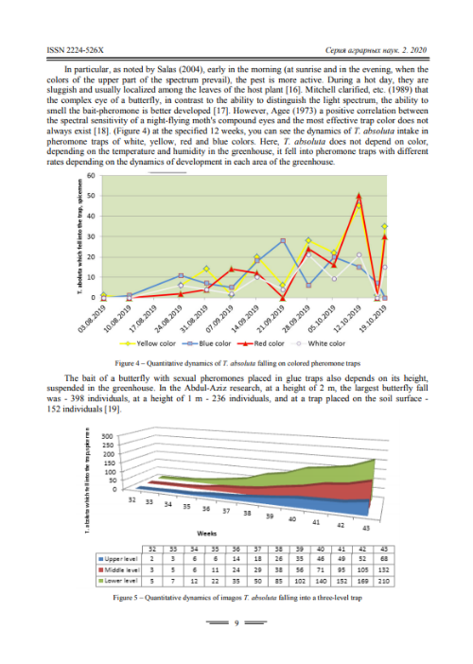

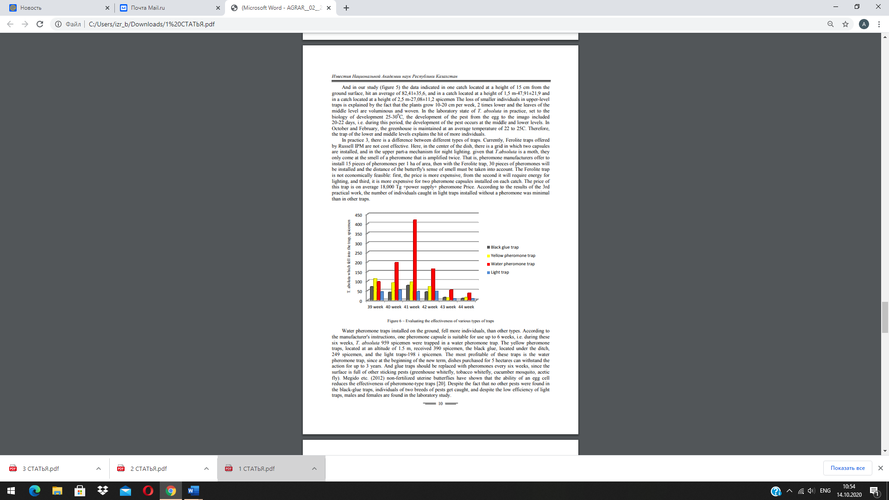
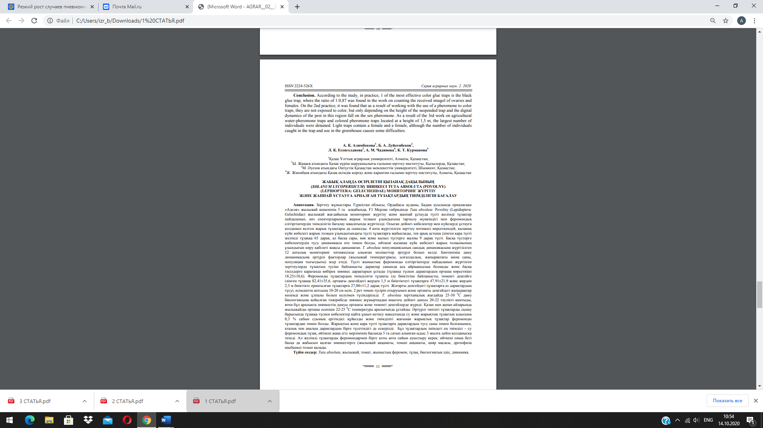

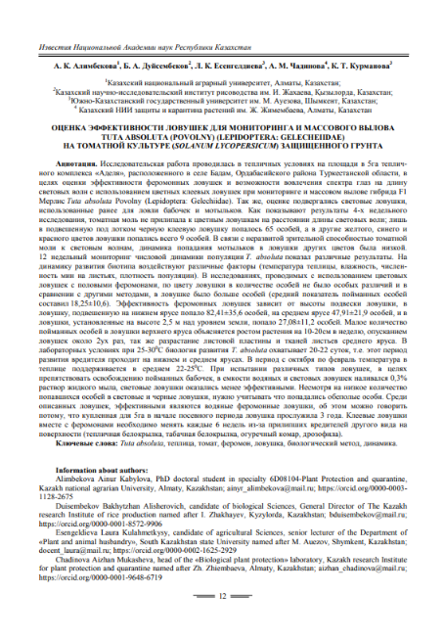
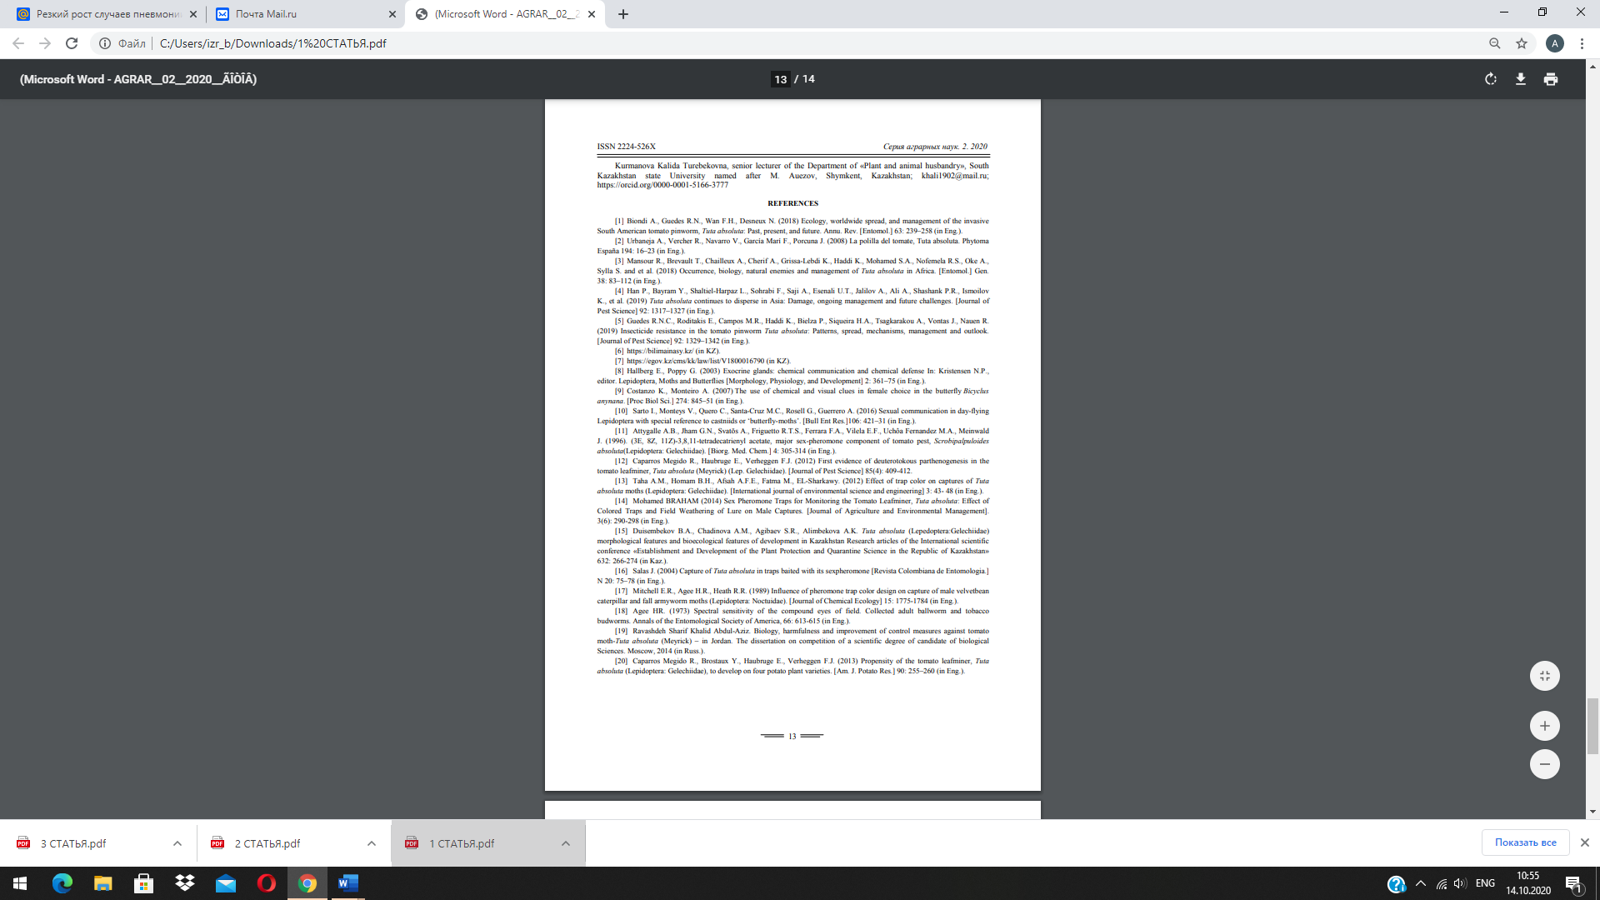

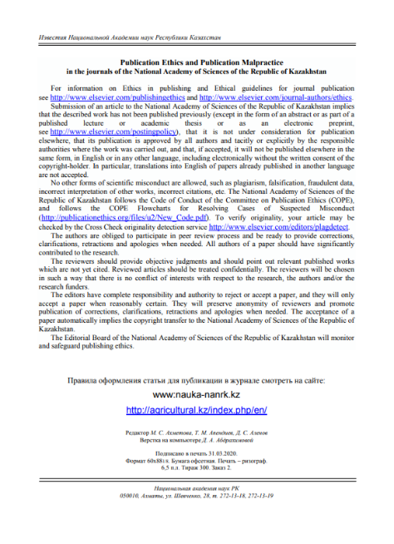

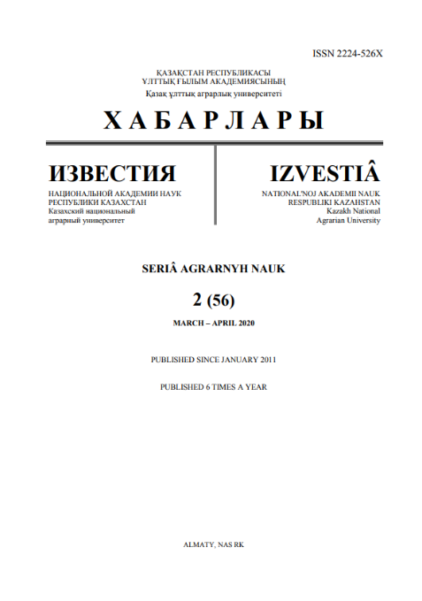

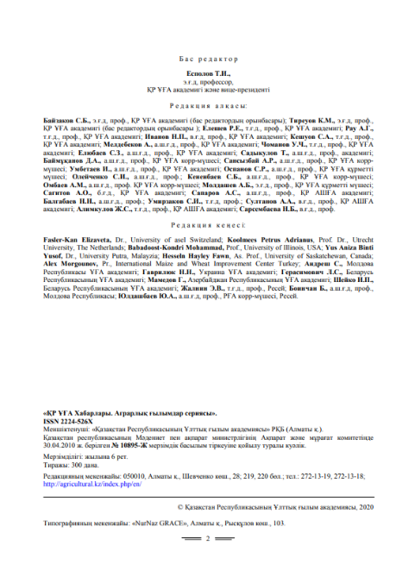
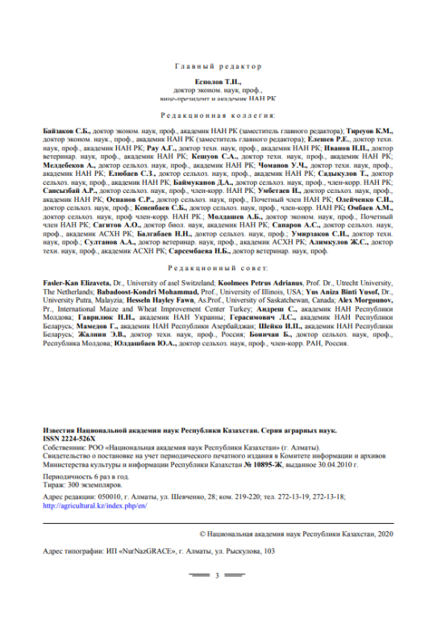
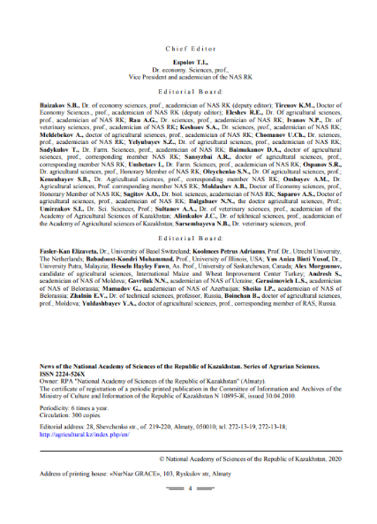
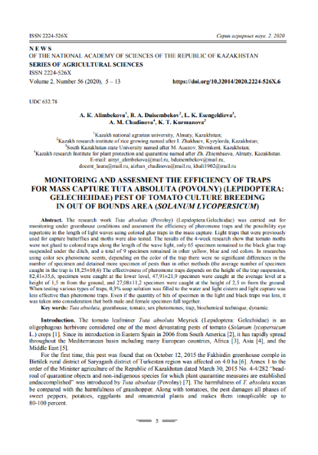
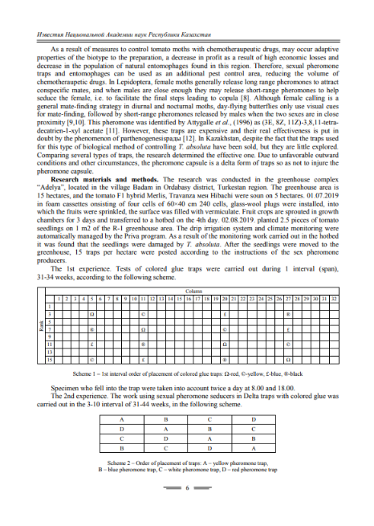

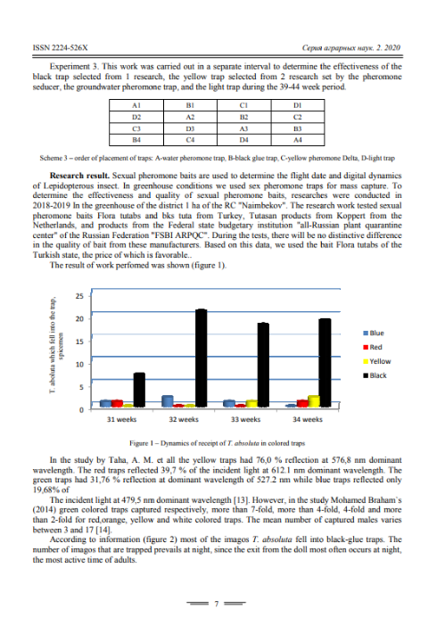
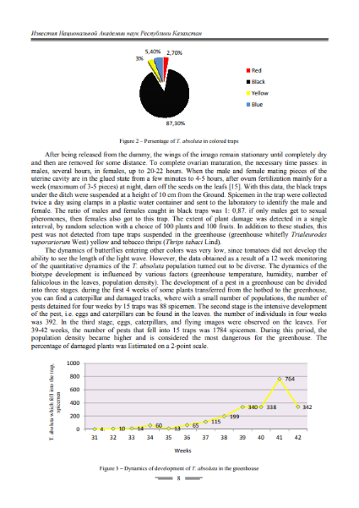
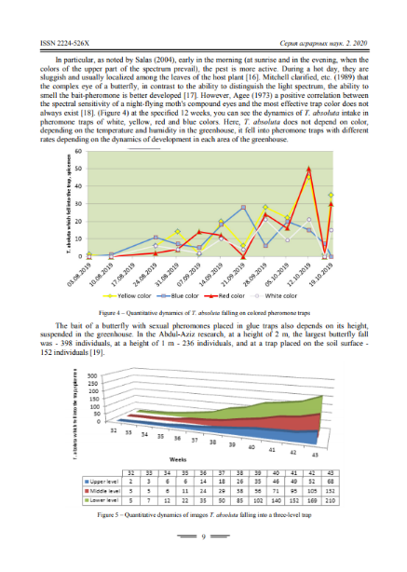

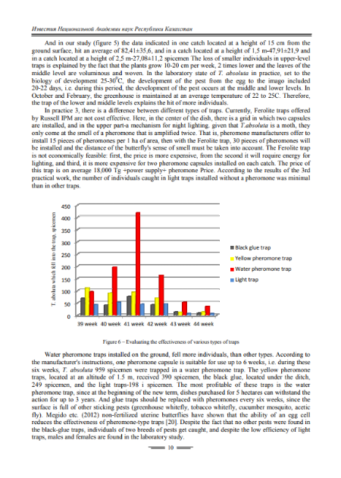

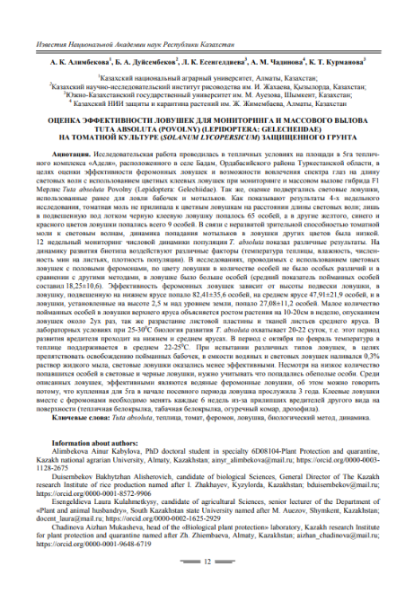
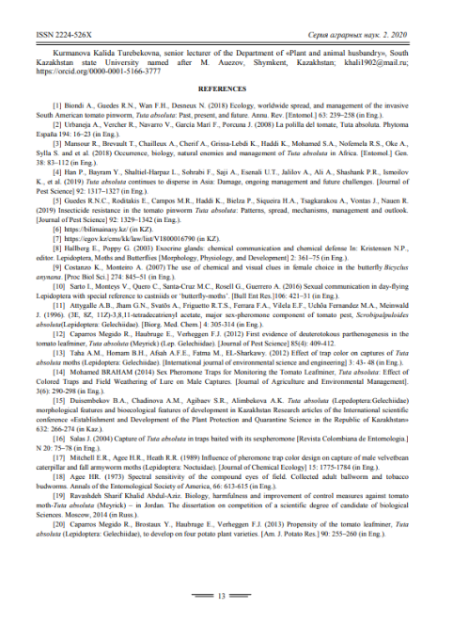

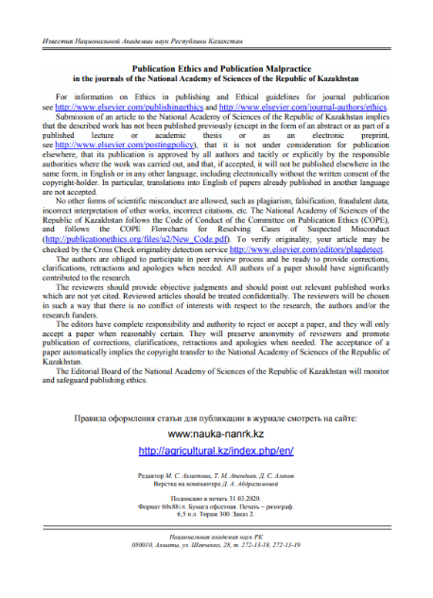

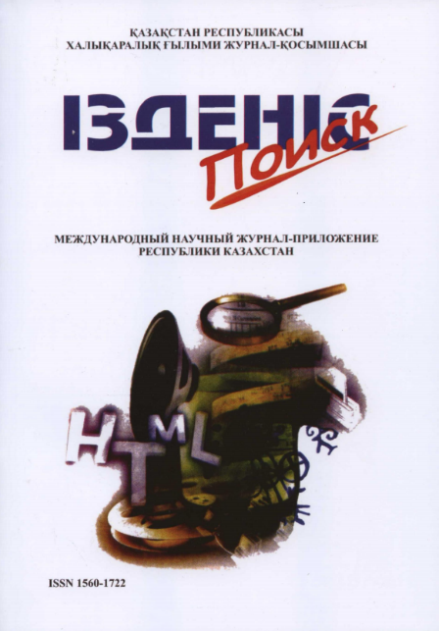
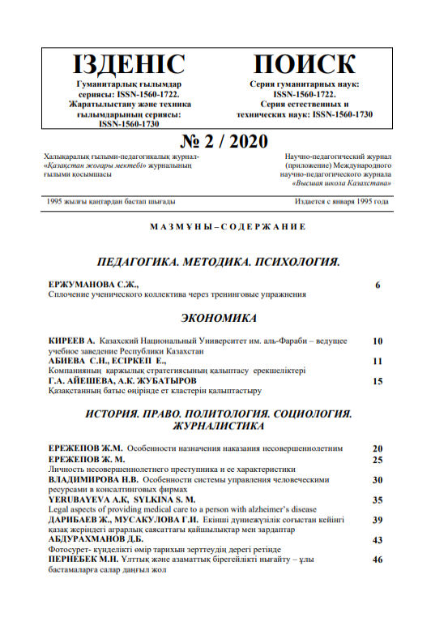

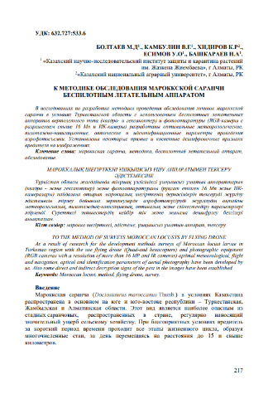

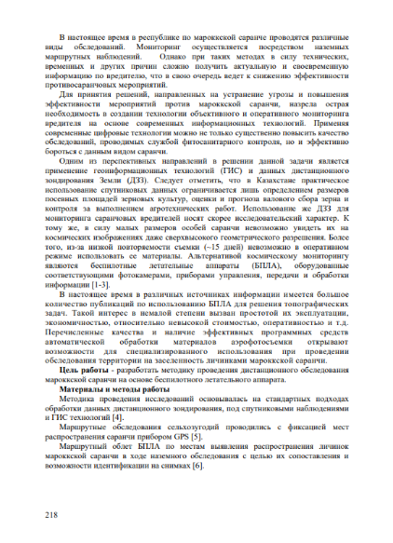

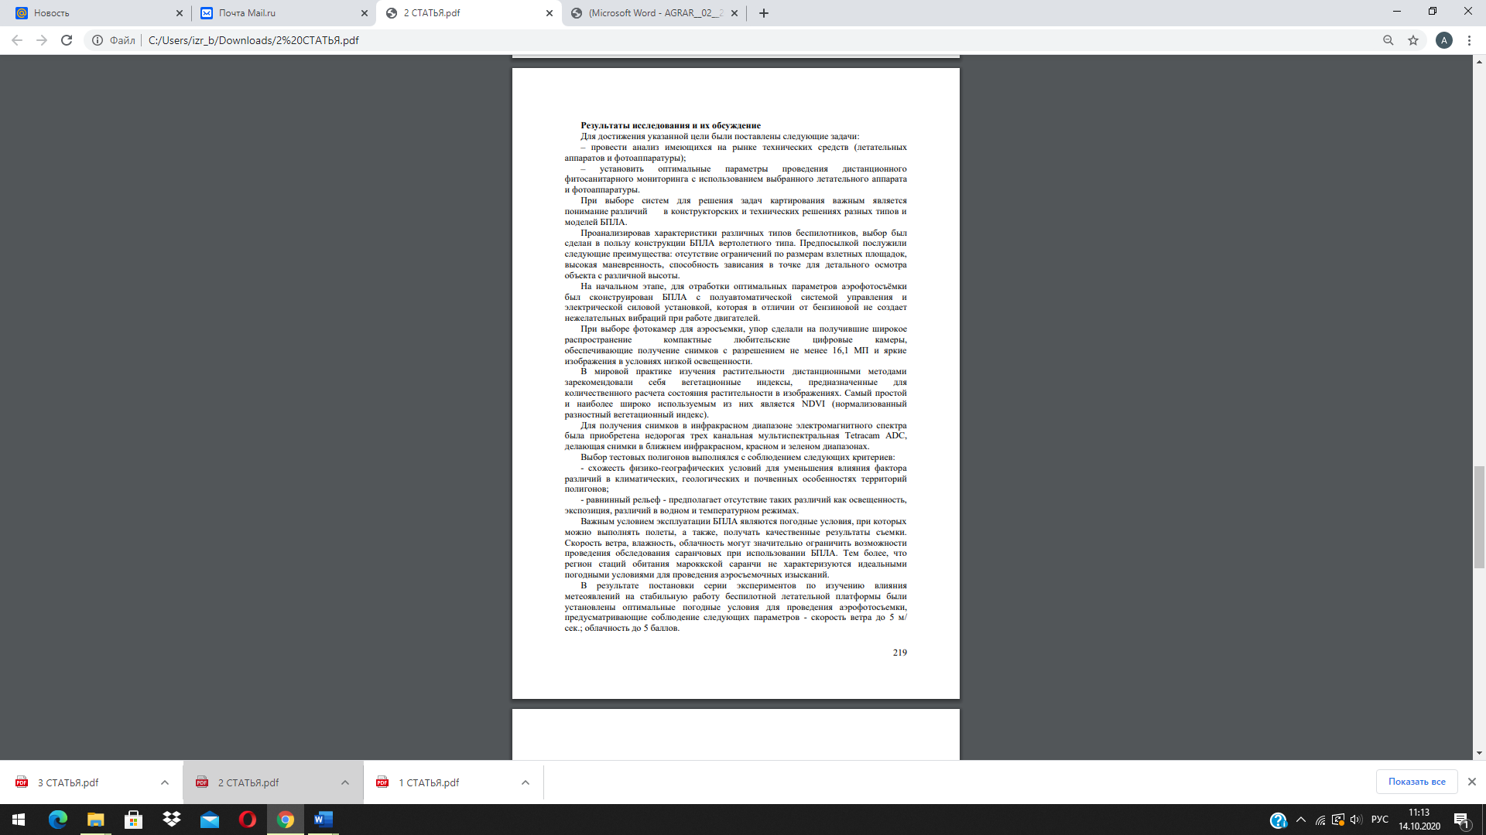

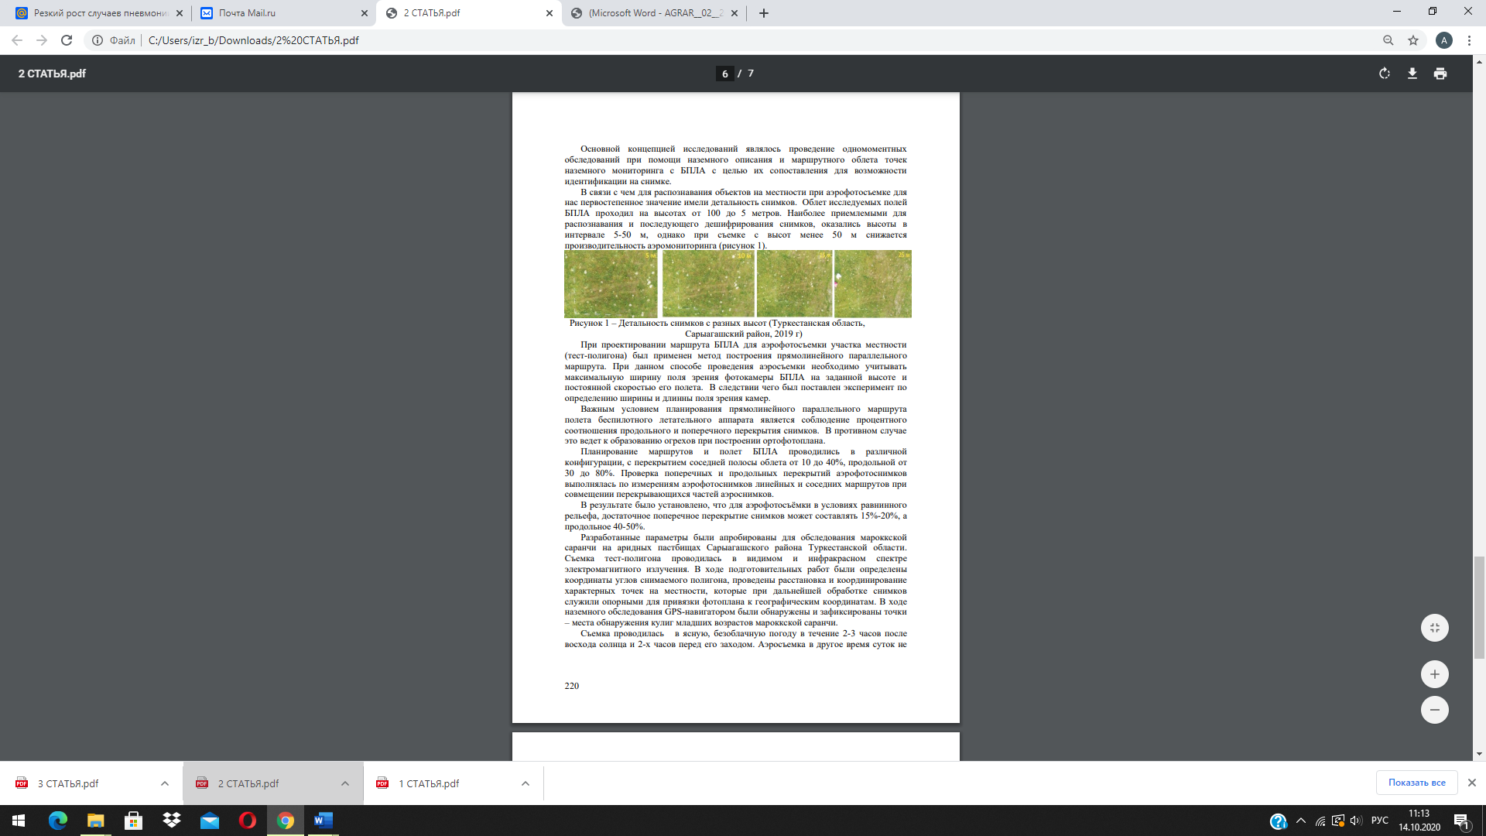

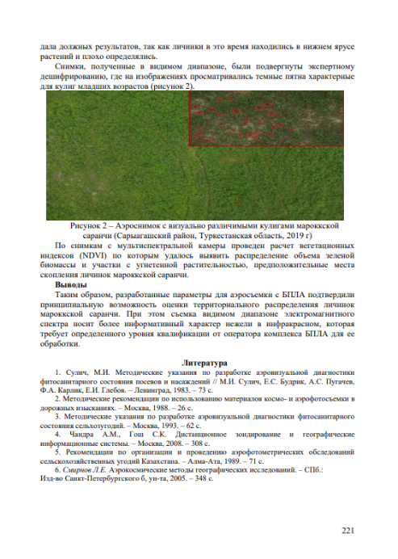

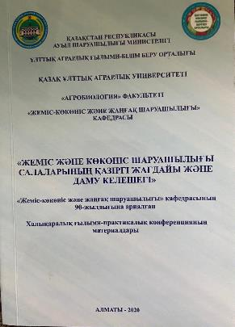

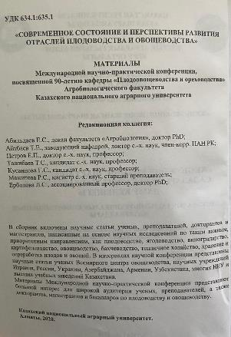

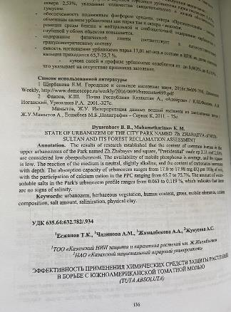

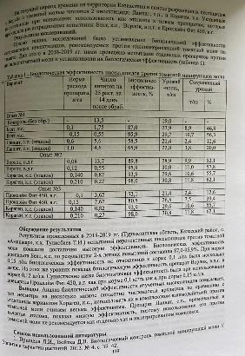

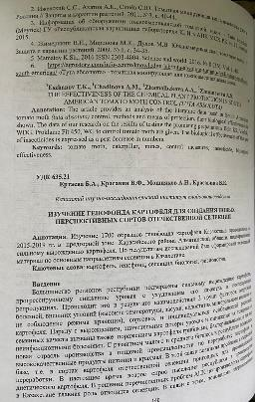

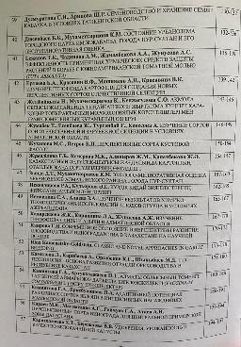

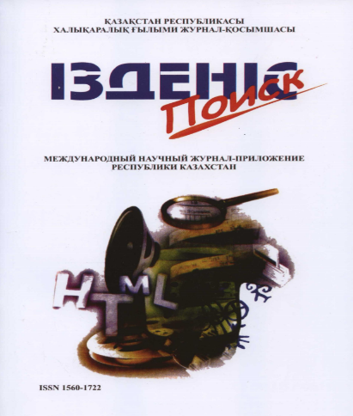

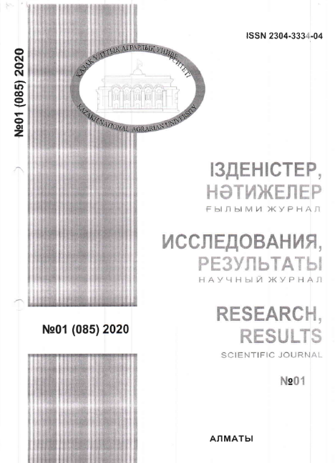

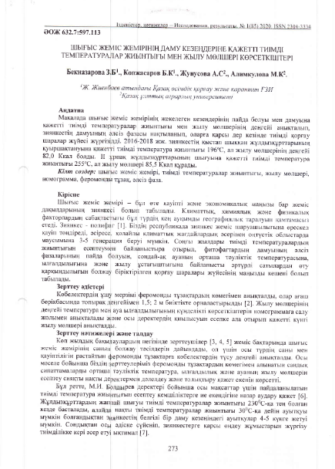

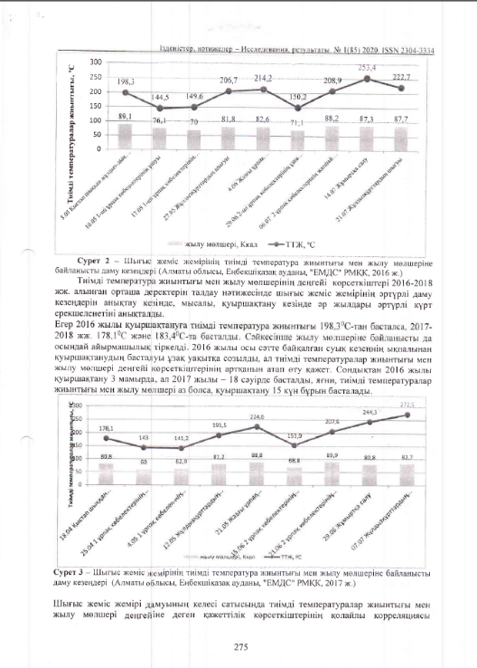

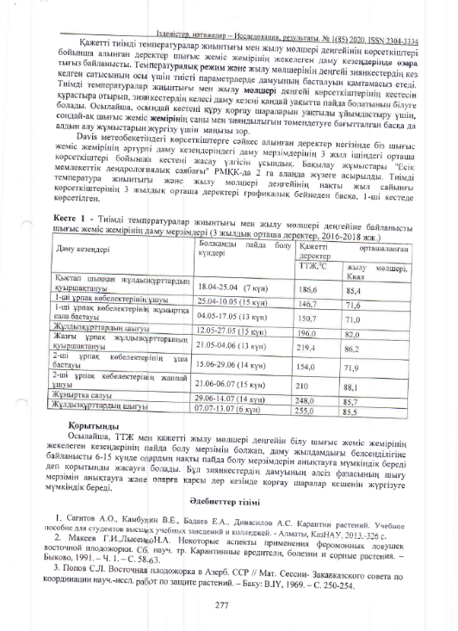

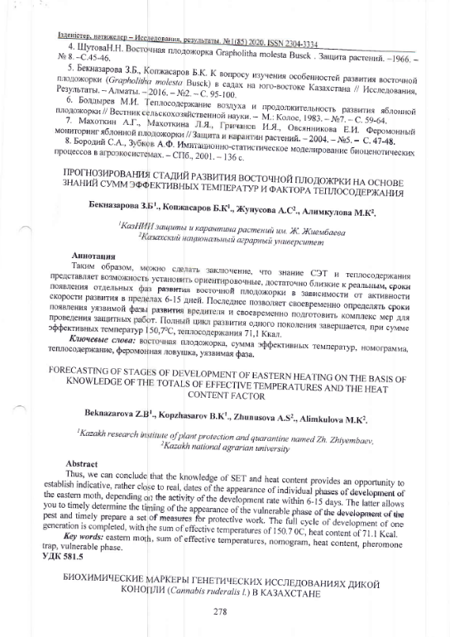
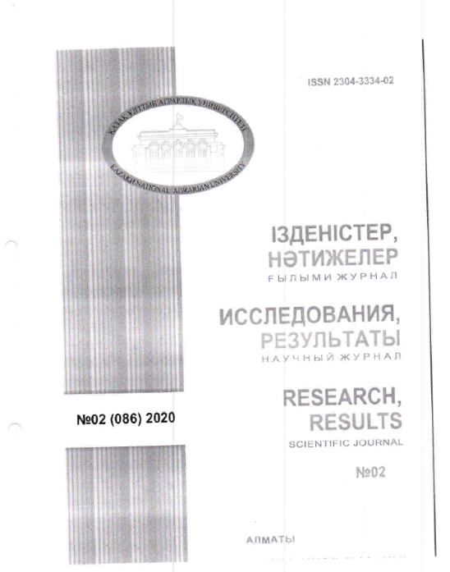

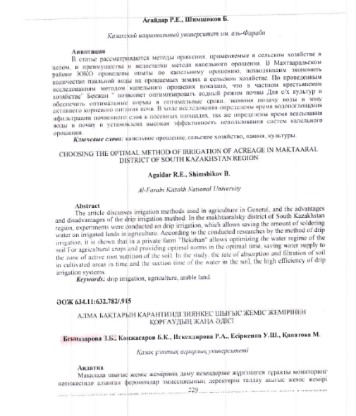

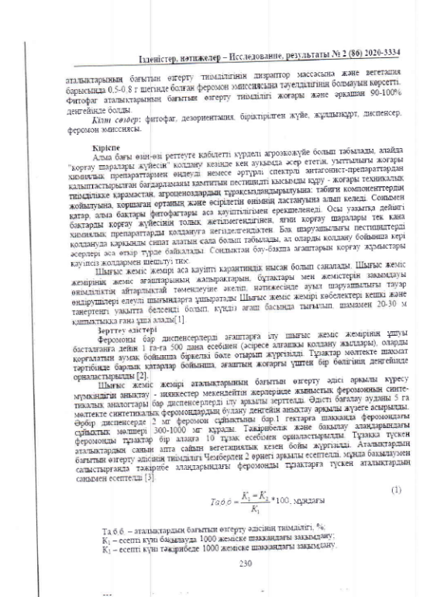

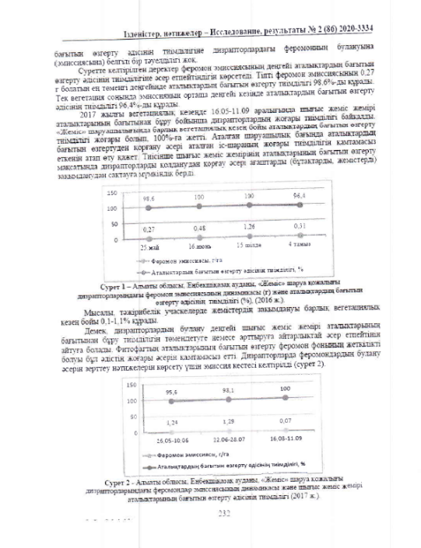

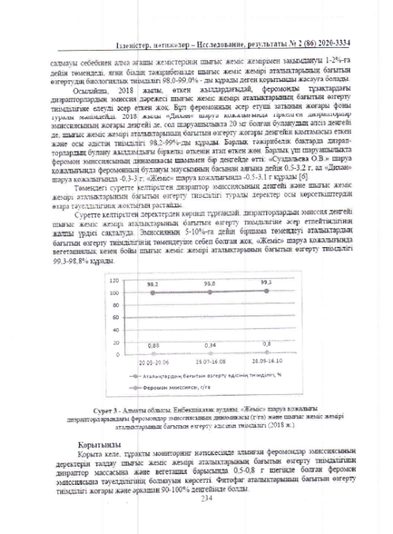

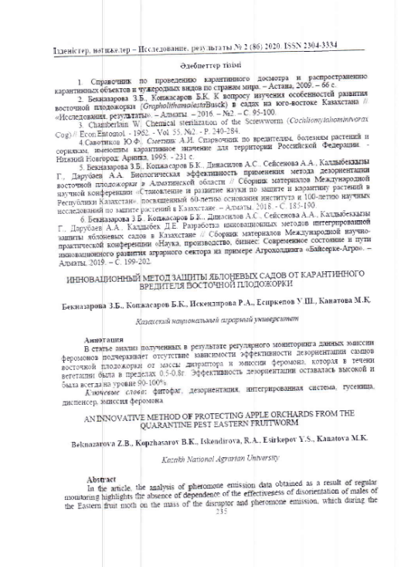
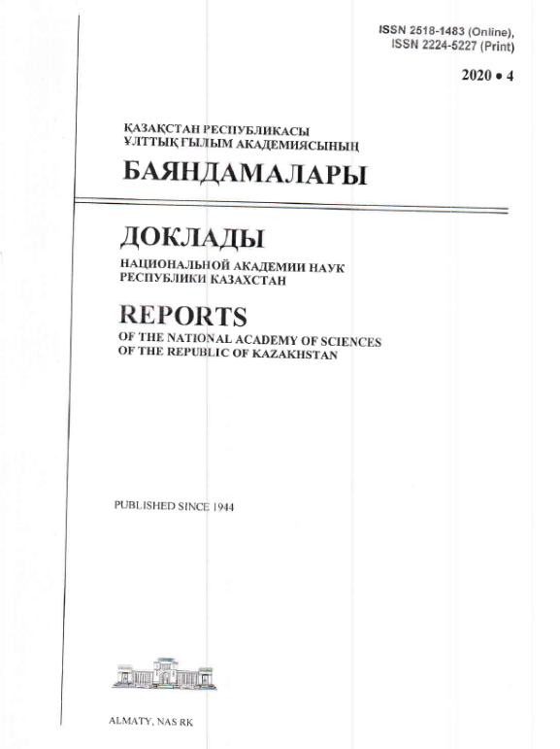

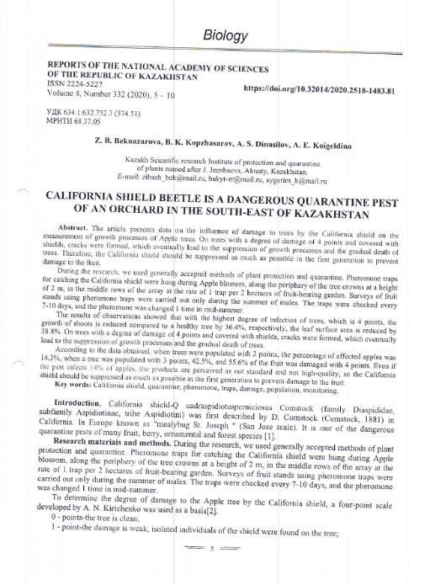

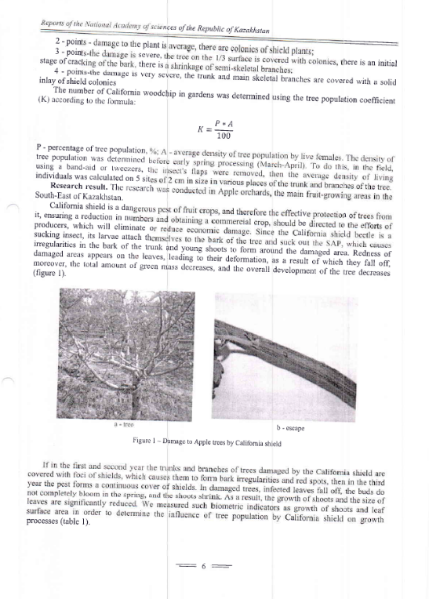

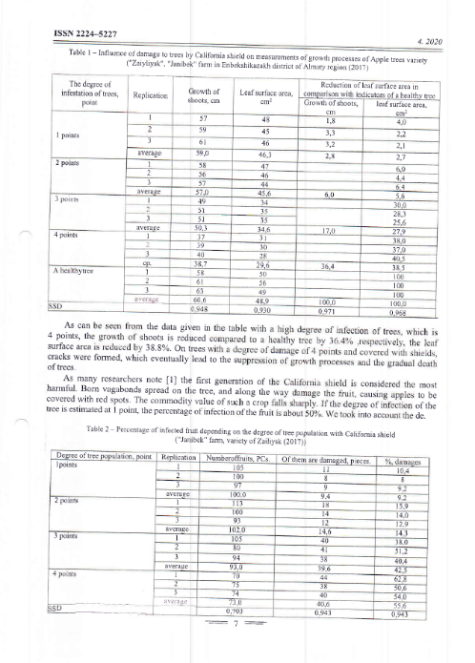

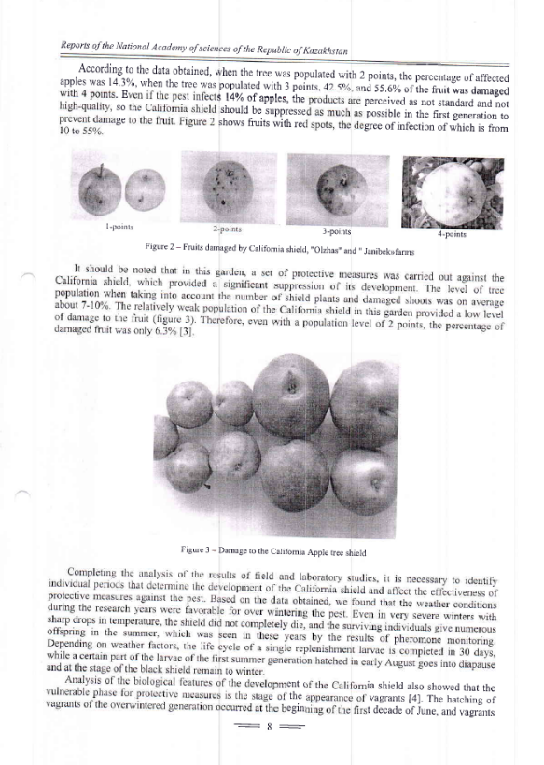

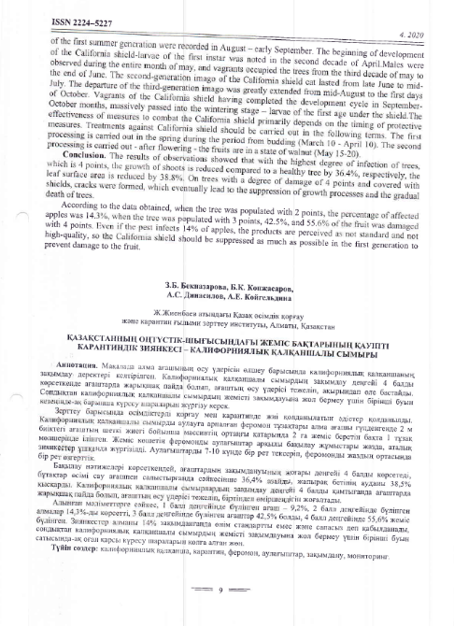

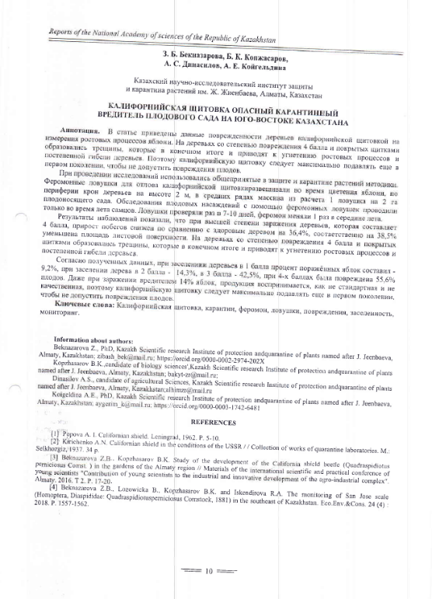

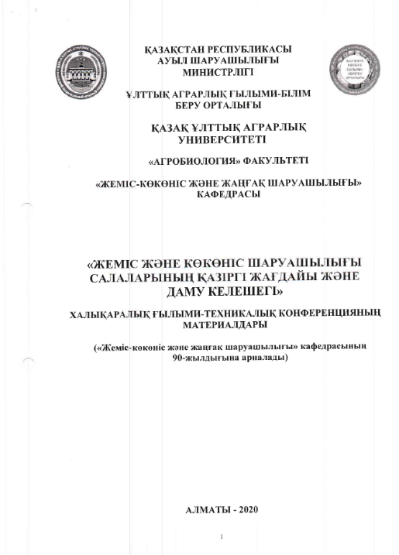

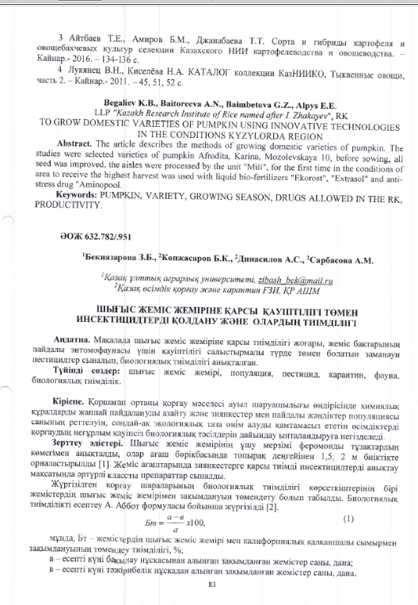

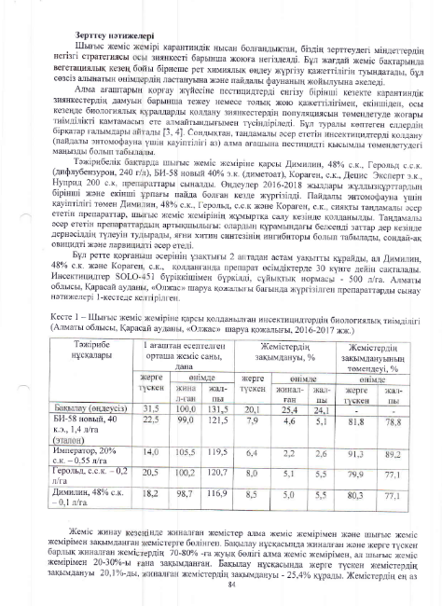

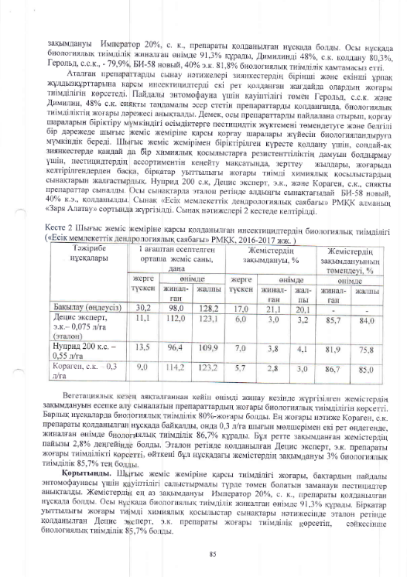

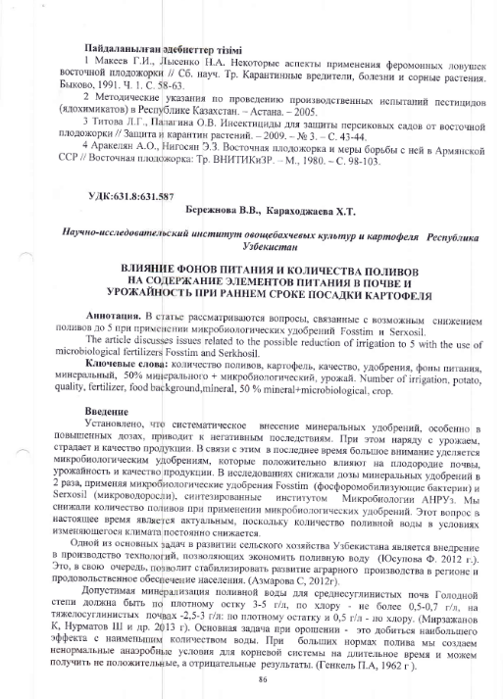
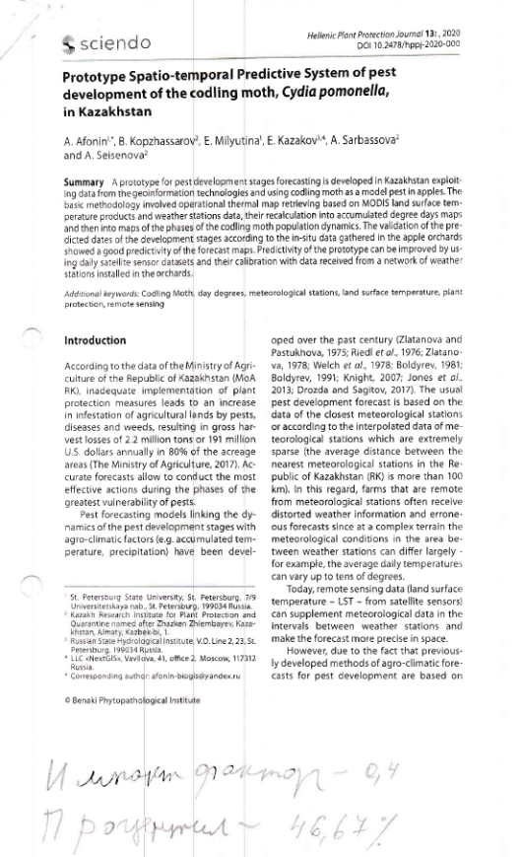

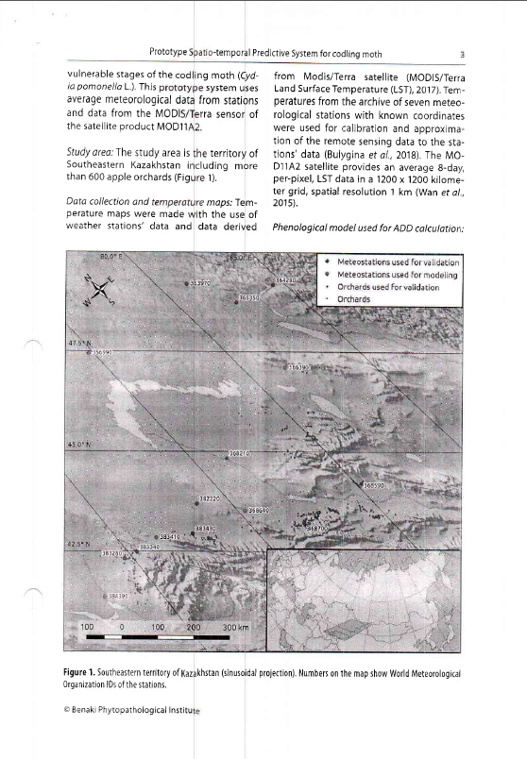

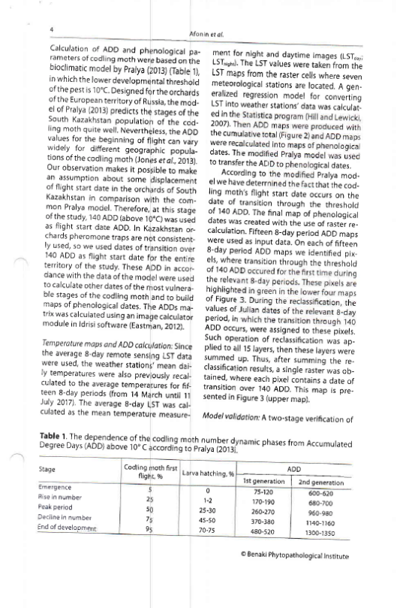

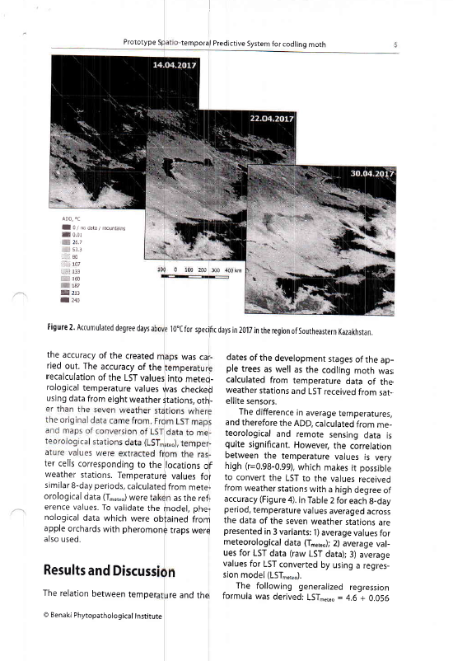
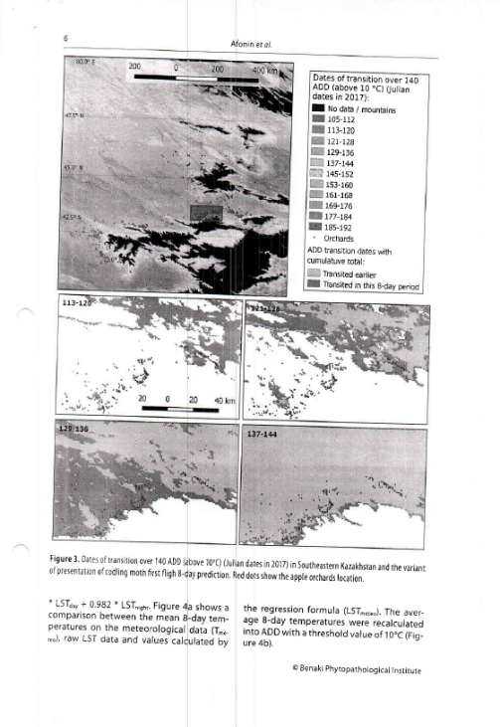

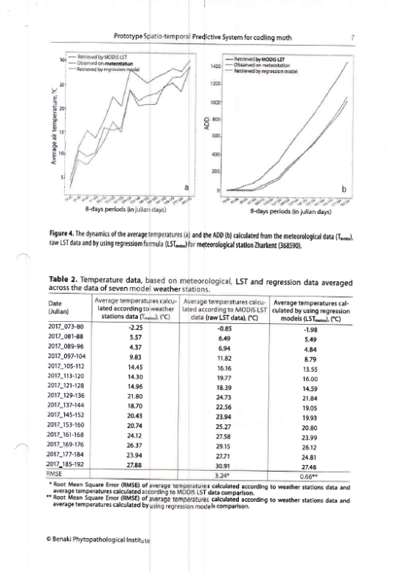

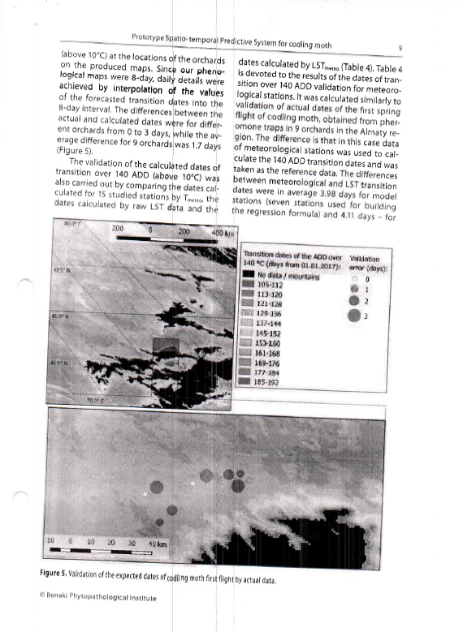

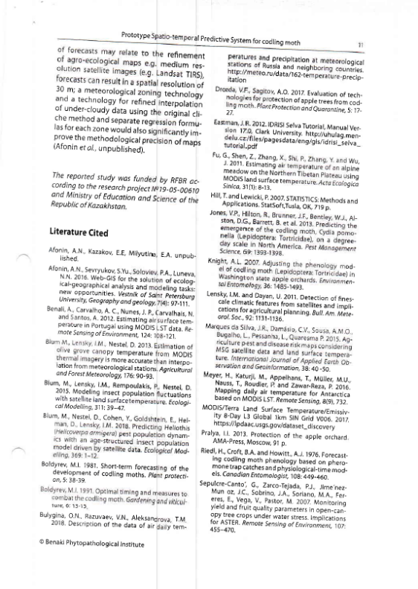

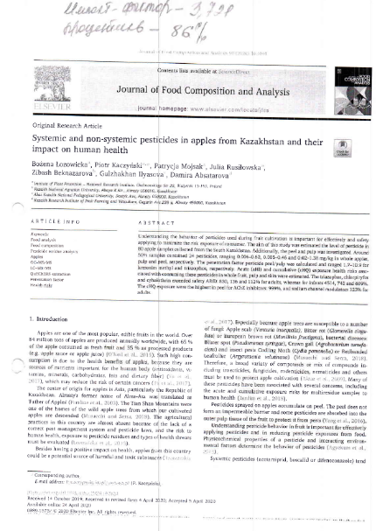

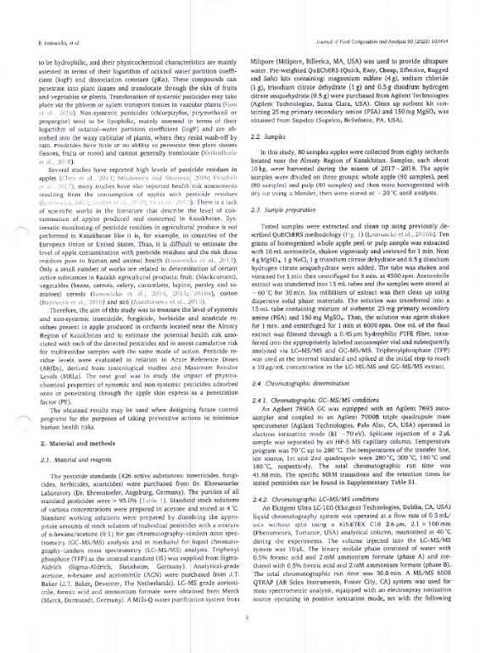

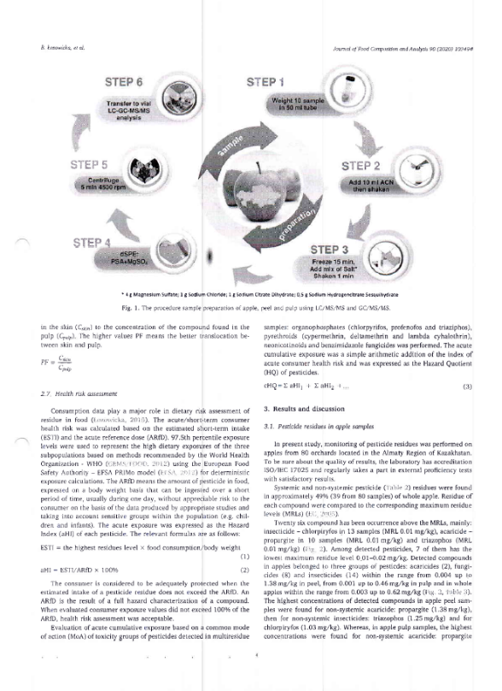

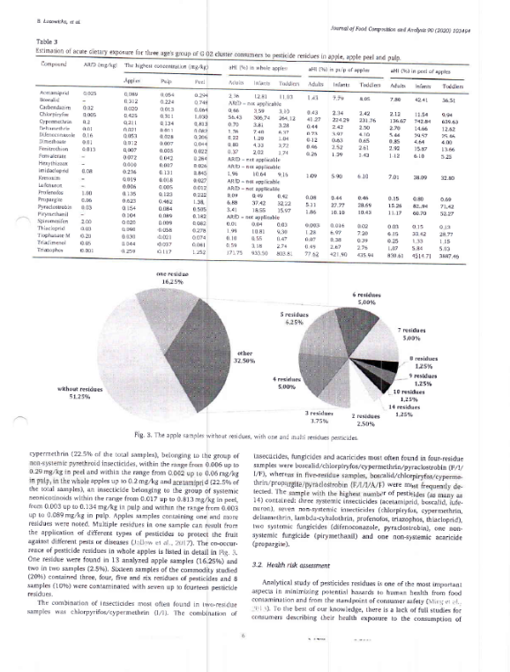

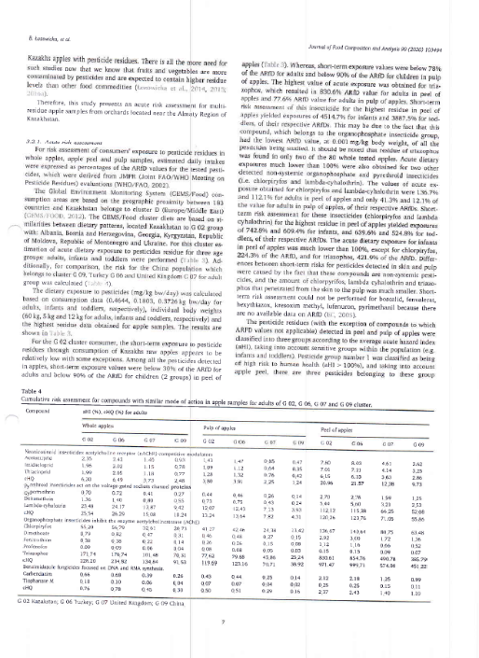

КОПИИ ПАТЕНТОВ, ЗАЯВОК НА ПОЛЕЗНУЮ МОДЕЛЬ И СВИДЕТЕЛЬСТВА
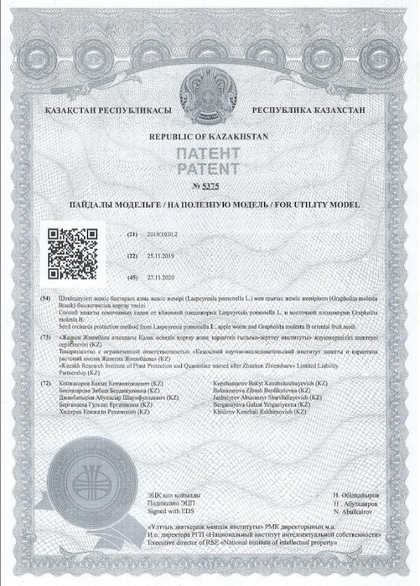

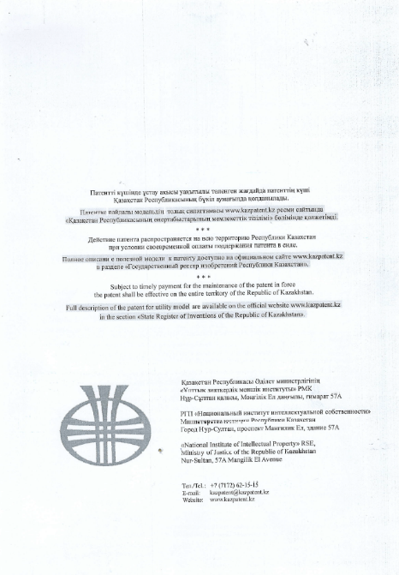
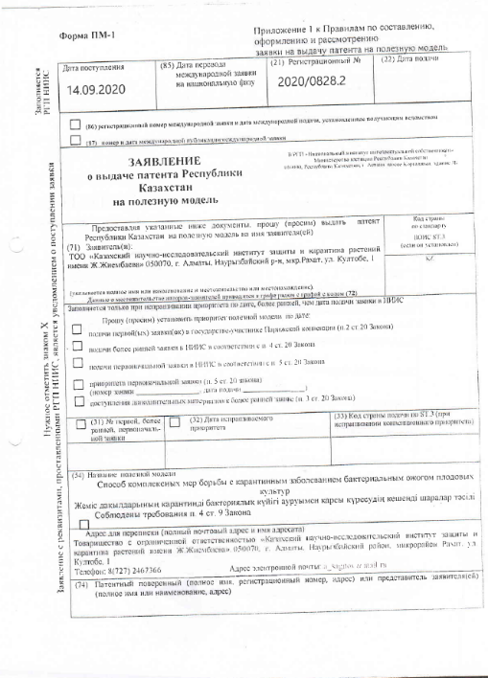

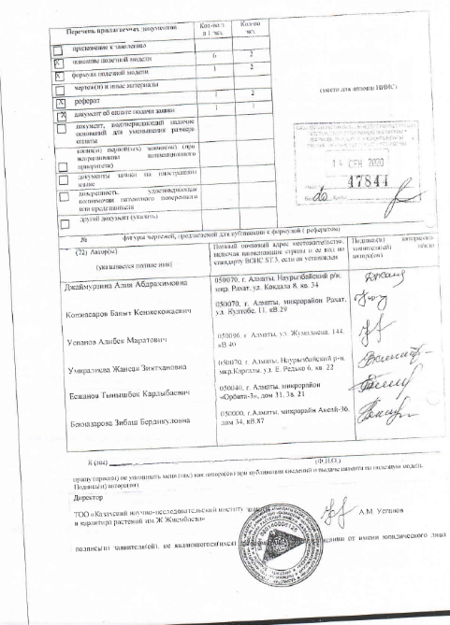


ДЕНЬ ПОЛЯ

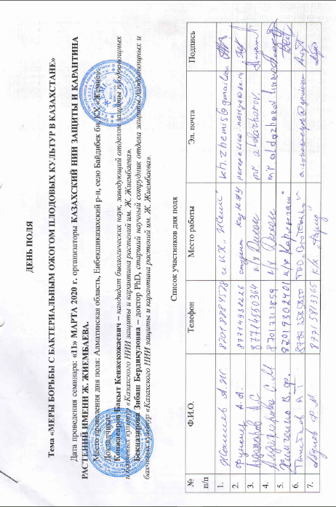

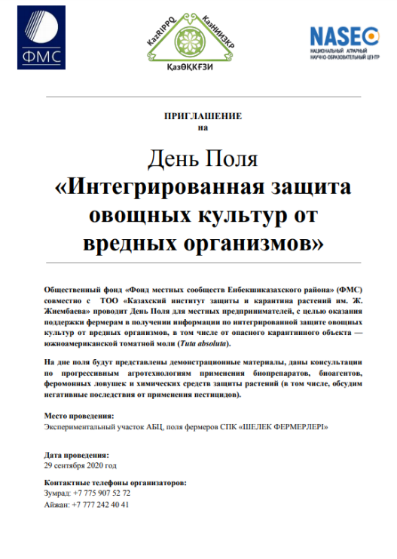

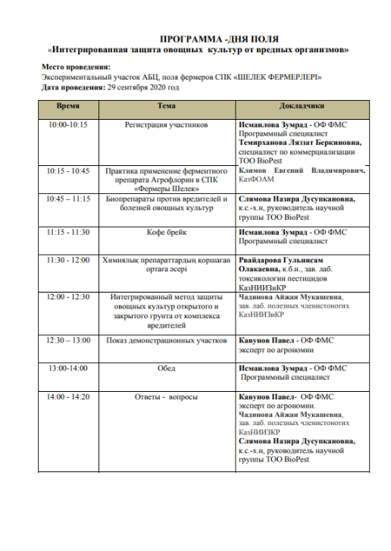

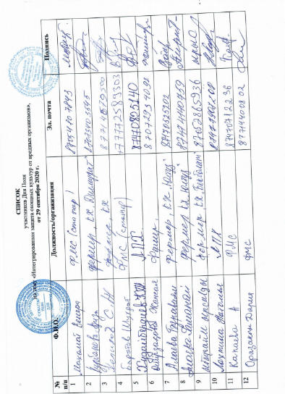



КОПИИ АКТА ВНЕДРЕНИЯ

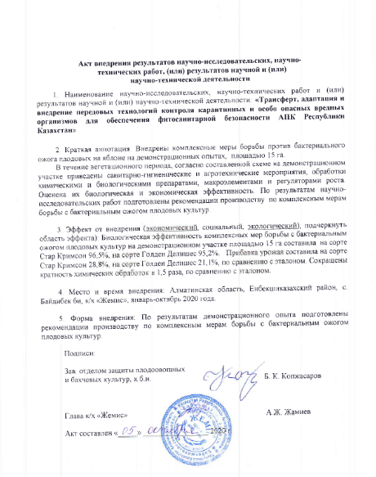

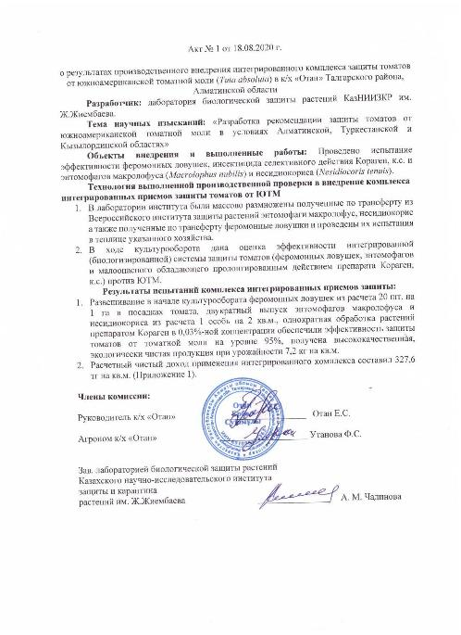
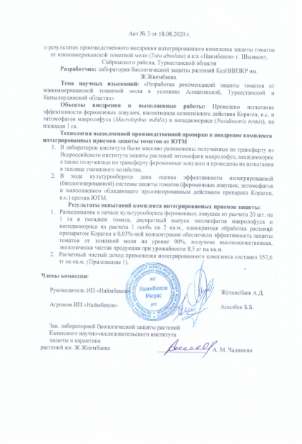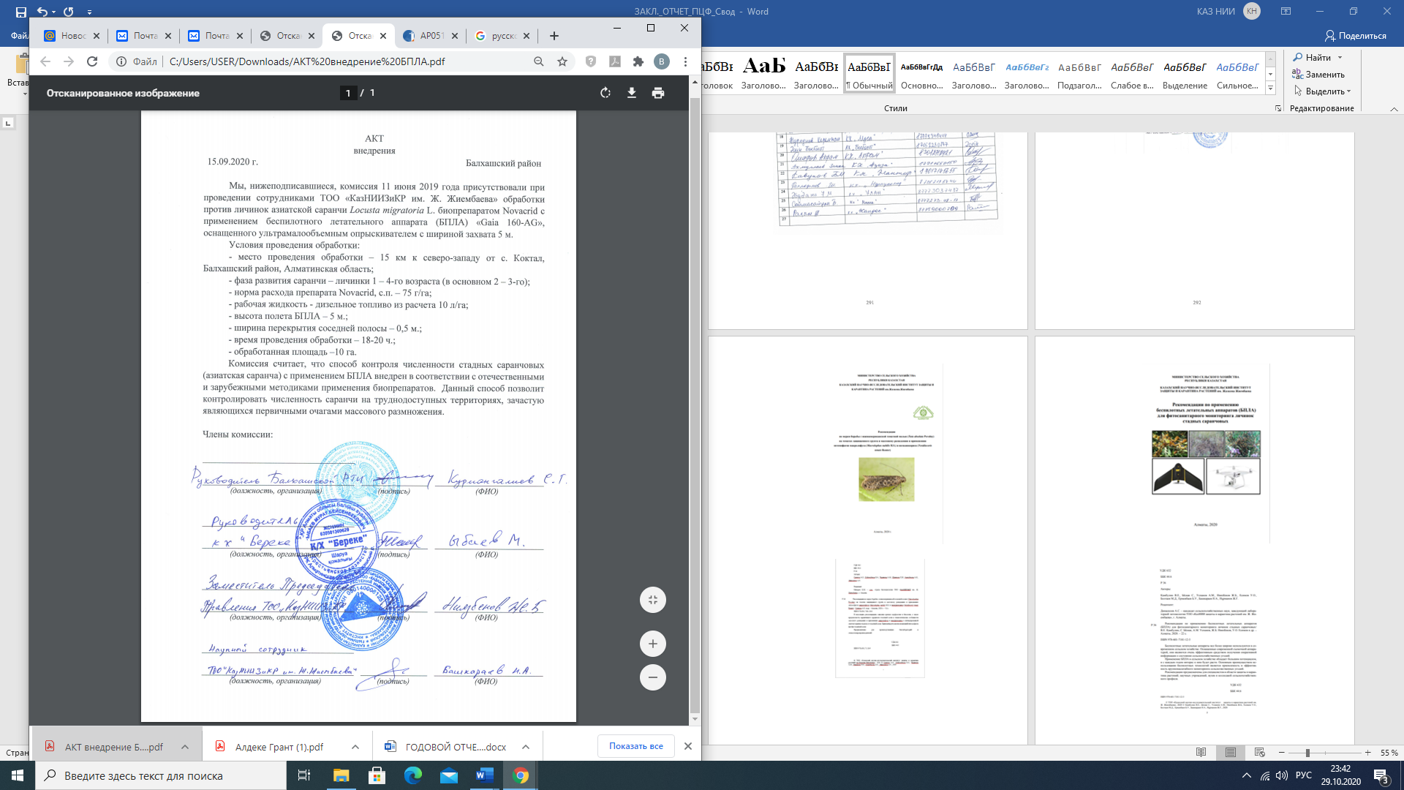
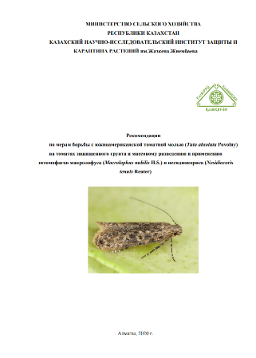

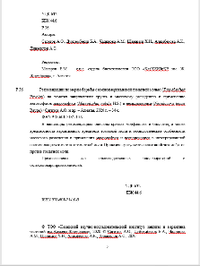

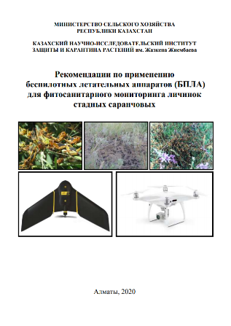

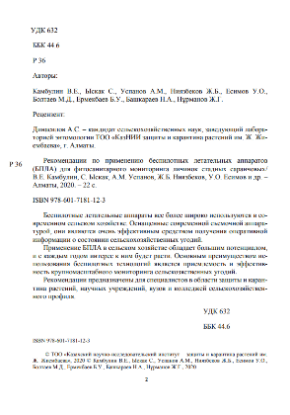

APPENDIX F
Report on patent research

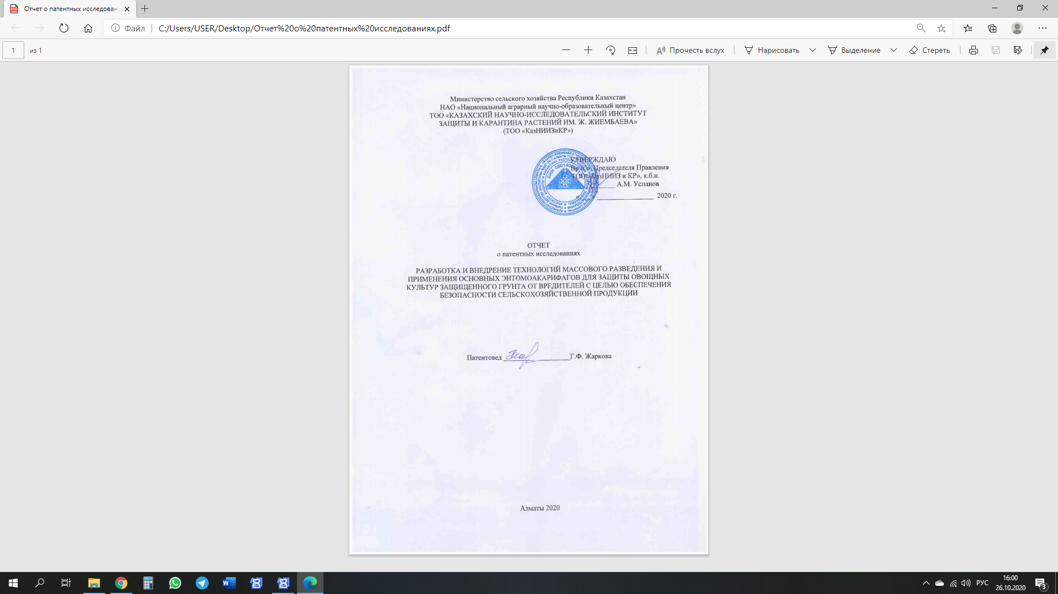

ЗАДАНИЕ № 3
на проведение патентных исследований

Наименование мероприятия: «Трансферт, адаптация и внедрение передовых технологий контроля карантинных и особо опасных вредных организмов для обеспечения фитосанитарной безопасности АПК Республики Казахстан»
Этап – проведение научных исследований, анализ и обобщение информации в соответствии с поставленными перед патентными исследованиями задачами
Задачи патентных исследований: определение технического уровня объекта разработки в сравнении с лучшими отечественными и зарубежными аналогами.

Краткое содержание работ | Срок исполнения | Отчетный документ
1.Исследование технического уровня трансферта, адаптации и внедрения передовых технологий контроля карантинных и особо опасных вредных организмов для обеспечения фитосанитарной безопасности АПК РК  2.Анализ научно-технической деятельности ведущих фирм Анализ тенденций трансферта, адаптации и внедрения передовых технологий контроля карантинных и особо опасных вредных организмов для обеспечения фитосанитарной безопасности АПК РК  3.Технико-экономический анализ технических решений (изобретений, отвечающих задачам разработки).  4. Исследование технического уровня трансферта, адаптации и внедрения передовых технологий контроля карантинных и особо опасных вредных организмов для обеспечения фитосанитарной безопасности АПК РК  5. Обоснование целесообразности правовой защиты объекта промышленной собственности в стране и за рубежом.  6.Обоснование технического уровня трансферта, адаптации и внедрения передовых технологий контроля карантинных и особо опасных вредных организмов для обеспечения фитосанитарной безопасности АПК РК  7 Оформление отчета о патентных исследованиях. | сентябрь 2018 г.-октябрь 2020 г.  сентябрь 2018 г.-октябрь 2020 г.  сентябрь 2018 г.-октябрь 2020 г.  сентябрь 2018 г.-октябрь 2020 г.  сентябрь 2018 г.-октябрь 2020 г.  сентябрь 2018 г.-октябрь 2020 г.  октябрь 2020 г. | Форма 2.1  Форма 1.2  Таблицы 6.1;6.2;6.3; 6.5;  Формы  1.2;2.1;

Регламент поиска № 3

Наименование мероприятия: «Трансферт, адаптация и внедрение передовых технологий контроля карантинных и особо опасных вредных организмов для обеспечения фитосанитарной безопасности АПК Республики Казахстан»
Номер и дата утверждения задания: № 3 от 10.02.2020 г. Этап работы: проведение научных исследований, анализ и обобщение информации в соответствии с поставленными перед патентными исследованиями задачами
Цель поиска информации: Исследование технического уровня разработки передовых технологий контроля карантинных и особо опасных вредных организмов для обеспечения фитосанитарной безопасности АПК Республики Казахстан в сравнении с лучшими отечественными и зарубежными аналогами.
Ведущими странами являются Россия, страны СНГ, Франция, США, Великобритания, ФРГ, Япония, Казахстан . Поиск по патентной документации проводился по следующим рубрикам международной патентной классификации: А01N 1/00 – A01N /65/00; А01Н 1/02-А01Н 4/00; А01G1/00 –А01G25/06; А01С1/00--А01С25/02; А01В 21/08- А01В 79/02; А23L 3/30; В05В 3/02, В04С 9/00, В09С1/08; С02F1/28 – С02F 3/34; С12 N 1/20 С05F 3/00- С05 F11/08; С09К 17/00; С07D 239/00; С05В 11/04; Е01В 3/06; Е02В11/00-Е02В 15/04; Е02D3/046; F02В13/00; F04 F1/04; F 01G 25/02.
Поиск по научно-технической информации проводился по следующим рубрикам УДК:632.693.2; 633.273;632.35;631.85;631.674.6; 631.879.1; 631.628.381;631.8. Начало поиска 2018 г.
Предмет поиска | Страна поиска | Источники информации, по которым будет проводиться поиск |  |  |  | Ретро-  спективность | Наименование информационной базы
 |  | патентные |  | НТИ
 |  | Наименование | рубрики МПК | Наименование | Рубрики УДК
Трансферт, адаптация и внедрение передовых технологий контроля карантинных и особо опасных вредных организмов для обеспечения фитосанитарной безопасности АПК РК | Россия,  Франция, США, Великобритания, ФРГ, Япония,  Казахстан | База данных РФ: азе  1.http://www1.fips.ru/wps/wcm/connect/content_ru/ru/inform_resources/  2.ru-patent.info | А01N1/00- 65/00; А01Н  1/00-4/00; А01G  1/00- 25/06; А01С  1/00-25/02; А01В 21/00-79/02; В04С9/00, С02F  1/28 - 3/34 | Реферативные и отраслевые научные журналы, книги, авторефераты | 632.693.2; 633.273;  632.35;  631.85;  631.674.6; 631.879.1; 631.628.381;  631.8 | 20 лет | Базы данных РФ: 1.http://www1.fips.ru/wps/wcm/connect/content_ru/ru/inform_resources/  2.ru-patent.info  РПФРК

Форма отчета о поиске

В.1 Поиск проведен в соответствии с заданием: № 3 от 10.02.2020 г.
В.2 Этапы работы: проведение научных исследований. В.3 Начало поиска 10.03.2018 г. В.4 Регламент поиска по патентной и научно-технической информации выполнен в полном объеме и в соответствии с рубриками МКИ и УДК. Поскольку в тематику входят исследования по трансферту, адаптации и внедрении передовых технологий контроля карантинных и особо опасных вредных организмов для обеспечения фитосанитарной безопасности АПК РК, то данная научно-исследовательская работа классифицируется как патентоспособная, научные результаты которой подлежат защите патентами РК.
В.6 Материалы, отобранные для последующего анализа.

Таблица В.6.1 – Патентная документация
Предмет поиска (объект исследования, его составные части) | Страна выдачи, вид и номер охранного документа.  Классификационный индекс | Заявитель (патентообладатель), страна. Номер заявки, дата публикации | Название изобретения (полезной модели, промышленного образца)
Трансферт, адаптация и внедрение передовых технологий контроля карантинных и особо опасных вредных организмов для обеспечения фитосанитарной безопасности АПК Республики Казахстан | KZПатент №18945  МПК C12N1/20A01N 63/00C12R 1/07 | ТОО «Казахский НИИ защиты и карантина растений». Заявка № 2006/0996.1 07 от 15.08.2012 г. | Штамм бактерийBacillus turingiensis (Drury).
 | KZПатент на полезную модель № 2851  МПК A01N 59/00 | ТОО «Казахский НИИ защиты и карантина растений». Заявка№ 2017/0488.2 от 25.07.2017 г. | Состав для защиты плодово-ягодных культур от болезней
 | KZ Инновационный патент № 31008  МПК А01С 1/00; А01N 63/00 | ТОО «Казахский НИИ защиты и карантина растений». Заявка№ 2015/0457.1 от 01.04.2015; опубл. 15.04.2016, Бюл. № 4. | Способ диагностики карантинного заболевания от бактериального ожога на плодовых культурах
 | KZПатент на полезную  модель № 2850  МПКA01N 59/00 | ТОО «Казахский НИИ защиты и карантина растений». Заявка № 2017/0487.2 от 25.07.2017 г. | Состав для защиты плодово-ягодных культур от болезней
 | KZПатент на полезную модель № 2056 МПК А01М 1/20 | ТОО "Казахский НИИ защиты и карантина растений". Заявка №2016/0303.2 от 27.05.2016 г. | Способ защиты насаждений томатов от комплекса фитофагов
 | RU Патент № 2598251 МПК А01N 63/04 | ФГБ НУ «Всероссийский НИИ защиты растений». Заявка № 2015135955/10 от 25.08.2015 г. | Штамм гриба Lecanicilliummuacarium, обладающий инсектоакарицидной и антибиотической активностью для борьбы против сосущих вредителей, грибных и бактериальных болезней
 | KZПатент на полезную модель №2157  МПК А01N 63/00 | ТОО «Казахский НИИ защиты и карантина растений». Заявка №2016/0251.2 от 05.05.2016 г. | Способ контроля численности и вредоносности томатной минирующей моли Tuta absoluta Meyrick (Lepidoptera, Gelechiidae)
 | KZПатент РК №32401  МПКA01N 63/00 C12N 1/20 C12N 5/20 | ТОО «Казахский НИИ защиты и карантина растений» заявка №2016/0258.1 от 16.03.2016г. | Штамм гриба Мetarhizium anisopliaemak-01r3 для получения биопрепарата против саранчовых
 | RU Патент № 2658430  МПК A01C1/06; А01N 63/04 | ООО "Органик парк"  Заявка № 2016151237 от 26.12.2016г. | Способ получения биопрепарата для обработки растений
 | KZ Инновационный патент № 25997  МПК A01G 13/00; A01N 63/00 | Ажбенов В.К., Костюченков Н.В.  Заявка № 2011/1082.1 от 20.10.2011;  опуб. 14.09. 2012, Бюл. № 9. | Способ фитосанитарного мониторинга за особо опасными вредителями зерновых культур с использованием глобальной спутниковой навигационной технологии GPS/ГЛОНАСС
 | KZ Инновационный патент № 30505.  МПК A01G 13/00 | АО «Казахский агротехнический университет им. С.Сейфуллина». Заявка № 2014/1033.1 от 30.07.2014; опубл. 16.11.2015, Бюл. № 11. | Способ выявления очага саранчи и фитосанитарного контроля над нашествием особоопасных вредителей.
 | RU Патент № 2478290  МПК А 01N63/02; C12N 1/20  R2478290 | ООО "Бациз". Заявка № 2011145665/10 от 11.11.2011; опубл. 10.04.2013,Бюл. № 14. | Биопрепарат для стимуляции роста и защиты растений от болезней, повышения урожайности и почвенного плодородия
 | RU Патент № 2409030  МПК А01N 51/00; А01N 47/40; А01Р 7/04 | МИЦУЙ КЕМИКАЛС, ИНК. (JP).  Заявка РСТ: JP 2007/072526 от 21.11.2007; опубл. 20.01.2011, Бюл. № 2. | Способ профилактики болезней растений и повреждений растений насекомыми
 | Патент RU № 2559548 МПК С12N 1/20; A01N 63/02 | ГНУ «Всероссийский научно-исследовательский институт защиты растений», заявка №2013153071/10,28.11.2013; опубл. 10.06.2015, Бюл.№16 | Штамм бактерий Вacillus thuringiensisдля борьбы с колорадским жуком
 | Патент РК № 32395  МПК A01N 63/00 C12N 1/20 C12N 5/20 | ТОО «Казахский НИИ защиты и карантина растений» заявка №2016/0259.1 от 16.03.2016г. | Штамм гриба Beauveria bassiana (Balsamo) vuillemin bbk-01r2 для получения биопрепарата против саранчовых
 | Патент RU № 2493247  МПК С12N 1/14; A01N 63/04 | ФГБОУ ВПО «Российский университет дружбы народов"(РУДН). Заявка № 2012109980 от 15.03.2012; опубл. 20.09.2013, Бюл. № 26 | Ингибитор возбудителя бактериального ожога плодовых культур (Erwiniaamylovora)
 | RU Патент № 2504153  МПК A01M 1/14 A01M 7/00 | Лотов В. А. Заявка № 2012131325/13 от 20.07.2012; опубл. 20.01.2014, Бюл.№ 2. | Средство для борьбы с саранчой и массовыми скоплениями других насекомых
 | RU Патент № 2669300  МПК А01К 67/00; А01К 67/33 | ФГБНУ «Всероссийский НИИ биологической защиты растений». Заявка № 2017140591 от 21.11.2017; опубл. 09.10.2018, Бюл. № 38. | Способ разведения хищного клопа подизуса (PodisusMaculiventrisSay)
 | RU Патент № 2504153  МПК С12N 1/20 A01N 63/00  A01N 63/02 | ГНУ ВНИИСХМ Россельхозакадемии  Заявка № 2012156501/10 от 26.12.2012 г. | Штамм Bacillus thuringiensis var. Darmstadiensis No25 (BtH10No25) в качестве средства комплексного воздействия на вредных жесткокрылых насекомых и фитопатогенные грибы
 | RU Патент № 2646890  МПК С02F 1/00; A01G 31/00  C05G 3/00 | Коваленко Д.В. Заявка № 2017103968 от 08.02.2017; опубл. 12.03.2918, Бюл. № 8. | Способ приготовления концентрата питательного раствора для растений
 | RU Патент № 2506747  МПК А01М 5/00 | ГНУ «Всероссийский НИИ биологической защиты растений». Заявка № 2010124405/13 от 15.06.2010; опубл. 20.02.2014, Бюл. № 5. | Устройство для привлечения насекомых и аппликации на них биоагентов
 | RU Патент на полезную модель № 179386  МПК В64D 1/18; В64С 39/02. | ООО "Агродронгрупп". Заявка № 2017128369 от 09.08.2017; опубл. 11.05.2018, Бюл. № 14 | Беспилотный летательный аппарат для обработки растений
 | KZПатент РК № 33598.  МПК C12N 1/20; A01N 63/00 | ТОО «Казахский НИИ защиты и карантина растений». Заявка № 2017/0868.1 от 10.10.2017. | «Штамм гриба Beauveriabassiana (Balsamo) VuilleminBSc3-15 для получения биопрепарата против жука короеда».
 | KZ Патент РК № 33597  МПК C12N 1/20; A01N 63/00 | ТОО «Казахский НИИ защиты и карантина растений». Заявка № 2017/0866.1 от 10.10.2017. | «Штамм гриба Metarhizium robertsii (Metschn.) SorokinUK-7 для получения биопрепарата против колорадского жука»
 | RU Патент № 2661458  МПК G01C 11/02 | ФГБНУ «Всероссийский НИИ агрохимии им. Д.Н. Прянишникова". Заявка № 2017131126 от 05.09.2017; опубл. 16.07.2018, Бюл. № 20 | Способ фотометрической диагностики азотного питания растений с использованием беспилотных летательных аппаратов (бпла).
 | RU Патент РФ № 2539025  МПК С12N 1/20 A01N 63/00 | ООО «Малое инновационное предприятие "Кубанские агротехнологии". Заявка № 2013131339 от 08.07.2013; опубл. 10.01.2015, Бюл. № 1 | Средство для микробиологической защиты растений и способ микробиологической защиты растений с использованием этого средства
 | RU Патент № 2715645  МПК А61К 36/258; А61К 36/25 | ФГБОУ ВО «Казанский государственный аграрный университет»  Заявка № 2019114522 от 13.05.2019; публикация патента 02.03.2020, Бюд. № 7 | Способ получения адаптогена для повышения устойчивости биологических агентовбиофунгицидов к действию неблагоприятных условий и увеличении эффективности биологического контроля болезней растений и адаптоген, полученный способом
 | RU Патент № 2596031  МПК А01N57/12; А01N33/00; А01P13/00 | Игуменова Татьяна Ивановна  Чичварин Александр Валерьевич.  Заявка № 2014146545 от 19.11.2014; публикация патента 10.06.2016, Бюл. № 24 | Гербицид на основе аддуктов фуллеренов
 | RU Патент № 2596031  № 2 607013  МПК А01 N 65/08; В01D 11/02 | Зайцева Наталья Владимировна.  Заявка № 2015112684 от 07.04.2015.  Публикация патента 10.01.2017, Бюл.№ 1 | Способ получения биологически активных препаратов, повышающих всхожесть семян культурных растений и усиливающих их устойчивость к неблагоприятным условиям
 | WO2017/082761А1  МПК А12N1/20; C12R1/01; А01 N 63/02 | ООО «Промышленные инновации» (OBSHCHESTVO S OGRANICHENNOI OTVETSTVENNOSTIU  "PROMYSHLENNYEINNOVATSII").  Заявка РСТ/RU2015/000929 от 25.12.2015 | Штамм PAENIBACLLLUS MUCILAGINOSUS, используемый в качестве удобрения и для стимуляции роста и защиты растений от грибковых болезней
 | RU Патент № 2701644  МПК А01М 1/02 | ФГАОУВО «Крымский федеральный университете им. В.И.Вернадского».  Заявка № 2018136414 от 15.10.2018; публикация патента 30.09.2019, Бюл. № 28 | Способ привлечения и отлова самцов вредителя THERESIMIMA AMPELLOPHAGA
 | RU Патент № 2654569  МПК А01 N 63/02 | ФГБУ «Институт биохимии и генетики Уфимского научного центра РАН»  Заявка № 2015154434 от 17.12.2015; публикация патента 21.05.2018, Бюл.№ 15 | Микробиологический состав для увеличения урожайности сельскохозяйственных культур и защита от вредителей и болезней
 | RU Патент № 2539025  МПК А01N 63/00; C12N1/20 | Малое инновационное предприятие «Кубанские агротехнологии».  Заявка № 2013131339/10 от 08.07.2013; публикация патента 10.01.2015, Бюл. № 1 | Средство для микробиологической защиты растений и способ микробиологической защиты растений с использованием этого средства
 | RU Патент № 2665555  МПК A01K67/00 | ФГБНУ «Всероссийский научно-исследовательский институт биологический защиты растений». Заявка № 2017133698 от 2017.09.27; публикация патента 31.08. 2018 | Способ производства искусственной питательной среды для разведения хищного клопа подизуса (podisus maculiventris say)
 | Евразийский патент № 013402.  Int.Cl. A01N 43/90;  A01N 37/44 | Зингента Партисипейшнс АГ (СН). Заявка № 200602153; дата выдачи и публикация патента 2010.04.30 | Способы уменьшения повреждения нематодами.  Бактериальный стимулятор роста растений.
 | RU Патент № 2690420  МПК С12N 1/20; A01N 63/02 | ООО «Органик парк».  Заявка № 2018103115 от 26.01.2018  Публикация патента 03.06.2019 | Бактериальный стимулятор роста растений
 | US Патент № 2677980  МПК A01N 43/40 | Дау Агросайенсиз Эл Эл Си(US). Заявка  US 2014/012859 от 24.01.2014; публикация патента 22.01.2019 | Способы селективной борьбы с сорняками
 | BY патент № 17430  МПК A01N 33/00 | РНДУП «Институт защиты растений»( BY)  Заявка № а 20100679 от 07.05.2010; публикация патента 30.12.2011 | Способ защиты посевов кукурузы от проволочника
 | RU Патент № 2641525  МПК A01G1/00; A01P7/04 | ФГБОУ ВО "Чеченский государственный университет". Заявка № 2016142105 от 2016.10.24; публикация патента 18.01.2018 | Способ защиты посевов томатов открытого грунта от томатного листового минера
 | RU Патент № 2646898  МПК A01G1/00; A01P7/04 | ФГБОУ ВО "Чеченский государственный университет". Заявка № 2016142104 от 2016.10.24; публикация патента 12.03.2018 | Способ защиты посевов томатов открытого грунта от колорадского жука
 | RU Патент № 2690419  МПК A01N 63/00 | ФГБНУ «Всероссийский НИИ картофельного хозяйства им. А.Г.Лорха»  Заявка № 2018114028 от 17.04.2018; публикация патента 03.06.2019, Бюл. № 16 | Способ защиты растений
 | RU Патент № 2676145  МПК A01М 5/00 | ФГБОУ ВО «Ставропольский государственный аграрный университет». Заявка № 2017138731 от 07.11.2017; публикация патента 07.11.2017, Бюл. № 36. | Способ уничтожения саранчи и устройство для его осуществления
 | RU Патент № 2621027  МПК А01M5/04 | ФГБОУВО «Астраханский государственный университет». Заявка № 2015134161 от 13.08.2015; публикация патента 30.05.2017, Бюл. № 16 | Устройство для уничтожения молоди саранчи
 | RU Патент № 2670134  МПК А01М 27/00 | ФГБОУВО «Ставропольский государственный аграрный университет». Заявка № 2017135905 от 09.10.2017; публикация патента 18.10.2018, Бюл № 29 | Способ механического уничтожения масс саранчи и устройство для его осуществления
 | RU Патент № 2707817  МПК А01М 5/08 | Кунгурцев Юрий Николаевич  Заявка № 2019100796 от 10.01.2019; публикация патента № 29.11.2019, Бюл. № 34 | Устройство для отлова и утилизации саранчи
 | RU Патент № 2730603  МПК А01N 63/00 | Старовойтов В.И., Старовойтова О.А., Бойко Ю.П., Масюк Ю.А.. Подача заявки от 05.02.2020; публикация патента 24.08.2020 | Способ борьбы с насекомыми вредителями
 | BY Патент на полезную модель № 8909  МПК А01М 1/10 | ГНУ «Институт леса Национальной академии наук Беларуси». Заявка № 20120420. Публикация патента 2013.02.28 | Феромонная ловушка для насекомых
 | RU Патент № 252224  МПК А01М 1/10 | ФГБНУ «Всероссийский НИИ биологической защиты растений»  Заявка № 2014147994 от 27.11.2014 | Ловушка-аппликатор для насекомых
 | RU Патент № 2506747 | ФГБНУ «Всероссийский НИИ биологической защиты растений»  Заявка № 2010124405 от 15.05.2010 | Устройство для привлечения насекомых и аппликации на них биоагентов «Ферон- 1
 | KZ Патент на полезную модель № 4662  МПК А01К 47/00 | ТОО «УНПЦ «БайсеркеАгро».  Заявка № 2019/0701.2 от 06.08.2019 | Искусственное гнездилище для разведения энтомофагов и опылителей на полях кормовых культур
 | KZ Патент на полезную модель № 5364  МПК A01N 33/00 | KZ Патент на полезную модель № 5364  ТОО «Казахский НИИ защиты и карантина растений».  Заявка № 2019/1073.2 от 09.12.2019 | Способ защиты зернобобовых культур от комплекса заболеваний и вредителей, передаваемых через семена и почву
 | KZ Патент на полезную модель № 4802  МПК A01N 33/00 | ТОО «УНПЦ «Байсерке Агро». от | Защитно-стимулирующий состав для обработки семян зерновых культур (пшеница, ячмень)
 | KZ Патент на полезную модель № 5364  МПК А01К 47/00 | ТОО «Казахский НИИ защиты и карантина растений».  Заявка № 2020/0610.2 от 24.06.2020 | Способ комплексной защиты кукурузы от болезней и вредителей
 | KZ Патент на полезную модель № 5363 | ТОО «Казахский НИИ защиты и карантина растений».  Заявка № 2020/0298.2 от 20.03.2020 | Способ массового разведения макролофуса при защите томатов в условиях закрытого грунта от вредителей
 | KZ Патент на полезную модель № 5375  МПК А01К 47/00 | ТОО «Казахский НИИ защиты и карантина растений».  Заявка № 2019/1073.2 от 09.12.2019 | Способ защиты семечковых садов от яблонной плодожорки Laspeyresia pomonella и восточной плодожорки Grapholita molesta B.
 | RU Патент № 2386241  МПК A01G 13/06;  A01G 7/06;  A01N 63/02 | Закрытое акционерное общество Промышленная Группа "АЛСИКО" (RU). Заявка № 2009105780/12 от 19.12.2009; публикация патента 20.04.2010 | Способ защиты плодовых культур от грибных заболеваний
 | KZ Инновационный патент № 29086  МПК А01М 1/00 | ТОО «Казахский НИИ защиты и карантина растений».  Заявка № 2013/1845.1 от 17.11.2013; публикация патента 17.11.2014, Бюл. № 11 | Способ биологической защиты плодовых садов от вредных организмов
 | RU Патент № 2648696  МПК G01N 35/10$ G06F 7/00$ A01G 2/00 | Гаврилов НиколайАндреевич  Заявка 2017117895 от 23.05.2017; публикации патента 28.03.2018, Бюл. № 10 | Агротехнический комплекс с беспилотным летательным аппаратом
 | RU Патент № 2471338  МПК А01В 79/00 | Российская Академия Сельскохозяйственных наук ВНИИ электрификации сельского хозяйства РАСХН Заявка № публикация патента 10.01.2013 | Устройство позиционирования мобильных агрегатов при возделывании агрокультур
Таблица В.6.2 – Научно-техническая, конъюнктурная, нормативная документация и материалы государственной регистрации (отчеты о НИР)
Предмет поиска | Наименование источника информации | Автор, фирма | Год, место и орган издания источника
Трансферт, адаптация и внедрение передовых технологий контроля карантинных и особо опасных вредных организмов для обеспечения фитосанитарной безопасности АПК Республики Казахстан | Configuration and specifications of an unmanned aerial vehicle (UAV) for early site specific weed management, с.1-15. | Torres-Sanchez J, Lopez-Granados F, De Castro A I, Pena-Barragan J M. | PlosOne, 2013; 8(3)
 | Обзор распространения карантинных объектов в РК - Главная Гос. инспекция по карантину растений РК |  | Астана, 2014.
 | Перспективы использования радиационных технологий в агропромышленном комплексе РФедерации, С.1-8. | АлексахинР.М., Санжарова Н.И., Козьмин Г.В. и др. | Вестник Российской академии естественных наук.-2014.- №1
 | Программа по развитию агропромышленного комплекса в Республике Казахстан на 2013 - 2020 годы «Агробизнес - 2020» |  | http://adilet.zan.kz/rus/docs/P1300000151
 | Фитосанитарные проблемы тепличных хозяйств Казахстана: материалы межд. науч. конф. «Защита растений и экологическая устойчивость агробиоценозов». - С.363-364 | Толеубаев К.М. | Алматы: КазНИИЗиКР, 2014
 | Экокиллер –безопасное средство для защиты растений // Современные подходы и методы в защите растений: материалы всероссийской научно-практической конференции с международным участием.- С.48-50 | Шкляр Т.Л. | Екатеринбург: УрФУ, 2018
 | Крупномасштабное картографирование почвенного покрова с использованием беспилотных летательных аппаратов // Применение беспилотных летательных аппаратов в географических исследованиях: материалы Всероссийской научно-практической конференции . – С. 127-128 | Шевырногов А.П., Ларько А.А., Кононова Н.А., Ботвич И.Ю. | Иркутск: Издательство Института географии им. В.Б. Сочавы СО РАН, 2018.
 | Экологически безопасные технологии защиты зерновых культур. - С.37-39. | Ямалиева А.М. | Вестник Марийского государственного университета, 2015.
 | Энтомопатогенные нематоды и их роль в снижении численности вредителей яблони. – С. 122-125 | Агасьева И.С., Настасий А.С., Исмаилов В.Я. | Международный научно-исследовательский журнал. – 2018. - № 5 (71)
 | Технология получения биопестицида, предназначенного для подавления численности саранчовых вредителей. – С.25-29 | Чарыкова И.В., Кравченко Н.Л., Балпанов Д.С., Тен О.А. | Биотехнология. Теория и практика. – 2012. - № 4.
 | Роботизированная платформа для точного земледелия. – С.138-139 | Пузановский К.В., Шуткин И.Ю. | Молодой ученый. – 2015. - № 9 (89).
 | Использование беспилотных летательных аппаратов для целей фитосанитарного мониторинга в отношении сорных растений.- С. 22-27 | Шумилов Ю.В., Лунева Н.Н., Ермоленко С.А., Савва А.П., Закота Т.Ю., Мысник Е.Н., Данилов Р.Ю. | Вестник защиты растений . – 2018. - № 4(98)
 | Способ выявления очага саранчи для фитосанитарногоконтроля над нашествием особо опасных вредителей:материалы Республиканской научно-теоретической конференции «Сейфуллинские чтения–12: Молодежь в науке-инновационный потенциал будущего». – С. 7-11 | Костюченков Н.В.,Ажбенов В.К., Костюченкова О. Н. | Астана: КазАгро, 2016. – Т.І, ч.1
 | Качество биоагентов для тепличных хозяйств - на уровень мировых стандартов. – С.14-16 | Ахатов А.К. | Защита и карантин растений. – 2018. - № 11
 | Карты распространения зон вредоносности вредителей зерновых культур. – 85 с. | Гричанов И.Я., Овсянникова Е.И. | Вестник защиты растений (приложения). – Санкт-Петербург, 2018. - Вып. 27
 | Опыт разработки ловушек насекомых с использованием сверхъярких светодиодов: Материалы Международной научно-практической конференции «Биологическая защита растений - основа стабилизации агроэкосистем» с молодежной стратегической сессией «Кадры, ресурсы, возможности, инновации» .- С. 45-50 | Исмаилов В.Я., Садковский В.Т., Соколов Ю.Г., Шумилов Ю.В., Мкртчян А.Г | Биологическая защита растений – основа стабилизации агроэкосистем. – Краснодар, 2016
 | Создание серии электронных сельскохозяйственных карт Северного Вьетнам с использованием ГИС-технологий и данных ДЗЗ из космоса. – С. 110-116. | Пластинин Л.А., Олзоев Б.Н., Хоанг Зыонг Хуан. | Интерэкспо Гео-Сибирь, 2016
 | Интегрированный способ защиты томата посевного от вредителей.- с.103-106 | Болахоненков В. Е.,  Петров Ю. Н.,  Замирайло Н. А. | Труды Кубанского государственного аграрного университета. – Краснодар, 2011
 | Энтомопатогенные нематоды и их роль в снижении численности вредителей яблони. – С. 122-125 | Агасьева И.С., Настасий А.С., Исмаилов В.Я. | Международный научно-исследовательский журнал. – 2018. - № 5 (71)
 | Использование беспилотных летательных аппаратов для целей фитосанитарного мониторинга в отношении сорных растений.- С. 22-27 | Шумилов Ю.В., Лунева Н.Н., Ермоленко С.А., Савва А.П., Закота Т.Ю., Мысник Е.Н., Данилов Р.Ю. | Вестник защиты растений . – 2018. - № 4(98)
 | Способ выявления очага саранчи для фитосанитарного контроля над нашествием особо опасных вредителей:– С. 7-11 | Костюченков Н.В.,Ажбенов В.К., Костюченкова О. Н. | Матер. Республиканской науч.-теоретич. конференции «Сейфуллинские чтения–12: Молодежь в науке-инновационный потенциал будущего». Астана: КазАгро, 2016. – Т.І, ч.1
 | Качество биоагентов для тепличных хозяйств - на уровень мировых стандартов. – С.14-16 | Ахатов А.К. | Защита и карантин растений. – 2018. - № 11
 | Карты распространения зон вредоносности вредителей зерновых культур. – 85 с. | Гричанов И.Я., Овсянникова Е.И. | Вестник защиты растений (приложения). – Санкт-Петербург, 2018. - Вып. 27
 | Применение новых биоудобрений и биопрепаратов при возделывании яровой пшеницы (Triticum aestivum L.) и картофеля (SolanumtuberosumL.). – С. 665-672 | Рабинович Г.Ю., Ковалев Н.Г., Смирнова Ю.Д. | Сельскохозяйственная биология. – 2015. – Т.50, № 5.
 | Эхинотрипс пуансеттиевый и его энтомофаги. – С 37-41 | Мешков Ю.И., Яковлева И.Н. | Теплицы России. – 2018. - № 3
 | Проблемы вирусных заболеваний овощных культур защищенного грунта. – С.60-62 | Будынкин Н.И. | Теплицы России. – 2013. - № 3
 | Комплексная биологизированная защита пасленовых овощных культур. – 96 с. | Сорокин Р.В. | Астрахань, 2015
 | Информационные технологии в системе защиты растений. – С.66-69 | Варинова Н.С., Романович Д.,  Калягина Е.И. | Материалы научно-практической конференции. -  Новосибирск, 2016 г.
 | Биопрепараты на основе бактерий рода BACILLUS для управления здоровьем растений. – 284 с. | Штерншис М.В., Беляев А.А., Цветкова В.П., Шпатова Т.В.,  Леляк А.А., Бахвалов С.А. | Новосибирск, 2015
 | Синтетические феромоны –экологически безопасные средства защиты растений от насекомых вредителей. – С.333-335 | Шахмаев Р.Н., Сунагатуллина А.Ш., Зорнин В.В. | Матер. Научн-практической конференции. – Уфа, 3013
 | Томатная минирующая моль и меры борьбы в Таджикистане | Бобоев А.А., Расулов Б.Р | Дангара, 2018
 | Комплексные феромонные композиции. – С. 26-30 | Рябчинская Т.А., Саранцева Н.А., Харченко Г.Л. | Защита и карантин растений. – 2013.- № 4
 | Использование феромонных ловушек для мониторинга томатной моли.. – С.40-42 | Заец В.Г., Абдельвали М.И., Халид Ш.Р. | Сборник статей V Международной научно-практической конференции. – М., 2013
 | Применение ГИС-технологий в сельском хозяйстве. | Жеруков Т.Б. | Сельскохозяйственные науки. – 2016. - № 57-4.
 | Перспективы использования инновационных форм удобрений, средств защиты и регуляторов роста растений в агротехнологиях сельскохозяйственных культур. – 244 с. | Шаповал О.А., Ббражникова Н.В., Веревкина Т.М., Можарова И.П | Материалы научно-практической конференциии «Анапа-2018». Анапа, 2018
 | Разработка новых способов управления численностью вредных видов насекомых с помощью феромонов и энтомопатогенов на примере яблонной плодожорки. – 149 с. | Пачкин Алексей Александрович | Дисс….к.б.н..- М., 2015
 | Разработка технологии получения нового экологически безопасного биофунгицида на основе бактерий Bacillus subtilis для защиты озимой пшеницы от экономически значимых болезней– С. 82–83 . | Хомяк А.И., Асатурова А.М. | Молодой Ученый, 2015. - № 9-2 (89).
 | Адаптивные технологии возделывания полевых культур, обеспечивающие стабильное производство продукции растениеводства и повышение плодородия почв |  | Каталог инновационных проектов ФГБОУВО «Ижевская ГСХА». - Ижевск, 2017
 | Влияние штамма BACILLUS SUBTILIS М-22 – продуцента биопрепарата Гамаир на развитие инфекции вируса мозаики томата. – С. 50-55 | Зорина Е.А., Фоминых Т.С., Новикова И.И. | Вестник защиты растений 2(88) – 2016
 | Рекомендации по разведению жалящих перепончатокрылых (опылителей и энтомофагов) на полях кормовых культур. – 2017. – 29 с. | Темрешев И.И., Есенбекова П.А., Сагитов А.О., Мухамадиев Н.С. | Алматы, 2017
 | Интегрированная защита растений от основных вредителей и болезней в Восточной Европе и на Кавказе | Габор Ветек, Ася Тимуш, Мариам Чубинишвили, Гаяне Авакян, Вардан Торчан, Жужанна Хайду, Андреа Вереш и Аветик Нерсисян | Будапешт, 2017
 | Синтетические феромоны – экологически безопасные средства защиты растений от насекомых вредителей. – С.333-335 | Шахмаев Р.Н., Сунагатуллина А.Ш., Зорин В.В. | Стратегические направления и инструменты повышения эффективности сотрудничества стран Шанхайской организации сотрудничества: по материалам Международной науч.-практич. конф. – Уфа, 2013
 | Экологически безопасные методы борьбы с желтой пятнистостью листьев пшеницы. - С. 21- 27 | Асатурова А.М., Жевнова Н.А., Кремнева О.Ю. | Таврический вестник аграрной науки. – 2019. - № 1(17)
 | Изучение возможности хранения хищных клопов подсемейства Asopinae, используемых для защиты пасленовых культур от колорадского жука.- С. 90-93 | Агасьева И.С., Нефедова М.В. | Современные концепции научных исследований: сб. тр. Межд. науч.-практич. конф. –М.: Евразийский союз ученых (ЕСУ), 2015. -№ 6. - ч. 5.-
 | Оценка действия инсектицидов на полезных членистоногих.- С.21-23 | Долженко Т.В., Козлова Е.Г. | Российская сельскохозяйственная наука. – 2016. - № 2-3
 | Биология, вредоносность и совершенствование мер борьбы против томатной моли – Tuta absoluta (Meyrick) в условиях Иордании. – 144 с. | Равашдех Шариф Халид Абзул-Азиз | Дисс…кандидата биологических наук. – М., 2014
 | Особенности токсического действия инсектицидов, применяемых в закрытом грунте, на хищных клопов NESIDIOCORIS TENUIS REUTER И MACROLOPHUS PYGMAEUS H.-S. (HETEROPTERA, MIRIDAE). – С.777-787 | Сухорученко Г.И., Белякова Н.А., Пазюк И.М., Иванова Г.П. | Журнал «Энтомологическое обозрение» . – 2015. – Т.94, № 4
 | Опыт применения биометода на Ставрополье. – С.7-10 | Стамо П.Д., Коваленков В.Г., Кузнецова О.В. | Защита и карантин растений. – 2015. - № 3.
 | Пути повышения эффективности природных опылителей при органическом земледелии. – С.25-29 | Ченикалова Е.В., Черкашин В.Н. | Международный журнал прикладных и фундаментальных исследований. – 2019. № 8
 | Опыт применения биосредств в защите огурца от комплекса вредителей в теплицах. – С. 39-42 | Козлова Е.Г., Красавина Л.П., Орлова Г.С. | Защита и карантин растений . – 2019. - № 11
 | Биологические особенности применения Nesidiocoris tenuis Reuter (Heteroptera, Miridae) в качестве энтомофага вредителей овощных культур в закрытом грунте.- 207 с. | Пазюк Ирина Михайловна | Дисс…..канд.биологических наук. – Спб., 2010
 | Внимание – томатная минирующая моль. – С43-46 | Байрамбеков Ш.Б,, Корнева О.Г., Анишко М.Ю., Кисилева Г.Н.п | Защита и карантин растений .- 2019. - № 11
 | Разработка методов разведения и применения хищных клопов Perillus bioculatus Fabr. и Podisus mаculiventris Say для биологического контроля колорадского жука с учетом эффективности природных популяций энтомофагов. -207 с. | Нефедова Мария Владимировна | Дисс….кандидата биологических наук. – М., 2018
 | Технологии, средства и техника для борьбы с вредными саранчовыми . – 58 с. | В. И. Долженко, А. А. Никулин | Москва: ГНУ Всероссийский НИИ защиты растений Россельхозакадемии, 2011
 | Биопрепарат регулирующего действия против саранчовых на основе энтомопатогенного гриба Metarhizium anisoplia. – С.82-83 | Васильева А.В., Зюзькевич Ю.С., Марквичев Н.С. | Успехи химии и химической технологии. – 2009. - № 3(96)
 | Состояние и перспективы использования микоинсектицидов для контроля численности саранчовых. – С.18-20 | Леднев Г.Р., ЛевченкоМ.В., Крюков В.Ю., Успанов А.М. | Защита и карантин растений. – 2010. - № 6
 | Новые подходы в преддверии нашествия саранчи на волгоградских землях. – С.72-82 | Москвичев А.Ю., Карпова Т.Л., Мкртчян В.С., Гузенко А.Ю | Известия агроуниверситетского комплекса: наука и высшее профессиональное образование. – 2018. - № 1 (49)
 | Применение ГИС- технологий в сельском хозяйстве | Мелентьев Н,А., Затолокина А.М. | Вектор ГеоНаук/Vektor of Geosciences. – 2018.- № 1(2)
 | Мониторинг стадных видов саранчовых на основе дистанционного зондирования земли беспилотным летательным аппаратом. – С.339-342 | Камбулин В.Е., Ниязбеков Ж.Б., Есимов У.О., Болтаев М.Д., Башкараев Н.А. | Ізденістер, нəтижелер – Исследования, результаты. – 2017. - № 4 (76)
 | Применение бактериофагов ERWINIA AMYLOVORA против бактериального ожога плодовых культур. 132 с. | Самойлова Анна | Дисс….доктора биологических наук. – Кишинев, 2016
 | Биопрепарат регулирующего действия против саранчовых на основе энтомопатогенного гриба Metarhizium anisoplia. – С.82-83 | Васильева А.В., Зюзькевич Ю.С., Марквичев Н.С. | Успехи химии и химической технологии. – 2009. - № 3(96)
 | Препарат на основе коллоидного серебра  «Зерокс» - эффективное средство борьбы с  бактериальным ожогом плодовых культур | Жеребин Павел Михайлович | Материалы международной конференции . – Алматы, 2016
 | Вирусные болезни и современные методы оздоровления плодовых и ягодных культур. – 479 с. | Упадышев Михаил Тарьевич | Дисс…. Доктора сельскохозяйственных наук. – М., 2011
 | Бактериальный ожог плодовых культур. – С. 44-46 | Реаухова Н.В., Шутко А.П., Тутутржанс Л.В., Михно Л.А. | Защита и карантин растений. – 2016.- № 8
 | Новые регуляторы роста и антидоты для экологизированной защиты растений | Дядюченкл Л.В., Назаренко Д.Ю., Дмитриева И.Г. | Научный журнал КубГау. - 2017
 | Биологические методы борьбы с вирусами растений. – С.42-46 | Кириченко А. | Пропозиція - Главный журнал по вопросам агробизнеса. - 2017

Таблица В.6.3 – Перечень покупных комплектующих изделий, по которым запрошена документация.
Дата запроса.  Реквизиты письма запроса | Наименование и обозначение покупных комплектующих изделий | Запрашиваемая документация (ответ о ПИ, выписка из отчета, ПФ). Цель запрашиваемой документации | Вид и номер документа, полученного при запросе или причина отказа – Реквизиты письма - ответа | Наименование запрашиваемой организации или предприятия с указанием (местонахождения) адреса

По комплектующим изделиям документация не запрашивалась.

Таблица В.6.5- Взаимное патентование. Патентов аналогов по данной НИР не обнаружено.

Форма Д.1.2 «Трансферт, адаптация и внедрение передовых технологий контроля карантинных и особо опасных вредных организмов для обеспечения фитосанитарной безопасности АПК Республики Казахстан»
Выявление тен-денции | Источники информации | Технические решения, реализующие тенденции
 |  | в объектах организаций (фирм) | в исследуемом объекте
Трансферт, адаптация и внедрение передовых технологий контроля карантинных и особо опасных вредных организмов для обеспечения фитосанитарной безопасности АПК Республики Казахстан | KZ патент №18945 «Штамм бактерий Bacillus turingiensis (Drury), используемый для получения биологического препарата против чешуекрылых насекомых» МПК C12N1/20A01N 63/00C12R 1/07  Заявка № 2006/0996.1 по предпатенту №18945 от 18.12.2007 оп.15.08.2012 | ТОО «Казахский НИИ защиты и карантина растений» | Исполь-  зуется
 | KZПатент на полезную модель № 2851 «Состав для защиты плодово-ягодных культур от болезней»  МПК A01N 59/00  Заявка№ 2017/0488.2 от 25.07.2017 | ТОО «Казахский НИИ защиты и карантина растений». | Исполь-  зуется
 | KZПатент на полезную модель № 2850 "Состав для защиты плодово-ягодных культур от болезней»  МПКA01N 59/00  Заявка № 2017/0487.2 от 25.07.2017 | ТОО «Казахский НИИ защиты и карантина растений». | Исполь-  зуется
 | KZПатент на полезную модель №2157.«Способ контроля численности и вредоносности томатной минирующей молиTutaabsolutaMeyrick (Lepidoptera, Gelechiidae)»  МПК А01N 63/00. Заявка №2016/0251.2 от 05.05.2016 | ТОО «Казахский НИИ защиты и карантина растений». | Исполь-  зуется
 | KZПатент РК № 32401. «Штамм грибА Мetarhizium anisopliaeMAK-01R3 для получения биопрепарата против саранчовых».  МПКA01N 63/00 C12N 1/20 C12N 5/20  Заявка № 2016/0258.1 от 16.03.2016 | ТОО «Казахский НИИ защиты и карантина растений».. | Исполь-  зуется
 | KZ Патент № 32395 «Штамм гриба Вeauveria bassiana (Вalsamo) Vuillemin BBK-01R2 для получения биопрепарата против саранчовых»  МПК A01N 63/00 C12N 1/20 C12N 5/20  Заявка № 2016/0259.1 от 16.03.2016 . | ТОО «Казахский НИИ защиты и карантина растений». | Исполь-  зуется
 | KZПатент на полезную модель №2056 «Способ защиты насаждений томатов от комплекса фитофагов».  МПК А01М 1/20  Заявка №2016/0303.2 от 27.05.2016 | ТОО "Казахский НИИ защиты и карантина растений". | Исполь-  зуется
 | KZ Инновационный патент № 31008 «Способ диагностики карантинного заболевания от бактериального ожога на плодовых культурах»  МПК А01С 1/00; А01N 63/00  Заявка№ 2015/0457.1 от 01.04.2015; опубл. 15.04.2016, Бюл. № 4. | ТОО «Казахский НИИ защиты и карантина растений». | Исполь-  зуется
 | KZПатент РК № 33598. «Штамм гриба Beauveriabassiana (Balsamo) VuilleminBSc3-15 для получения биопрепарата против жука короеда».  Заявка № 2017/0868.1 от 10.10.2017 | ТОО «Казахский НИИ защиты и карантина растений». | Исполь-  зуется
 | KZПатент № 33597.«Штамм гриба Metarhiziumrobertsii (Metschn.) SorokinUK-7 для получения биопрепарата против колорадского жука»  Заявка № 2017/0866.1 от 10.10.2017 | ТОО «Казахский НИИ защиты и карантина растений». | Исполь-  зуется
 | RU Патент № 2504153 « Средство для борьбы с саранчой и массовыми скоплениями других насекомых»  Заявка № 2012131325/13 от 20.07.2012 | Лотов Василий Агафонович. | Не используется
 | RU Патент № 2478290 «Биопрепарат для стимуляции роста и защиты растений от болезней, повышения урожайности и почвенного плодородия»  Заявка № 2011145665/10 от 11.11.2011 | Общество с ограниченной ответственностью "Бациз" | Не используется
 | RU Патент № 2658430 «Способ получения биопрепарата для обработки растений»  Заявка № 2016151237 от 26.12.2016 | Общество с ограниченной ответственностью "Органик парк". | Не используется
 | RU Патент № 2646890 «Способ приготовления концентрата питательного раствора для растений»  МПК С02F 1/00; A01G 31/00; C05G 3/00  Заявка № 2017103968 от 08.02.2017; опубл. 12.03.2918, Бюл. № 8. | Коваленко Дарья Викторовна. | Не используется
 | RU Патент № 2506747 «Устройство для привлечения насекомых и апликации на них биоагентов»  МПК А01М 5/00  Заявка № 2010124405/13 от 15.06.2010; опубл. 20.02.2014, Бюл. № 5. | ГНУ «Всероссийский НИИ биологической защиты растений». | Не используется
 | RU Патент на полезную модель № 179386 «Беспилотный летательный аппарат для обработки растений»  МПК В64D 1/18; В64С 39/02.  Заявка № 2017128369 от 09.08.2017; опубл. 11.05.2018, Бюл. № 14 | Общество с ограниченной ответственностью  "АГРОДРОНГРУПП". | Не используется
 | RU Патент № 2661458 «Способ фотометрической диагностики азотного питания растений с использованием беспилотных летательных аппаратов (бпла)».  МПК G01C 11/02  Заявка № 2017131126 от 05.09.2017; опубл. 16.07.2018, Бюл. № 20 | ФГБНУ «Всероссийский НИИ агрохимии им. Д.Н. Прянишникова". | Не используется
 | RU Патент РФ № 2539025 «Средство для микробиологической защиты растений и способ микробиологической защиты растений с использованием этого средства»  МПК С12N 1/20 A01N 63/00  Заявка № 2013131339 от 08.07.2013; опубл. 10.01.2015, Бюл. № 1 | ООО «Малое инновационное предприятие "Кубанские агротехнологии". | Не используется
 | RU Патент № 2669300 «Способ разведения хищного клопа подизуса (PodisusMaculiventrisSay)»  МПК А01К 67/00; А01К 67/33  Заявка № 2017140591 от 21.11.2017; опубл. 09.10.2018, Бюл. № 38 | ФГБНУ «Всероссийский НИИ биологической защиты растений».. | Не используется
 | KZ Инновационный патент № 30505 «Способ выявления очага саранчи и фитосанитарного контроля над нашествием особоопасных вредителей»  МПК A01G 13/00  Заявка № 2014/1033.1 от 30.07.2014; опубл. 16.11.2015, Бюл. № 11. | АО «Казахский агротехнический университет им. С.Сейфуллина». | Исполь-  зуется
 | RU Патент № 2661458 «Способ фотометрической диагностики азотного питания растений с использованием беспилотных летательных аппаратов (бпла)».  МПК G01C 11/02  Заявка № 2017131126 от 05.09.2017; опубл. 16.07.2018, Бюл. № 20 | ФГБНУ «Всероссийский НИИ агрохимии им. Д.Н. Прянишникова". | Не используется
 | KZ Инновационный патент № 25997 «Способ фитосанитарного мониторинга за особо опасными вредителями зерновых культур с использованием глобальной спутниковой навигационной технологии GPS/ГЛОНАСС»  МПК A01G 13/00; A01N 63/00  Заявка № 2011/1082.1 от 20.10.2011; публикация патента 14.09. 2012, Бюл. № 9 | Ажбенов В.К., Костюченков Н.В.  . | Не используется
 | RU Патент № 2596031 «Гербицид на основе аддуктов фуллеренов»  МПК А01N57/12; А01N33/00; А01P13/00  Заявка № 2014146545 от 19.11.2014; публикация патента 31.08. 2018, Бюл. № 24 | Игуменова Татьяна Ивановна  Чичварин Александр Валерьевич. | Не используется
 | RU Патент № № 2 607013 «Способ получения биологически активных препаратов, повышающих всхожесть семян культурных растений и усиливающих их устойчивость к неблагоприятным условиям».  МПК А01 N 65/08; В01D 11/02  Заявка № 2015112684 от 07.04.2015; публикация патента 10.01.2017, Бюл.№ 1 | Зайцева Наталья Владимировна. | Не используется
 | BY Патент на полезную модель № 8909  «Феромонная ловушка для насекомых»  МПК А01М 1/10  Заявка № 20120420; публикация патента 2013.02.28 | ГНУ «Институт леса Национальной академии наук Беларуси».
 | WO2017/082761А1  «Штамм PAENIBACLLLUS MUCILAGINOSUS, используемый в качестве удобрения и для стимуляции роста и защиты растений от грибковых болезней»  МПК А12N1/20; C12R1/01; А01 N 63/02  Заявка РСТ/RU2015/000929 от 25.12.2015 | ООО «Промышленные инновации» (OBSHCHESTVO S OGRANICHENNOI OTVETSTVENNOSTIU "PROMYSHLENNYE INNOVATSII"). | Не используется
 | RU Патент № 2715645  «Способ получения адаптогена для повышения устойчивости биологических агентов биофунгицидов к действию неблагоприятных условий и увеличении эффективности биологического контроля болезней растений и адаптоген, полученный способом»  МПК А61К 36/258; А61К 36/25  Заявка № 2019114522 от 13.05.2019; публикация патента 02.03.2020, Бюл. № 7 | ФГБОУ ВО «Казанский государственный аграрный университет» | Не  используется
 | RU Патент № 2701644  «Способ привлечения и отлова самцов вредителя THERESIMIMAAMPELLOPHAGA»  МПК А01М 1/02  Заявка № 2018136414 от 15.10.2018; публикация патента 30.09.2019, Бюл. № 28 | ФГАОУВО «Крымский федеральный университете им. В.И.Вернадского». | Не  используется
 | RU Патент № 2676145  «Способ уничтожения саранчи и устройство для его осуществления»  МПК A01М 5/00  Заявка № 2017138731 от 07.11.2017; публикация патента 07.11.2017, Бюл. № 36 | ФГБОУ ВО «Ставропольский государственный аграрный университет».. | Не  используется
 | RU Патент № 2654569  «Микробиологический состав для увеличения урожайности сельскохозяйственных культур и защита от вредителей и болезней»  МПК А01 N 63/02  Заявка № 2015154434 от 17.12.2015; публикация патента 21.05.2018, Бюл.№ 15 | ФГБУ «Институт биохимии и генетики Уфимского научного центра РАН» | Не  используется
 | RU Патент № 2665555  «Способ производства искусственной питательной среды для разведения хищного клопа подизуса (podisus maculiventris say)»  МПК A01K67/00  Заявка № 2017133698 от 2017.09.27; публикация патента 31.08. 2018 | ФГБНУ «Всероссийский научно-исследовательский институт биологический защиты растений». | Не  используется
 | Евразийский патент № 013402  «Способы уменьшения повреждения нематодами».  Int.Cl. A01N 43/90;  A01N 37/44  Заявка № 200602153; публикация патента 2010.04.30 | Зингента Партисипейшнс АГ (СН). | Не  используется
 | RU Патент № 2690420  «Бактериальный стимулятор роста растений».  МПК С12N 1/20; A01N 63/02  Заявка № 2018103115 от 26.01.2018; публикация патента 03.06.2019 | ООО «Органик парк». | Не  используется
 | US Патент № 2677980  «Способы селективной борьбы с сорняками»  МПК A01N 43/40  Заявка US 2014/012859 от 24.01.2014; публикация патента 22.01.2019 | Дау Агросайенсиз Эл Эл Си(US). | Не  используется
 | RU Патент № 2690419  «Способ защиты растений» интегрированный комплекс на основе максимальной биологизации защитных мероприятий в борьбе с томатной молью  МПК A01N 63/00  Заявка № 2018114028 от 17.04.2018; публикация патента 03.06.2019, Бюл. № 16 | ФГБНУ «Всероссийский НИИ картофельного хозяйства им. А.Г.Лорха | Не  используется
 | RU Патент № 2641525  «Способ защиты посевов томатов открытого грунта от томатного листового минера»  МПК A01G1/00; A01P7/04  Заявка № 2016142105 от 2016.10.24; публикация патента 18.01.2018 | ФГБОУ ВО "Чеченский государственный университет". | Не используется
 | RU Патент № 2646898  «Способ защиты посевов томатов открытого грунта от колорадского жука»  МПК A01G1/00; A01P7/04  Заявка № 2016142104 от 2016.10.24; публикация патента 12.03.2018 | ФГБОУ ВО "Чеченский государственный университет". | Не используется
 | KZ Патент на полезную модель № 4662  «Искусственное гнездилище для разведения энтомофагов и опылителей на полях кормовых культур»  МПК А01К 47/00  Заявка № 2019/0701.2 от 06.08.2019 | ТОО «УНПЦ «БайсеркеАгро». | Исполь-  зуется
 | RU Патент № 252224  «Ловушка-аппликатор для насекомых»  МПК А01М 1/10  Заявка № 2014147994 от 27.11.2014 | ФГБНУ «Всероссийский НИИ биологической защиты растений» | Не используется
 | RU Патент № 2506747  Устройство для привлечения насекомых и аппликации на них биоагентов «Ферон- 1  Заявка № 2010124405 от 15.05.2010 | ФГБНУ «Всероссийский НИИ биологической защиты растений» | Не используется
 | KZ Патент на полезную модель № 5361  «Способ защиты зернобобовых культур от комплекса заболеваний и вредителей, передаваемых через семена и почву»  Заявка № 2019/1073.2 от 09.12.2019 | ТОО «Казахский НИИ защиты и карантина растений». | Используется
 | KZ Патент на полезную модель № 4802  «Способ защиты семечковых садов от яблонной плодожорки Laspeyresia pomonella и восточной плодожорки Grapholita molesta B.»  МПК А01К 47/00  Заявка № 2019/1073.2 от 09.12.2019 | ТОО «Казахский НИИ защиты и карантина растений». | Используется
 | KZ Патент на полезную модель № 5361  «Способ комплексной защиты кукурузы от болезней и вредителей»  МПК А01К 47/00  Заявка № 2020/0610.2 от 24.06.2020 | ТОО «Казахский НИИ защиты и карантина растений», ТОО «Agropark Ontustik». | Используется
 | KZ Патент на полезную модель № 4802  «Защитно-стимулирующий состав для обработки семян зерновых культур (пшеница, ячмень)»  МПК А01К 47/00 | ТОО «УНПЦ «Байсерке Агро». | Используется
 | KZ Патент на полезную модель № 5363  «Способ массового разведения макролофуса при защите томатов в условиях закрытого грунта от вредителей»  Заявка № 2020/0298.2 от 20.03.20 | ТОО «Казахский НИИ защиты и карантина растений». | Используется
 | RU Патент № 2621027  «Устройство для уничтожения молоди саранчи»  МПК А01M5/04  Заявка № 2015134161 от 13.08.2015; публикация патента 30.05.2017, Бюл. № 16 | ФГБОУВО «Астраханский государственный университет» | Не используется
 | RU Патент № 2670134  «Способ механического уничтожения масс саранчи и устройство для его осуществления»  МПК А01М 27/00  Заявка № 2017135905 от 09.10.2017; публикация патента 18.10.2018, Бюл № 29 | ФГБОУВО «Ставропольский государственный аграрный университет». | Не используется
 | RU Патент № 2707817  «Устройство для отлова и утилизации саранчи»  МПК А01М 5/08  Заявка № 2019100796 от 10.01.2019; публикация патента № 29.11.2019, Бюл. № 34 | Кунгурцев Юрий Николаевич | Не используется
 | RU Патент № 2621027  «Устройство для уничтожения молоди саранчи»  МПК А01M5/04  Заявка № 2015134161 от 13.08.2015; публикация патента 30.05.2017, Бюл. № 16 | ФГБОУВО «Астраханский государственный университет» | Не используется
 | RU Патент № 2621027  «Устройство для уничтожения молоди саранчи»  МПК А01M5/04  Заявка № 2015134161 от 13.08.2015; публикация патента 30.05.2017, Бюл. № 16 | ФГБОУВО «Астраханский государственный университет» | Не используется
 | RU Патент № 2670134  «Способ механического уничтожения масс саранчи и устройство для его осуществления»  МПК А01М 27/00  Заявка № 2017135905 от 09.10.2017; публикация патента 18.10.2018, Бюл № 29 | ФГБОУВО «Ставропольский государственный аграрный университет». | Не используется
 | RU Патент № 2707817  «Устройство для отлова и утилизации саранчи»  МПК А01М 5/08  Заявка № 2019100796 от 10.01.2019; публикация патента № 29.11.2019, Бюл. № 34 | Кунгурцев Юрий Николаевич | Не используется
 | RU Патент № 2621027  «Устройство для уничтожения молоди саранчи»  МПК А01M5/04  Заявка № 2015134161 от 13.08.2015; публикация патента 30.05.2017, Бюл. № 16 | ФГБОУВО «Астраханский государственный университет» | Не используется
 | RU Патент № 2670134  «Способ механического уничтожения масс саранчи и устройство для его осуществления»  МПК А01М 27/00  Заявка № 2017135905 от 09.10.2017; публикация патента 18.10.2018, Бюл № 29 | ФГБОУВО «Ставропольский государственный аграрный университет». | Не используется

Д.2 Использование патентов РК, инновационных патентов РК, патентов РФ, защищающих разработки по трансферту, адаптации и внедрению передовых технологий контроля карантинных и особо опасных вредных организмов для обеспечения фитосанитарной безопасности АПК Республики Казахстан

Форма Д.2.1 Анализ применимости в данной НИР известных патентов РК, патентов РФ.
Вид промышленной собственности, наименование объекта промышленной собственности | Номер охранного документа, классификационный индекс, номер и дата подачи заявки | Наименование составных частей объекта исследования, в которых могут быть использованы объекты промышленной собственности | Использование объектов  промышленной собственности | Возможность и целесообразность использования объекта промышленной собственности или причины отказа от использования
KZПатент на полезную модель №1685 ТОО "Казахский НИИ защиты и карантина растений" | KZПатент на полезную модель №1685 Заявка № 2016/0228.2 от 20.04.2016 | Способ защиты насаждений томатов от томатной минирующей моли Tutaabsoluta Meyrick (Lepidoptera, Gelechiidae) | Используется | Целесообразно
KZПатент на полезную модель №1507 ТОО "Казахский НИИ защиты и карантина растений" | KZПатент на полезную модель №1507. Заявка №2016/0016.2 от 08.01.2016 г. | Способ защиты многолетних насаждений от американской белой бабочки (HyphantriaсuneaDrury) | Используется | Целесообразно
KZПатент на полезную модель № 1714 ТОО "Казахский НИИ защиты и карантина растений" | KZ патент на полезную модель № 1714. Заявка №2016/0113.2 от 02.03.2016 г. | Способ защиты аронии черноплодной (Аronia melanocarpa Мichx. Еlliot) от вредных организмов | Используется | Целесообразно
RU Патент № 2506747 «ГНУ «Всероссийский НИИ биологической защиты растений».  МПК А01М 5/00 | RU Патент № 2506747. Заявка № 2010124405/13 от 15.06.2010; опубл. 20.02.2014, Бюл. № 5. | Устройство для привлечения насекомых предназначено для биологической борьбы с насекомыми вредителями. | Используется | Целесообразно
KZПатент на полезную модель №1716 ТОО "Казахский НИИ защиты и карантина растений" | KZ патент на полезную модель №1716. Заявка №2016/0093.2 от 17.02.2016 г. | Способ защиты насаждений аронии черноплодной (Aronia melanocarpaMichx. Elliot) от грибных фитопатогенов | Используется | Целесообразно
KZПатент на полезную модель № 2056 ТОО "Казахский НИИ защиты и карантина растений" | KZ патент на полезную модель №2056 Заявка №2016/0303.2 от 27.05.2016 г. | Способ защиты насаждений томатов от комплекса фитофагов | Используется | Целесообразно
KZПатент на полезную модель №2157 ТОО «Казахский НИИ защиты и карантина растений» | KZПатент на полезную модель №2157 заявка №2016/0251.2 от 05.05.2016 г. | Способ контроля численности и вредоносности томатной минирующей олиTutaabsolutaMeyrick (Lepidoptera, Gelechiidae) | Используется | Целесообразно
KZПатент №32401 ТОО «Казахский НИИ защиты и карантина растений» | KZПатент на изобретение заявка № 2016/0258.1 от 16.03.2016г. | «Штамм гриба Мetarhizium АnisopliaeMAK-01R3 для получения биопрепарата против саранчовых» | Используется | Целесообразно
KZ Инновационный патент № 31008 ТОО «Казахский НИИ защиты и карантина растений».  МПК А01С 1/00; А01N 63/00 | KZ Инновационный патент № 31008 Заявка № 2015/0457.1 от 01.04.2015; опубл. 15.04.2016, Бюл. № 4. | Способ диагностики карантинного заболевания от бактериального ожога на плодовых культурах | Используется | Целесообразно
КZ Патент № 33598  ТОО «Казахский НИИ защиты и карантина растений» | KZ Патент на изобретение заявка №№ 2017/0868.1 от 10.10.2017 г. | Штамм гриба Beauveriabassiana (Balsamo) VuilleminBSc3-15 для получения биопрепарата против жука короеда». | Используется | Целесообразно
КZ Патент РК № 33597. ТОО «Казахский НИИ защиты и карантина растений» | KZ Патент на изобретение заявка №№ 2017/0866.1 от 10.10.2017 г. | Штамм гриба Metarhizium robertsii (Metschn.) UK-7 для получения биопрепарата против колорадского жука. | Используется | Целесообразно
RU Патент № 2669300. ФГБНУ «Всероссийский НИИ биологической защиты растений».  МПК А01К 67/00; А01К 67/33 | RU Патент № 2669300. Заявка № 2017140591 от 21.11.2017; опубл. 09.10.2018, Бюл. № 38. | Способ разведения хищного клопа подизуса (PodisusMaculiventrisSay) относится к сельскому хозяйству для разведения полезных насекомых, используемых для защиты сельскохозяйственных культур. | Не используется | Целесообразно
RU Патент РФ № 2478290  ООО "Бациз" | RU Патент на изобретение № 2478290  Заявка № 2011145665/10 от 11.11.2011 | Биопрепарат для защиты растения от грибных и бактериальных болезней, улучшения фитосанитарного состояния почвы и повышения ее плодородия, увеличения урожайности культур и улучшения качества сельскохозяйственной продукции | Не используется | Целесообразно
KZ Инновационный патент № 25997.Ажбенов В.К., Костюченков Н.В. | KZ Инновационный патент № 25997  Заявка № 2011/1082.1 от 20.10.2011;  опуб. 14.09. 2012, Бюл. № 9. | Способ фитосанитарного мониторинга за особо опасными вредителями зерновых культур с использованием глобальной спутниковой навигационной технологии GPS/ГЛОНАСС | Не используется | Целесообразно
KZ Инновационный патент № 30505. АО «Казахский агротехнический университет им. С.Сейфуллина».  МПК A01G 13/00 | KZ Инновационный патент № 30505/. Заявка № 2014/1033.1 от 30.07.2014; опубл. 16.11.2015, Бюл. № 11. | Способ выявления очага саранчи и фитосанитарного контроля над нашествием особоопасных вредителей» | Используется | Целесообразно
RU Патент на полезную модель № 179386 «ООО "Агродронгрупп".  МПК В64D 1/18; В64С 39/02. | RU Патент на полезную модель № 179386Заявка № 2017128369 от 09.08.2017; опубл. 11.05.2018, Бюл. № 14 | Беспилотный летательный аппарат для обработки растений | Не используется | Целесообразно
RU Патент № 2596031  Игуменова Татьяна Ивановна  Чичварин Александр Валерьевич. | RU Патент № 2596031  МПК А01N57/12; А01N33/00; А01P13/00  Заявка № 2014146545 от 19.11.2014; публикация патента 10.06.2016, Бюл. № 24 | Гербицид на основе аддуктов фуллеренов  Предназначен для создания водорастворимых биологически активных препаратов для защиты растений от сорняков на всех этапах их развития, а также водорастворимых и спирторастворимых препаратов для лечения различных болезней растений, в частности высокоэффективных противогрибковых средств) | Не использовано | Не целесообразно
RU Патент № 2415573  ДЖАПЭН САЙЕНС ЭНД ТЕКНОЛОДЖИ ЭЙДЖЕНСИ (JP) | RU Патент № 2415573  Заявка № 2009123026. Дата публикации патента 20110410 | Регулятор роста растений и его применение.  Композиция для увеличения индекса урожайности растения содержит глутатион, в частности окисленный глутатион. Композиция предназначена для увеличения числа семян и/или цветков растения, для увеличения числа боковых побегов и/или отростков от корня растения. | Не использовано | Не целесообразно
RU Патент № 2 607013  Зайцева Наталья Владимировна. | RU Патент № 2 607013  МПК А01 N 65/08; В01D 11/02  Заявка № 2015112684 от 07.04.2015.  Публикация патента 10.01.2017, Бюл.№ 1 | Способ получения биологически активных препаратов, повышающих всхожесть семян культурных растений и усиливающих их устойчивость к неблагоприятным условиям. | Не использовано | Не целесообразно
BY Патент на полезную модель № 8909  ГНУ «Институт леса Национальной академии наук Беларуси» | BY Патент на полезную модель № 8909  МПК А01М 1/10  Заявка № 20120420. Публикация патента 2013.02.28 | Феромонная ловушка для насекомых | Используется | Целесообразно
WO2017/082761А1  ООО «Промышленные инновации» (OBSHCHESTVO S OGRANICHENNOI OTVETSTVENNOSTIU  "PROMYSHLENNYEINNOVATSII"). | WO2017/082761А1  МПК А12N1/20; C12R1/01; А01 N 63/02  Заявка РСТ/RU2015/000929 от 25.12.2015 | Штамм PAENIBACLLLUS MUCILAGINOSUS, используемый в качестве удобрения и для стимуляции роста и защиты растений от грибковых болезней | Не использовано | Не целесообразно
RU Патент № 2715645  ФГБОУ ВО «Казанский государственный аграрный университет» | RU Патент № 2715645  МПК А61К 36/258; А61К 36/25  Заявка № 2019114522 от 13.05.2019; публикация патента 02.03.2020, Бюл. № 7 | Способ получения адаптогена для повышения устойчивости биологических агентов биофунгицидов к действию неблагоприятных условий и увеличении эффективности биологического контроля болезней растений и адаптоген, полученный способом | Не использовано | Не целесообразно
RU Патент № 2701644  ФГАОУВО «Крымский федеральный университете им. В.И.Вернадского» | RU Патент № 2701644  МПК А01М 1/02  Заявка № 2018136414 от 15.10.2018; опубл.30.09.2019, Бюл. № 28 | Способ привлечения и отлова самцов вредителя THERESIMIMA AMPELLOPHAGA | Не использовано | Целесообразно
RU Патент № 2676145  ФГБОУ ВО «Ставропольский государственный аграрный университет». | RU Патент № 2676145  МПК A01М 5/00  Заявка № 2017138731 от 07.11.2017; публикация патента 07.11.2017, Бюл. № 36. | Способ уничтожения саранчи и устройство для его осуществления | Не использовано | Целесообразно
RU Патент № 2654569  ФГБУ «Институт биохимии и генетики Уфимского научного центра РАН» | RU Патент № 2654569  МПК А01 N 63/02  Заявка № 2015154434 от 17.12.2015; публикация патента.21.05.2018, Бюл.№ 15 | Микробиологический состав для увеличения урожайности сельскохозяйственных культур и защита от вредителей и болезней | Не использовано | Не целесообразно
RU Патент № 2539025  Малое инновационное предприятие «Кубанские агротехнологии». | RU Патент № 2539025  МПК А01 N 63/00; C12N1/20  Заявка № 2013131339/10 от 08.07.2013; публикация патента 10.01.2015, Бюл. № 1 | Средство для микробиологической защиты растений и способ микробиологической защиты растений с использованием этого средства | Не использовано | Не целесообразно
Евразийский патент № 013402  Зингента Партисипейшнс АГ (СН).. | Евразийский патент № 013402.  Int.Cl. A01N 43/90;  A01N 37/44  Заявка № 200602153; публикация патента 2010.04.30 | Способы уменьшения повреждения нематодами | Не использовано | Не целесообразно
RU Патент № 2665555  ФГБНУ «Всероссийский научно-исследовательский институт биологический защиты растений». | RU Патент № 2665555  МПК A01K67/00  Заявка № 2017133698 от 2017.09.27; публикация патента 31.08. 2018 | Способ производства искусственной питательной среды для разведения хищного клопа подизуса (Рodisus maculiventris say)  Заключается в перемешивании овсяной муки с соевым шротом и гидролизацией в течение получаса на водяной бане, затем постепенно вводят сахарозу, после охлаждения добавляют пивные дрожжи, размолотых замороженных бабочек вощинной моли, свежий желток куриного яйца, аскорбиновую кислоту, метиловый эфир п-оксибензойной кислоты и дистилированную воду | Не используется | Целесообразно
RU Патент № 2690420  ООО «Органик парк». | RU Патент № 2690420  МПК С12N 1/20; A01N 63/02  Заявка № 2018103115 от 26.01.2018;  публикация патента 03.06.2019 | Бактериальный стимулятор роста растений.  Наличие штамма фитогормон-подобной активности, его применение позволяет улучшать минеральное питание растений за счет мобилизации труднорастворимых фосфатов и добиться существенной стимуляции роста растений и, как следствие, повышения их продуктивности. | Не использовано | Целесообразно
US Патент № 2677980  Дау Агросайенсиз Эл Эл Си(US). Заявка US | US Патент № 2677980  МПК A01N 43/40  2014/012859 от 24.01.2014; публикация патента 22.01.2019 | Способы селективной борьбы с сорняками | Не использовано |  | Не целесообразно
RU Патент № 252224  МПК А01М 1/10 | ФГБНУ «Всероссийский НИИ биологической защиты растений»  Заявка № 2014147994 от 27.11.2014 | Ловушка-аппликатор для насекомых | Не используется |  | Целесообразно
RU Патент № 2506747 | ФГБНУ «Всероссийский НИИ биологической защиты растений»  Заявка № 2010124405 от 15.05.2010 | Устройство для привлечения насекомых и аппликации на них биоагентов «Ферон- 1 | Не используется |  | Целесообразно
RU Патент № 2690419  ФГБНУ «Всероссийский НИИ картофельного хозяйства им. А.Г.Лорха» | RU Патент № 2690419  МПК A01N 63/00  Заявка № 2018114028 от 17.04.2018; публикация патента 03.06.2019, Бюл. № 16 | Способ защиты растений  Способ включает посев растений, привлекающих врагов вредителей, размножение энтомофагов с последующей интродукцией в природу | Не используется |  | Целесообразно
RU Патент № 2641525  ФГБОУ ВО "Чеченский государственный университет". | RU Патент № 2641525  МПК A01G1/00; A01P7/04  Заявка № 2016142105 от 2016.10.24; публикация патента 18.01.2018 | Способ защиты посевов томатов открытого грунта от томатного листового минера | Не используется |  | Не целесообразно
RU Патент № 2646898  ФГБОУ ВО "Чеченский государственный университет". | RU Патент № 2646898  МПК A01G1/00; A01P7/04  Заявка № 2016142104 от 2016.10.24; публикация патента 12.03.2018 | Способ защиты посевов томатов открытого грунта от колорадского жука | Не используется |  | Целесообразно
KZ Патент на полезную модель № 4662  ТОО «УНПЦ «Байсерке Агро» | KZ Патент на полезную модель № 4662  МПК А01К 47/00  Заявка № Заявка №2019/0701.2от 06.08.2019 | Искусственное гнездилище для разведения энтомофагов и опылителей на полях кормовых культур | Используется |  | Целесообразно
KZ Патент на полезную модель № 5361  МПК А01К 47/00 | ТОО «Казахский научно-исследовательский институт защиты и карантина растений», ТОО «Agropark Ontustik». Заявка № 2020/0610.2 от 24.06.2020; публикация патента 11.09.2020 | Способ комплексной защиты кукурузы от болезней и вредителей | Используется |  | Целесообразно
KZ Патент на полезную модель № 4802  ТОО «УНПЦ «Байсерке Агро». | KZ Патент на полезную модель № 4802  МПК А01К 47/00 | Защитно-стимулирующий состав для обработки семян зерновых культур (пшеница, ячмень) | Используется |  | Целесообразно
KZ Патент на полезную модель № 5363  ТОО «Казахский НИИ защиты и карантина растений» | KZ Патент на полезную модель  Заявка № 2020/0298.2 от 20.03.20 | Способ массового разведения макролофуса при защите томатов в условиях закрытого грунта от вредителей | Используется |  | Целесообразно
RU Патент № 2621027  ФГБОУВО «Астраханский государственный университет» | RU Патент № 2621027  МПК А01M5/04  Заявка № 2015134161 от 13.08.2015; публикация патента 30.05.2017, Бюл. № 16 | Устройство для уничтожения молоди саранчи | Используется |  | Целесообразно
RU Патент № 2670134  ФГБОУВО «Ставропольский государственный аграрный университет». | RU Патент № 2670134  МПК А01М 27/00  Заявка № 2017135905 от 09.10.2017; публикация патента 18.10.2018, Бюл № 29 | Способ механического уничтожения масс саранчи и устройство для его осуществления  Для уничтожения масс саранчи воздействуют на стаю саранчи промытым и откалиброванным кварцевым песком. Кинетическая энергия каждой песчинки при ударе о насекомое составляет 0,1- 0,15 Дж. Энергия удара обеспечивается свободным падением песка при начальной нулевой скорости. Устройство уничтожения саранчи состоит из летательного аппарата с запасом кварцевого песка | Не используется |  | Не целесообразно
RU Патент № 2707817  Кунгурцев Юрий Николаевич | RU Патент № 2707817  МПК А01М 5/08  Заявка № 2019100796 от 10.01.2019; публикация патента № 29.11.2019, Бюл. № 34 | Устройство для отлова и утилизации саранчи | Не используется |  | Не целесообразно
RU Патент № 2730603  Старовойтов В.И., Старовойтова О.А., Бойко Ю.П., Масюк Ю.А.. | RU Патент № 2730603  МПК А01N 63/00  Подача заявки от 05.02.2020; публикация патента 24.08.2020 | Способ борьбы с насекомыми вредителями | Не используется |  | Не целесообразно
RU Патент № 2386241  Закрытое акционерное общество Промышленная Группа "АЛСИКО" (RU). | RU Патент № 2386241  МПК A01G 13/06; A01G 7/06;  A01N 63/02  Заявка № 2009105780/12 от 19.12.2009; публикация патента 20.04.2010 | Способ защиты плодовых культур от грибных заболеваний | Не используется |  | Не целесообразно
KZ Инновационный патент № 29086  ТОО «Казахский НИИ защиты и карантина растений». | KZ Инновационный патент № 29086  МПК А01М 1/00  Заявка № 2013/1845.1 от 17.11.2013; публикация патента 17.11.2014, Бюл. № 11 | Способ биологической защиты плодовых садов от вредных организмов | Используется |  | Целесообразно
KZ Патент на полезную модель № 5364  ТОО «Казахский НИИ защиты и карантина растений». | KZ Патент на полезную модель № 5363  Заявка № 2019/1073.2 от 09.12.2019 | Способ защиты зернобобовых культур от комплекса заболеваний и вредителей, передаваемых через семена и почву | Используется |  | Целесообразно
RU Патент № 2648696  Гаврилов Николай Андреевич | RU Патент № 2648696  МПК G01N 35/10$ G06F 7/00$ A01G 2/00  Заявка 2017117895 от 23.05.2017; публикации патента 28.03.2018, Бюл. № 10 | Агротехнический комплекс с беспилотным летательным аппаратом | Не используется |  | Не целесообразно
RU Патент № 2471338  Российская Академия Сельскохозяйственных наук ВНИИ электрификации сельского хозяйства РАСХН | RU Патент № 2471338  МПК А01В 79/00  Заявка № публикация патента 10.01.2013 | Устройство позиционирования мобильных агрегатов при возделывании агрокультур | Не используется |  | Не целесообразно

ЗАКЛЮЧЕНИЕ

Целью решения проблем по обеспечению фитосанитарной безопасности в рамках ПЦФ предусматривается трансферт, адаптация и внедрение передовых технологий против карантинных и особо опасных вредных организмов с применением биологических средств защиты растений, ГИС и IT-технологий, молекулярно-генетических методов и внедрение разработок в АПК Республики Казахстан..
При выполнении исследования решены следующие задачи: Проведен мониторинга бактериального ожога в условиях Алматинской, Южно-Казахстанской и Жамбылской областей. Испытаны химические и биологические препараты, микроэлементы и регуляторы роста в садах и полевых условиях; проведены изоляция и идентификация возбудителя БОП; выполнено молекулярно-генетическое изучение местных штаммов патогена. Проведена оценка метода дезориентации самцов южно-американской томатной моли на зараженном участке теплицы; проведены производственные испытания эффективности феромоновых ловушек, черных клеевых ловушек, биопрепаратов; оценена эффективность дезориентации и снижения популяции южно-американской томатной моли при применении феромоновых ловушек; подбор тепличных хозяйств для внедрения интегрированной системы защиты томатов, мониторинг, степени заселения вредителями и производственная проверка интегрированной системы. Разработаны технологии проведения дистанционного фитосанитарного мониторинга очагов стадных саранчовых с использованием беспилотной летательной платформы (Гексакоптер и др.). Созданы тематические цифровые карты распространения и численности стадных саранчовых на основе ГИС; отобраны и адаптированы отечественные и зарубежные биопрепараты на основе энтомопатогенных грибов и способы их применения для контроля численности стадных саранчовых. осуществлен трансферт различных видов феромоновых ловушек и оценён метод дезориентация самцов южноамериканской томатной моли на зараженном участке теплицы; разработана схема интегрированной системы защиты томатов от южно-американской томатной моли; проведены производственные испытания эффективности феромоновых ловушек, цветных клеевых ловушек, биопрепаратов (Ак-кобелек, битоксибацилин, липидоцид,) в сочетании с малотоксичными инсектицидами селективного действия; Разработаны рекомендации по комплексным мерам борьбы с бактериальным ожогом с использованием эффективных химических и биологических препаратов и регуляторов роста; разработана технология проведения обследований с использованием ГИС-технологий и БПЛА.
В связи с чем, данные исследования требуют дальнейших научных изысканий. Поэтому назрела необходимость научно-обоснованных подходов к решению данной проблемы.
С этой целью проанализирована следующая патентная документация, найденная в процессе поиска по разработке передовых технологий против карантинных и особо опасных вредных организмов с применением биологических средств защиты растений. Для этого нами была проанализирована следующая патентная документация и научно-техническая литература, найденная в процессе поиска:KZПатент №18945, KZ Патент на полезную модель № 2851, KZ Инновационный патент № 31008, KZ Патент на полезную модель № 2850, KZ Патент на полезную модель № 2056 , RU Патент № 2598251, KZПатент на полезную модель №2157, KZПатент РК № 32401, KZ Патент РК № 33598, KZПатент РК № 33597, RU Патент № 2661458, RU Патент № 2539025, KZ Патент на полезную модель № , KZ Патент на полезную модель № 4662; KZ Инновационный патент № 29086, KZ Патент на полезную модель № 5361, KZ Патент на полезную модель № 5363, KZ Патент на полезную модель № 4802,RU Патент № 2658430, KZ Инновационный патент № 25997, KZ Инновационный патент № 30505, RU Патент № 2478290, RU Патент № 2409030, Патент RU № 2559548, Патент РК № 32395, Патент RU № 2493247, RUПатент № 2504153,RU Патент № 2669300, RU Патент № 2504153, RU Патент № 2646890, RU Патент № 2506747, RU Патент на полезную модель № 179386, Патент на полезную модель № 5364, RU Патент № 2415573; RU Патент № 2596031; RU Патент № 2596031; WO2017/082761А1; RU Патент № 2701644; RU Патент № 2676145; RU Патент № 2654569; RU Патент № 2665555; Евразийский патент № 013402; US Патент № 2677980; RU Патент № 2641525; RU Патент № 2646898; RU Патент № 2690419, RU Патент № 252224, RU Патент № 2621027, RU Патент № 2670134, RU Патент № 2707817, RU Патент № 2730603, RU Патент № 2386241, RU Патент № 2648696, RU Патент № 2471338, RU Патент № 2506747, BY Патент на полезную модель № 8909 и др.

По выполняемой программе была проанализирована следующая научно-техническая литература: Configuration and specifications of anunmannedaerialvehicle (UAV) forearlysitespecificweedmanagement; Обзор распространения карантинных объектов в РК - Главная Гос. инспекция по карантину растений РК; Перспективы использования радиационных технологий в агропромышленном комплексе РФедерации; Программа по развитию агропромышленного комплекса в Республике Казахстан на 2013 - 2020 годы «Агробизнес - 2020»; Фитосанитарные проблемы тепличных хозяйств Казахстана: материалы межд. науч. конф. «Защита растений и экологическая устойчивость агробиоценозов»; Экокиллер –безопасное средство для защиты растений // Современные подходы и методы в защите растений: материалы всероссийской научно-практической конференции с международным участием; Крупномасштабное картографирование почвенного покрова с использованием беспилотных летательных аппаратов // Применение беспилотных летательных аппаратов в географических исследованиях: материалы Всероссийской научно-практической конференции; Экологически безопасные технологии защиты зерновых культур; Энтомопатогенные нематоды и их роль в снижении численности вредителей яблони;Технология получения биопестицида, предназначенного для подавления численности саранчовых вредителей; Роботизированная платформа для точного земледелия; Использование беспилотных летательных аппаратов для целей фитосанитарного мониторинга в отношении сорных растений; Способ выявления очага саранчи для фитосанитарногоконтроля над нашествием особо опасных вредителей: материалы Республиканской научно-теоретической конференции «Сейфуллинские чтения–12: Молодежь в науке-инновационный потенциал будущего»; Качество биоагентов для тепличных хозяйств - на уровень мировых стандартов; Карты распространения зон вредоносности вредителей зерновых культур; Опыт разработки ловушек насекомых с использованием сверхъярких светодиодов: Материалы Международной научно-практической конференции «Биологическая защита растений - основа стабилизации агроэкосистем» с молодежной стратегической сессией «Кадры, ресурсы, возможности, инновации»; Создание серии электронных сельскохозяйственных карт Северного Вьетнам с использованием ГИС-технологий и данных ДЗЗ из космоса, Энтомопатогенные нематоды и их роль в снижении численности вредителей яблони; Использование беспилотных летательных аппаратов для целей фитосанитарного мониторинга в отношении сорных растений; Способ выявления очага саранчи для фитосанитарного контроля над нашествием особо опасных вредителей:материалы Республиканской научно-теоретической конференции «Сейфуллинские чтения–12: Молодежь в науке-инновационный потенциал будущего»; Качество биоагентов для тепличных хозяйств - на уровень мировых стандартов; Карты распространения зон вредоносности вредителей зерновых культур; Применение новых биоудобрений и биопрепаратов при возделывании яровой пшеницы (Triticum aestivum L.) и картофеля (SolanumtuberosumL.); Эхинотрипс пуансеттиевый и его энтомофаги; Проблемы вирусных заболеваний овощных культур защищенного грунта; Комплексная биологизированная защита пасленовых овощных культур; Информационные технологии в системе защиты растений; Биопрепараты на основе бактерий рода BACILLUS для управления здоровьем растений; Применение ГИС-технологий в сельском хозяйстве; Перспективы использования инновационных форм удобрений, средств защиты и регуляторов роста растений в агротехнологиях сельскохозяйственных культур; Разработка новых способов управления численностью вредных видов насекомых с помощью феромонов и энтомопатогенов на примере яблонной плодожорки; Рекомендации по разведению жалящих перепончатокрылых (опылителей и энтомофагов) на полях кормовых культур; Синтетические феромоны – экологически безопасные средства защиты растений от насекомых вредителей; Экологически безопасные методы борьбы с желтой пятнистостью листьев пшеницы; Влияние штамма BACILLUS SUBTILIS М-22 – продуцента биопрепарата Гамаир на развитие инфекции вируса мозаики томата; Рекомендации по разведению жалящих перепончатокрылых (опылителей и энтомофагов) на полях кормовых культур; Интегрированная защита растений от основных вредителей и болезней в Восточной Европе и на Кавказе; Синтетические феромоны – экологически безопасные средства защиты растений от насекомых вредителей; Экологически безопасные методы борьбы с желтой пятнистостью листьев пшеницы; Изучение возможности хранения хищных клопов подсемейства Asopinae, используемых для защиты пасленовых культур от колорадского жука; Оценка действия инсектицидов на полезных членистоногих; Биология, вредоносность и совершенствование мер борьбы против томатной моли – Tuta absoluta (Meyrick) в условиях Иордании; Особенности токсического действия инсектицидов, применяемых в закрытом грунте, на хищных клопов NESIDIOCORIS TENUIS REUTER И MACROLOPHUS PYGMAEUS H.-S. (HETEROPTERA, MIRIDAE); Опыт применения биометода на Ставрополье; Пути повышения эффективности природных опылителей при органическом земледелии; Опыт применения биосредств в защите огурца от комплекса вредителей в теплицах; Биологические особенности применения Nesidiocoris tenuis Reuter (Heteroptera, Miridae) в качестве энтомофага вредителей овощных культур в закрытом грунте; Внимание – томатная минирующая моль; Разработка методов разведения и применения хищных клопов Perillus bioculatus Fabr. и Podisus mаculiventris Say для биологического контроля колорадского жука с учетом эффективности природных популяций энтомофагов, Разработка методов разведения и применения хищных клопов Perillus bioculatus Fabr. и Podisus mаculiventris Say для биологического контроля колорадского жука с учетом эффективности природных популяций энтомофагов (Дисс….к.б.на., М., 2018), Технологии, средства и техника для борьбы с вредными саранчовыми, Биопрепарат регулирующего действия против саранчовых на основе энтомопатогенного гриба Metarhizium anisoplia, Состояние и перспективы использования микоинсектицидов для контроля численности саранчовых, Новые подходы в преддверии нашествия саранчи на волгоградских землях, Мониторинг стадных видов саранчовых на основе дистанционного зондирования земли беспилотным летательным аппаратом, Применение ГИС- технологий в сельском хозяйстве, Применение бактериофагов ERWINIA AMYLOVORA против бактериального ожога плодовых культур, Препарат на основе коллоидного серебра «Зерокс» - эффективное средство борьбы с бактериальным ожогом плодовых культур, Вирусные болезни и современные методы оздоровления плодовых и ягодных культур, Бактериальный ожог плодовых культур, Интегрированная защита растений от основных вредителей и болезней в Восточной Европе и на Кавказе, Новые регуляторы роста и антидоты для экологизированной защиты растений, Биологические методы борьбы с вирусами растений и др.
Проанализированная патентная документация и научно-техническая литература не решает в полной мере проблемы по обеспечению фитосанитарной безопасности и внедрению передовых технологий против карантинных и особо опасных вредных организмов с применением биологических средств защиты растений, однако подтверждена актуальность работы и возможность дальнейшего внедрения результатов в практику преимущественно в данной области.
Данные научно-исследовательских работ классифицируются как патентоспособные, научные результаты которых подлежат защите патентами РК.

