Ministry of Education and Science of the Republic of Kazakhstan
NATIONAL ACADEMY OF EDUCATION NAMED AFTER Y. ALTYNSARIN
(NAE NAMED AFTER Y. ALTYNSARIN)

UDC 37
State Registration No.0118РК01287
Inv. No.

APPROVED BY
President of the NAE named after Y. Altynsarin
_____________________ Zh.O. Zhilbayev
Ph.D. in Pedagogical Sciences, Professor
September 16, 2020

RESEARCH REPORT

АР05131049 “METHODOLOGY OF PATRIOTIC EDUCATION OF SCHOOLCHILDREN ON THE BASIS OF THE VALUES OF «MANGILIK EL»”
(final)

Project Coordinator,
President __________________ Zh.O. Zhilbayev

Nur-Sultan, 2020
List of Executors

Principal Investigator,  Ph.D. in Pedagogical Sciences, Professor | ___________________  (signature, date) | Zh.O. Zhilbayev (introduction, section 1)
Performers:
D.Sc. in Philosophical Sciences, Professor | ___________________  (signature, date) | G.T. Telebayev  (section 3)
Senior Research Scientist, Ph.D. in Pedagogical Sciences, Associate Professor | ___________________  (signature, date) | O.I. Nakatkova  (section 2)
Chief Research Scientist, Master of Social Sciences | ___________________  (signature, date) | Ye.V. Payevskaya  (abstract, conclusion, references)
Compliance Supervisor | ___________________  (signature, date) | Ye.V. Payevskaya

Abstract

Report: 56 pages (61 pages in russian version), 1 book, 26 references, 6 annexes.
EDUCATION, PATRIOTIC EDUCATION, EDUCATIONAL CONTENT, EDUCATIONAL PROCESS, NATIONAL IDEA, VALUES, “MANGILIK EL” VALUES.
The research is targeted at the patriotic education process in the context of updating the school education content in Kazakhstan.
The research objective is to develop practical proposals for updating the content and modernizing the forms and methods of teaching and educating schoolchildren in keeping with the values of the national idea “Mangilik El” (“Eternal People”).
The research relies on theoretical methods (analysis of philosophical, psychological, pedagogical, and scientific-methodical literature; modeling, forecasting, comparison, synthesis, classification, concluding, etc.) and empirical methods (observation, questionnaire, survey, technological monitoring procedures, etc.).
The results obtained to cover the following completed activities:
- Analyze the content of humanitarian and social disciplines amid the objectives set before the patriotic education of schoolchildren;
- Development of the conceptual framework of the “Matrix to implement the “Mangilik El” values in the educational process of comprehensive schools”; developing the “Matrix to implement the “Mangilik El” values in the educational process of comprehensive schools”;
- Development and publication of scientific and methodological recommendations for the practical application of the “Matrix to implement the “Mangilik El” values in the educational process of comprehensive schools”;
- Publication of an article in a peer-reviewed foreign scientific journal with a non-zero impact factor;
- Preparation of a monograph.
The implementation status: not implemented.
The application area is the educational process in comprehensive schools.
Significance of the results. The results obtained will be applied while implementing scientific, psychological, and pedagogical research, developments and expertise of the State Compulsory Educational Standard, educational programs, textbooks, and will also contribute to the replenishment of modern pedagogical science and practice.
TABLE OF CONTENTS

INTRODUCTION………………………………………………………………………… |  | 5
1 | Current state and prospects of teaching and educating schoolchildren in the context of patriotic education…………………………………………………….… | 8
1.1 | Conceptual models of patriotic education in Kazakhstan and the world educational system……………………………………………………..………….. | 8
1.2 | Regulatory legal and program documents on the education issues…………….…. | 11
1.3 | Methodological and conceptual-categorical framework of the research……..…… | 13
1.4 | Essence and details of the educational content…………………………………….. | 16
2 | Analysis of the values forming the national idea “Mangilik El” in the context of their possible implementation in the content of school curricula…………………. | 18
2.1 | Methodological analysis of the values forming the “Mangilik El” idea for its use in patriotic education…………………………………………………………….… | 18
2.2 | Psychological and pedagogical conditions of patriotic education of schoolchildren based on the values of the “Mangilik El” idea………………………….………… | 22
2.3 | Content analysis of humanitarian and social disciplines amid the objectives set before the patriotic education of schoolchildren………………………..………… | 24
3 | Development of the “Matrix to implement the “Mangilik El” values in the educational process of comprehensive schools”…………………………………… | 27
CONCLUSION………………………………………………………………………..…… |  | 28
LIST OF REFERENCES USED ………………………….…………............................... |  | 32
ANNEX A. – Matrix to implement the values of the “Mangilik El” idea in the educational process of schools …………………………………………….……………... |  | 35
ANNEX B. – Scientific reports, articles, reviews of the project performers under the topic “Methodology of patriotic education of schoolchildren on the basis of the values of «Mangilik El»” for 2018 ……………….………….……………………………………... |  | 40
ANNEX C. – Scientific reports, articles, reviews of the project performers under the topic “Methodology of patriotic education of schoolchildren on the basis of the values of «Mangilik El»” for 2019 ……………….………….……………………………………... |  | 42
ANNEX D. – Scientific reports, articles, reviews of the project performers under the topic “Methodology of patriotic education of schoolchildren on the basis of the values of «Mangilik El»” for 2020 ……………….………….……………………………………... |  | 44
ANNEX E. – Scientific and technical products prepared as a result of the project realization |  | 45
ANNEX F. – Calendar plan |  | 53

INTRODUCTION
Today, the solvation of the patriotic education problem is of particular importance in Kazakhstan in response to social and economic modernization. It is quite difficult to observe this process given the high need for active social performance, actions, moral and legal deeds for the benefit of the homeland, people, and loved ones. Patriotism belongs to forming the spiritual culture of the younger generation. However, in practice, it may be noted that the schoolchildren’s patriotic feelings are not formed, they are socially passive, have a low level of civic culture, etc.
Emphasizing the importance of patriotic education of young people, the First President N.A. Nazarbayev in his annual Address to the people of Kazakhstan “Kazakhstan-2050 strategy: a new political course of the established state” noted, “the new Kazakhstani patriotism forms the basis for the success of our multinational and multi-confessional society. Our main goal in this direction is simple and clear: we must preserve and strengthen social harmony. This is an indispensable condition for our existence as a state, as a society, and as a nation.
The foundation of Kazakhstani patriotism is the equality of all citizens and their common responsibility for the honor of the Motherland” [1].
The patriotic education of schoolchildren is an obligatory element of educational work in secondary schools. The fact is that patriotism, namely love for the homeland, for the country, may testify to the same attitude towards the world in general. It is through patriotic education that the formation of other positive personality traits is possible; such traits include respect for elders, teachers, parents; respect for nature, its wealth; prudent use of resources: water, light, time; responsible attitude to study, to life in general. All these traits can and should be understood in the context of respect for the native land, of which all its citizens, the personality itself, nature, and its components are a part.
Several aspects are important in patriotic education: educational, imitative, and practical ones. The educational aspect can be intensively realized through such academic subjects as Geography, History, Literature, etc.
In this respect, the “Mangilik El” values are of great help. It is acceptable to interpret each of the seven values in the context of patriotism and use it in patriotic education.
Analyzing the values of the national idea “Mangilik El” to use them in the patriotic education of schoolchildren is the project essence; the main emphasis here is laid on the methodological issues of this topic.
The relevance of this research is based on the lack of background including:
- a system of scientific knowledge of the “patriotism” concept taking into account the modern realities of the rapidly changing world;
- a comprehensive understanding of Kazakhstani patriotism, as there is a shortage of theoretical scientific developments in the pedagogical sphere;
- a grounding consisting of scientific, popular science, journalistic publications, articles, and reports for public education;
- special studies that explore the conditions for the effective use of innovative methods and techniques of influencing schoolchildren to actualize the activity-based expression of patriotism;
- new theoretical approaches to patriotic education at this stage.
In this regard, we believe that it is required to conduct fundamental research addressing the patriotic education system of the modernized secondary school incorporated in the Republic of Kazakhstan based on the state-forming, national values of “Mangilik El”.
The research goal is to develop practical proposals for updating the content and modernizing the forms and methods of teaching and educating schoolchildren in keeping with the values of the national idea “Mangilik El”.
It is assumed that the matrix to implement the values of the national idea “Mangilik El” in the educational process developed as a result of the work on the project, will serve as a reference point for the entire system of educational work in the general education school and reveal the essence of each of the seven “Mangilik El” values.
The project comprises three stages. The project implementation period is 3 years (2018-2020). The main results obtained at the first and second stages are set out in the interim report on research work AR05131049 “Methodology of patriotic education of schoolchildren on the basis of the values of «Mangilik El»” for 2018 (Inv. No. 0218RK00606), as well as in the interim report on research work AR05131049 “Methodology of patriotic education of schoolchildren on the basis of the values of «Mangilik El»” for 2019 (Inv. No. 0219РК00815).
At the third stage, which ends in 2020, the following objectives were addressed to achieve this goal:
- Analyze the content of humanitarian and social disciplines amid the objectives set before the patriotic education of schoolchildren;
- Development of the conceptual framework of the “Matrix to implement the “Mangilik El” values in the educational process of comprehensive schools”; developing the “Matrix to implement the “Mangilik El” values in the educational process of comprehensive schools”;
- Development of and publication of scientific and methodological recommendations for the practical application of the “Matrix to implement the “Mangilik El” values in the educational process of comprehensive schools”;
- Publication of an article in a peer-reviewed foreign scientific journal with a non-zero impact factor;
- Preparation of a joint monograph “Patriotic education of schoolchildren based on the “Mangilik El” values”.
This research will make a significant contribution to the development of pedagogical science and the modernization of general secondary education, and will also contribute to increasing the effectiveness of patriotic education of schoolchildren in the Republic of Kazakhstan.

1 Current state and prospects of teaching and educating schoolchildren in the context of patriotic education
1.1 Conceptual models of patriotic education in Kazakhstan and the world educational system

The methodological framework for the formation of Kazakhstani patriotism is the Patriotic Act “Mangilik El” approved at the XXIV session of the ANC chaired by N.А. Nazarbayev, the First President of the Republic of Kazakhstan, Chairman of the Assembly.
The Patriotic Act emphasizes the need to strengthen, preserve, and pass on the Seven unshakable foundations of Mangilik El from generation to generation. They are as follows:
– Independence of Kazakhstan and Astana;
– National unity, peace, and harmony;
– Secular state and high spirituality;
– Sustainable economic growth based on innovation;
– Universal labor society;
– Commonality of history, culture, and language;
– National security and global participation of Kazakhstan in solving global and regional problems [2].
For the Turkic philosophical tradition, the idea of the “Eternal People” (“Mangilik El”) is one of the key ones. This idea embodied the Turkis’ understanding of an ideal society, which can exist “forever” due to its qualities. They gave different names to such a society: “Mangi El”, “Otuken”, “Jeruıyq”, and “virtuous city”. In the Turkic philosophical tradition, the “Mangilik El” idea has the following semantic connotations:
- a strong state, the building of which requires such conditions as a wise ruler, supportive relations among residents, fair laws, a desire for knowledge, etc.;
- an ideal society, “Jeruıyq”, which embodied the people’s aspirations for a peaceful country and prosperous people living in comfortable natural conditions;
- striving for “Mangi omir”, eternal life, which is not opposed to Death in the end, but is understood as the immortality of good deeds and a glorious name that remains in the descendants’ memory forever.
The Conceptual Framework of Education, developed in keeping with the Mangilik El values and approved by order of the Minister of Education and Science of the Republic of Kazakhstan dated April 22, 2015 No. 227, defines the goal of educating Kazakhstani patriotism and citizenship, legal education as the formation of a patriot and a citizen capable of living in a new democratic society; the formation of the political, legal and anti-corruption culture of the individual; the formation of legal awareness of children and youth, their readiness to resist acts of cruelty and violence in children and youth.
An important component within the national model of patriotic education is the maximum involvement of the younger generation in social movements. The interaction of schools, further education establishments, and children’s public organizations, associations based on partnership, voluntariness, mutual profit is an important condition for creating an educational system.
On February 11, 2011, at the XIII Congress of the Nur Otan PDP, President N.A. Nazarbayev noted the need to unite the country’s youth by creating a single movement “Jas Ulan” and a new system of children’s organizations “Jas Qyran”. On July 6, 2011, the Republican Public Association “United Children and Youth Organization “Jas Ulan” was established. The organization aims to educate the younger generation as the Motherland patriots based on love and devotion to the Kazakh people, culture, traditions of tolerance and peacemaking, national values, a relentless desire for knowledge, and self-improvement. The senior link “Jas Ulan” members are schoolchildren of grades 5-10 and the junior link “Jas Qyran” members are schoolchildren of grades 1-4.
In November 1989, the first scout squads were created in Kazakhstan. In March 2017, the Council established by the Organization of the Scout Movement of Kazakhstan (OSMK) decided to change the name of the Organization “Scouts of Kazakhstan” to “Scouts of the Great Steppe” (SGS). In 2017, the Scouts of the Great Steppe adopted a Youth Program. Its main goal is to form the inner core in youth; education should be based on the values of the Great Steppe. The program defines 3 educational levels, and also applies the Scout ladder of incentives. As a result, the program makes it possible to form independent, purposeful young people who can withstand life’s difficulties and crises [3]-[4].
On February 22, 2016, Baldauren, Republican Education Health Center, established a new children’s and youth organization “Academy of young Kazakhstani patriots” aimed at conducting targeted organizational activities to provide means for effective patriotic education of schoolchildren; contributing to the formation of an effective system of patriotic education providing optimal conditions for the development of each student’s loyalty to the Fatherland, readiness to benefit society and Kazakhstan [5].
In 1991, the “Jyldyz” program was developed and recommended for implementation by the Ministry of Education of the Republic of Kazakhstan. In August 2004, the Republican Union “Jyldyz” was registered; its representative offices operate in ten regions of Kazakhstan. Today the Union is a public non-governmental organization that consolidates voluntarily a wide variety of children and youth groups that recognize the Union’s charter and program documents. The Union has its symbols: a banner, an emblem, a motto, ties, flags, ribbons, badges, various insignia, and other attributes [6].
We have analyzed the experience acquired by foreign countries to study the problem.
The United States does not have a unified state program of national-patriotic education; nevertheless, elements of state policy on patriotic education can be observed in American society.
Samuel Huntington (American sociologist and political scientist) studied the phenomenon of American patriotism and defined it “not only as a love of one’s territory or history but also as a commitment to the ideas and ideals that the American state professes. He called their totality “the American credo”. It includes ideological and cultural principles, in the strength and steadfastness of which every American believes. These are freedom, power, law, individualism, progress, and cultural pluralism [7].
In Turkey, patriotic education of children begins from the first day, and the very first responsibility and homework are to learn the country’s national anthem by heart because every morning children sing it before entering school or in class in the first lesson. The educational program is ideological and glorifies the leader Kemal Ataturk. Almost all textbooks contain his stories from childhood or further life, and his portrait is an obligatory decoration in all classes. Exam questions often mention his name, and test tasks refer to various dates associated with his life [8].
Germany uses the method of unobtrusive patriotic education. Thus, schools have introduced the programs “Voluntary Social Year” and “Voluntary Environmental Year”, which help the younger generation to successfully join the society’s social problems and develop a sense of civic responsibility and patriotism [9].
In Japan, the national character of the Japanese nation plays a significant role in patriotic education. In 1962, Japan adopted the Person Formation Program (Hitozukuri), the content of which is the statement of the need for harmonious education of an individual: intellectual and physical development, moral education, cultural and artistic improvement. At the same time, “the formation of virtues and patriotism in young people, loyalty and defense consciousness” and “increasing labor productivity for their happiness and the happiness of other people” were considered the main goal [10].
The Concept of educating youth in a military-patriotic spirit was approved by Resolution No. 140 adopted by the Cabinet of Ministers of Uzbekistan on February 23, 2018. Basic concepts and patriotic feelings for the protection and glorification of the Motherland, devotion, and readiness to fulfill young people’s civic duty and constitutional duty to protect public and state interests are the aspects addressed by the main content of this document to form youth from early childhood. The Concept also defines the system, principles, methods and forms, stages, and directions, the procedure for assessing the effectiveness of educating young people in a military-patriotic spirit [11].
At the same time, the traditional concept of patriotic education is being replaced by another conceptual approach in many countries, especially Western Europe. Due to the danger of replacing the patriotism concept with the radical nationalism concept, the patriotism concept was reconsidered, and patriotic education was replaced by the formation of citizenship as a new integrative personality trait that contributes to the socialization of young people in the modern world. Dzhurinsky A.N., Poddubnyak S., and other scientists mention this. This education direction pursues the following goals: educating a harmonious expression of patriotic feelings, tolerance, humanism, self-esteem, and inner freedom, discipline, and respect for government in citizens [12].
Thus, each country has its conceptual approaches to the patriotic education of children and youth, taking into account national interests, and there are many different models applied to form patriotic feelings.

1.2 Regulatory legal and program documents on education issues

Thus far, Kazakhstan has put into effect several national legislative documents that define the implementation of the state education policy as the priority activity area:
- Law “On Education” No. 319-III dated 27.07.2007;
- Law of the Republic of Kazakhstan “On the Rights of the Child” No. 345-II dated August 8, 2002;
- Law of the Republic of Kazakhstan “On State Youth Policy” No. 285-V LRK dated February 9, 2015;
- “Kazakhstan-2050” strategy;
- Strategic Development Plan of the Republic of Kazakhstan until 2025 dated February 15, 2018;
- Address of N. Nazarbayev, the President of the Republic of Kazakhstan, to the people of Kazakhstan dated January 17, 2014;
- Address of K. Tokayev, the President of the Republic of Kazakhstan, to the people of Kazakhstan dated September 1, 2020;
- State education and science development program in the Republic of Kazakhstan for 2020-2025.
Since 2015, several articles of the Law “On Education” No. 319-III dated 27.07.2007 [13] have been amended and supplemented. The very concept of “education” has undergone a fundamental reconsideration. It is understood primarily not as a learning process, but as a process of education:
9-1) education is a continuous process of educating and training implemented for moral, intellectual, cultural, physical development, and the formation of professional competence.
It should be emphasized that the stated goals were reconsidered from many positions: following a competency-based approach, conceptual directions of education in the Republic of Kazakhstan, and priorities of the state education policy.
The legislative base, which regulates the youth policy issues in our state, is being improved. The Law of the Republic of Kazakhstan “On State Youth Policy” No. 285-V LRK was adopted on February 9, 2015 [14]; through it, the state provides for educating citizenship and strengthening the feeling of Kazakhstani patriotism.
According to Article 3, Paragraph 3, the state youth policy is based on the following principles:
1) the priority of cultural, moral, and spiritual values;
2) citizenship, responsibility, and hard work;
3) inter-faith harmony and inter-ethnic tolerance;
4) the continuity of generations, the priority of family education;
5) the participation of youth in the formation and implementation of the state youth policy;
6) a scientific, comprehensive, and consistent approach to the formation and implementation of the state youth policy.
Undoubtedly, a high educational potential lies in youth organizations assembling pupils, schoolchildren, activists, and target groups of youth non-governmental organizations. The law creates the required prerequisites for the successful implementation of educational tasks to strengthen Kazakhstani patriotism, inter-faith harmony, and inter-ethnic tolerance within the framework of the youth organizations functioning in the Republic.
The education conditions rely on the Strategies and programs of the Republic of Kazakhstan.
In December 2012, the Address of the Head of the State to the people of the country presented the Development Strategy of the Republic of Kazakhstan until 2050 [15]. Its main goal is to create a welfare society based on a powerful state, a developed economy, and universal labor openings, Kazakhstan’s entry into the thirty most developed countries in the world.
To achieve this goal, a long-term priority is envisaged:
7. New Kazakhstani patriotism forms the basis for the success of our multinational and multi-confessional society.
Among the documents regulating education issues, it is worth to highlight the State education and science development program in the Republic of Kazakhstan for 2020-2025. According to the Passport, one of the program objectives is as follows: “To ensure the intellectual, spiritual, moral, and physical development of schoolchildren” [16].
Thus, a review of the existing legislative and regulatory documents shows that the education sphere operates based on qualitatively new effective strategies and mechanisms required for the effective implementation of the objectives assigned to the education system at each of its levels.

1.3 Methodological and conceptual-categorical framework of the research

The developed methodological base of our research contains two blocks: theories and concepts in the field of patriotic education reflected in the scientific works of domestic and foreign scientists; and research methods.
Let us consider the first block of the methodological base included in the research; the topic is “Methodology of patriotic education of schoolchildren on the basis of the values of «Mangilik El»”. The following works are of the utmost interest for our research: the teaching system by J. Dewey, personality theories (K. Rogers, A. Maslow, and E. Fromm), the multicultural personality concept by J. Banks, etc., works on the education methodology (Krayevskiy V.V., Berezhnova E.V., Zagvyazinsky V.I., Gershunsky B.S., Danilova M.A., Novikova L.I., Babansky Yu.K., etc.), as well as works by Kazakh philosophers, psychologists, and teachers (Abdildin Zh.M., Nysanbayev A.N., Seiteshov A.P., Sadykov T.S., Namazbayeva Zh.I., Aliyev U.Zh., Taubayeva Sh.T., Kozhakhmetova K.Zh., etc.).
In general, the Kazakh scientific base has several areas of research on patriotism:
- in the context of a national idea that requires active involvement in its implementation (Kalmyrzayev A.S., Nyssanbayev A.N., Bizhanov A.Kh., Abdygaliyev B.B., Biekenov M.A., Baideldinov L.A., Mashan M.S., Turyszhanova R.K., etc.);
- as the basis for Kazakhstan’s model of national development (Udartsev S.F., Matakbayeva L., Seisen N.B., Mamirova K.N., etc.);
- as a factor in the social harmony policy and a means for achieving universal spiritual well-being of all ethnoses and ethnic groups in our country (Kenzhalin Zh., Smirnova Zh.A., Kuzhukeyeva N.S., Nurligenova Z.N., Zhiyenbayev M.B., etc.);
- within the framework of patriotic education of schoolchildren through folk pedagogy (K.Zh. Kozhakhmetova, Kenzhebayeva R.N., Kaliyev Zh.N., Beisembayeva A.A., Mukhamedinova N.A., Seidakhmetova L.T., etc.);
- based on the formation of high moral principles, behavioral norms, and rules within the educational systems of schools and further education establishments, strengthening the educational component in the cycle of school disciplines (Demeuova M.Ye., Kozhakhmetova K.Zh., Aratay L.B., Moldybayeva Sh.B., Zhaksybekov A.S., Ryabova V.I., Ivakina I.I.,. Yesnazarova U.A, Imangulova T.V., Kunanbayeva M.N., Kassymbekov Zh.A., etc.).
Such Kazakh scientists as Argynov A.Kh., Zhumakanova R.A., Beisembayeva A.A., Battalkhanov Ye.Z., Baiserkeyev L.A., Salimbayev O., Kim V.A., Boleyev K.,. Praliyev K.K, Rakhimbekova Kh.M., etc. were engaged in the study of ideological, moral, and humanistic issues devoted to the patriotic education problem.
A literature study has shown that the “Kazakh patriotism” concept is widely used in modern patriotic semantics of Kazakhstan; it is based on the common historical destinies of ethnic groups, mentality traits, nationwide involvement, civic responsibility, and tolerance as an expression of understanding and acceptance of the culture established by any ethnic group in Kazakhstan and the world.
While conducting our research, we identified similar issues described by scientists from Russia and Belarus [17].
Western researchers develop the patriotism ideas based on a psychological point of view (L. Deb, USA), as a value category of modern Western society (W. Thune, Germany), the place and role of patriotism in the history and modern mass consciousness of French society (J. Lenyan), etc.
In general, while developing this block of the methodological basis for our research, we concluded that it is required to conduct fundamental research addressing the patriotic education system of the modernized secondary school incorporated in the Republic of Kazakhstan based on the state-forming, national values of “Mangilik El”.
The second block of the methodological base is a set of research methods. In our work, we used a set of research methods that are adequate to the nature of the phenomenon under study: theoretical methods – the study and analysis of philosophical, psychological, pedagogical, and scientific-methodical literature, regulatory and program-methodological documents on the research topic and problem; modeling, forecasting, comparison, synthesis, generalization, classification, concluding, etc.; empirical methods – observation, questionnaire, survey, the expert assessment method, technological monitoring procedures, etc. All these methods will be applied taking into account the dialectics of the educational system development, education synergy, theory of activity, and theory of personality. The above theories in this project will be used as forms of organized reliable knowledge in the field of the problem under study.
Our research is targeted at the patriotic education process in the context of updating the school education content in Kazakhstan.
The research focuses on the mechanisms implementing the “Mangilik El” values in the school education content.
The research goal is to develop practical proposals for updating the content and modernizing the forms and methods of teaching and educating schoolchildren in keeping with the values of the national idea “Mangilik El”.
Our research proposes the following objectives:
1) Studying the current state and prospects of teaching and educating schoolchildren in the context of patriotic education.
2) Analyzing the values forming the national idea “Mangilik El” in the context of their possible implementation in the content of school curricula.
3) Developing the “Matrix to implement the “Mangilik El” values in the educational process of comprehensive schools”.
We identified the following actions as subtasks to the primary objectives:
1.1 Studying the conceptual models of patriotic education in Kazakhstan and the world educational system.
1.2 Studying the normative legal and program documents on education issues.
1.3 Developing the methodological and conceptual-categorical framework of the research.
1.4 Revealing the essence and details of the educational content.
2.1 Methodological analysis of the values forming the “Mangilik El” idea for its use in patriotic education.
2.2 Revealing the psychological and pedagogical conditions of the patriotic education of schoolchildren based on the values of the “Mangilik El” idea.
2.3 Analyzing the content of humanitarian and social disciplines amid the objectives set before the patriotic education of schoolchildren.
3.1 Conceptual development of the “Matrix to implement the “Mangilik El” values in the educational process of comprehensive schools”.
3.2 Developing and publishing scientific and methodological recommendations for the practical application of the “Matrix to implement the “Mangilik El” values in the educational process of comprehensive schools”.

1.4 Essence and details of the educational content

The most relevant is the identification of the essence and details of the educational content through the analysis of the Model curricula in general education subjects, which were approved by order of the Minister of Education and Science of the Republic of Kazakhstan No. 393 dated June 18, 2015 “On Amendments to the Order of the Minister of Education and Science of the Republic of Kazakhstan No. 115 dated April 3, 2013”.
Our scientific research focuses on the structural elements of curricula regarding the above seven values of the Patriotic Act “Mangilik El” adopted on April 26, 2016, at the 24th session of the Assembly of the People of Kazakhstan.
The analysis covered programs for grades 5-9 at the level of basic secondary education (with Russian as the teaching language) in the following subjects:
– Russian Literature;
– Russian;
– History of Kazakhstan;
– Geography (for grades 6-9).
As part of the program, we considered the following elements: 1. Explanatory note (tasks of teaching the subject concerning personal results); 7. Requirements for the schoolchildren’s level of training. The schoolchildren’s level of training is assessed taking into account the subject, personal, and system-activity results. We selected personal results for analysis.
In the context of our research, values should reflect:
– the educational potential of the educational process;
– the connection of the subject curriculum with the Conceptual framework of education for schoolchildren, based on the “Mangilik El” values.
The completed analysis of the Model curricula in general education subjects for 5-9 grades at the level of basic secondary education (with Russian as the teaching language), namely Russian Literature, Russian, History of Kazakhstan, and Geography (for grades 6-9), testifies to the presence of the structural elements based on the seven strategic values comprising the Patriotic Act “Mangilik El”. The following are specifically actualized: patriotism, respect for the Constitution of the Republic of Kazakhstan, its state symbols, active life, and civic position, knowledge of the state and native languages, respect for the history, culture, traditions, national values of the Kazakh people and other ethnic groups, healthy lifestyle, and environmentally-oriented behavior.
The curricula comparison revealed that some elements contained uncompleted tasks; the others showed a duplication of personal results, and also, not all values were fully covered.
Based on the identified issues, we can conclude that it is required to improve the mechanism of scientific and methodological support for the development of model curricula following the modern requirements.

2 Analysis of the values forming the national idea “Mangilik El” in the context of their possible implementation in the content of school curricula
2.1 Methodological analysis of the values forming the “Mangilik El” idea for its use in patriotic education

Education of Kazakhstani patriotism forms an integral part of the preservation of people’s spirituality and culture. In this regard, the “Mangilik El” values became a subject for a methodological analysis within the patriotic education context.
Independence as a value is regarded mainly on two levels: personal independence and freedom and independence of the country.
The country’s independence is a value for many peoples, but ethnic groups that have not had it for a long time are especially sensitive to it. Our recent (by historical standards) history, when we were part of the Russian Empire, and then the Soviet Union has convincingly proved to us that only independent development can lead to the people’s development, to deepen their historical self-awareness, and to acquire national dignity.
First of all, it is required to show young people the advantages of independent development of the state under modern processes. For example, only an independent state can be a member of international organizations, institute embassies in different countries of the world, and protect its citizens, regardless of where they are.
Secondly, state independence should be combined with personal freedom and independence. In this regard, many examples show how an independent state provides its citizens with freedom of movement in the world, the opportunity to study at prestigious universities, freedom of creative expression, etc.
The country’s independence is associated with Astana (Nur-Sultan) in two aspects. First of all, it is the principal city that ensures our independence, i.e., the most important political decisions are made in the capital; these decisions strengthen the economic, political, and spiritual independence of the country.
Furthermore, transferring the state capital to Akmola became possible only under the independence conditions, and, at the same time, it appeared to be the most striking symbol of an independent state policy.
In practical terms, independence, first of all, means mental freedom. It is required to cultivate critical thinking and creativity in schoolchildren. It may start with the simplest things: the ability to doubt, ask questions, and try to figure out any complicated problem without outside help. Elementary crafts, drawings, poetry, etc. may also help to cultivate a creative attitude.
The value of national unity, peace, and harmony in such a multi-ethnic state as Kazakhstan is difficult to overestimate [18]. At the same time, it is required to explain from the earliest years that national unity means civil unity, the unity of all the country’s citizens, regardless of their ethnicity. Peace and harmony are indisputably impossible without a tolerant attitude of all ethnic groups towards each other, without respect for the languages spoken by the country’s ethnic groups, their culture, and customs [19]-[20].
It is essential to mention holidays in educational work. For example, concerning the formation of the national unity values, the celebration of Nauryz (March 21-23), the Day of Gratitude (March 1), and Kazakhstan People’s Unity Day (May 1) acquire great importance and meaning. On the Day of Gratitude, it will be fruitful to visit the monuments “Qazaq halqyna myn algys” (Many thanks to the Kazakh people) with schoolchildren; these monuments may be found in several cities of the country today. Festivals of ethnic costume and ethnic cuisine may be organized on Unity Day.
At the same time, it is required to pay attention to the fact that such a relevant and requiring unremitting efforts value as national unity should be formed in the everyday communication practice. Respectful attitude to each schoolchild, to his/her ethnicity, language, culture, and customs, avoidance of ridicule, and inappropriate jokes – all this will help to form a tolerant communication environment for schoolchildren.
According to the Constitution, Kazakhstan is a secular state; therefore, it is essential to form secular consciousness among schoolchildren, which has two characteristics. First, secular consciousness does not mean anti-religious – it is consciousness that recognizes the significant role of religion in moral education, in the priority of spiritual values. Secular consciousness should be combined with respect for the religious choice of schoolchildren.
Second, secular consciousness does not allow the “protrusion” of religious affiliation, its deliberate expression. Secular consciousness is not compatible with the opinion about the superiority of any religion; it recognizes an equally respectful attitude towards all religious thoughts, as well as to irreligiousness, an atheistic worldview [21].
It is vital to cultivate these methodological attitudes precisely at school age when the worldview attitudes of an individual undergo the formation process. Another circumstance is the spread on the Internet of a lot of false information about religion, about faith in general, about religious confessions, “true faith”, etc.
Secular consciousness contributes to patriotic education since it forms an adequate perception of traditional religions, based on the close connection of religious thoughts with the ethnic group’s culture, its customs, and traditions. Also, many non-traditional movements try to attract young people in different ways: by opening foreign language courses, participating in youth camps, colorful brochures, and outstanding music. All this should put educational work at school and the formation of secular consciousness on the priority of traditional religious values, many of which are universal values.
An essential value is a high spirituality. In general, it is understood as the presence of high moral qualities in a person, on the one hand, and the desire for knowledge, education, and a broad outlook, on the other. For schoolchildren, high spirituality acts as a paramount value since it is during this period of life, the acquisition of knowledge, and the cultivation of the best qualities is their meaning and life orientation.
High spirituality is the backbone of patriotic education since the country needs an educated, highly professional young generation with strong moral foundations for confident development.
The economic growth value must be shown through its connection with the social well-being of Kazakhstani families. It should be clear to schoolchildren that only economic growth can contribute to the development of all society spheres: education, health care, the availability of high-quality roads, and comfortable housing, as well as an increase in the citizens’ material well-being.
Sustainable economic growth, which leads to GDP growth, is the key indicator that determines the country’s place in the world “table of ranks”. Therefore, the feeling of patriotic pride in the country should be based precisely on such measurable indicators as the level of GDP per capita or the country’s rating according to the Doing Business indicator.
It is also required to develop a tendency towards innovative thinking from school years. From the idea that only innovation-based economic growth will be long-term, constant, and efficient, it is imperative to move smoothly to the conception of the vital importance of innovation for everyone [22]. Innovative thinking, focus on coming up with something non-standard, and creativity help not only in everyday life but also in mastering knowledge, as well as with professional growth.
One of the most important values for the younger generation is the value of labor (Universal labor society), diligence [23]. It is essential to cultivate hard work both in school and in the family. Only the joint efforts of parents and teachers will help to develop in children a respectful attitude to work.
First of all, it is required to cultivate an attitude to study as to work (and not only as to a game), clearly indicating the need to form perseverance and determination, striving to overcome difficulties and consistency. Cultivating respect for the work performed by a teacher, an educator, and for intellectual work in general, is important. It is required to remind that only the presence of a large number of intellectually developed citizens engaged in science, creativity, and other innovative types of labor, can make this country prosperous.
At the same time, we must not forget about physical labor. Physical labor should be at the same height as intellectual labor for schoolchildren. This goal is not easy to achieve, especially in this age of rapid growth of information technology, but the joint efforts of the family and the school will yield results. First of all, it is critical to foster a respectful attitude towards domestic work, be sure to involve children in household chores for cleaning an apartment or house, cooking, taking care of clothes, etc. Works on a household plot, in a garden, and a vegetable garden, in caring for pets appear to be very useful. In many aspects, the educational effect of children’s participation in educating younger brothers and sisters is high.
Children who have received such labor education in a family will treat physical labor at school with understanding. At the same time, parents should understand that a child who participates in snow removal or classroom cleaning will help at home and will generally grow up to be hardworking.
The value of the community of history, culture, and language is very high in our country. This community has several dimensions and was formed for a very long time.
First of all, in our country, it is required to speak about the community of history, culture, and language of the Turkic peoples. The history of the Turkic peoples is rooted in the era of the Turkic Khaganates, and, if we take into account the history of the ancestors, those tribes that inhabited Kazakhstan since ancient times, then this is the history of the Huns, Sakas, and other peoples. Culture, customs and traditions, ancient manuscripts, and oral traditions are the common heritage of all Turkic peoples.
The community of history and culture binds not only the Turkic but also other ethnic groups in the country. Our shared history started at the beginning of the 20th century, when first Russian and Ukrainian settlers, then repressed ethnic groups, then the participants of virgin land development and Komsomol construction projects, settled the blessed land of Kazakhs. And only the fraternal assistance of the Kazakhs helped Koreans and Germans, Chechens and Ingush, Turks and Balkars, etc. to survive in those difficult years. Therefore, today, all Kazakhstanis are united by the community of history in the 20th century.
National security is one of the most significant values within the patriotic education context. Security preservation is the first condition for the development of the state. Conveying this patriotic idea to modern schoolchildren is critical.
It is required to show that despite globalization as a trend in international relations, the peaceful and multi-vector foreign policy of our country, good-neighborly relations with neighboring states, national security requires strengthening.
The patriotic education of schoolchildren is one of the principal tasks of modern schools and parents. Patriotic education should rely on a value-based approach. The most significant values are those indicated in the national patriotic idea “Mangilik El”. Each of the values may and should be used in the educational and training process within the patriotic education context.

2.2 Psychological and pedagogical conditions of patriotic education of schoolchildren based on the values of the “Mangilik El” idea

To form a patriotism sense in the system of educational work at school, it is required to know not only its essence and details but also those internal psychological and pedagogical components that act as carriers of this quality in their totality. I.F. Kharlamov, D.Sc. in Pedagogical Sciences, professor determined such components as follows [24]:
- motivational
- intellectual
- emotional
- strong-willed
The motivational component of patriotism.
Currently, different scientists understand this concept in different ways. For instance, V.K. Vilyunas believes that motivation is an aggregate system of processes that are responsible for impulsion and activity. In turn, K.K. Platonov considers motivation as a set of motives.
In the course of the educational process, the teacher forms the motivational component of patriotism and adheres to the following principles:
- systematic character and consistency,
- personal integrity, the activity of the schoolchild,
- respect for an individual combined with reasonable exactingness,
- reliance on the schoolchild’s positive qualities,
- inclusion in activities.
The methods of forming motives may vary considerably; they include persuasion, assignment, encouragement, and creation of a successful situation. The schoolchildren must be full and active participants in the process, i.e., they are not an object for applying these methods, but they take part in the use of these methods. It is required to demonstrate the significance of civil patriotic activity of schoolchildren for society and, above all, create situations in which schoolchildren would experience feelings of love, pride in their homeland, and admire its history [24].
The intellectual component of patriotism.
It is based on the schoolchild’s level of knowledge. Different levels of knowledge make it possible to realize an in-depth understanding of patriotism, as well as the ways of its expression in various activities.
The indicators showing the development of schoolchildren’s patriotic knowledge are knowledge about patriotism and requirements for a citizen, knowledge, and understanding of civil rights and obligations, the ability to correlate knowledge with an adequate system of values, self-esteem, and a vision of ways to improve their patriotic qualities.
Depending on the schoolchild’s age, it is possible to use various forms and methods of teaching and education. These include expressive reading, heuristic conversation, and emotional storytelling.
Giving a positive example, discussing videos, writing abstracts and compositions on a historical theme, essays, working with memoirs, biographies, and working with documents develop theoretical thinking, skills, and abilities to work with a large amount of information, and develop historical memory. Collective creative activities form the behavioral experience and regulate relationships with peers and adults. Preparing multimedia projects and presentations develops communication skills and experience of a role-based interaction.
The emotional component of patriotism.
The emotional component of education and training consists of the formation of patriotic feelings, attitudes, and beliefs in schoolchildren. It promotes the formation of such high moral qualities as humanism, altruism, courage, the ability to stand up for oneself, one’s family, and one’s homeland. It is crucial that the knowledge about patriotism gained by schoolchildren acquire a personal meaning, go through emotional experiences, and turn into guiding principles of their activities and behavior. In this case, educational work should present vivid examples of patriotism, it needs careful thought and selection, creating such pedagogical situations that would include elements of discussions, as a result of which the children form their position.
The stability and maturity of the emotional state in the patriotism issue is achieved only when schoolchildren’s knowledge becomes attitudes and beliefs, and also begins to act as behavioral attitudes and motives [24].
The strong-willed component of patriotism.
The strong-willed component of patriotism includes such qualities as purposefulness and initiative. Purposefulness is a conscious and active orientation of a person towards a certain activity result. An initiative is a person’s ability for independent volitional expressions; it is denoted by the independent setting of goals and the independent organization of actions aimed at achieving these goals. Fostering the initiative is possible only by involving schoolchildren in the independent solution of problems available to them by difficulty.
The volitional component is the formation of schoolchildren’s ability to manifest volition in patriotism. The strong-willed component of patriotic education is closely related to national education, which aims to preserve folk customs, rituals, traditions, language, and transfer this knowledge to a new generation [24].
Thus, a well-organized system of work on patriotic education enriches schoolchildren with knowledge of the history and culture of Kazakhstan and the whole world, forms historical consciousness, prepares for life in modern multicultural society, from the first days of a child’s arrival at school, includes the children in a multifaceted activity that organically merges with the whole life of a growing person, forming a wise and responsible citizen.

2.3 Content analysis of humanitarian and social disciplines amid the objectives set before the patriotic education of schoolchildren

Moral education is the core of humanitarian education.
Such a subject as Literature continues to occupy a fundamental place in the system of spiritual education of an individual.
In Literature lessons, various methods and techniques are used to achieve the goals of spiritual, moral, and patriotic education; they provide means for developing attentive reading, the ability to conclude, analyze what a person reads: reading with notes, constructing texts, continue reading, double entry diary, thin and thick questions, a silent conversation, a decision tree, take a position, etc. The required tool for influencing the schoolchildren’s hearts is a literary text. In the updated program on Russian Literature, texts by Russian and Kazakh writers have been selected in such a way that they correspond to the schoolchildren’s age characteristics. The selected tasks develop the ability to analyze and interpret a literary text. Literature lessons complement the system of components that form a healthy, strong personality with a pronounced civic position, a sense of patriotism, competitive, with leadership qualities.
Activation of the spiritual and moral aspect of the lesson and the teacher’s ability to evoke a feeling of admiration, pride in the faithful, selfless service to the native people, for the love and respect for the native language of the creators of the artistic word. Examples from the lives of writers whose creative achievements have become the people’s property can serve as an effective means of educating schoolchildren. In the lessons-disputes, when analyzing the universal values presented in the work, identifying the author’s position, and comparing it with modern views, the teacher can propose to discuss the issues of the moral choice of action, behavior, or fate that are relevant for schoolchildren.
Literature lessons are designed to form the needs of an individual for continuous improvement, to develop creativity, and creative independent thinking. An obligatory element in the lesson is an appeal to the children’s personal experience and their reflections on the topic under discussion through modeling life situations because the experience can be claimed and developed by the subject only in the course of real relationships and experiences affecting personal values.
The main goal of studying history is the education of a socially active personality with high ideological and moral qualities, a clearly expressed national and cultural identity, who has joined universal human values and assimilated humanistic ideals [25].
The educational tasks of a History lesson in the aspect of the spiritual and moral development of schoolchildren can be reduced to the following:
- to teach how to determine the essence and details of spiritual values, without which not a single era could exist (what is good and evil and how the ideas about them have changed in different periods of human history; which epochs moved towards moral progress, and which tended to material values; which civilizations have not stood the test of time, and why their values were weaker than other civilizations, etc.);
- to appeal to the highest values (love, courage, brotherhood, self-respect for life, consistent with ideals), equally showing the evil experience of history;
- to contribute to the formation of tolerance concerning those values that exist in different civilizations and concerning the values that other schoolchildren are carriers of.
An important role in spiritual and moral development in History lessons is played by the comprehension of both personal moral experience and other people’s experiences. Eyewitness’s eyes sometimes differ sharply from the researcher. One generation of people considers certain historical facts from one position, and the next generation has a different opinion.
Geography is a subject where the teacher can cultivate a love for the Motherland, respect for the nature of the region, teach to value and respect people, their work, culture, and traditions, show a tolerant attitude towards their nationality and confession. The transfer of ready-made knowledge in modern schools by visual, verbal, and practical methods is not enough to form spiritual and moral values in schoolchildren. Therefore, a different approach to organizing education is needed. In the methodology of teaching geography, there are various ways of cultivating spiritual and moral values in schoolchildren. With the help of gaming technologies, it is possible to simulate life and educational problem situations and to concentrate game actions around real issues and relationships. Complex modern problems, namely economic, social, and political issues, become more clear for schoolchildren.
The subject educational area, Technology and Art, affects the schoolchild’s inner world through explaining the program material, and, above all, contributes to the schoolchild’s personal development, since it provides an understanding of art as a means of communication between people. It reveals “eternal themes” of art, which are the most significant for the formation of a child’s personal qualities: good and evil, love and hate, life and death, motherhood, defense of the motherland, etc., captured in artistic images. Based on the development of the world of art by schoolchildren in the field of personal actions, aesthetic and value-semantic orientations of schoolchildren are formed, which create the basis for the formation of positive self-esteem, self-respect, life optimism, and the need for creative self-expression.
Thus, implementing the “Mangilik El” values in the educational process of comprehensive schools sets the vector of patriotic work, the concept of which is “Kazakhstani patriotism”; it is based on the commonality of the historical destinies of ethnic groups, traits of mentality, nation-wide involvement, civil responsibility, tolerance as an expression of understanding and acceptance of the culture existing among all ethnic groups in Kazakhstan and worldwide.

3 Development of the “Matrix to implement the “Mangilik El” values in the educational process of comprehensive schools”

One of the main trends in modernizing education in Kazakhstan is the improvement of teaching methods and tools aimed at internalizing knowledge to form multidimensional images of information at the schoolchild’s personal level and an idea of how to apply it in practice.
It is believed that schoolchildren retain in memory 10% of what they read; 26% of what they hear; 30% of what they see; 50% of what they hear; 70% of what they discuss with others; 80% of what is based on their personal experience; 90% of what they say (speak) while doing; and 95% of what they teach themselves. It is fundamentally important for a teacher to develop the basic abilities of the schoolchild’s personality, to actualize the educational potential of the academic subject, using the case of the best modern techniques and technology tools.
These guidelines propose an “implementation matrix” as a tool. The implementation matrix (to implement means “to put into effect” in English), claiming to be of theoretical significance, in its object contains the ways (mechanisms, algorithms) to implement in practice and putting into effect the national idea “Mangilik El” (Annex A).
Updating the content of academic disciplines involves the inclusion of the “Mangilik El” topics in the educational process content in keeping with the ideas proposed by N.А. Nazarbayev, the President (Elbasy), in the article “A glance at the future: modernization of public consciousness”. Besides, many topics can be supplemented or revised. In the context of the consciousness openness and other ideas expressed by the Elbasy, the methods and forms of educational work of schoolchildren should be reconsidered.
The issues of developing practical proposals for updating the content and modernizing the forms and methods of teaching and educating schoolchildren in keeping with the values of the national idea “Mangilik El” and the Program “Rukhani Jangyru” [26] remain urgent.

CONCLUSION
The project results are related to the analyzed values of the national idea “Mangilik El” in the context of their use in the patriotic education of schoolchildren with an emphasis on the methodological issues of this topic.
All tasks and activities planned at the first stage of the research (2018) were solved under the schedule. At this stage of the research, we have solved the first task, which includes studying the state and prospects of teaching and education of schoolchildren based on patriotic education.
To achieve this objective, the following subtasks were solved:
- studying the conceptual models of patriotic education in Kazakhstan and the world educational system;
- studying the normative legal and program documents on the education issues;
- developing the methodological framework for the research;
- developing the conceptual-categorical framework for the research;
- revealing the essence and details of the educational content.
As a result of solving the first subtask, it was found that each country has its conceptual approaches to the patriotic education of children and youth, taking into account national interests. There are many different models for the formation of patriotic feelings. We came to this conclusion based on studying the experience of patriotic education through several foreign countries and strategic documents in the field of education in Kazakhstan.
As a result of solving the second subtask based on a review of the existing legislative and regulatory documents, we established that the education sphere operates based on qualitatively new effective strategies and mechanisms required for the effective implementation of the objectives assigned to the education system at each of its levels.
As a result of solving the third subtask, two blocks were included in the methodological framework of our research:
1) theories and concepts in the field of patriotic education, reflected in the scientific works of domestic and foreign scientists;
2) research methods.
We came to such a decision based on an understanding of the essence of the methodological framework of research as a set: first, certain concepts and theories that are important for the clarification of the main issue, and which contribute to the formation of harmonious and structured conclusions; secondly, general and special scientific methods, which are extremely important for obtaining a reliable and truthful final result.
When solving the fourth subproblem, we relied on those provisions according to which the construction of a conceptual-categorical framework provides scientific research with the obligatory properties of orderliness, rigor, and unambiguous use of the language of pedagogical science.
In the course of solving the fifth subtask, we came to the preliminary conclusion that in some programs there are flaws in the tasks, others contain duplication of personal results, moreover, not all values are fully covered. In this regard, we can conclude that it is required to improve the mechanism of scientific and methodological support for the development of model curricula following the modern requirements.
The main results of the research at this stage are presented in scientific articles published in the open press and prepared for publication (Annex B). In total, 16 scientific articles were published (including 1 article in the RSCI journal, 3 articles in the journals recommended by the Control Committee in Education and Science of the Ministry of Education and Science, the Republic of Kazakhstan); we also compiled an Analytical note on regulatory and program documents on the education issues.
All tasks and activities planned at the second stage of the research (2019) were also solved under the schedule. At this stage of the research, we have solved the first and second subtasks of the second research objective, which is to analyze the “Mangilik El” values in the context of their possible implementation in the school curricula content.
The following subtasks were solved to achieve this objective:
- conducting a methodological analysis of the values forming the “Mangilik El” idea for its use in patriotic education;
- revealing the psychological and pedagogical conditions of the patriotic education of schoolchildren based on the values of the “Mangilik El” idea.
As a result of solving the first subtask, the features of each value in the pedagogical context were determined, a prototype of the matrix to implement the “Mangilik El” values in the educational process and extracurricular time was drawn up.
Solving the second subtask provided means for determining the psychological characteristics of the patriotic education of schoolchildren as well as considering various patriotism components.
Besides, a round table “Psychological and pedagogical conditions of patriotic education of schoolchildren based on the values of the idea of “Mangilik El” took place with the purpose to accumulate and structure information on implementing the “Mangilik El” values in the educational process of secondary school. The round table discussed the socio-historical and pedagogical aspects of educating schoolchildren based on the “Mangilik El” values.
The main results of the research at this stage were reflected in scientific articles published in the open press and prepared for publication (Annex B). In total, 8 scientific articles were published (including 2 article in the journals of the SCOPUS base, 1 article in the RSCI journal, 2 articles in the journals recommended by the Committee of Control in Education and Science of the Ministry of Education and Science, the Republic of Kazakhstan). Also, 1 collective monograph “Mangilik El» idea: yesterday, today, tomorrow” was published which included part 4.2. “The way to modernize the patriotism system” is dedicated to the issues of patriotic education based on the “Mangilik El” values.
All tasks and activities planned at the third stage of the research (2020) were also solved under the schedule. At this stage of the research, we have solved the third subtask of the second research objective, which addresses analyzing the content of the humanities and social disciplines in keeping with the tasks of patriotic education of schoolchildren, as well as the third, fourth, fifth and sixth objectives of the schedule.
Based on the analysis of the content of humanitarian and social disciplines in keeping with the tasks of patriotic education of schoolchildren, scientific and methodological recommendations were prepared for the development of the “Mangilik El” values while studying the following subjects at school: History of Kazakhstan, World History, Kazakh Literature, Kazakh, Geography of Kazakhstan, Secularism and the Foundations of Religious Studies, Fundamentals of Entrepreneurship and Business, Artistic Labor, Initial Military and Technological Training.
The following subtasks were solved to achieve the third objective:
1. developing the conceptual framework of the “Matrix to implement the “Mangilik El” values in the educational process of comprehensive schools”; developing the “Matrix to implement the “Mangilik El” values in the educational process of comprehensive schools”;
2. developing and publishing scientific and methodological recommendations for the practical application of the “Matrix to implement the “Mangilik El” values in the educational process of comprehensive schools”;
Scientific and methodological recommendations are intended to accompany the educational process of comprehensive schools based on putting into effect the Matrix to implement the “Mangilik El” values and in the context of the Program “Rukhani Jangyru”, and include a brief description of the key ideas of “Mangilik El”, a methodological analysis of the “Mangilik El” values in keeping with patriotic education, the matrix and developed approaches to the organization of the educational process in the context of applying general education curricula and textbooks of updated content through the implementation of values.
As a solution to the fourth objective, an article was published in a peer-reviewed foreign scientific journal with a non-zero impact factor: Zhetpisbayeva B.A., Zhilbayev Zh.O., Syrymbetova L.S., Dyakov D.V., Muratova L.M. (2020). Spiritual modernization of student youth. Journal of Siberian Federal University. Humanitarian and Social Sciences, 13 (2)? 258-267 / The journal is included in the Scopus database and the list of the Higher Attestation Commission of the Russian Federation (Impact factor according to the RSCI – 0.485).
In the course of solving the fifth objective, a collective monograph “Patriotic education of schoolchildren based on the “Mangilik El” values” was prepared; it is the result of our three-year work; it includes scientific ideas and pedagogical experience of the participants of the Republican scientific and practical conference on education based on the “Mangilik El” values carried out in the framework of solving the second subtask of the third objective according to the schedule.
As a solution to the sixth objective, this final report has been prepared, which sets out the main results of the work for three years.
The main results of the research at this stage were reflected in scientific articles published in the open press (Annex D). In total, 4 scientific articles were published (including 1 article in the journals of the SCOPUS base, 1 article in the journals recommended by the Control Committee in Education and Science of the Ministry of Education and Science, the Republic of Kazakhstan). Besides, 1 collective monograph “Continuous education at the Higher School of Pedagogy” was published, in the 3 chapters of which, entitled “Development of ideas of continuous pedagogical education in theoretical research and innovative practical solutions”, the article “On the question of spiritual modernization of student youth” was published; it addressed the analysis of the key provisions of the national program “Ryhanı Jangyry”, where the tasks of the spiritual revival of the nation were substantiated.
The social and economic effect of the research results is determined by the fact that real preconditions have been created for solving the tasks set by N.A. Nazarbayev, the First President of the Republic of Kazakhstan, in the program article “A glance at the future: modernization of public consciousness”, the implementation of the national idea and the Patriotic Act “Mangilik El” in patriotic education.
The applicability of scientific results is determined by the need for innovative approaches to the domestic education system in the context of globalization and social and economic modernization of the country. Target consumers of the results obtained are as follows: pedagogical teams of educational organizations, scientists, researchers, parents, as well as training centers, centers for an independent assessment of the education quality, non-governmental associations, etc.
LIST OF REFERENCES USED
- Nazarbayev N.A. Kazakhstan-2050 strategy: a new political course of the established state. Address of the President of the Republic of Kazakhstan to the people of Kazakhstan // Kazakhstanskaya Pravda. 2012, December 14.
- Patriotic Act “Mangilik El” / Kazakhstanskaya Pravda. – 2016. – April 27.
- Nikitina E. 1 Eurasian Scout Educational Forum [Electronic resource] / Access mode: URL: http://belscout.by/news.html?id=196 (accessed on 22.08.2020).
- On April 28-29, 2017, Astana will host the I Eurasian Scout Educational Forum on the topic “Non-formal education of the young generation” [Electronic resource] / Access mode: URL: http://edurk.kz/ru/news/5881-28_29_aprela_2017 (accessed on 29.08.2020).
- Baldauren, Republican Education Health Center [Electronic resource] / Access mode: URL: http://baldauren.kz/akademiya-yunyh-patriotov/ (accessed on 22.08.2020).
- Zhuldyz NGO, Union of Children’s Public Organizations [Electronic resource] / Access mode: URL: http://zhuldyz.kz/ (accessed on 23.08.2020).
- Novashina M.S. Concept of fostering a patriotic sense among the US schoolchildren / Electronic scientific journal // URL: http://theoryofculture.ru/issues/77/977/ (accessed on 20.08.2020).
- Zorina N.A. Education in Turkey. A former Russian teacher’s view on Turkish schools [Electronic resource] / Access mode: URL: Pedsovet.su (accessed on 25.08.2020).
- Poddubnyak S. Patriotic education: foreign experience [Electronic resource] / Access mode: URL: http://blog.liga.net/user/spoddubnyak/article/14719 (accessed on 22.08.2020).
- Japanese Society [Electronic resource] / Access mode: URL: http://www.oxoz.ru/fenovs-1011-2.html (accessed on 29.08.2020).
- The government approved the concept of the military-patriotic education of youth [Electronic resource] / Access mode: URL: https://www.norma.uz/novoe_v_zakonodatelstve/pravitelstvo_utverdilo_koncepciyu_voenno-patrioticheskogo_vospitaniya_molodeji (accessed on 11.08.2020).
- Jurinsky A.N. Practices of civic education in a comprehensive school abroad [Electronic resource] / Access mode: URL: https://cyberleninka.ru/article/n/praktiki-grazhdanskogo-vospitaniya-v-obscheobrazovatelnoy-shkole-za-rubezhom (accessed on 10.09.2020).
- Law of the Republic of Kazakhstan dated July 27, 2007, No. 319-III “On Education” (with amendments and additions as of December 28, 2017) [Electronic resource] / Access mode: URL: http://online.zakon.kz/Document/?doc_id=30118747&doc_id2= 31074729No.pos=1;-8&pos2=545;14 (accessed on 11.09.2020).
- Law of the Republic of Kazakhstan “On State Youth Policy” No. 285-V LRK dated February 9, 2015. [Electronic resource] / Access mode: URL: http://edu.resurs.kz/elegal/molodezhnaya-politika (accessed on 25.08.2020).
- Address of the President of the Republic of Kazakhstan to the people of Kazakhstan dated December 14, 2012. Kazakhstan-2050 strategy. – Astana, Akorda, 2012
- On approval of the State education and science development program in the Republic of Kazakhstan for 2020-2025. Resolution of the Government of the Republic of Kazakhstan No. 988 dated December 27, 2019.
- Travin D. Can patriotism be a national idea? [Electronic resource] / Access mode: URL: https//ok-inform.ru/politics/domestic/55533-mozhet-li-patriotizm-byt-natsionalnoj-ideej.html (accessed on 20.08.2020).
- Telebayev G.T. Education of the younger generation in terms of Kazakhstani homogeneity: the national idea of "Mangilik El" // Education – Education. No. 1 (80), 2017. Astana, 2017. – 50-56 pp.
- Telebayev G.T. Kazakhstan model of interethnic tolerance in the globalized world // XI Congress of Anthropologists and Ethnologists of Russia: a collection of articles. Yekaterinburg, July 2-5, 2015 / Resp. ed.: Tishkov V.A., Golovnev A.V. – Moscow; Yekaterinburg: Institute of Ethnology and Anthropology, RAS, Institute of History and Archeology, the Ural Branch, RAS, 2015. – 504 p.
- Telebayev G.T. Inter-ethnic harmony through the education system: The Kazakh model of tolerance // To the SCO summit. Russia and Kazakhstan: problems and prospects of interstate cooperation in the educational system: a collection of scientific articles of the International Scientific and Practical Conference, February 18-20, 2015. – Ufa: Informreklama, 2015. – 352 p. - P. 284-288.
- Aliyarov Ye.K., Kalzhekov T.B. Inter-faith and inter-ethnic relations in Kazakhstan: state and development prospects. [Electronic resource] / Access mode: URL: http://www.sarap.kz/index.php/ru/pol-ob/religyi-i-obshestvo/336 (accessed on 12.09.2020).
- Tekuyeva M.T. Innovations as a tool for ensuring sustainable economic growth // IV International Scientific and Practical Conference “Economic system of the XXI century: problems and development prospects”. / Bulletin of international scientific conferences. - Yoshkar-Ola, 2015. - No.: 7 (11). – P. 17-22.
- Nazarbayev, N.A. Social modernization of Kazakhstan: Twenty steps to the Universal labor society [Electronic resource] / Official website of the President of the Republic of Kazakhstan. URL: www.akorda.kz (accessed on 13.09.2020).
- Psychological and pedagogical components underlying patriotic education [Electronic resource] / Official website of the Ilyinsk comprehensive school named after Full Cavalier of the Order of Glory I.I. Sidorov. URL: https://domodilsch.edumsko.ru/activity/vospitanie/post/156905 (accessed on 10.09.2020).
- Pedagogical encyclopedic dictionary / Ed.-in-chief Bim-Bad B.M.- M.: BRE, 2002. – P.110.
- Methodological manual clarifying the Patriotic Act “Mangilik El” / Assembly of the people of Kazakhstan, RSU “Qogamdyq kelisim” under the President of the Republic of Kazakhstan, Ministry of Culture and Sports of the Republic of Kazakhstan, Ministry of Education and Science of the Republic of Kazakhstan. – Astana, 2013. – 50 p.

ANNEX А
Matrix to implement the values of the “Mangilik El” idea in the educational process of schools

Values | Methodological attitudes | Subject | Textbook (pages) | Extracurricular activities | Prospective qualities
1 | 2 | 3 | 4 | 5 | 6
Independence of Kazakhstan and Astana | - to show the advantages of independent development of the state under modern processes;  - state independence should be combined with personal freedom and independence;  - The capital is the principal city that ensures our independence; the most important political decisions are made here; these decisions strengthen the economic, political, and spiritual independence of the country;  - transferring the state capital to Akmola became possible only under the independence conditions | History of Kazakhstan, Kazakh Literature, Kazakh, Geography of Kazakhstan |  | December 16-17 – Independence Day;  July 6 – Day of the Capital City  Visiting museums  Opening of a local history museum in the capital | critical thinking and creativity
National unity, peace, and harmony | - National unity means civil unity, the unity of all the country citizens regardless of their ethnicity;  - national unity should concentrate on the Turkic horse-nomadic civilization, the values of the Turkic world, Kazakh traditions and customs, and the state language;  - peace and harmony are impossible without a tolerant attitude of all ethnic groups towards each other, without respect for the languages spoken by the country’s ethnic groups, their culture, and customs. | History of Kazakhstan,  World History,  Kazakh Literature, Kazakh |  | Celebration of Nauryz (March 21-23),  the Day of Gratitude (March 1),  Kazakhstan People’s Unity Day (May 1) | Tolerance, openness, respect for different peoples
Table A.1 continued
1 | 2 | 3 | 4 | 5 | 6
Secular society and high spirituality | - secular consciousness does not mean anti-religious – it is consciousness that recognizes the significant role of religion in moral education, in the priority of spiritual values;  - secular consciousness should be combined with respect for the religious choice of schoolchildren;  - secular consciousness does not allow the “protrusion” of religious affiliation, its deliberate expression;  - secular consciousness is not compatible with the opinion about the superiority of any religion; it recognizes an equally respectful attitude towards all religious thoughts, as well as to irreligiousness, an atheistic worldview;  - to put educational work at school and the formation of secular consciousness on the priority of traditional religious values, many of which are universal values;  - for schoolchildren, high spirituality acts as a paramount value since it is during this period of life, the acquisition of knowledge, and the cultivation of the best qualities is their meaning and life orientation. | History of Kazakhstan,  World History,  Fundamentals of Religious Studies; |  | Celebration of Oraza-ait,  Eid al-Adha, Easter, Christmas, and other religious holidays | Religious tolerance, education, social training

Table A.1 continued
1 | 2 | 3 | 4 | 5 | 6
Economic growth based on industrialization and innovation | - the feeling of patriotic pride in the country should be based precisely on such measurable indicators as the level of GDP per capita or the country’s rating according to the Doing Business indicator;  - it is required to develop a tendency towards innovative thinking from school years;  - innovative thinking, focus on coming up with something non-standard, and creativity help not only in everyday life but also in mastering knowledge, as well as with professional growth | Fundamentals of Economics and Business |  | Business circles, fairs of innovative ideas, robotics | Entrepreneurial skills, business consciousness
Universal labor society | - to cultivate an attitude to study as to work (and not only as to a game), clearly indicating the need to form perseverance and determination, striving to overcome difficulties, and consistency;  - to cultivate respect for the work performed by a teacher, an educator, and for intellectual work in general;  - to remind that only the presence of a large number of intellectually developed citizens engaged in science, creativity, and other innovative types of labor, can make this country prosperous;  - physical labor should be at the same height as intellectual labor for schoolchildren;  - it is critical to foster a respectful attitude towards domestic work, be sure to involve children in household chores for cleaning an apartment or house, cooking, taking care of clothes, etc.;  - works on a household plot, in a garden, and a vegetable garden, in caring for pets appear to be very useful;  - children who have received such labor education in a family will treat physical labor at school with an understanding | Fundamentals of Economics and Business, Technology |  | Labor practice at the extracurricular time, during vacations | Diligence
Table A.1 continued
1 | 2 | 3 | 4 | 5 | 6
The commonality of history, culture, and language | - in our country, it is required to speak about the community of history, culture, and language of the Turkic peoples;  - customs and traditions, ancient manuscripts, and oral traditions are the common heritage of all Turkic peoples;  - it is crucial to make schoolchildren informed on the fact that the great al-Farabi and Zhussup Balasagun, Mahmud Kashgari and Kozha Akhmet Yassaui, Ibn Sina and Nizami do not belong to one particular community; it is wrong to consider them modern Kazakhs, Uighurs, Uzbeks, or Tajiks; they represent the shared intellectual and cultural heritage of our entire region, Central Asia;  - the community of history and culture binds not only the Turkic but also other ethnic groups in the country;  - our shared history started at the beginning of the 20th century, when first Russian and Ukrainian settlers, then repressed ethnic groups, then the participants of virgin land development and Komsomol construction projects, settled the blessed land of Kazakhs | History of Kazakhstan,  World History,  Kazakh Literature, Kazakh |  | Celebration of  the Day of Gratitude  (March 1),  Kazakhstan People’s Unity Day (May 1), Day of the Turkic Written Language | Respect for ancestors, for the peoples living in Kazakhstan, Turkic unity

Table A.1 continued
1 | 2 | 3 | 4 | 5 | 6
National security and global participation of our country in solving global and regional problems | - security preservation is the first condition for the development of the state; conveying this patriotic idea to modern schoolchildren is critical;  - despite globalization as a trend in international relations, the peaceful and multi-vector foreign policy of our country, good-neighborly relations with neighboring states, national security requires strengthening;  - it is required to be responsible towards our borders with all our neighbors, which have not only been delimited but also demarcated;  - there are several specific aspects of strengthening national security (for example, intelligence and counterintelligence), which should also be familiar to schoolchildren to the extent that information is available in open sources;  - it is required to arouse the schoolchildren’s interest in military professions, which can play a significant role both in strengthening their patriotic sentiments and in choosing a life path | History of Kazakhstan, Fundamentals of Law, Basic Military Training |  | Day of the Armed Forces of Kazakhstan – May 7; | Patriotism, courage, and bravery

ANNEX B
Scientific reports, articles, reviews of the project performers under the topic “Methodology of patriotic education of schoolchildren on the basis of the values of «Mangilik El»” for 2018
А) Publications in foreign scientific journals and conference materials:
1 Zhilbayev Zh.O., Moisseyeva L.V., Barsanova M.V. Pedagogical foundations of the educational policy in the field of sustainable development of Eurasia. Journal: Education and Science. – Yekaterinburg. – 2018. No. 4 (146). P. 62-74. (Impact factor according to the RSCI – 1,120). (Confirmation: a journal in PDF format) (Russian)
2 Urunbassarova E.A., Baimbetova R.K., Nakatkova O.I., Alkeyeva S.M. The development of communicative competence among students as an important task in the multilingual education system // XV International Scientific and Practical Conference “European research”, May 7, 2018. Russian Federation, Penza. – P.119-125. (Confirmation: a collection in PDF format) (Russian)
3 Nakatkova O.I., Bekenova S.K., Alkeyeva S.M., Baimagambetova K.N. Education and development of spiritual and moral qualities of an individual // XV International Scientific and Practical Conference “European research”, May 7, 2018. Russian Federation, Penza. – P.115-119. (Confirmation: a collection in PDF format) (Russian)
4 Nakatkova O.I., Alkeyeva S.M., Ospanova M.B., Topanova M.S. Innovative technologies and methods of organizing training in the spiritual and moral development of schoolchildren // II International Scientific and Practical Conference “Innovative development: the potential of science and modern education”, April 20, 2018. Russian Federation, Penza. (Confirmation: a collection in PDF format) (Russian)
5 Tastanbekova N.D., Utarova N.B. Intensification of the educational process in the context of dual education // Urgent issues of pedagogy and social pedagogy. (Confirmation: a collection in PDF format) (Russian)
6 Payevskaya Ye.V. Review of the educational activity types in a learning city on the example of the city of Astana // Materials of the International Conference “Education throughout life: continuous education for sustainable development”. – Rostov-on-Don, October 2018. (Confirmation: a collection in PDF format) (Russian)

B) Publications in Kazakhstani scientific journals and conference materials:
1 Zhilbayev Zh.O. Kazakhstani patriotism of youth based on the national idea “Mangilik El”. Materials of the Republican Scientific and Theoretical Conference: Kazakhstani patriotism: historical experience and modern problems. – Karagandy, 2018. – P. 128-135. (Confirmation: a collection in PDF format) (Russian)
2 Nauryzbay Zh.Zh., Nakatkova O.I. Patriotic education of schoolchildren based on the “Mangilik El” values. Continuous education for sustainable development: new challenges. A collection of materials of the International Scientific and Practical Conference. National Academy of Education named after Y. Altynsarin – Astana: NAE named after Y.Altynsarin, 2018 - P. 171-175. (Confirmation: a collection in PDF format) (Russian)
3 Nauryzbay Zh.Zh., Utemuratova B.K. Kazakhstani patriotism as a phenomenon of national subculture identity // Materials of the Republican Scientific and Theoretical Conference “Kazakhstani patriotism: historical experience and modern problems”. – P.175-182. (Confirmation: a collection in PDF format) (Russian)
4 Zhilbayev Zh.O., Syrymbetova L.S. Analysis of normative legal and program documents on the education issues. Continuous education for sustainable development: new challenges. A collection of materials of the International Scientific and Practical Conference. National Academy of Education named after Y. Altynsarin. – Astana: NAE named after Y. Altynsarin, 2018. – P.42-45. (Confirmation: a collection in PDF format) (Russian)
5 Zhetpisbayeva B.A., Zhilbayev Zh.O., Eskazinova Zh.A. “On some education problems of children-оralmans: historical background” // Bulletin of Karagandy State University. Pedagogy series. No. 1(89)/2018 – P.98-104. (Confirmation: a journal in PDF format) (English)
6 Kulsharipova Z.К., Zhilbayev Zh.O., Kairbekova B. Problems of macro societal structure of the contemporary community, their communication and interrelation» // Bulletin of Karagandy State University. Pedagogy series. No. 1(89)/2018 – P.140-146. (Confirmation: a journal in PDF format) (English)
7 Zhilbayev Zh.O., Syrymbetova L.S., Tastanbekova N.D. Patriotic education methodology for schoolchildren based on the “Mangilik El” values: towards the development of a conceptual-categorical framework // Bilim-Education. - No. 2. – 2018. – P. 51-56. (Confirmation: a journal in PDF format) (Russian)
8 Telebayev G.T. The idea of "Mangilik El" and the holiday of Nauryz // Materials of the Republican Scientific Conference "Nauryz is the Great Day of the Nation". – Astana, 2018. – P.164-167. (Confirmation: a collection in PDF format) (Kazakh)
9 Telebayev G.T. «Mangilik El»: The historical roots of the President idea // A collection of materials of the International Scientific and Practical Conference “The First President of the Republic of Kazakhstan – Elbassy: the public administration strategy and the leadership phenomenon. – Astana, 2018. – P.67-75. (Confirmation: a collection in PDF format) (Kazakh)
10 Zhilbayev Zh.O., Syrymbetova L.S., Shaimerdenova A.G. Patriotic education methodology for schoolchildren based on the “Mangilik El” values: towards the development of a methodological base for the research // Bulletin of Karagandy State University. Pedagogy series, No. 4. – 2018. (Confirmation: a collection in PDF format) (Russian)

ANNEX C
Scientific reports, articles, reviews of the project performers under the topic “Methodology of patriotic education of schoolchildren on the basis of the values of «Mangilik El»” for 2019
А) Publications in foreign scientific journals and conference materials:
- Zhilbayev Zh., Syrymbetova L., Mukasheva M., Zhetpisbayeva B., Smagulova G. Promotion of Trilingual Education in Kazakhstan Schools: Online Monitoring Results // Humanities & Social Sciences. Journal of the Siberian Federal University. – 2019. – No. 12 (2). – P. 285-301 (Scopus, RSCI, impact factor according to RSCI – 0.3). (Confirmation: a collection in PDF format) (English)
- Zhilbayev Zh.O., Syrymbetova L.S., Kaiypbayeva A.T. Conceptual models of patriotic education of youth in Kazakhstan // Modern social technologies of working with youth in Internet communications: a collection of articles of the III International Scientific and Practical Conference (Ufa, December 20-21, 2018) / Resp. ed.: Shaikhislamov R.B. – Ufa: Printing and Publishing Center, Bashkir State University, 2018. – P. 196-203 (the article is not included in the acts of 2018). (Confirmation: a collection in PDF format) (Russian)
- Yessekeshova M.D., Sagalieva Zh.K., Issabekova A.O., Tastanbekova N.D. On the systemic approach in dual training // Revista Espacios. Vol. 40 (Nº 44), 2019. Page 16. – SCOPUS (Impact factor according to the SJR – 0.485) (Confirmation: a collection in PDF format). (English)

B) Publications in Kazakhstani scientific journals and conference materials:
- Telebayev G.T., Zhilbayev Zh.O., Nauryzbay Zh.Zh. The methodological analysis of the values forming the “Mangilik El” idea for its use in patriotic education // Bulletin of Karagandy University. Pedagogy series. – 2019. – No.1 (93). – P. 51-58. (Confirmation: a collection in PDF format) (Russian)
- Zhilbayev Zh.O., Syrymbetova L.S., Muratova L.M. Values of modernization of public consciousness or spiritual revival in the context of cognitive pedagogy // Bulletin of Karaganda University. Pedagogy series. – 2019. – No. 2 (94). – P. 88-95 (Confirmation: a collection in PDF format) (Russian)
- Zhilbayev Zh.O., Nauryzbay Zh.Zh., Syrymbetova L.S., Payevskaya Ye.V. Civil-patriotic education through gaming technologies in the classroom // Development of a teacher’s professional competencies: main issues and values: a collection of scientific papers of the V International Forum on Teacher Education: Part 1. – Kazan: Otechestvo, 2019. – P. 278-282 (Confirmation: a collection in PDF format) (Russian)
- Telebayev G.T. Values of the “Mangilik El” idea in the educational process // Materials of the 1st International Scientific and Practical Conference “Sultangazin Readings”. – Kostanay, 2019. – P. 310-316 (Confirmation: a collection in PDF format) (Russian)
- Zhilbayev Zh.O., Mukasheva M.U., Seidina M.Z. The role of Y. Altynsarin schools in the development of education and culture in the Kazakh steppes // Materials of the international conference "Turkestan – the cradle of the Turkic world." May 29. – Shymkent: Alem Publishing House, 2019. – P. 16-21 (Confirmation: a collection in PDF format) (Kazakh)
- Zhilbayev Zh.O., Nauryzbay Zh. Zh., Payevskaya Ye.V. The way to renew the system of patriotism // The idea of "Mangilik El": yesterday, today, tomorrow. Collective monograph / Ed. management. Rakhymzhanov A.М., Kaipova B.М., Editorial Board: Telebayev G.T., Atabayeva G.М.. – Nur-Sultan: Library of the First President of the Republic of Kazakhstan - the Leader of the Nation, 2019. – P. 372-401. (Confirmation: a collection in PDF format)

ANNEX D
Scientific reports, articles, reviews of the project performers under the topic “Methodology of patriotic education of schoolchildren on the basis of the values of «Mangilik El»” for 2020
А) Publications in foreign scientific journals and conference materials:
- Zhetpisbayeva B.A., Zhilbayev Zh.O., Syrymbetova L.S., Dyakov D.V., Muratova L.M. Spiritual modernization of student youth // Journal of Siberian Federal University. Humanitarian and Social Sciences. 2020. – 13 (2) – P. 258-267/ The journal is included in the Scopus database and the list of the Higher Attestation Commission of the Russian Federation (Impact factor according to the RSCI – 0.485). (Confirmation: a collection in PDF format) (English)
- Nakatkova O.I. Psychological and pedagogical support of innovative processes in the education of Kazakhstan // Psychological and pedagogical coordinates of the personality development: a collection of scientific materials of the І International Scientific and Practical Conference, June 2-3, 2020. – Poltava: Yuriy Kondratyuk National University, 2020. – P. 192-198. (Confirmation: a collection in PDF format) (Russian)
- Zhilbayev Zh.O. On the question of spiritual modernization of student youth // Continuous education at the Higher School of Pedagogy: Collective monograph / under the general editorship of Skudareva G.N. – Orekhovo-Zuyevo: Editorial and Publishing Department of State Humanitarian and Technological University, 2020. – P. 76-81. (Confirmation: a collection in PDF format) (Russian)

B) Publications in Kazakhstani scientific journals and conference materials:
- Zhilbayev Zh.O., Nauryzbay Zh.Zh., Payevskaya Ye.V. Pedagogical foundations of the “Mangilik El” values // Bulletin of L.N. Gumilyov Eurasian National University. Series “Pedagogy. Psychology. Sociology” No. 1(130)/2020 – P. 59-67. (Confirmation: a collection in PDF format) (Russian)
- Payevskaya Ye.V. Comparative characteristics of platforms for creating educational web quests // Science and education in the XXI century: dynamics of development in the Eurasian space. Materials of the V International Scientific and Practical Conference. Pavlodar: Innovative University of Eurasia, 2020. – P. 370-374. (Confirmation: a collection in PDF format) (Russian)

ANNEX E
Scientific and technical products prepared as a result of the project realisation

А) Monograph “Patriotic education of schoolchildren based on the “Mangilik El” values”

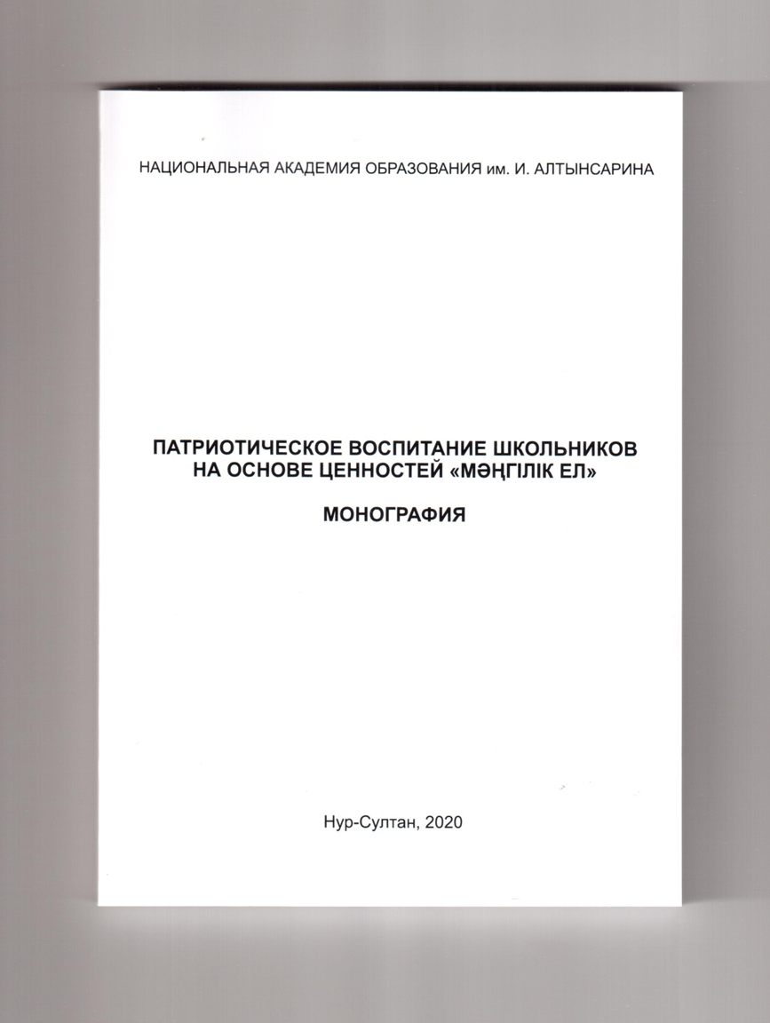
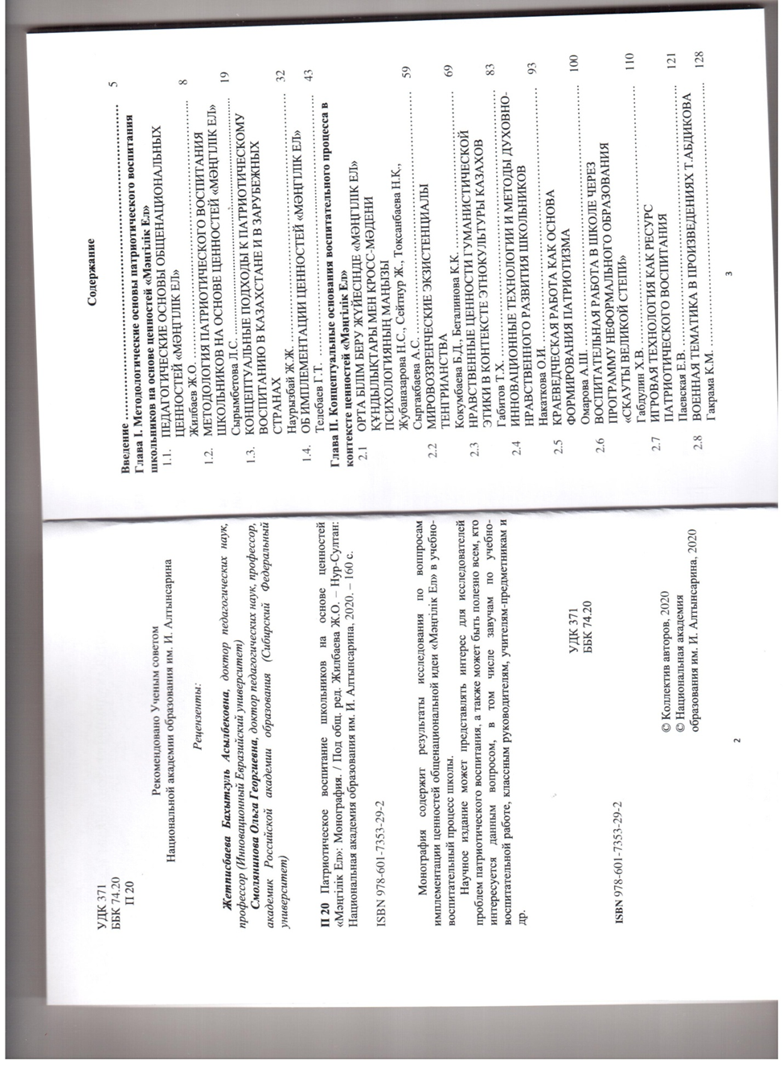
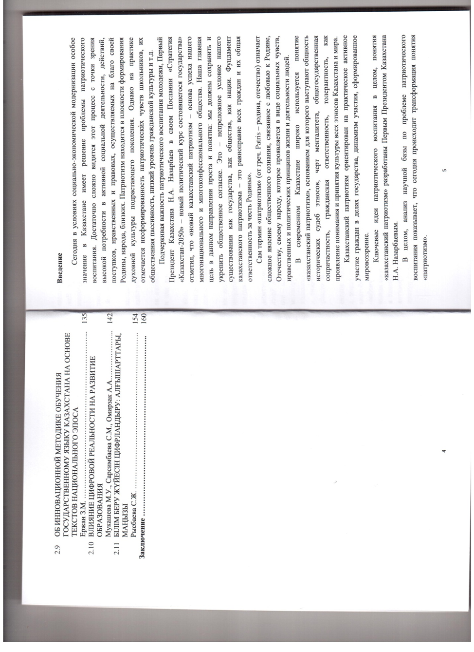
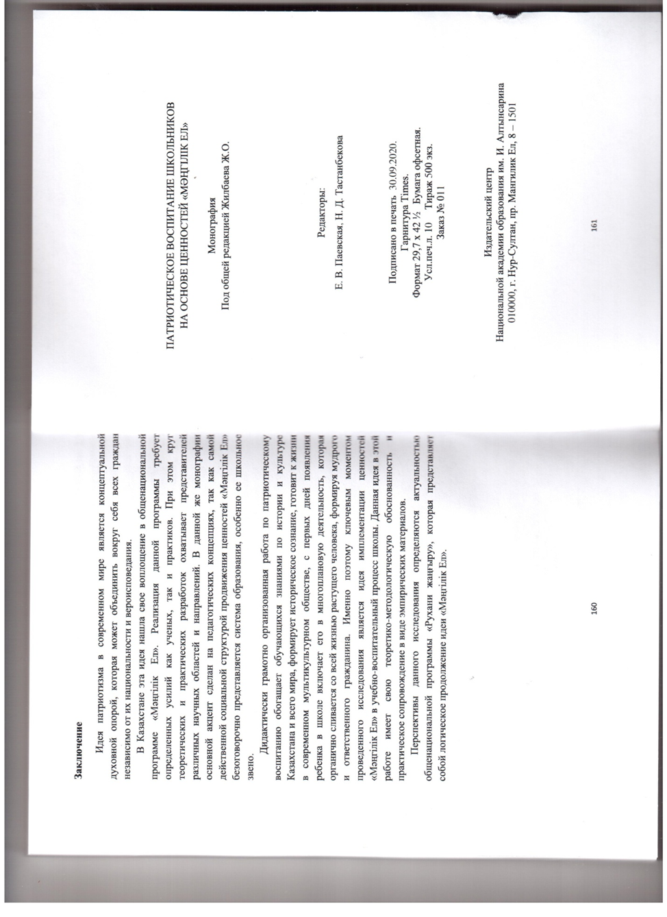

В) Scientific and methodological recommendations for the practical application of the “Matrix to implement the “Mangilik El” values in the educational process of comprehensive schools”
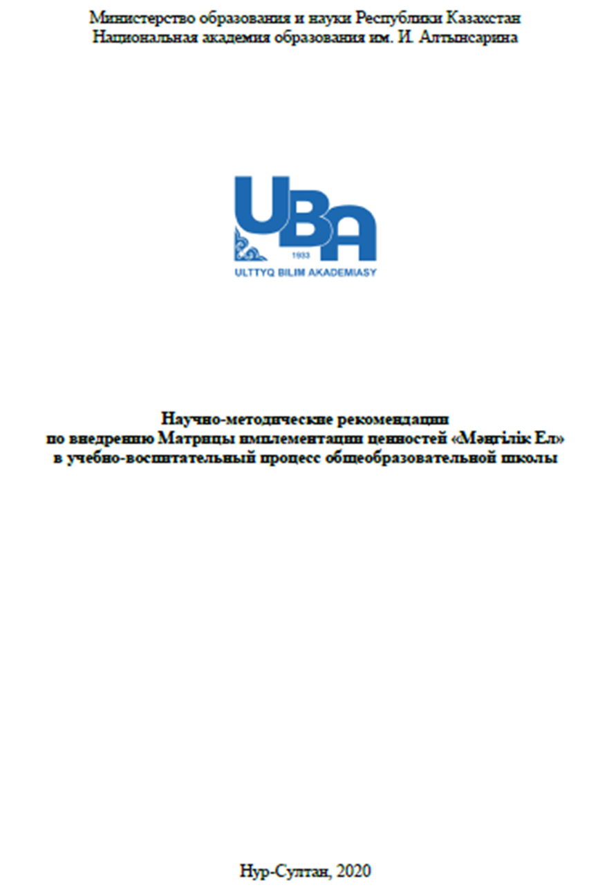
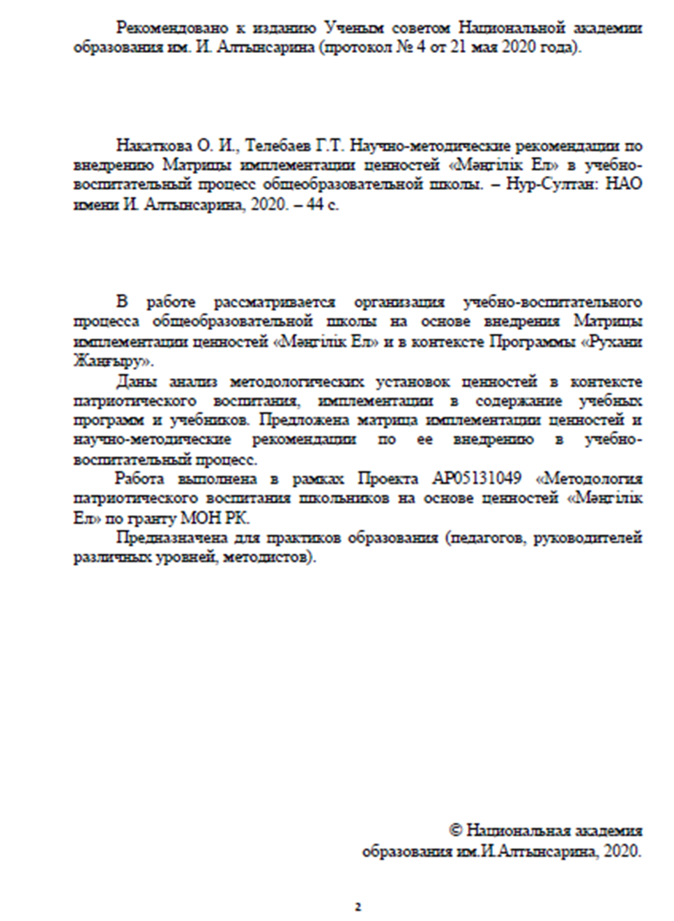
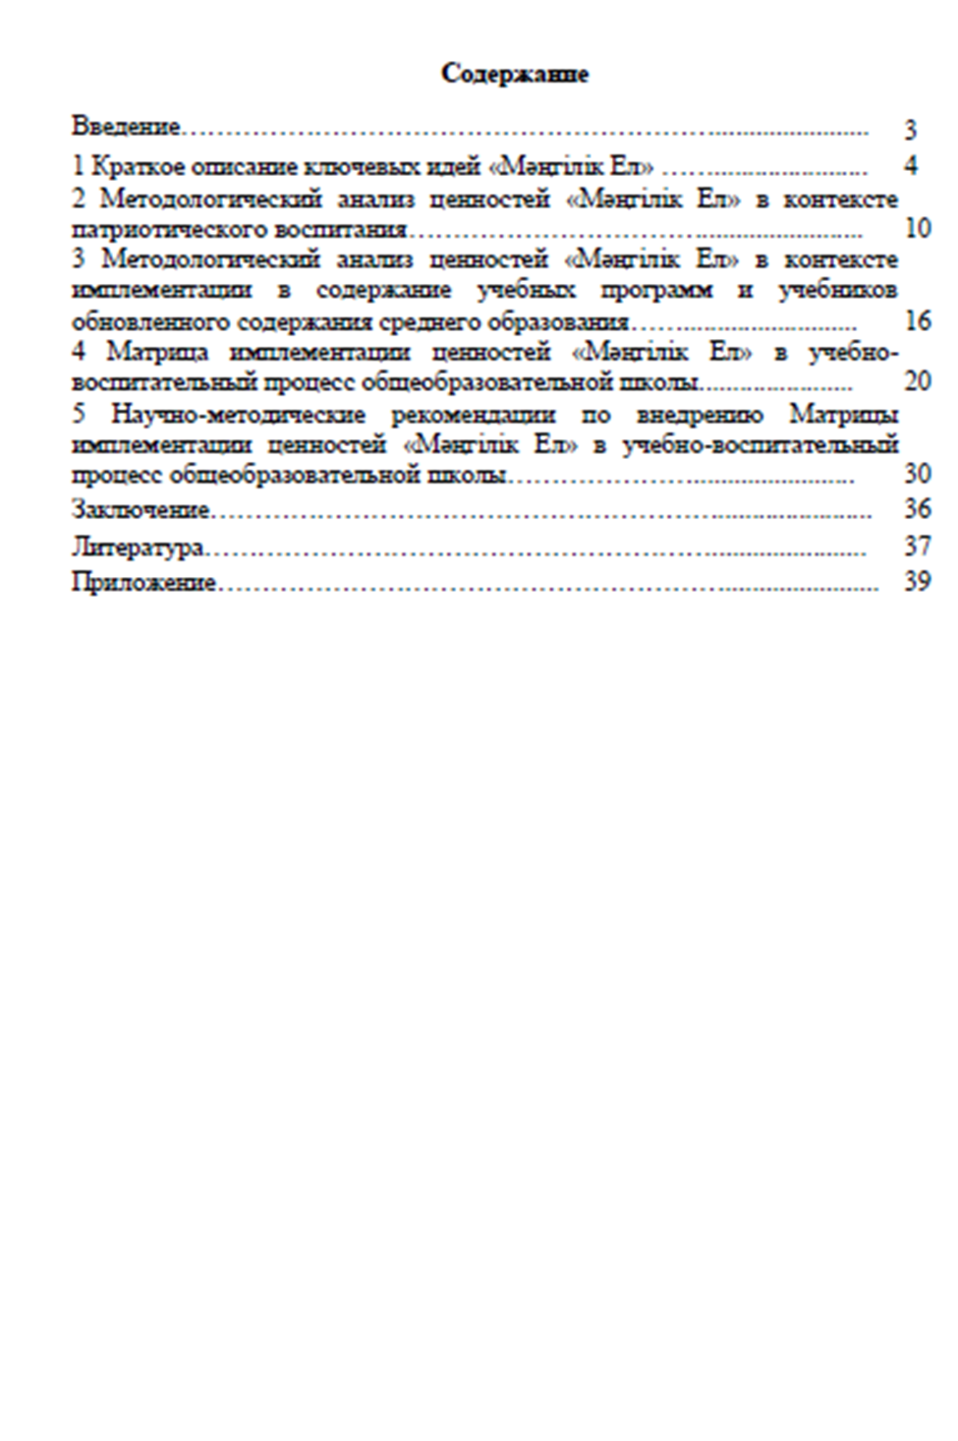
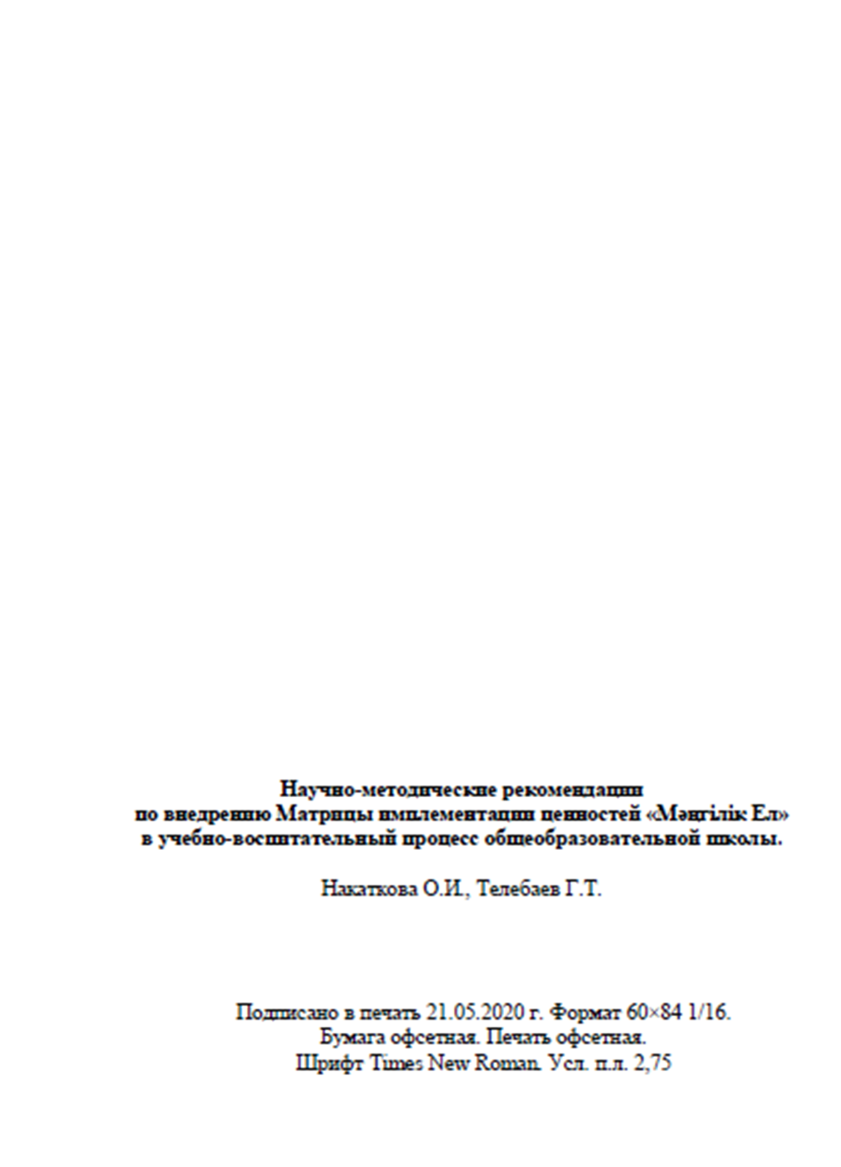
ANNEX F
Calendar plan
