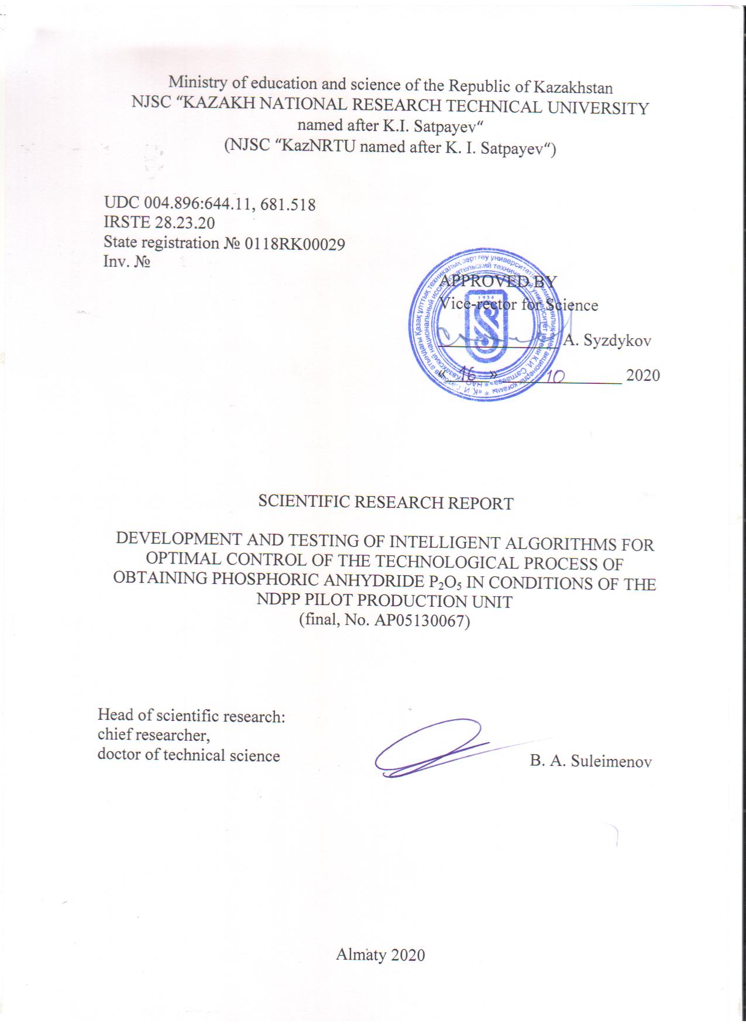

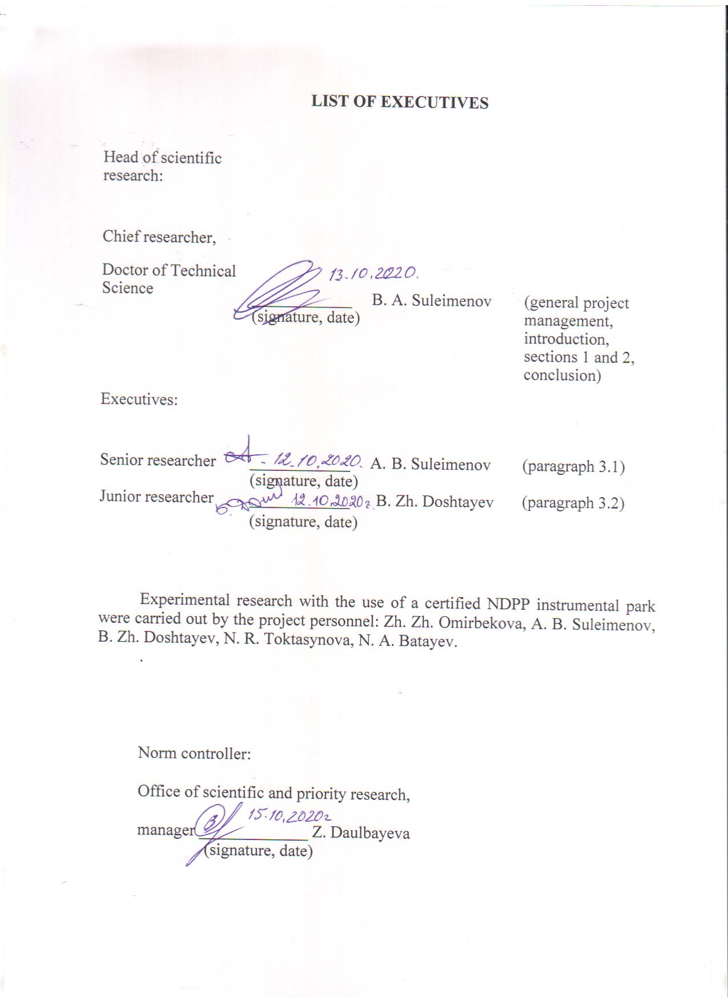

**Abstract**

Report 64 pages, 13 figures, 9 tables, 30 bibliographic sources, 7 appendices.

PHOSPHORIC ANHYDRIDE, P2O5, FUZZY MODELS, NEURAL NETWORK MODELS, NEURO-FUZZY MODELS, PHOSPHORUS PRECIPITATION, PHOSPHORUS OXIDATION, PHOSPHORUS SEDIMENTATION, PHOSPHORIC ANHYDRIDE COOLING

The object of research is the processes of sedimentation, oxidation, precipitation and cooling of phosphorus.

The aim of the study is to develop a system for optimal process control of obtaining dry phosphoric anhydride Р2О5 using artificial intelligence methods.

The goal of the work stage for 2020: To test intelligent algorithms for technological processes control for obtaining Р2О5 in the industrial conditions of NDPP.

Method of work: During the research, there were used modern intelligent technologies.

Work results and their novelty:

- software was developed that implements intelligent algorithms in industrial controllers;

- industrial tests of software and intelligent algorithms for controlling the process of obtaining phosphoric anhydride were carried out.

Basic constructive, technological, technical and operational characteristics. In contrast to traditional methods of constructing mathematical models, the work proposes to synthesize intelligent models of process control based on the knowledge and experience of intuition of operators-technologists.

Degree of implementation - industrial tests of models for controlling the processes of obtaining P2O5 were carried out.

Recommendations for the implementation or the research results implementation resume. Based on the results of industrial tests, the plant's management will make a decision to implement an intelligent control system.

Application area. The developed models and control algorithms can be adapted for other technological processes.

Economic efficiency, the specific output of finished products increased by 5%, and the waste-heat boiler produced 3% more specific heat energy.

Predictive proposals for the development of the research object. The developed methods and proposed algorithms can be used to create automated systems for optimal control of any technological processes after their adaptation to specific production conditions.

**Table of contents**

|  |  |
| --- | --- |
| DEFINITIONS …………………………………………………………………… | 6 |
| 1 Formation of FFE planning matrixes for the processes: sedimentation, |  |
| combustion, cooling and precipitation of dry P2O5 (research results for2018)... | 12 |
| 1.1 Formulate the concept of synthesis of intelligent control algorithms for |  |
| technological processes for obtaining P2O5 ………………………………... | 12 |
| 1.2 Collect expert opinions from experienced operators-technologists and |  |
| create FFE planning matrices for modeling process control: sedimentation, |  |
| combustion, cooling and precipitation of dry P2O5………………….…… | 14 |
| 1.2.1 Formation of the FFE matrix for the synthesis of intelligent algorithms |  |
| for combustion process control ….……………………………………. | 14 |
| 1.2.2 Formation of the FFE matrix for the synthesis of intelligent algorithms |  |
| for cooling process control ……………………………….…………… | 15 |
| 1.2.3 Formation of the FFE matrix for the synthesis of intelligent algorithms |  |
| for precipitation process control ……………………………………….. | 16 |
| 2 Development and exploration of intelligent controi models (algorithms) of |  |
| P2O5 production processes (research results for 2019) ..................................... | 17 |
| 2.1 Synthesize control models created with the use of methods: fuzzy |  |
| modeling, neural networks and neuro-fuzzy algorithms ………………… | 17 |
| 2.1.1 Synthesis of a fuzzy control model………..………………………….. | 18 |
| 2.1.2 Synthesis of a neural network control model ……………………….…. | 19 |
| 2.1.3 Synthesis of the neuro-fuzzy control model.…………………………… | 20 |
| 2.2 Conduct research of control models for sensitivity, stability, unambiguity |  |
| and assess the degree of their adequacy …………………………..……… | 21 |
| 2.3 Synthesis and study of simplified models for phosphoric anhydride |  |
| production control ……………………………………………….…. | 22 |
| 3 Testing intellectual control algorithms for technological processes of P2O5 |  |
| production in industrial conditions of NDPP (research results for 2020) ……. | 24 |
| 3.1 Development of software that implements intelligent algorithms in |  |
| industrial controllers…………………………………………….……….. | 24 |
| 3.1.1 Purpose and structure of software (SW) ……………………………... | 24 |
| 3.1.2 System software ………………………………………….…………… | 24 |
| 3.1.3 Service software ………………………………………………………. | 25 |
| 3.1.4 Technical support of the intelligent system……………………..…….. | 26 |
| 3.1.5 Coordination of software of the lower and upper levels of ACSTP …. | 28 |
| 3.2 Conduct tests of intelligent algorithms in industrial conditions of NDPP … | 33 |
| 3.2.1 Software testing…………………………………………………...…….. | 33 |
| 3.2.2 Industrial testing of intelligent algorithms in conditions of NDPP ….…. | 41 |
| CONCLUSION………………………………………………………………….... | 42 |
| REFERENCES………………………………………………………………...….. | 45 |
| APPENDIX A. Calendar plan for 2018-2020 …..………………………………... | 48 |
| APPENDIX B. List of published works for 2018-2020 …………………………. | 53 |
| APPENDIX C. Protocol of discussion of the final report on research work for |  |
| 2020 at a meeting of the Scientific and Technical Council of |  |
| "KazNRTU" NJSC. ……………………………………………….. | 56 |
| APPENDIX D. Protocol of discussion of the final report on research work for |  |
| 2020 at a meeting of the Academic council of the Institute |  |
| of industrial automation and informatization …………..……….. | 57 |
| APPENDIX E. Protocol of discussion of the final report on research work for |  |
| 2020 at a meeting of the department of automation and control … | 59 |
| APPENDIX F. Registration card (kaz., Rus.) ………………………………….. | 60 |
| APPENDIX G. Intelligent algorithm testing act ………………………………. | 64 |

**DEFINITIONS**

In current research report, the following terms are used with appropriate definitions:

Fuzzy model - a branch of mathematics that is a generalization of classical logic and set theory, based on the concept of a fuzzy set that takes any values ​​in the interval (0-1), not just 0 and 1, firstly introduced by Lotfi Zadeh in 1965 as an object with a function of an element membership to a set, on the basis of this concept, various logical operations on fuzzy sets are introduced, and the concept of a linguistic variable is formulated, the values ​​of which are fuzzy sets.

Neural network model - a mathematical model, as well as its software or hardware implementation, created on the principle of the organization and functioning of biological neural networks - networks of nerve cells of a living organism. This concept arose when studying the processes in the brain, and when trying to model them. The first such attempt was the neural networks of W. McCulloch and W. Pitts. After the development of training algorithms, the resulting models began to be used for practical purposes: in forecasting problems, for pattern recognition, in control problems, etc.

Neuro-fuzzy model - these systems from the field of artificial intelligence were proposed by S. R. Chang, which combine the methods of artificial neural networks and fuzzy logic systems. Neuro-fuzzy systems are the result of an attempt to create a hybrid intelligent system that would give a synergistic effect of these two approaches by combining the human-like style of reasoning of fuzzy systems with learning and the connectionist structure of neural networks. The main strength of neuro-fuzzy systems is that they are universal approximators with the ability to query interpreted IF-THEN rules.

**SYMBOLS AND ABBREVIATIONS**

In this research report, the following abbreviations and symbols are used:

|  |  |
| --- | --- |
| ACSTP | - automated control systems for technological processes |
| ISD | - initial statistical data |
| PFE | - full factorial experiment |
| ACS | - automated control system |
| AaC | - Department of Automation and Control of KazNRTU named after K.I. |
|  | Satpayev |
| AI | - artificial intelligence |
| TE | - technological equipment |
| NDPP  Р2О5 | - Novodzhambul phosphoric plant  - phosphoric anhydride |

**Introduction**

Assessment of the current state of the problem and its relevance. Nowdays, the task of developing optimal control systems for technological processes in metallurgy, chemical industry, petrochemistry, etc. is becoming more and more acute, allowing more rational use of mineral resources, saving heat and electric energy, reducing environmental problems, increasing economic returns from production. A stormy stage in the development of optimal control systems for various technological processes in the world, the USSR and Kazakhstan fell on the 60-80s of the last century. However, until now, for example, in Kazakhstan, no significant optimal control system has been introduced [28 - 30]. This is due to the extreme complexity of technological processes in non-ferrous and ferrous metallurgy, chemical and other sectors of the economy of Kazakhstan. Attempts to create sufficiently adequate mathematical models of such complex processes, unfortunately, had no success, and the trend for developing models gradually faded away. In recent years, publications in this direction have noticeably decreased.

Basis and initial data for the development of the topic. The basis for the development of this topic is the decision of the Ministry of Education and Science of the Republic of Kazakhstan to provide grant financing for this project. The initial data for the implementation of the project are articles, reports, textbooks and monographs, as well as technical documentation received at the NDPP.

Justification of the need for research. The rapid development of modern methods for the development and creation of intelligent systems has led to a significant increase in publications on the practical application of these methods in the creation of control systems.

We propose to test the developed methods and means of creating intelligent technologies for controlling the process of obtaining P2O5 anhydride. At the same time, it is necessary to take into account the fact that even a slight improvement in the indicators of this process can lead to significant economic and environmental effects.

Information about the planned scientific and technical level of development.

Despite the more than 40-year history of attempts in creation of optimal control systems for technological processes using traditional methods of mathematical modeling in Kazakhstan, in the CIS countries and in the world, no noticeable system has been introduced either in non-ferrous metallurgy, or in the chemical and petrochemical industry, or in other industries. This is due to the extreme complexity of modern technologies, in this connection, the creation of sufficiently adequate mathematical models of such processes is practically impossible.

Numerous studies carried out at the Department of Automation and Control of KazNRTU, as well as the analysis of publications, showed that intelligent technologies can be used in the development of a model of optimal process control, and not a model of the technological process itself. That is, the considered intelligent technologies (IT) allow developing control algorithms immediately, in contrast to the traditional chain: developing the structure of the process model → conducting experimental research on site → identifying the model → formulating an optimization problem → selecting an optimization method → ​​developing an optimal control algorithm. The traditional approach presupposes a long (sometimes several years), expensive and not always successful way of creating an optimal control system [28–30].

The use of IT allows solving similar problems immediately, and as experience has shown, quite successful. The fact is that artificial intelligence methods involve the use of knowledge, experience and intuition of expert people who are well acquainted with the subject area. That is, the so-called “ready knowledge” effect is used here. In contrast to this, the development of a mathematical model (the main component of the system) is a process of creating "new knowledge", and therefore requires a rather long time for theoretical research, as well as large material and labor costs for experimental research and identification of the model [1 - 27].

In addition, experienced operators-technologists during their long-term work have learned how to conduct the technological process in optimal modes under various initial situations (and they often succeed). The transfer of "ready knowledge" from experts to the knowledge base of an intelligent system greatly simplifies the creation of intelligent systems, and their operation eliminates the effect of the "human factor" in process control (these are properties of the human body such as: fatigue, insufficiently fast reaction, insufficient psychological stability, drowsiness during monotonous work, little experience of young operators and other reasons).

As it mentioned above, we have not found examples of the use of intelligent technologies in the control of technological processes. At the same time, we received 3 security documents for the methodology of developing such systems.

The end result of the project will be intelligent algorithms for controlling the process of obtaining P2O5. Since this process is unique and exists only at NDPP, there are no domestic and foreign analogues.

Information about the metrological support of research work. All experimental studies will be carried out at NDPP using its instrument park, which has passed all the necessary certification and verification procedures.

Relevance

In conditions of a market economy, the task of developing methods and means of creating intelligent optimal control systems for technological processes is urgent, which can significantly increase their economic efficiency. It is especially important in creating optimal control systems for complex, high-tonnage technologies that produce expensive products. This class includes technologies for the production of non-ferrous and rare metals, products of the chemical and petrochemical industries, pharmaceutical technologies, etc.

The relationship of this work with other research projects. This work is closely related to previously carried out studies on the development of intelligent algorithms for controlling the processes of phosphorus smelting in an ore-thermal furnace (2012-2014) and sintering firing of phosphorite fines under at NDPP (2013-2015).

Research goals and objectives. The goal of this project is to develop and test intelligent optimal control algorithms for the technological process of obtaining phosphorus anhydride on the pilot production unit of the Novodzhambul Phosphorus Plant (NDPP). The main objectives of the project for 2018-2020:

- to formulate the concept of creating intelligent optimal control algorithms for the technological process of obtaining phosphorus anhydride;

- to collect expert opinions from experienced operators-technologists and draw up a FFE planning matrix for modeling the processes: sedimentation, combustion, cooling and precipitation of solid phosphorus anhydride;

- to synthesize intelligent optimal control models (algorithms) for processes: phosphorus combustion, mixture cooling and sedimentation of dry P2O5 by three different methods;

- to conduct research of the obtained intellectual models for adequacy, sensitivity and uniqueness;

- to develop and test software for integrating an industrial controller with the Matlab environment;

- to conduct industrial tests of intelligent algorithms.

The results of previous research are presented in the 2018 R&D report. with inventory number No. 0218RK00977 (interim report) and in the 2019 research report. with inventory number No. 0219RK00994 (interim report).

Scientific novelty of the results obtained. As the analysis of works in the field of theory and practice of artificial intelligence has shown, nowadays there have been created quite effective technologies of artificial intelligence, which are used in various practical applications, including in control. However, most authors use these technologies for the development, research and implementation of local control systems intended mainly for solving the problems of stabilizing some variables of the technological process. We found no examples of the use of intelligent technologies to create optimal control systems for technological processes.

For ten years, the Department of Automation and Control has been conducting research on the development of optimal control systems for technological processes using intelligent technologies. Generalization of the accumulated experience allows to solve the stated goal of the project - to develop methods and means of creating intelligent control systems for technological processes for any industry.

Based on the research carried out in 2018-2020, the following new scientific results will be obtained:

- proposed methods and means for the development of intelligent or hybrid models of the object control process;

- compiled matrixes for planning a full factorial experiment (FFE) for the synthesis of process control models: sedimentation, combustion, cooling and precipitation of dry phosphoric anhydride;

- synthesized, investigated and tested intelligent process control models: sedimentation, combustion, cooling and precipitation of dry phosphoric anhydride;

- proposed means for integrating an industrial controller with the Simulink environment of the Matlab package.

- carried out tests of intelligent control algorithms.

**1 Formation of FFE planning matrixes for the processes: sedimentation, combustion, cooling and precipitation of dry P2O5 (research results for 2018)**

For 2018, there were planned works on formulating a concept for the synthesis of intelligent algorithms for controlling the processes of obtaining phosphorus anhydride and their research.

**1.1 Formulate the concept of synthesis of intelligent control algorithms for technological processes for obtaining P2O5**

The technological scheme for obtaining phosphorus anhydride is shown on Figure 1.1. In 2018, we analyzed the technology and identified the main input and output variables of the processes: sedimentation, combustion, cooling and precipitation.

The sedimentation process in the dosing unit

In this regard, the phosphorus is sedimented in the dosing unit at a temperature of 70°C - 85°C. Respectively, according to its chemical properties, phosphorus turns into a solid state at temperatures above + 70°C, and if it is below + 43°C, it turns into a liquid form of phosphorus. In the dosing unit, phosphorus sediments together with water and nitrogen for at least 2 hours, since nitrogen prevents the appearance of a toxic gas - phosphine. The density of phosphorus in the dosing unit is distributed so that it sediments on the bottom, while water at a high temperature fills the top of the dosing unit by 30 centimeters, and nitrogen is contained in the dosing unit between them. Since the temperature in the dosing unit is 70°C, phosphorus and water do not mix.

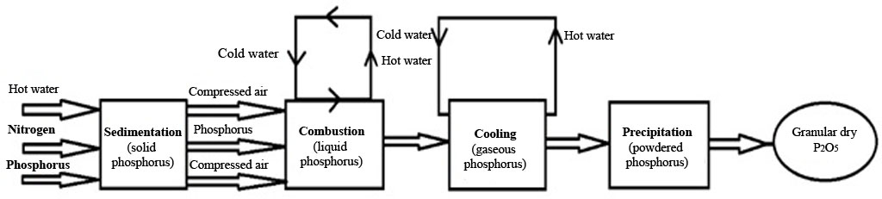

Figure 1.3 – Stages of obtaining dry Р2О5

Due to the fact that the sedimentation process is periodic, and no chemical transformations take place in it - it is a simple object with a delay and serves as a doser, we will not consider it as a control object. In this connection, we do not need to conduct experimental research in order to synthesize a control system for it.

Combustion process in the combustion chamber

Phosphorus leaves the dosing unit in liquid form and is supplied to the burner. Compressed air is supplied to the burner from both sides, and cold water comes from the outside, which comes out hot along circular flows. This principle goes on continuously in order to keep the temperature constant. Compressed air penetrates into the burner from two sides: the principle of operation of the first one - sprays phosphorus in the center, and the second one - the periphery, similar to a vortex ignites phosphorus. This will ensure a more complete combustion of phosphorus. In the burner, phosphorus burns at a temperature of 1500°C – 2000°C. After combustion, the gaseous phosphorus is sent to the waste heat boiler in order to cool down.

The combustion process is the main process in which phosphorus anhydride is obtained in a gaseous state. During the survey of experienced operators-technologists, the following main input variables were identified:

X1 - recirculation gases flow rate;

X2 - compressed air consumption;

X3 - technical oxygen O2 consumption;

X4 - yellow phosphorus consumption from the dosing unit.

The main output variable on which the completeness of phosphorus combustion depends is the temperature in the burner, due to the fact that the temperature inside the burner is very high (up to 2000°C) - it is very difficult to measure it, indirectly the temperature in the burner can be measured by the temperature at the output (up to 600°C). Therefore, we have chosen the temperature at the output of the burner (or at the input of the boiler) - Y1 as the output variable of the combustion process.

Cooling process in a waste heat boiler

The waste heat boiler consists of a lining brick (to enhance the fire resistance of materials) inside which there is a pipe, in which cold water flows, and between the brick and the pipe there is a space through which the gaseous phosphorus passes. The water flowing inside the pipe cools the hot phosphorus. A drum is installed on the upper part of the waste heat boiler, in which the water level is half of its volume. Cold water helps to maintain the temperature in the boiler in a uniform state. Water passing through the pipes, having completed a cycle, is brought back into the drum. Water at a low temperature enters the waste heat boiler, and leaves it at a sufficiently high temperature. If there is a small amount of water in the drum, the pipe can melt. In order to avoid this, the amount of water must always be controlled.

We selected the following input variables (with the help of experienced operators-technologists):

X5 - the flow rate of gases leaving the combustion chamber. Since this flow rate is extremely difficult to measure, we can indirectly determine it by the total amount of consumption: recirculated gases, compressed air and technical oxygen, i.e. we will assume that Х5 = Х1 + Х2 + Х3;

X6 - the temperature at the input of the waste heat boiler, which is equal to the temperature at the output from the combustion chamber, i.e. Х6 = Y1;

X7 - cooling water consumption. Due to the fact that the water consumption is not measured, it can be indirectly estimated by the water pressure at the input to the waste heat boiler, i.e. Х7 = Рвк.

The output variables of the cooling process in the waste heat boiler are: the temperature at the boiler output - Y2 and the flow rate of the generated steam - Y3. Due to the fact that steam consumption is not measured, it can be indirectly estimated by its pressure - Рд.

The precipitation process in the economizer

The process of precipitation, or crystallization of Р2О5 occurs in the economizer when it is further cooled to a temperature below 160°C, and in the cyclone only crystalline P2O5 is separated from the recirculation gases. We have defined the following input variables:

X8 - consumption of gases leaving the waste heat boiler, while Х8 = Х1 + Х2 + Х3;

X9 - the temperature at the input to the economizer, which is equal to the temperature at the output of the waste heat boiler, i.e. Х9 = Y2;

X10 - the flow rate of the economizer cooling water. Due to the fact that the water consumption is not measured, it can be indirectly estimated by the water pressure at the input to the economizer, i.e. Х10 = Рвэ.

The output variables of the cooling process the exhaust gases in the economizer are: the temperature at the output of the economizer - Y4 and the consumption of the obtained solid phosphorus anhydride - Y5.

Thus, our proposed concept for the synthesis of intelligent models for controlling the processes of obtaining phosphorus anhydride made it possible to identify 10 input and 5 output variables for the processes: combustion, cooling and precipitation of solid P2O5.

**1.2 Collect expert opinions from experienced operators-technologists and create FFE planning matrices for modeling process control: sedimentation, combustion, cooling and precipitation of dry P2O5**

The main task in the development of a control model is to compile a planning matrix for a full factorial experiment (FFE). The efficiency of the entire control system will depend on the quality of the FFE matrix. The FFE planning matrix should reflect the experience, knowledge and intuition of operator-technologists who have worked for a long time on three-circuit phosphor furnaces.

1.2.1 Formation of the FFE matrix for the synthesis of intelligent algorithms for combustion process control

As it was noted above, the task of the optimal process control subsystem is to determine the optimal values ​​of the gas temperature after the combustion chamber (Y1) depending on the flow rate of recirculation gases (X1), the flow rate of compressed air (X2), the flow rate of technical oxygen (X3) and the flow rate of yellow phosphorus from the dosing unit (X4). As a rule, such calculations must be made constantly (approximately once every 5-7 minutes), depending on the situation. A survey of the technologists made it possible to compile the FFE planning matrix for 81 experiments with a three-level assessment (0.0; 0.5 and 1.0), four input variables: N = 34 = 81 (a fragment of the FFE matrix is ​​given in Table 1.1).

Table 1.1 – FFE planning matrix for the yellow phosphorus combustion process

|  |  |  |  |  |  |
| --- | --- | --- | --- | --- | --- |
| Input variables | | | | | Output  variables |
| Exp.№ | Х1 | Х2 | Х3 | Х4 | Y1 |
| 1 | 0.0 | 0.5 | 0.0 | 0.5 | 0,76 |
| 2 | 0.5 | 0.5 | 0.0 | 0.5 | 0,53 |
| 3 | 1.0 | 0.5 | 0.0 | 0.5 | 0 |
| … | … | … | … | … | … |
| 78 | 1.0 | 0.0 | 1.0 | 1 | 0,04 |
| 79 | 0.0 | 1.0 | 1.0 | 1 | 0,78 |
| 80 | 0.5 | 1.0 | 1.0 | 1 | 0,63 |
| 81 | 1.0 | 1.0 | 1.0 | 1 | 0,07 |

Normalization in the range from 0 to 1 of input and output variables was carried out according to formula (1.1). In table 2.7 all variables are normalized in the range from 0.0 to 1.0. At the same time, the lower and upper boundaries of the ranges given in Table 2.4 (on the recommendation of experienced operators-technologist) were expanded taking into account possible fluctuations in the input variables that do not allow switching to emergency modes of the phosphorus combustion process. Thus, we have provided the ability to control the process over a wide range of input variables, which will allow to control the combustion process more efficiently. Taking into account the recommendations of experienced operators-technologists - the range of variation of the input variables was decided to expand as follows:

238,0 nm3/hour < Х1 < 438,0 nm3/hour;

1,0 nm3/hour < Х2 < 2,0 nm3/hour;

40,0 nm3/hour < Х3 < 50,0 nm3/hour;

10,0 kg/hour < Х4 < 60,0 kg/hour;

350ºС < Y1 < 550ºС.

Taking into account the accepted ranges of variation of the input variables, the FFE planning matrix was compiled by experienced operators-technologists using a "mental" experiment. Table 2.7 contains many years of experience of the technologists of facility No. 6.

1.2.2 Formation of the FFE matrix for the synthesis of intelligent algorithms for cooling process control

As it was noted above, the task of the optimal process control subsystem is to determine the optimal values ​​of the gas temperature after the waste heat boiler (Y2) and the amount of generated steam (Y3), depending on the flow rate of gases leaving the combustion chamber (X5), the temperature at the input of waste heat boiler (X6) and consumption (pressure) of cooling water (X7).

A survey of the technologists made it possible to compile the FFE planning matrix for 27 experiments with a three-level assessment (0.0; 0.5 and 1.0), three input variables: N = 33 = 27 (a fragment of the FFE matrix is ​​given in Table 1.2).

Table 1.2 - FFE planning matrix for the cooling process

|  |  |  |  |  |  |
| --- | --- | --- | --- | --- | --- |
| Exp.№ | X5 | X6 | Х3 | У2 | У3 |
|
| 1 | 1.0 | 1.0 | 1.0 | 0,68 | 1 |
| 2 | 1.0 | 1.0 | 0.0 | 0,68 | 1 |
| 3 | 1.0 | 1.0 | 0.5 | 0,68 | 1 |
| 23 | 0.5 | 0.5 | 0.0 | 0,52 | 0,35 |
| 24 | 0.5 | 0.5 | 0.5 | 0,52 | 0,35 |
| 25 | 0.5 | 0.0 | 1.0 | 0,2 | 0,6 |
| 26 | 0.5 | 0.0 | 0.0 | 0,2 | 0,6 |
| 27 | 0.5 | 0.0 | 0.5 | 0,2 | 0,6 |

Normalization in the range from 0 to 1 of input and output variables was carried out according to formula (1.1). In table 2.8 all variables are normalized in the range from 0.0 to 1.0. At the same time, the lower and upper boundaries of the ranges shown in Table 2.2 (on the recommendation of experienced operators-technologists) were expanded taking into account possible fluctuations in the input variables that do not allow switching to emergency modes of the phosphorus combustion process. Taking into account the recommendations of experienced operators-technologists - the range of variation of the input variables was decided to expand as follows:

280,0 nm3/hour < Х5 <500,0 nm3/hour;

350ºС < Х6 < 550ºС;

11 kg/sm2 < Х7 < 18 kg/sm2;

160ºС < Y2 < 220ºС;

10,0 kg/hour < Y3 < 60,0 kg/hour.

1.2.3 Formation of the FFE matrix for the synthesis of intelligent algorithms for precipitation process control

The task of the subsystem for optimal control of the precipitation process of crystalline phosphorus anhydride in the economizer is to determine the optimal values ​​of the gas temperature after the economizer (Y4) and the flow rate of the formed solid phosphorus anhydride P2O5 (Y5) depending on the flow rate of exhaust gases from the waste heat boiler (X8), the temperature at the input to economizer (X9) and consumption (pressure) of water cooling economizer (X10).

A survey of the technologists made it possible to compile the FFE planning matrix for 27 experiments with a three-level assessment (0.0; 0.5 and 1.0), three input variables: N = 33 = 27 (a fragment of the FFE matrix is ​​given in Table 1.3).

Table 1.3 - FFE planning matrix for the precipitation process

|  |  |  |  |  |  |
| --- | --- | --- | --- | --- | --- |
| Exp.№ | X8 | X9 | Х10 | У4 | У5 |
|
| 1 | 1.0 | 1.0 | 1.0 | 0,48 | 1 |
| 2 | 1.0 | 1.0 | 0.0 | 0,52 | 1 |
| 3 | 1.0 | 1.0 | 0.5 | 0,61 | 1 |
| … | … | … | … | … | … |
| 25 | 0.5 | 0.0 | 1.0 | 0,21 | 0,56 |
| 26 | 0.5 | 0.0 | 0.0 | 0,23 | 0,59 |
| 27 | 0.5 | 0.0 | 0.5 | 0,27 | 0,62 |

Normalization in the range from 0 to 1 of input and output variables was carried out according to formula (1.1). In table 2.9 all variables are normalized in the range from 0.0 to 1.0. At the same time, the lower and upper boundaries of the ranges shown in Table 2.4 were expanded taking into account possible fluctuations in the input variables that do not allow switching to emergency modes of the phosphorus combustion process:

150,0 nm3/hour < Х8 < 500,0 nm3/hour;

160ºС < Х9 < 220ºС;

10 kg/sm2 < Х10 < 19 kg/sm2;

140ºС < Y4 < 200ºС;

10 kg/sm2 < Y5 < 16 kg/sm2.

Taking into account the accepted ranges of variation of the input variables, the PFFE planning matrix was compiled by experienced operators-technologists using a "mental" experiment. Table 2.8 contains many years of experience of the technologists of the facility.

**2 Development and exploration of intelligent controi models (algorithms) of P2O5 production processes (research results for 2019)**

In 2019, the calendar plan provides the synthesis of intelligent models for controlling the process of obtaining phosphorus anhydride and their study

**2.1 Synthesize control models created with the use of methods: fuzzy modeling, neural networks and neuro-fuzzy algorithms**

Let us consider the methodology for the synthesis of intelligent models of combustion process control. Intelligent models for controlling the processes of cooling and precipitation of phosphorus anhydride were synthesized similarly.

2.1.1 Synthesis of a fuzzy control model

Firstly, the rules of fuzzy production are formed, i.e. each experiment from Table 1.1 has its own production rule, for example [2]:

RULE 1: "IF X1 EQUALS 0" AND "X2 EQUALS 0.5" AND "X3 EQUALS 0" AND "X4 EQUALS 0.5", THEN "Y EQUALS 0.76"

RULE 2: "IF X1 EQUALS 0.5" AND "X2 EQUALS 0.5" AND "X3 EQUALS 0" AND "X4 EQUALS 0.5", THEN "Y EQUALS 0.53"

RULE 3: "IF X1 EQUALS 1" AND "X2 EQUALS 0.5" AND "X3 EQUALS 0" AND "X4 EQUALS 0.5", THEN "Y EQUALS 0"

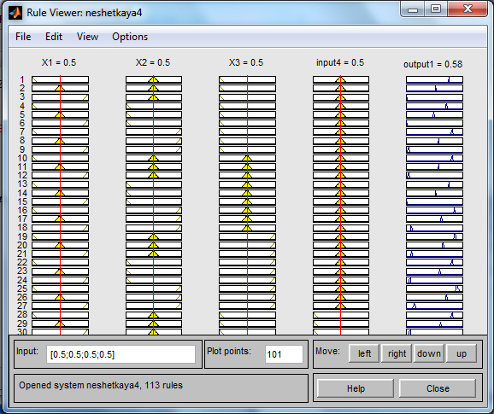

Figure 2.1 – Rule editor graphical interface after setting the rule base for a given fuzzy inference system

Production rules for all 81 experiments from Table 1.1 are compiled similarly, as shown on Figure 2.1.

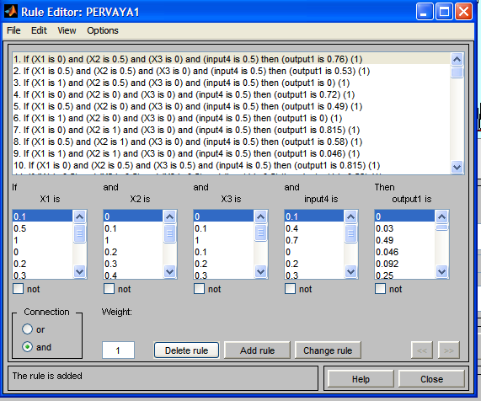

Figure 2.2 – Fuzzy process control model

After Matlab performs all the necessary procedures in accordance with the selected fuzzy inference algorithm (for example, the Mamdani algorithm), a fuzzy model of optimal control of the combustion process will be presented in the graphical interface for viewing the rules (see Figure 2.2), which is the model (algorithm) of optimal control, with the help of which it is possible to simulate various modes for all possible combinations of values of the input variables.

2.1.2 Synthesis of a neural network control model

Instead of fuzzy models, neural networks can also be used to model the control process. To train a neural network, you need to enter the results of 81 experiments from Table 1.1.

In the input data field, specify the previously created data, set the type of neural network, select the perceptron (Feed-Forward Back Propagation) with 10 sigmoid (TANSIG) neurons of the hidden layer and one linear (PURELIN) neuron of the output layer. We will train using the Levenberg - Marquardt algorithm, which implements the TRAINLM function. The error function is MSE.

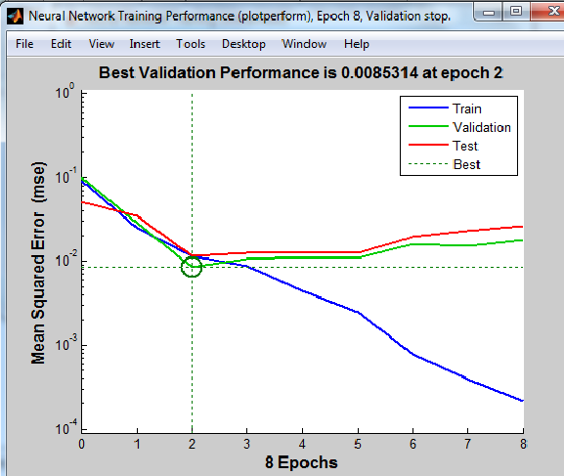

Figure 2.3 – Neural network training progress

The program will show progress and training outcomes as shown on Figure 2.3.

2.1.3 Synthesis of the neuro-fuzzy control model

Instead of fuzzy models and neural networks, there can be used hybrid models, such as neuro-fuzzy networks, which, by essence, should combine all the advantages of the above two methods. The capabilities of MATLAB allow to conduct these studies. In order to do this, MATLAB has an ANFIS editor that allows to create or load a specific model of an adaptive neuro-fuzzy inference system, train it, visualize its structure, change and adjust its parameters, and also use a configured network to obtain fuzzy inference results.

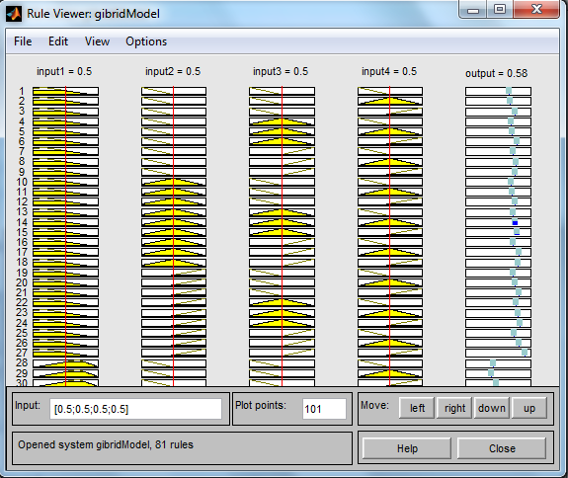

Figure 2.4 – Neuro-fuzzy control model

As a result, after the network training is completed, a neuro-fuzzy control model will be synthesized (see Figure 2.4), it can be tested, test data can be loaded, or viewed and set any valid values ​​in the FIS of the Rule Viewer editor, as well as in fuzzy logic.

**2.2 Conduct research of control models for sensitivity, stability, unambiguity and assess the degree of their adequacy**

After the synthesis of control models (algorithms), it is necessary to investigate their quality by the analysis of models for sensitivity, stability, unambiguity and adequacy.

Figure 2.5 shows the temperature changes (according to table 2.1) behind the burner depending on the flow rate of the circulating gas (X1), the flow rate of compressed air (X2), the flow rate of technical oxygen (X3) and the flow rate of yellow phosphorus from the dosing unit (X4). Each curve was obtained with the value of the other input variables equal to 0.5.

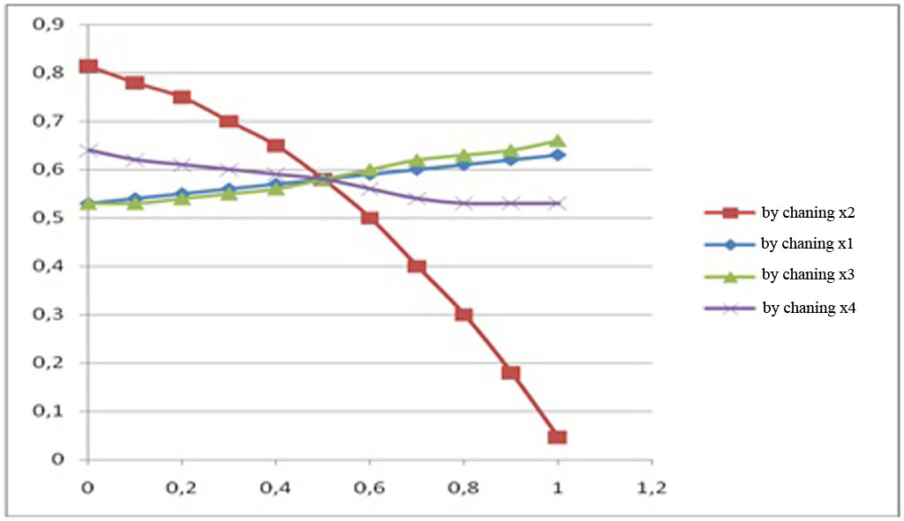

Figure 2.1 – Curves obtained from the FFE planning matrix

The results of modeling with three types of models were obtained, which showed their high adequacy (see table 2.1).

Table 2.1 – Comparative assessment of the absolute error for different methods

|  |  |
| --- | --- |
| Modeling method | The value of the absolute error % |
| *Y* |
| 1. Fuzzy algorithms | 0,3 |
| 2. Neural network algorithms | 2,9 |
| 3. Neuro-fuzzy networks | 0,2 |

Model robustness is the ability to maintain adequacy when examining system performance over the entire possible range of workloads, as well as when making changes to the system configuration.

Sensitivity means that with a small change of the input parameters, there is occurred such a change in the indicators of the properties of the system, which can be detected in the conditions of calculation error.

Sensitivity analysis identifies changes in the model's response to deviations of individual model parameters. This allows to conclude about the relative importance of the input variables for a particular model, to select key variables and to identify those that can be excluded from consideration without prejudice.

The purpose of the sensitivity analysis is to comparatively analyze the influence of various factors on the result of solving the modeling problem.

When analyzing the sensitivity (Figure 2.6), we assessed the influence of the accepted initial data (for each set of significant factors, hypotheses, assumptions) on the result. The calculations showed the sensitivity coefficients for: Х1 = 1,25, Х2 = 0.16, Х3 = 0,37 and Х4 = 0,15. Thus, the neuro-fuzzy model is most sensitive to changes in the traverse height. The results of the sensitivity analysis of the neuro-fuzzy model are also shown graphically on Figure 2.6 (a graph with data after modeling by the neuro-fuzzy method is drawn in blue, and in red when these data changes by 0.02).

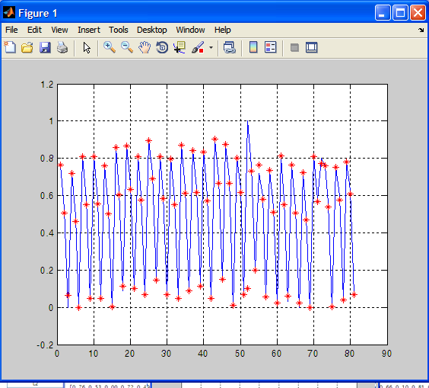

Figure 2.6 – Results of comparative sensitivity assessments

Similar research was carried out for intelligent control models for the processes of cooling and precipitation of solid phosphorus anhydride.

All research has shown that the synthesized models do not contradict the physicochemical laws of the processes of combustion, cooling and precipitation during the production of P2O5.

**2.3 Synthesis and study of simplified models for phosphoric anhydride production control**

The above studies have shown that the synthesized models do not contradict the physicochemical laws of the processes of combustion, cooling and precipitation during the production of P2O5.

However, as it was found from the survey of operators-technologists, in fact, in practice, they do not take into account such a large number of variables: 10 input and 4 output is too difficult. In practice, when controlling the production of phosphorus anhydride, they are mainly guided by two input variables: phosphorus consumption and compressed air consumption, and one output variable - the gas temperature after the collector.

The fact is that all the other 8 input variables are indirectly dependent on these two control actions, and the temperature in the collector is well measurable and basically characterizes the course of all three processes: combustion, cooling and precipitation of phosphorus anhydride.

That is, in fact, the operators consider all these three processes, which occur as if in one unit (see figure 2.7)

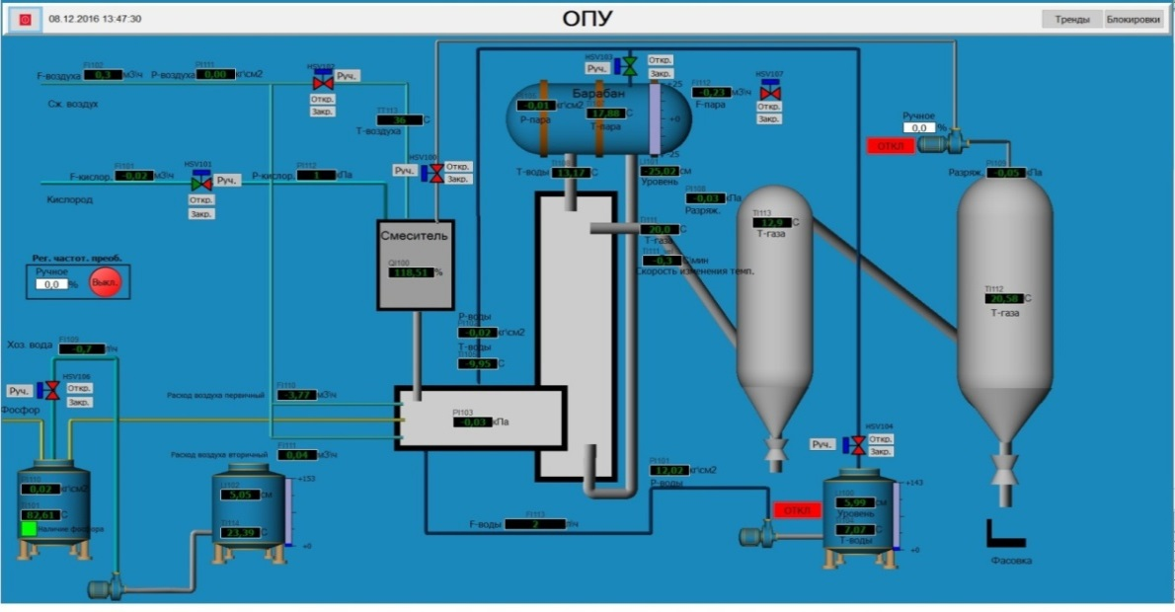

Figure 2.8 – The main window of the dispatcher mnemonic diagram

Therefore, it was decided to synthesize and research also a simplified intelligent control model with two input and one output variable. Experience has shown [3-15] that the use of simpler intelligent models close to "manual" control is more efficient in practice than complex ones with many input and output variable algorithms. The synthesis and research of the simplified model was carried out similarly to the above mentioned ones.

**3 Testing intellectual control algorithms for technological processes of P2O5 production in industrial conditions of NDPP (research results for 2020)**

In 2020, the calendar plan provides the development of software for an industrial controller and testing of control algorithms for the process of obtaining phosphorus anhydride.

**3.1 Development of software that implements intelligent algorithms in industrial controllers**

3.1.1 Purpose and structure of software (SW)

The software (SW) of the intelligent operational control system (IOCS) is designed to perform the functions of automatic modeling of the optimal control system and the implementation of control actions based on the calculations of the intelligent optimal control model. The software is developed in the Simulink simulation environment of the MatLab package, information display and operational control is carried out using Experion PKS.

The structure of the software has a two-level hierarchy.

At the lower level there is the Experion PKS-based software for ACSTP developed by Honeywell-ACS LLP, which implements the functions of operational and process control.

At the top level, there is software that directly simulates the optimal control system based on intelligent algorithms using the MatLab package. The visualization of the calculated model values ​​is carried out using Experion PKS tools.

The software of the upper level is a collection of subsystems that carry their own individual functional load. It has a modular structure and is created on the principles of the concept of open systems.

The implementation of an open architecture is based on the selection and standardization of interfaces for interaction of software components with data storages and components among themselves.

The system software structure includes the following main components:

- system software (SS);

- service software;

- applied software (AS).

3.1.2 System software

System software (SS) is an environment for the normal functioning of service and applied software. System software provides:

### - functioning of the software and hardware complex (SHC) and interaction with external systems with the achievement of the specified requirements for reliability and fault tolerance;

### - development and execution of applications that directly implement the functions of the ACSTP and modeling;

### - development and implementation of the required human-machine interface;

### - testing and diagnostics of hardware and software means.

### The upper level workstation system software includes:

### - operating system (OS) Windows2007;

### - support components of the network protocol TCP/IP.

### The operating system (OS) Windows 2007 provides an environment for the normal functioning of the ACSTP and of the modeling system. Windows 2007 OS has the following distinctive features:

### - wide opportunities for system administration;

### - support for a variety of protocols for data transmission over the network;

### - functional distribution;

### - the presence of convenient graphic shells;

### - availability of translators from C and C++ languages.

#### The main functions of the OS of the upper level are:

- initial loading of software when turning on the equipment;

- checking the state of computing and network equipment at launching and during operation;

- restart in case of failures and refusals in programs and equipment;

- software support in real time;

- implementation of input/output operations;

- handling interrupts, events and situations;

- distribution of CPU time between executors;

- protection of executors from each other during operation;

- exchange of messages between executors;

- joint use of external equipment, including technological, by executors.

The distributed OS also provides:

- exchange of messages between processes running on different network nodes;

- gateway connection to external networks on the assumption that the latter works over TCP/IP;

- registration of faults and failures of computing equipment for the subsequent issuance of final reports.

3.1.3 Service software

Experion PKS package (EPKS) ​​is based on the latest software developments and techniques. EPKS is an open and scalable DCS system that supports the most common interfaces and allows to create applications of varying complexity. The openness of the EPKS is supported at all levels of operation of this system through the use of open interfaces and the availability of internal EPKS structures. Data exchange with other Windows-applications is carried out using DDE, OLE, ODBC/SGL mechanisms.

Support for the OLE 2.0 interface allows embedding both OLE documents and ActiveX components into an EPKS application. The archiving subsystem is based on well-known relational databases. The database is accessed through the standard ODBC interface and through the EPKS API-interface. The EPKS GlobalScripts subsystem includes an interpreter for writing event handlers and functions in C language. Event handlers can include your own DLLs developed in Visual C ++.

EPKS adheres to open standards of communication drivers for controllers and supports internationally known specifications for data exchange. EPKS has a built-in standard Microsoft SQL server database that stores all the list design and process data.

The EPKS database can be accessed using the SQL Structured Query Language or ODBC driver. Through these access methods, EPKS opens its data, for example, to other programs and Windows databases.

Standard interfaces like DDE and OLE for communicating between Windows programs are integral parts of EPKS, allowing unproblematic embedding of ActiveX control elements and OPC client/server functionality.

3.1.4 Technical support of the intelligent system

The structure of the complex of technical means (hereinafter CTM) is based on the basic principles of creating automated control systems for industrial facilities:

- compatibility with the software of the monitoring, data collection and management systems;

- open architecture;

- redundancy of local networks, workstations and technological protections to ensure the required operational reliability;

- use of unified devices, blocks and nodes;

- ensuring uninterrupted power supply;

- high reliability and maintainability;

- rational accounting of purchase and maintenance costs.

Based on the above mentioned, the structure of the IOCS consists of a server, a workstation and an HC900 hybrid controller, and is designed to implement the functions and tasks of operational control of the object.

The server is the head part of the IOCS computer system, controls all types of software and collects data. It performs the tasks of monitoring and managing the collection and storage of data from the Experion PKS server of the existing ACSTP ECS, implements important tasks of managing the real and archived database, including:

- storage and maintenance of databases and databases of the state of devices;

- typical information processing;

- logging and documentation;

- storage and maintenance of the system configuration;

- performance of functions of network administration in the LAN;

- access control to the system.

### A workstation is a “man-machine” relationship between an operator and a computer IOCS. The operator from the workplace receives detailed information about the state of the control object, the results of calculation and analytical tasks, performs input-output of data and system results.

### Honeywell's HC900 Hybrid Controller is an advanced loop and logic controller with a modular design to meet the control and data acquisition requirements of a wide range of process equipment. Combination with the optional 1042 or 559 high performance operator interfaces, fully integrated with the controller database, allows to minimize configuration and installation time. This powerful combined system, together with advanced control technology developed by Honeywell, provides the user with an ideal solution to the process control problem. The Ethernet connectivity also enables network access using HMI/SCADA software. Easy-to-use, Windows-based Hybrid Control Designer software with the use of Ethernet, RS232 port or modem communication greatly simplifies controller and operator interface configuration. It provides advanced control functions for debugging, enables configuration changes to limit process interruptions, downloads annotated graphics controller and operator interface configurations, and provides a series of printouts for extended documentation.

The HC900 controller provides superior closed-loop PID (proportional-integral-derivative) control and more robust analog signal processing than most logic controllers without sacrificing logic performance. A separate fast scan cycle is provided to execute a wide range of logic and computational function blocks. Logic blocks can also run simultaneously with analog function blocks. These function blocks can be fully integrated into a combined analog and logic control strategy for consistent control performance.

Description of the PID block of HC 900 controller. Control Loop - robust control loops of the HC900 controller support configurations that implement different control ways from simple PID control to interactive cascade, ratio control, duplex control, position-proportional control, and 3-position stepping control for motor positioning or custom control strategies. Automatic control is standard on every control loop, based on Honeywell's advanced Accutune II control algorithm. For each control loop, it is also possible to use the "Fuzzy Logic" algorithm (data compression mode) to suppress unwanted process setpoint overshoots. The soft start feature allows to limit the output rate by protecting the boot process on startup or after a power failure.

The PID algorithm includes:

- automatic tuning system Accutune II and a preset method of suppression of emissions "fuzzy logic";

- control operations of the type PID A (normal) or PID B (only combined response to a change in the SP task), as well as DUPA and DUPB operations, switching control constants for heating/cooling processes;

- two sets of PID control constants, selectable using software control. Select entering the gain or proportional band, as well as entering the integral time or the number of repetitions per minute;

- tasks (two values ​​of the task or one value and one remote task);

- task monitoring — when a remote RSP task is changed to a local LSP task, the local task monitors the PV process parameter or the remote task.

- task limits, output limits, speed of change of SP task;

- soft start of output speed, limited at running or after power failure (not used at output monitoring);

- selection of ratio and local/remote shift for ratio control operations;

- direct connection input (scaled in% from output);

- inverse calculation output for the cascade control operation (applied to the primary circuit);

- output monitoring for remote access (for backup operations);

- outputs for remote switching of A/M, R/L modes and mode status;

- functional block of access to control constants for gain planning;

- alarms (two outputs having up to two high, low or corresponding states each to a deviation from the range);

Inputs: process parameter (PV), remote task, direct connection, output monitoring and output control, ratio, shift, switching block enable, mode switching enable, and reverse calculations

Outputs: control output, operation task, alarm status, auto-regulation indication, mode status

3.1.5 Coordination of software of the lower and upper levels of ACSTP

Under the upper level of the ACSTP we mean the implementation of the intelligent algorithms given in the second and third sections of the report, and under the lower level of the ACSTP we mean the solution of the problem of stabilization of the optimal operating modes found at the upper level. Coordination of the upper and lower levels of the ACSTP is carried out using special standards such as OPC and technical means: the servers of the operating ACSTP, a workstation and an intelligent controller НС 900.

Description of the OPC standard.Coordination of the lower and upper (intelligent algorithms) levels of the ACSTP is carried out by means of OPC data transmission technologies.

OPC is a standard based on Microsoft's COM/DCOM (Component Object Model / Distributed COM) technology for control systems in industrial automation (IA) and is designed to provide a universal mechanism for data exchange between sensors, actuators, controllers and systems for presenting technological information, operational dispatch control, as well as database control systems.

The OPC standard was created by the OPC Foundation consortium, in which almost all the world's leading manufacturers of hardware and software for IA participate. Today, the OPC standard has been implemented to a certain extent and continues to evolve. The OPC Foundation consortium tries to cover all aspects related to the interaction between software components, between software and between systems such as SCADA and technological equipment.

Currently, there are about ten OPC specifications - Data Access (access to real-time data), Alarms & Events (processing alarms and events), Historical Data Access (access to historical data), etc. Therefore, OPC can be defined as a standard for interaction between software components for data collection and control (DCC). Through OPC interfaces, some applications can read or write data to other applications, exchange information about events, notify each other about emergency situations, and access data registered in archives. These applications can be located both on a single computer and be distributed over a network. At the same time, regardless of the supplier's company, the OPC standard, recognized and supported by all leading manufacturers of SCADA systems and equipment, will ensure their joint functioning.

Description of the OPC DA standard. In this project, we use the OPC DA (Data Access) standard. This is the main and most requested standard. It describes a set of functions for real-time data exchange with PLC, DCS, HMI, CNC and other devices.

The central concept of the OPC Data Access standard is the data element. One data element is used to represent the current value of any of the process parameters or an auxiliary value. Each data element has a type. Besides meaning, each element of data necessarily has a quality and a time stamp. Quality determines the validity of the current value of an element and can be good, bad, or undefined. The time stamp shows the moment when the element value or its quality was last changed.

Each element of data with a numeric type can have two more values ​​associated with it: an upper and lower change limit. Unlike quality and time stamp, these values ​​are optional. The Data Access OPC standard does not require a data element value to under any circumstances go beyond the specified limits: these limits only specify the characteristic range of the value change that is used for debouncing.

Each data element has a string identifier (name) that is unique within the server. The collection of the names of all data elements constitutes the server address space. The address space can be flat and hierarchical. The OPCDA server class can implement the IOPC Browse Server Address Space interface, which allows a client to browse the server address space.

The access to the OPCDA client data is carried out through special objects called groups. Groups are implemented by a non-created co-class, they are created through calls to the IOPC Server interface functions of the server object. The client can create an unlimited number of groups and add an unlimited number of data elenments to each of them. The same element can be added to several groups at the same time and several times to one group.

The OPC DA standard recommends the use of periodic data reading from the device and its buffering. When receiving requests, COM objects of groups can return values ​​from the buffer to the client or access the communication subprogram with the device, initiating an extraordinary request to the device. In the last case, the client is guaranteed to get the most recent element values.

The communication subprogram with the device should not request all possible values ​​from the device, but only those that are added to at least one active group and are active in at least one such group. This reduces the load on the network by avoiding unnecessary requests.

When choosing a data source (buffer or device), the COM-object of the group is guided by the following rules:

1. When reading synchronously, the client can explicitly specify the data source. If a buffer is specified as a source and data elements from the request are inactive, the server sets bad quality for such elements.

2. When reading asynchronously, the data source is always the device.

3. When working on a subscription, out-of-order requests are not sent to the device. Instead, the information from the buffer is used to find the changed values.

Thus, the OPCDA client gets a wide range of possibilities for accessing the current values ​​of the technological process parameters. The client creates the number of groups he needs, into which he collects the data elements he is interested in, and receives the values ​​by subscription. Those elements of data for which the rate of change is critical are placed in a group with a high update rate, the rest are placed in other groups that are not often updated. If it is necessary to obtain the most reliable information about the current values ​​of the parameters, the client can make an out-of-order synchronous or asynchronous request. Complex clients consisting of several independent data consumers can create separate groups for each consumer, dynamically controlling the activity of these groups depending on the state of consumers (this behavior is typical, for example, for SCADA systems, many of which create a separate group for each of their windows, and when the window is minimized, the group is made inactive), that eliminates the overhead associated with transmission of parameters that are not required at the moment.

Coordination of software and hardware support of the upper and lower levels of the ACSTP. In order to implement fuzzy rules developed in the Fuzzy Logic Toolbox environment of the MatLab package in the ACSTP, they must be loaded into a programmable logic controller (PLC). In this case, it is required to integrate the controller with the Simulink modeling environment of the MatLab package, in which we include the fuzzy rules system developed in the above-mentioned Fuzzy Logic ToolBox block. OPC technology was used for integration. In our case, the OPC server is used as a link between the simulation environment and the controller. Data transfer between the simulation environment and the server is supported at the Simulink level, which includes the OPC Toolbox library, which allows to configure the OPC client. Data transfer between the controller and the server is supported at the level of drivers, which in this case are part of the OPC server distribution kit.

In order to configure the server to work with the controller, you need to create a new channel. At this stage, the device driver is selected and the connection parameters are specified. In this case, communication with the controller is carried out via a COM port using a COM - PPI converter.

Next, you need to create a new device. At this stage, the type of controller is selected from the list of devices supported by the selected driver. Next, you need to add tags into which the controller will write data and from which it will receive information. The link of a tag with a certain variable of the controller is carried out by specifying the address of the variable in the memory of the controller when creating the tag. The number of tags and their binding to variables depends on the program loaded into the controller.

The "Hybrid Control Designer" configuration software is used to configure the HC900 hybrid controller and operator interface and runs on a PC with Windows NT, 2000, ME, XP. The program uses graphic symbols and connection lines to create the required control algorithms. Menu in the software is provided for selecting operator interface displays, configuring screen access, and operator keys. The completed configuration is loaded into the control system through the dedicated communication port of the controller.

To ensure Simulink work with OPC, you need to add OPC Configuration, OPC Read, and OPC Write objects to the model. These objects are located in the OPC Toolbox section of the Simulink environment.

The OPC Configuration object is used to configure communication with the OPC server. Both local servers and servers on the network are supported. Simultaneous work with multiple servers is supported.

The OPC Read object is used to read the value of the specified server tag. This object has three outputs - V, Q and T. The V (value) output receives the value directly, the Q (quality) output is its quality indicator, and the T (timestamp) output is the time of the last tag update.

The OPC Write object is used to write information to the specified server tag.

Reading and writing occurs with a period equal to the simulation step. To ensure correct operation, the simulation step must be specified equal to the scan rate value specified when configuring the server. When the model is working with an OPC server, simulation occurs in real time.

Next, we write data from Simulink to the controller. Fuzzy rules imported from Simulink are processed using standard fuzzy control function modules of the HC900 controller.

The amount of power required to maintain the required process conditions is controlled by the HC900 controller. To calculate the required power, there are used algorithms of neuro-fuzzy logic. These algorithms were developed in the MatLab simulation program. Figure 3.1 shows the structural diagram of the project. Data on the state of the TCO (temperature, electrode rise height, temperature change rate) are transmitted from the server to the Matlab program using OPC data transfer technologies.

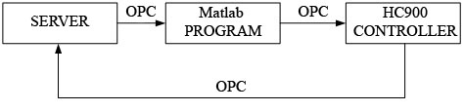

Figure 3.1. Data transmission block diagram

Further, in the Matlab program, the required power value is calculated. To calculate power, there are used neuro-fuzzy logic algorithms. Figure 3.2 shows a fragment of a program in Matlab.

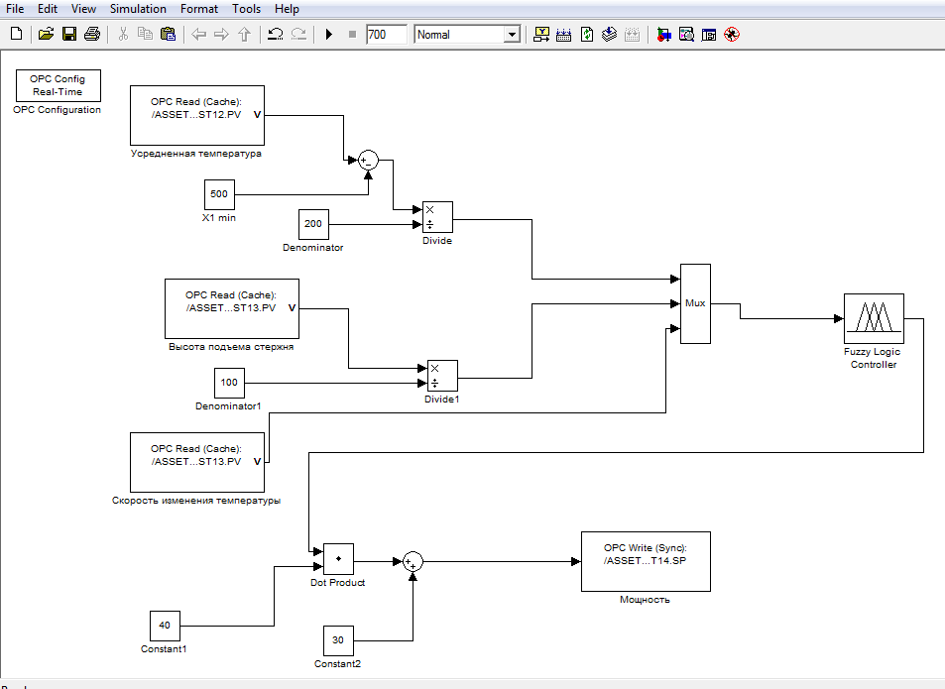

Figure 3.2 – Fragment of a program implemented in Matlab

In this program, the input values ​​are temperature (the average temperature value from five points), the height of the electrode rise and the rate of temperature change (this is the difference in temperature over a certain period of time), the operating voltage step, the values ​​of which are taken from the server. Then these variables are brought to their normal form - the value is from 0 to 1. The converted data is sent to the "fuzzy logic controller" block - a block of neuro-fuzzy logic, where the required power is calculated. Figure 3.3 shows the table of rules used to calculate the power. In these rules: input1 - the temperature; input2 - the height of the post; input 3 - temperature change rate; output - power. The power value is then transferred to the HC900 controller.

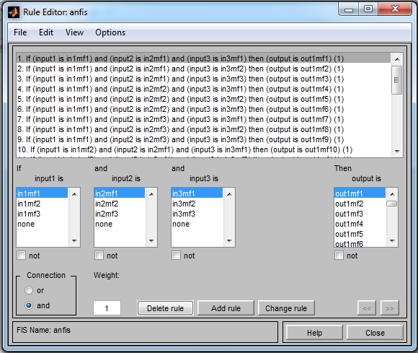

Figure 3.3 – Neuro-fuzzy control model rule table

The output value from the Matlab program - power, is transmitted to the PID block of the HC900 controller. This value is a remote control task for the PID block (connected to the RSP input). The output of the OP controller is sent to the server. Figure 3.4 shows a fragment of the program in the HC900.

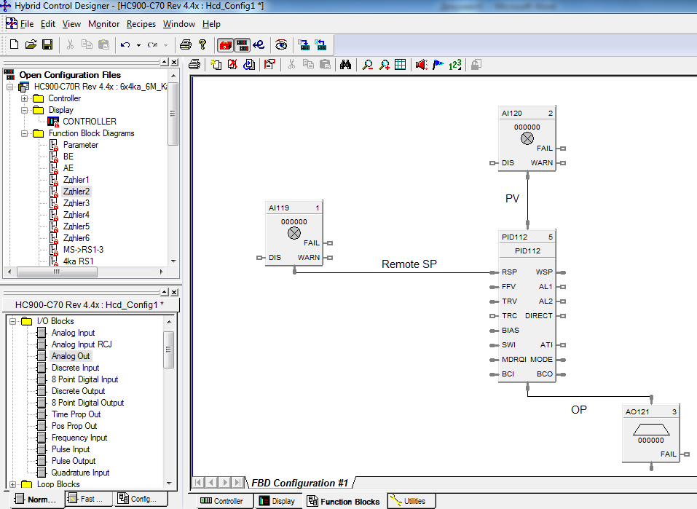

Figure 3.4 - Fragment of the program in the HC900 controller.

Figure 3.5 shows the PID controller configuration window, in which the settings for the remote and local control tasks are set.

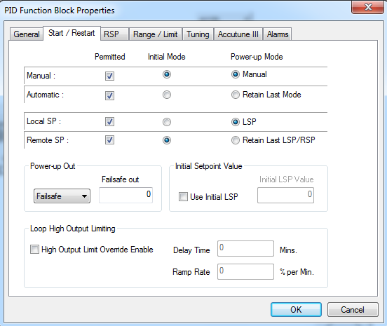

Figure 3.5 - PID controller configuration window

**3.2 Conduct tests of intelligent algorithms in industrial conditions of NDPP**

Testing of intelligent algorithms for controlling the process of obtaining phosphorus anhydride includes testing software and testing algorithms directly

3.2.1 Software testing

The test object is software that implements intelligent algorithms in industrial controllers in the conditions of the Novodzhambul Phosphorus Plant (NDPP).

During the tests, the following main functional subsystems were tested:

- a subsystem for data exchange with the server of the existing ACSTP control system;

- subsystem for calculating the optimal parameters of the technological process;

- operator interface subsystem.

The purpose of the tests is to check the performance of the developed algorithms for intelligent control and the reliability of the calculated indicators and management decisions generated by the proposed intelligent system.

The reliability of the functioning of the IOCS and the reliability of the tasks being solved are checked with the following types of tests:

- preliminary (autonomous and complex);

- trial operation;

Software tests were carried out on furnace No. 5 in the NDPP electric furnace facility. The tests were carried out from July 3 to July 13, 2020, the test duration was 72 hours. The developers of the system and representatives of the NDPP took part in the tests.

Preliminary software tests. During the preliminary tests, there was determined the performance of the system and the decision on the acceptance of the IOCS into trial operation. Preliminary tests were carried out by the developer after completing a set of interrelated works:

- installation of a server, workstation and communication equipment;

- laying and disconnecting network cables to servers, operator workstations and printing devices;

- installation of operator workstations;

- checking the switching in case of failure and loss of the main power supply of the IOCS equipment to power supply from an uninterruptible power supply;

- checking the correct installation of servers and workstation cables;

- debugging and testing of IOCS software and hardware.

During the debugging of the IOCS software, the following works were performed:

- adjustment of CTM of IOCS (for individual devices and complexes);

- adjustment of the general software of computer facilities;

- static and dynamic adjustment of special software;

- autonomous debugging of system functions;

- complex adjustment of the system;

The adjustment of the CTM of ACSTP is carried out in stages:

- autonomous adjustment of individual blocks and devices;

- adjustment of sets of technical means ensuring their interaction;

- adjustment of the CTM of the system as a whole.

At the beginning, the CTM was adjusted for those functions of the system, the connections between which are minimal. The adjustment of the general software was carried out according to standard tests after the adjustment of the CTM.

Autonomous debugging of individual system functions, including the necessary tools of special software, is performed in the order required to check all system components. After the completion of the autonomous debugging of the system, a comprehensive adjustment was carried out. The complex adjustment of the system was aimed at checking and ensuring the correctness of the system's performance of its algorithm of functioning and all consumer functions.

After the completion of the complex adjustment of the system, its autonomous and complex tests were carried out.

Autonomous tests were carried out to verify the interconnection of such functions of the IOCS as display, data input/output, simulation and optimization, monitoring, control, data archiving and diagnostics.

Display functions include:

- configuration (editing) of the composition of the output information (mnemonic diagrams);

- displaying mnemonic diagrams of technological control objects on the monitor of a workstation;

- displaying trends and tables of current and archived values ​​of technological parameters;

- formation of tabular forms of information display;

- displaying lists of alarms;

- formation of a dialogue on the technological objects control;

- displaying dialogs on parameterization of the IOCS database;

- displaying the dialog for configuring the operating modes of applied computational tasks;

- alarm.

I/O functions include:

- data input from the keyboard;

- correction of the entered information;

- formation of messages (documents);

- visual control of the entered information;

- formation of data into information arrays;

- displaying the generated document to the monitor;

- printing with data transfer to servers;

- output to the printing device: a list of alarm, warning and information signals entering the system; a list of control actions; report on the shift acceptance procedure;

- collection of data from subsystems of the ECS of ACSTP

- special information processing;

- typical information processing;

- formation of calculated signals and values;

- operational control of parameters;

- control of the current values ​​of parameters;

- internal information processing.

Modeling and optimization functions include:

- solving problems of modeling and optimization of the technological process;

- modeling and optimization of operational control;

- data exchange with the server of the existing ECS of ACSTP;

- data transmission through the server to the operator's workstation;

- provision of storage and operation of general and special software;

- providing storage of server administration and diagnostics software.

- simulation of abnormal and emergency situations;

- development of skills in the operational control of the technological process.

Display control functions include:

- control of the calculations correctness required to perform the object control function;

- control of the calculations correctness required to perform the control function of the technological mode of the object;

- control of the calculations correctness required to perform the control function over the implementation of the production plan.

Table 3.1 - Discrete signals

| Value | | Description |
| --- | --- | --- |
| primary | existing | < Parameter name > |
| Field equipment | | |
| 0 | 1 | Value |
| 0 | 1 | Sensor fault |
| Operator workstation | | |
| 0 | 1 | Set masking mode |
| 0 | 1 | Set simulation mode |
| 0 | 1 | Simulated value |
| 0 | 1 | Set overwrite mode to base value |
| 0 | 1 | Set overwrite mode to last valid value |
| 0 | 1 | Set overwrite mode to emergency value |

Control functions include:

- operational control of the object as a whole in order to fulfill the production plan;

- development of orders and instructions for operating personnel.

Archiving functions include:

- formation of the event log and system log;

- formation of a log of technological events and accidents;

- formation of a log of events and accidents of automation equipment;

- formation of the operator's actions log;

- accounting of emergency situations;

- formation of the operator's log;

- formation of a report on the results of optimization and modeling of the operating mode of the object;

- formation of archival information;

- archiving of operational information;

- configuration of archive parameters;

- maintenance of protocols: alarm and warning signals, both current and in the history; control actions; manually entered data; inaccurate data;

Table 3.2 - Analog signals

| Value | | Description | |
| --- | --- | --- | --- |
| primary | existing | < Parameter name > | |
| Field equipment | | |
| 0 | - | Parameter value | |
| 0 | 1 | Sensor circuit fault | |
| Operator workstation | | |
| 0 | - | Simulated value | |
|  | - | Setting the minimum 1st (limit) value | |
|  | - | Setting the maximum 1st (limit) value | |
| 0 | 1 | Set masking mode | |
| 0 | 1 | Set simulation mode | |
| REAL | | Lower measurement limit | |
| REAL | | Setting the minimum 2nd (alarm) value | |
| REAL | | Setting the maximum 2nd (alarm) value | |
| REAL | | Upper measurement limit | |
| REAL | | Emergency replacement value | |
| 0 | 1 | Set overwrite mode to base value | |
| 0 | 1 | Set overwrite mode to last valid value | |
| 0 | 1 | Set overwrite mode to emergency value | |
| 0 | 1 | Set the mode without replacement | |
| 0 | 1 | Lack of communication with the node | |
| Controller failure | |
| Discrete input module failure | |
| Invalid data in the channel of the analog input module | |
| 0 | 1 | Open, short circuit | |

Diagnostic functions include:

- diagnostics of the complex of software and hardware tools and IOCS equipment;

- prevention of emergency situations caused by failures and faults of the software and hardware complex;

- elimination of the violation and restoration of the IOCS operation;

- self-diagnosis;

- registration in the system log of failures and faults of the software and hardware complex;

- the possibility to develop new and make adjustments to existing images of technological objects;

- the possibility to develop new and make adjustments to existing reporting documents (reports, protocols);

- the possibility to develop applied computational problems, debugging and integrating them into the system;

- conducting dialogues on the administration of the IOCS equipment.

Complex tests of the IOCS were carried out in industrial operating conditions of the technological object in various modes of its operation.

Complex tests were carried out after:

- obtaining a conclusion on autonomous testing of IOCS elements;

- preparation of complex tests to check the response of the system to incorrect information and emergency situations;

Table 3.3 - High voltage switch status

|  |  |  |  |  |
| --- | --- | --- | --- | --- |
| Value | | | Description | |
| primary | existing | | < Parameter name > | |
| 1 | 2 | | 3 | |
| Field equipment | | | |
| 0 | | 1 | HV is enabled |
| 0 | | 1 | HV is disabled |
| 0 | | 1 | HV electrical protection |
| 0 | | 1 | HV switching circuit failure |
| 0 | | 1 | HV trip circuit failure |
| 0 | | 1 | Local / Remote Switch |
| 0 | | 1 | STOP button in place |
| Operator workstation | | | |
| t#2s | | | Maximum time for HV contacts switching |
| t#7s | |  | Maximum current rise time at HV switch on |
| t#7s | |  | Maximum downslope time at HV switch off |
| t#2s | |  | Delay for setting the "Undefined state" |
|  | |  | "HV on" and "HV off" |
| t#7h | |  | Maximum engine cool-down time at shutdown |
| t#2s | |  | Maximum downslope time when the HV is on |
| 0 | | 1 | Starting the engine |
| 0 | | 1 | Stopping the engine |
| 0 | | 1 | SIMULATION mode |
| 0 | | 1 | Motor current is normal |
| 1 | | 1 | Motor current below normal |
| 0 | | 1 | Motor current is not monitored (masked) |
| 0 | | 1 | Module failure |

The IOCS complex testing program defined a list of test objects, verified interrelationships between test objects, the sequence of system elements testing, the procedure and test methods, including the composition of software and equipment required for testing.

The tests were carried out on a fully assembled and well-adjusted system, during the operation of all its main and auxiliary nodes, including subsystems for information collection, working and emergency power supplies. The list of input signals is given in tables 3.1 - 3.6.

All equipment covered by the system was in operation. The operating and maintenance personnel have been properly instructed. In order not to interfere into the real technological process, there was installed a special (additional) server, which collected all data about the technological process from the main server via OPC communication.

The list of input data received by the IOCS from the existing ACSTP is given in Tables 3.2 - 3.5.

Table 3.4 - Discrete signals of control keys

|  |  |  |  |
| --- | --- | --- | --- |
| Value | | Description | |
| primary | existing | < Parameter name > | |
| Field equipment | | |
| 0 | 1 | Open | |
| 0 | 1 | REMOTE control mode | |
| 1 | 0 | Control circuits failure | |
| Table 3.5. Discrete control signals | | | | |
| Operator workstation | | | | |
| t#2s | | Maximum time to turn on (turn off) the starter | |
| t#2s | | Delay for removing the command in case of unauthorized disconnection of the starter | |
| 0 | 1 | Open | |
| 0 | 1 | Close | |
| 0 | 1 | Open automatically | |
| 0 | 1 | Close automatically | |
| 0 | 1 | Module failure | |

3.2.2 Industrial testing of intelligent algorithms in conditions of NDPP

The tests of the intelligent control system for the production of phosphorus anhydride were carried out in two stages. There were the results of software tests, which were carried out according to standard methods. However, in such a short time - 72 hours, it is impossible to collect statistics to assess the expected economic effect from the introduction of an intelligent control system. Therefore, it was decided to conduct long-term tests of the intelligent system in two modes: a control mode for measuring the performance of the furnace without taking into account the recommendations of the system, the operating mode of the furnace, taking into account the recommendations of the intelligent system.

For safety reasons, the plant's management decided to test the intelligent control system in an open mode - i.e. in operator advice mode.

Industrial tests were carried out in two stages: from August 17 to August 30, within 24 days, control measurements of the performance of the furnace No. 5 were carried out without computer intervention in the furnace control process, and in the period from August 31 to September 13, within 14 days, intelligent control algorithms were tested according to the recommendations calculated by these algorithms in real time by furnace operators.

Comparative analysis showed positive assessments of the proposed control algorithms: the specific yield of finished products increased by 5%, and the waste heat boiler produced 3% more specific heat energy (see Appendix G).

**CONCLUSION**

Brief conclusions based on the research results.According to the performed work and to the calendar plan, the following results were obtained:

1. There were synthesized intelligent control algorithms for the combustion of yellow phosphorus in the combustion chamber using three technologies: fuzzy, neuro-fuzzy algorithms and neural networks. In this case, the FFE matrices were used for four input variables:

X1 - recirculation gases flow rate;

X2 - compressed air consumption;

X3 - technical oxygen O2 consumption;

X4 - yellow phosphorus consumption from the dosing unit.

and one output variable - the temperature in the burner.

2. There were synthesized intelligent algorithms for controlling the process of cooling phosphorus anhydride in a waste heat boiler using three technologies: fuzzy, neuro-fuzzy algorithms and neural networks. In this case, the FFE matrices were used for three input variables:

X5 - the flow rate of gases leaving the combustion chamber. Since this flow rate is extremely difficult to measure, we can indirectly determine it by the total amount of consumption: recirculated gases, compressed air and technical oxygen, i.e. we will assume that Х5 = Х1 + Х2 + Х3;

X6 - the temperature at the input of the waste heat boiler, which is equal to the temperature at the output from the combustion chamber, i.e. Х6 = Y1;

X7 - cooling water consumption. Due to the fact that the water consumption is not measured, it can be indirectly estimated by the water pressure at the input to the waste heat boiler, i.e. Х7 = Рвк.

The output variables of the cooling process in the waste heat boiler are: the temperature at the boiler output - Y2 and the flow rate of the generated steam - Y3.

3. There were synthesized intelligent algorithms for controlling the process of precipitation of phosphorus anhydride in an economizer using three technologies: fuzzy, neuro-fuzzy algorithms and neural networks. In this case, the FFE matrices were used with three input variables:

X8 - consumption of gases leaving the waste heat boiler, while Х8 = Х1 + Х2 + Х3;

X9 - the temperature at the input to the economizer, which is equal to the temperature at the output of the waste heat boiler, i.e. Х9 = Y2;

X10 - the flow rate of the economizer cooling water. Due to the fact that the water consumption is not measured, it can be indirectly estimated by the water pressure at the input to the economizer, i.e. Х10 = Рвэ. The output variables of the cooling process the exhaust gases in the economizer are: the temperature at the output of the economizer - Y4 and the consumption of the obtained solid phosphorus anhydride - Y5.

Thus, our proposed concept for the synthesis of intelligent models for controlling the processes of obtaining phosphorus anhydride made it possible to identify 10 input and 5 output variables for the processes: combustion, cooling and precipitation of solid P2O5.

4. All synthesized models were investigated for adequacy, sensitivity, stability and unambiguity. All models showed a high degree of adequacy, optimal sensitivity and unambiguity. All these studies have shown that the synthesized models do not contradict the physicochemical laws of the processes of combustion, cooling and precipitation during the production of P2O5.

5. However, as it was found out during the survey of operators-technologists, in fact, in practice, they do not take into account such a large number of variables: 10 input and 4 output is too difficult. In practice, when controlling the production of phosphorus anhydride, they are mainly guided by two input variables: phosphorus consumption and compressed air consumption, and one output variable - the gas temperature after the collector.

Therefore, it was decided to synthesize and research also a simplified intelligent control model with two input and one output variable.

6. The OPC DA (Data Access) standard, which describes a set of functions for real-time data exchange with PLCs, DCS, HMI, CNC and other devices, has been chosen as the main standard for data exchange between the upper and lower levels of the ACSTP.

7. The following technical means were adopted: a server of the operating ACSTP, a new workstation and an intelligent controller НС 900.

8. In order to implement the fuzzy rules developed in the Fuzzy Logic Toolbox environment of the MatLab package, they were loaded into a programmable logic controller (PLC) - НС 900.

9. There were conducted industrial tests of software and intelligent algorithms in industrial conditions of NDPP.

Evaluation of the completeness of solutions to the stated tasks. The tasks set by the calendar plan for 2018-2020 were completed in full and with good quality.

Recommendations for the implementation or the results of the implementation of research results. Based on the results of industrial tests, the plant's management will make a decision to implement an intelligent control system.

The results of assessing the technical and economic efficiency of the development. The specific output of finished products increased by 5%, and the waste heat boiler produced 3% more specific heat energy.

The results of assessing the scientific and technical level of the completed research work in comparison with the best achievements in this area. Despite the more than 40-year history of attempts to create optimal control systems for technological processes using traditional methods of mathematical modeling in Kazakhstan, in the CIS countries and in the world, no noticeable system has been introduced either in non-ferrous metallurgy, or in the chemical and petrochemical industry, or in other industries. This is due to the extreme complexity of modern technologies, in this connection, the creation of sufficiently adequate mathematical models of such processes is practically impossible.

The end result of the project will be intelligent algorithms for controlling the process of obtaining P2O5. Since this process is unique and exists only at NDPP, there are no domestic and foreign analogues.

**REFERENCES**

1 Gaskarov G.A. Intelligent information systems: a textbook for universities. - M.: Higher. education, 2003 P.431. (rus)

2 DataDemocracy: Atthe Nexus of Artificial Intelligence, Software Development and Knowledge Engineering Edited by Feras A. Batarseh.  // Academic Press. - 2020, Vol.2, N 1. P.266.

3 Kumar C.R., Tripathy S., Rao D.S. **Characterization and pre-concentration of chromitevalues from plant tailings using floatex density separator //** J Miner Mater Charac Eng. - 2009; Vol.21, No 3. P. 64.

4 Abdel-Ghafar H.M., Abdel-Aal E.A., Ibrahim M.A.M., El-Shall H., Ismail A.K. Purification of high iron wet-process phosphoric acid via oxalate precipitation method // Hydrometallurgy. – 2019. Vol. 184 No 7. P.236

5 Gilmour R. Phosphoric acid: purification, uses, technology, and economics hardcover // CRC Press, Taylor & Francis Group. – 2014. Vol. 10, P.334

6 Aguel S., Meddeb Z., Jeday M.R. Parametric study and modeling of cross-flow heat exchanger fouling in phosphoric acid concentration plant using artificial neural network // Journal of Process Control. – 2019. Vol. 84, P.133-145.

7 Astley V., Stana R. The use of advanced process controls in a phosphoric acid reactor // Procedia Engineering. – 2014. Vol. 83, P.208-214.

8 Suleimenov B. A, Sugurova L. A., Suleimenov A. B. Intelligent systems of optimal control and operational diagnostics (methods of synthesis and application) // Shikula: Almaty 2016. P.207

9 Offermans T., Szymańska E., Buydens L.M.C., Jansen J.J. Synchronizing process variables in time for industrial process monitoring and control // Computers & Chemical Engineering. -2020. Vol. 140, P.25-28

10 Karafyllis I., Krstic M. Stabilization of nonlinear delay systems using approximate predictors and high-gain observers. Automatica. – 2013. Vol. 49,

P.3623–3631.

11 Heintz J., Belaud J.P., Gerbaud V. Chemical enterprise model and decision-making framework for sustainable chemical product design. Computers in Industry. – 2014. Vol. 65, P.505-520.

12 Rafiei M., Ricardez-Sandoval L.A. Integration of design and control for industrial-scale applications under uncertainty: a trust region approach. Computers & Chemical Engineering. – 2020. Vol. 141, P.25-27

13 Joa S., Durand A., Schreven O. Plant operability optimization through dynamic simulation, a case study focused on phosphoric acid concentration unit. Procedia Engineering. – 2016. Vol. 138, P.378-389.

14 Trafczynski M., Markowski M., Alabrudzinski S., Urbaniec K. The influence of fouling on the dynamic behavior of PID-controlled heat exchangers. // Therm. Eng. – 2016. Vol. 109, P.21-24

15 Awwad N.S., El-Nadia Y.A., Hamed M.M. Successive processes for purification and extraction of phosphoric acid produced by wet process // Chemical Engineering and Processing: Process Intensification. – 2013. Vol. 74, P.69-74.

16 Khamparia A., Pandey B., Pandeyc D. K., Gupta D., Khanna A., Hugo V. Comparison of RSM, ANN and fuzzy logic for extraction of oleonolic acid from ocimum sanctum // Computers in Industry. – 2020. Vol. 117, P.24-26.

17 **Silhavy F.,** Radek T. Artificial Intelligence and Algorithms in Intelligent Systems. Editors:  Proceedings of 7th Computer Science On-line Conference 2018, Vol. 2. P.118-121.

18 **Silhavy F.,** Radek T. Cybernetics and Automation Control Theory Methods in Intelligent Algorithms. Proceedings of 8th Computer Science On-line Conference 2019, Vol. 3.17. P.19-21.

19 [Yang Li,](https://www.amazon.com/s/ref=dp_byline_sr_book_1?ie=UTF8&field-author=Yang+Li+PhD&text=Yang+Li+PhD&sort=relevancerank&search-alias=books)  [Jianhua Zhang](https://www.amazon.com/s/ref=dp_byline_sr_book_2?ie=UTF8&field-author=Jianhua+Zhang+PhD&text=Jianhua+Zhang+PhD&sort=relevancerank&search-alias=books), [Wu Qiong.](https://www.amazon.com/s/ref=dp_byline_sr_book_3?ie=UTF8&field-author=Wu+Qiong+MA&text=Wu+Qiong+MA&sort=relevancerank&search-alias=books) [Adaptive Sliding Mode Neural Network Control for Nonlinear Systems](https://www.sciencedirect.com/science/book/9780128153727). Emerging Methodologies and Applications in Modelling // Academic Press – 2018. Vol.1. P.186

20 Mark K., Robert O. Software Engineering for Embedded Systems. // Newnes. - 2019. Vol.12. P.154

21 Chang D, Liu J, Mao N, Ge S. Measurement and analysis of virgin-rock temperature in Huanren metal mine. In: Proceedings of the Third International Symposium on Mine Safety Science and Engineering; 2016 Aug 13–19; Montreal, QC, Canada. - 2016. P. 204.

22 Leonenkov A.V. Fuzzy modeling in the MATLAB and fuzzTECH environment. - SPb: BHV-Petersburg, 2003 – p. 736. (rus)

23 Trabelsi W., Tlili A. Phosphoric acid purification through different raw and activated clay materials (Southern Tunisia). Journal of African Earth Sciences. – 2017. Vol. 129, P.647-658.

24 Paulino N.M.G., Foo M., Kim J., Bates D.G. On the stability of nucleic acid feedback control systems. Automatica. – 2020. Vol. 119, P.67-68.

25 He G., Dang Y., Zhou L., Dai Y., Que Y., Ji X. Architecture model proposal of innovative intelligent manufacturing in the chemical industry based on multi-scale integration and key technologies. Computers & Chemical Engineering. – 2020. Vol. 141, P.45-48.

26 Rafael, M., Sanchez, M., Muciño, V., & Cervantes, J. Impact of driving styles on exhaust emissions and fuel economy from a heavyduty truck: laboratory tests // International Journal of Heavy Vehicle Systems - 2006. Vol. 218 (Issue 1), P.56-73.

27 Methods of the modern theory of automatic control // Textbook: in 5 volumes - M.: MSTU named after N.E. Bauman, 1988 -T. 5 p. 764. (rus)

28 Suleimenov B.A., Sugurova L.A., Suleimenov A.B. Method of synthesis of optimal control systems for technological processes. Certificate of state registration of rights to an object of copyright (work of science), Astana, No. 985 dated May 28, 2015 (rus)

29 Suleimenov B.A., Sugurova L.A., Suleimenov A.B. Methods of creating an automated system for operational diagnostics of the state of technological equipment. Certificate of state registration of rights to the copyright object (work of science) Astana, No. 986 dated May 28, 2015. (rus)

30 Suleimenov B.A., Suleimenov A.B. The method of synthesis of the system of operational diagnostics of the state of turbine units of thermal power plants (a work of science). Certificate of state registration of rights to copyright object No. 0665 dated April 12, 2016. (rus)

**APPENDIX A**

**Calendar plan for 2018-2020**

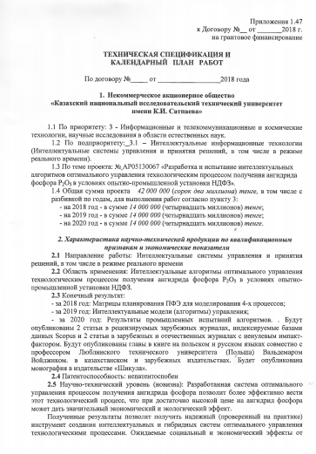

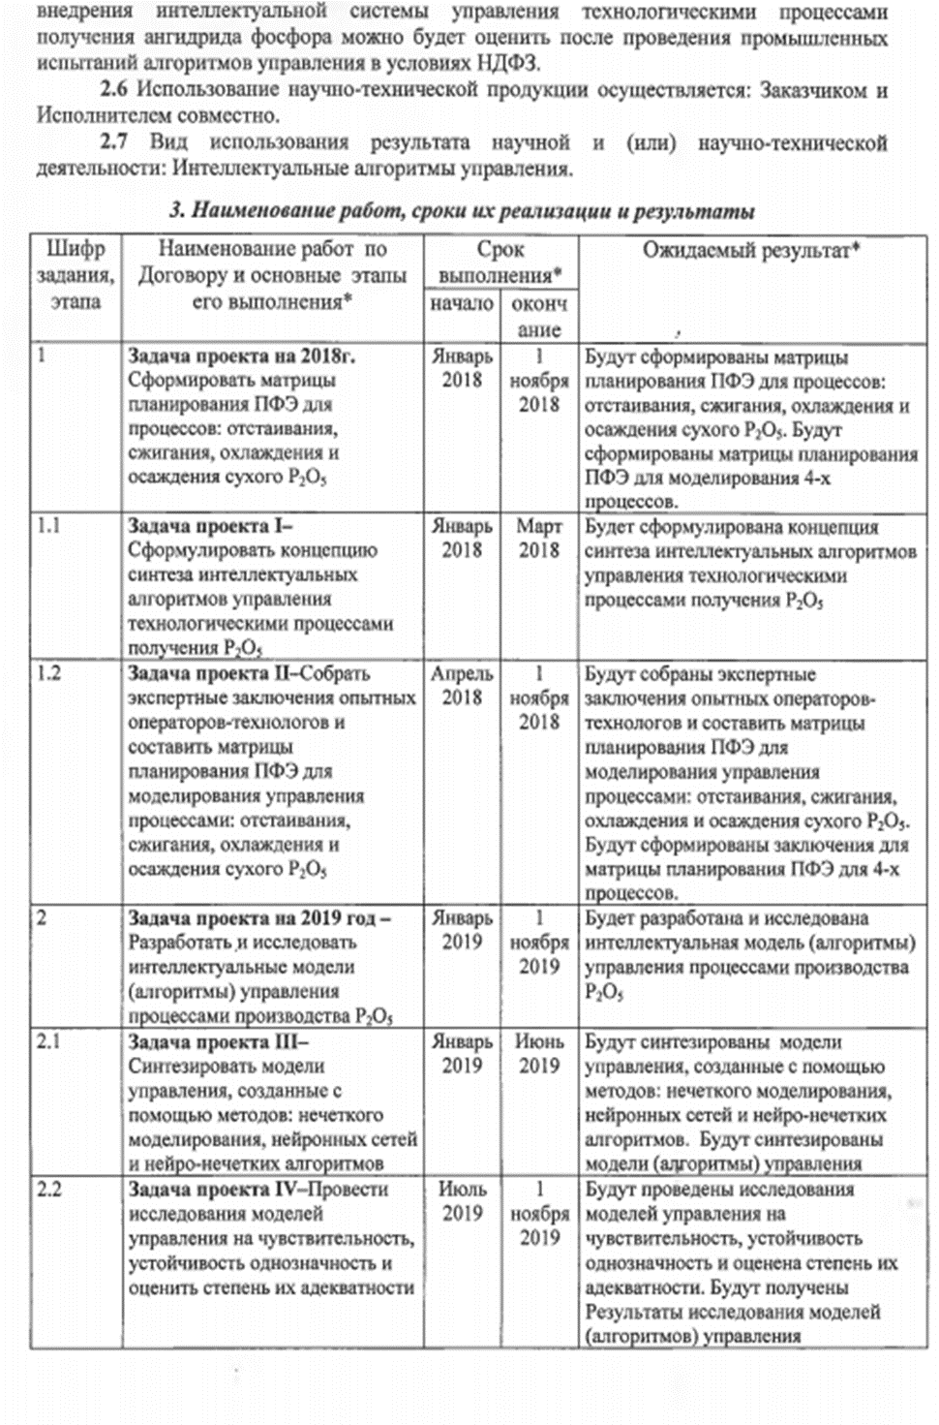

Appendix 1.47

to the Agreement № ___ from ________ 2018

On grant financing

**TECHNICAL SPECIFICATIONS AND**

**CALENDAR WORK PLAN**

under the Agreement № _____ from ___________ 2018

1. **Non-commercial joint stock company**

**"Kazakh National Research Technical University named after K.I.Satpayev**

1.1 By priority: 3 - Information and telecommunication and space technologies, scientific research in the field of natural sciences.

1.2 By sub-priority: 3.1 - Intelligent information technologies (Intelligent control and decision-making systems, including in real time)

1.3 On the topic of the project: No. АR05130067 "Development and testing of intelligent optimal control algorithms for the technological process for obtaining phosphorus anhydride P2O5 in the conditions of the pilot production unit of NDPP"

1.4 The total amount of the project is *42,000,000* (forty-two million) tenge, including by years, for the performance of work in accordance with paragraph 3:

- for 2018 - in the amount of *14,000,000* (fourteen million) tenge;

- for 2019 - in the amount of *14,000,000* (fourteen million) tenge;

- for 2020 - in the amount of *14,000,000* (fourteen million) tenge;

***2. Characteristics of scientific and technical products by qualification characteristics and economic indicators***

2.1 Direction of work: Intelligent control and decision-making systems, including in real time.

2.2 Field of application: Intelligent optimal control algorithms for the technological process of obtaining phosphorus anhydride P2O5 in the conditions of the pilot production unit of NDPP.

2.3 Final result:

- for 2018: FFE planning matrices for modeling 4 processes;

- for 2019: Intelligent control models (algorithms);

- for 2020: Results of industrial tests of algorithms. There will be published 2 articles in peer-reviewed foreign journals indexed by Scopus databases and 2 articles in foreign and domestic journals with a non-zero impact factor. Chapters in books in Polish and Russian will be published jointly with Professor of the Lublin Technical University (Poland) Waldemar Voidzhik, in Kazakhstan and foreign publishing houses. The monograph will be published in the publishing house "Shikula".

2.4 Patentability: not patentable

2.5 Scientific and technical level (novelty): The developed optimal control system for the technological process of obtaining phosphorus anhydride will make it possible to conduct this technological process more efficiently, which, with a sufficiently high price for phosphorus anhydride, can give a significant economic and environmental effect.

The results obtained will make it possible to obtain a reliable (proven in practice) tool for creating intelligent and hybrid systems of optimal control for technological processes. The expected social and economic effects from the implementation of an intelligent control system for technological processes for the production of phosphorus anhydride can be assessed after industrial testing of control algorithms at NDPP.

2.6 The use of scientific and technical products is carried out: by the Customer and by the Executor together.

2.7 Type of use of the result of scientific and (or) scientific and technical activities: Intelligent control algorithms.

***3. Name of work, terms of their implementation and results***

|  |  |  |  |  |
| --- | --- | --- | --- | --- |
| Work, stage code | Name of work under the Agreement and the main stages of its implementation * | Terms of execution * | | Expected results* |
|  |  | beginning | ending |  |
| 1 | **Project task for 2018.** Forming FFE planning matrices for the processes: sedimentation, combustion, cooling and precipitation of dry P2O5 | January 2018 | 1 November 2018 | FFE planning matrices will be formed for the processes: sedimentation, combustion, cooling and precipitation of dry P2O5. FFE planning matrices will be formed for modeling 4 processes. |
| 1.1 | **Project task I**  To formulate the concept of synthesis of intelligent control algorithms for technological processes of obtaining P2O5 | January 2018 | March 2018 | There will be formulated the concept of the synthesis of intelligent control algorithms for technological processes of obtaining P2O5. |
| 1.2 | **Project task II**  To collect expert opinions from experienced operators-technologists and compile FFE planning matrices for modeling process control: sedimentation, combustion, cooling and precipitation of dry P2O5 | April 2018 | 1 November  2018 | There will be collected expert opinions of experienced operators-technologists and FFE planning matrices will be compiled for modeling process control: sedimentation, combustion, cooling and precipitation of dry P2O5. Conclusions will be formed for the FFE planning matrix for 4 processes. |
| 2 | **Project task for 2019**  To develop and research intelligent control models (algorithms) for P2O5 production process | January 2019 | 1 November 2019 | There will be developed and studied an intelligent control model (algorithms) for P2O5 production process. |
| 2.1 | **Project task III**  To synthesize control models created using methods: fuzzy modeling, neural networks and neuro-fuzzy algorithms | January 2019 | June 2019 | There will be synthesized control models, created using methods: fuzzy modeling, neural networks and neuro-fuzzy algorithms. Control models (algorithms) will be synthesized |
| 2.2 | **Project task IV**  To conduct studies of control models for sensitivity, stability, unambiguity and to assess the degree of their adequacy | July 2019 | 1 November  2019 | There will be carried out research of control models for sensitivity, stability, unambiguity and assessment of their adequacy. Results of research of control models (algorithms) will be received |
| 3 | **Project task for 2020**  To conduct tests of intelligent control algorithms for technological processes of obtaining P2O5 in industrial conditions of NDPP | January 2020 | 1 november  2020 | There will be carried out tests of intelligent control algorithms for technological processes of obtaining P2O5 in industrial conditions of NDPP. Results of industrial tests of algorithms will be received |
| 3.1 | **Project task V**  To develop software that implements intelligent algorithms in industrial controllers | January 2020 | June 2020 | There will be developed software that implements intelligent algorithms in industrial controllers |
| 3.2 | **Project task VI**  To conduct tests of intelligent algorithms in industrial conditions of NDPP | April 2020 | 1 November  2020 | Intelligent algorithms will be tested in industrial conditions of NDPP. The results of testing algorithms in industrial conditions will be obtained. There will be published 2 articles in peer-reviewed foreign journals indexed by Scopus databases and 2 articles in foreign and domestic journals with a non-zero impact factor. Chapters in the book will be published in Polish and Russian together with Waldemar Voidzhik, professor of the Lublin Technical University (Poland), in Kazakhstan and foreign publishing houses. The monograph will be published in the publishing house "Shikula" |

**APPENDIX B**

**List of published works for 2018-2020 years**

List of published works for 2018 year

Domestic publications

1. Pavlenko P.N., Suleimenov B.A. - Mathematical modeling of automation objects - Almaty: Shikula, 2018, p.446 (Textbook) (rus)

Foreign publications

1. Intelligent systems for equipment health management and optimum control in Phosphate production, Suleimenov, B., Sugurova, L., Suleimenov, A., Suleimenov, A. Journal of Engineering and Applied Sciences 13(3), p. 607-618, 2018 (Scopus, journal percentile 11);

2. Synthesis of the equipment health management system of the turbine units' of thermal power stations, Batyrbek A. Suleimenov, Laura A. Sugurova, Alibek B. Suleimenov, Aituar B. Suleimenov and Oxana V. Zhirnova. Mechanics and Industry 19(2), 209, 2018 (Scopus, journal percentile 56/48/43) DOI: 10.1051/meca/2017056.

3.The 16th INTERNATIONAL SCIENTIFIC CONFERENCE INFORMATION TECHNOLOGIES AND MANAGEMENT 2018 April 26-27, 2018, ISMA University, Riga, Latvia: Intelligent subsystem for determining the optimum pulsation frequency of a jigging machine B A Suleimenov, Y A Kulakova, p. 51-53, http://geoml.info/?page_id=232

4. Synthesis modal and fuzzy regulators to maintain the frequency of pulsation of jigging machine, Suleimenov B A, Kulakova Y A, p. 53-55, 2018, ISMA University, Riga, Latvia http://geoml.info/?page_id=232

5. Synthesis and analysis of intellectual models for diagnostics the technical state of a turbine unit, A Suleimenov, L Boleeva, B Suleimenov, p. 57-59, 2018, ISMA University, Riga, Latvia, http://geoml.info/?page_id=232

6. Development of a virtual model for geometric inform specifying the motion kinematics of the mobile ro additive control system in engineering, G R Utegenova, B Zh Tilesheva, A S Turakbayev, O V Zhirnova, R М Uteshev, p. 61-64, 2018, ISMA University, Riga, Latvia http://geoml.info/?page_id=232

7. Intellectualization of the process of operational diagnostics of thermal processes at a thermal power plant M M Zhardem, R R Islamova, D G Zhaksybaev, O V Zhirnova, A Zhumabergenov, p. 64-66, 2018, ISMA University, Riga, Latvia http://geoml.info/?page_id=232

8. Modeling the temperature in the wind box of sintering process N R Toktassynova, B A Suleimenov, p. 70-73, 2018, ISMA University, Riga, Latvia

9. Machine learning approach for gas turbine parameters forecasting Nurlan Batayev1, Dauren F Akhmetov, Batrbek Suleimenov, p. 85-87, 2018, ISMA University, Riga, Latvia http://geoml.info/?page_id=232

10. Development of diagnostic systems for thermal facilities based on data processing Zh Omirbekova, A Suleimenov, L Boleeva, p. 89-91, 2018, ISMA University, Riga, Latvia <http://geoml.info/?page_id=232>

11. Mukhanov B.K., Omirbekova Z.Z., other. Numerical modeling of ORE body and development hydrodynamic models of in-situ leaching process // 14th ICECCO 20188634795. -2019. - p.65.

List of published works for 2019 year

Domestic publications

1. Toktasynova N.R., Suleimenov B.A., Boleyeva L. The main directions of modeling the agglomeration process. KazNRTU Bulletin No. 1 (131), Almaty, 2019. p.428-433. (rus.)

2. Toktasynova N.R., Suleimenov B.A., Boleyeva L. Basic types of equations of gas phase motion in the agglomeration process. KazNRTU Bulletin No. 3 (133), Almaty, 2019. p.354-357. (rus.)

3. Suleimenov B.A., Doshtayev B.Zh., Boleyeva L. Development of intelligent algorithms for controlling the process of obtaining P2O5 in the conditions of NDPP, Satpayev readings - Satbayev University / International scientific-practical conference, Almaty 2019. p.334-336 (rus)

Foreign publications

1. Toktassynova N. R. Fourati H., Suleimenov B. A. Modeling and Control Structure of a Phosphorite Sinter Process with Grey Model. Materials of the International Scientific and Practical Conference IEEE - 2019 (ICCAD'19), Grenoble-France. p.36

2. Toktasynova N.R., Suleimenov B.A. Predicting the spec point using the optimal gray convolution model. IV International scientific-practical conference "Integration of the scientific community before the global problems of our time", Sapporo (Japan) 2019 p.26 (rus)

3. Suleimenov B.A., Boleeva L., Doshtaev B. Development of intelligent control algorithms for the phosphorus anhydride production process. The 17th INTERNATIONAL CONFERENCE INFORMATION TECHNOLOGIES AND MANAGEMENT 2019 Information Systems Management Institute, Riga, Latvia p.28

4. Suleimenov B.A., Kulakova E., The prospects for the use of intelligent systems in the processes of gravitational enrichment, IAPGOŚ 2019; 9 (2): p.46-49; DOI: 10.5604/01.3001.0013.2547

List of published works for 2020 year

Domestic publications

1. Suleimenov B.A., Doshtayev B.Zh., Boleyeva L.K., Intelligent control systems for technological processes in the phosphorus industry / monograph. - Almaty: Shikula, 2020 – p. 223; 62 ill. (rus)

Foreign publications

1. Toktassynova, N.R., Fourati, H., Suleimenov, B.A. Application of grey system theory to phosphorite sinter process: From modeling to control, Asian Journal of Control, Article in press (Scopus, journal percentile 70), DOI: 10.1002 /asjc.2348.

2. Meruyert Makhanbet; Tiejun Lv; Marat Orynbet; Batyrbek Suleimenov, A Fully Distributed and Clustered Learning of Power Control in User-Centric Ultra-Dense HetNets. IEEE Transactions on Vehicular Technology (Early Access) 2020. P 1-1 (Scopus, journal percentile 98/98/96), DOI: 10.1109/TVT.2020.3013329

3. Suleimenov B.A., Kulakova E., Development of intelligent systems for optimal processes control. (Article). Resource-saving technologies of raw-material base development in mineral mining and processing. p. 198-204. Multi-authored monograph. - Petroșani, Romania: UNIVERSITAS Publishing, 2020 – p. 514. doi: 10.31713 / m913. (romanian)

4. Kulakova Ye.A. ,Suleimenov B.A. Development and Research of Intelligent Algorithms for Controlling the Process of Ore Jigging. International Journal of Emerging Trends in Engineering Research. Volum 8. No.9, 2020. 6240-6246 p-p. doi: 10.30534/iieter/2020/214892020

**APPENDIX C**

**Protocol of discussion of the final report on research work for 2020 at a meeting of the Scientific and technical council of "KazNRTU" NJSC.**

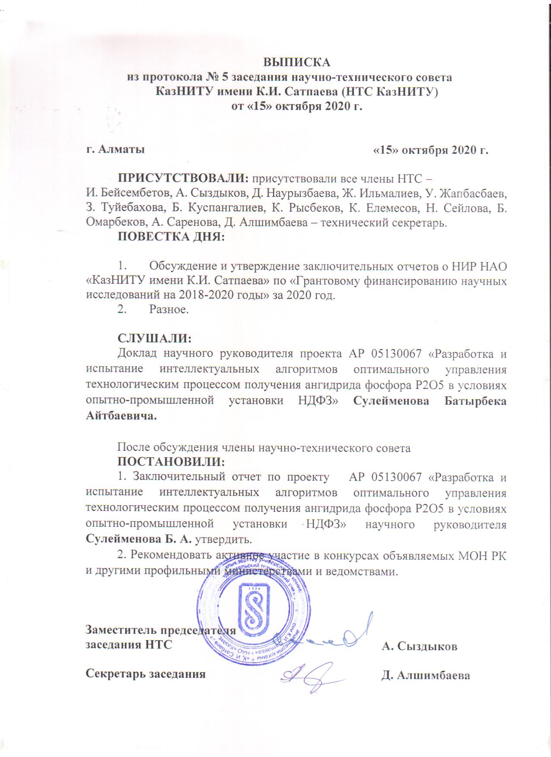

**APPENDIX D**

**Protocol of discussion of the final report on research work for 2020 at a meeting of the Academic council of the Institute of industrial automation and informatization**

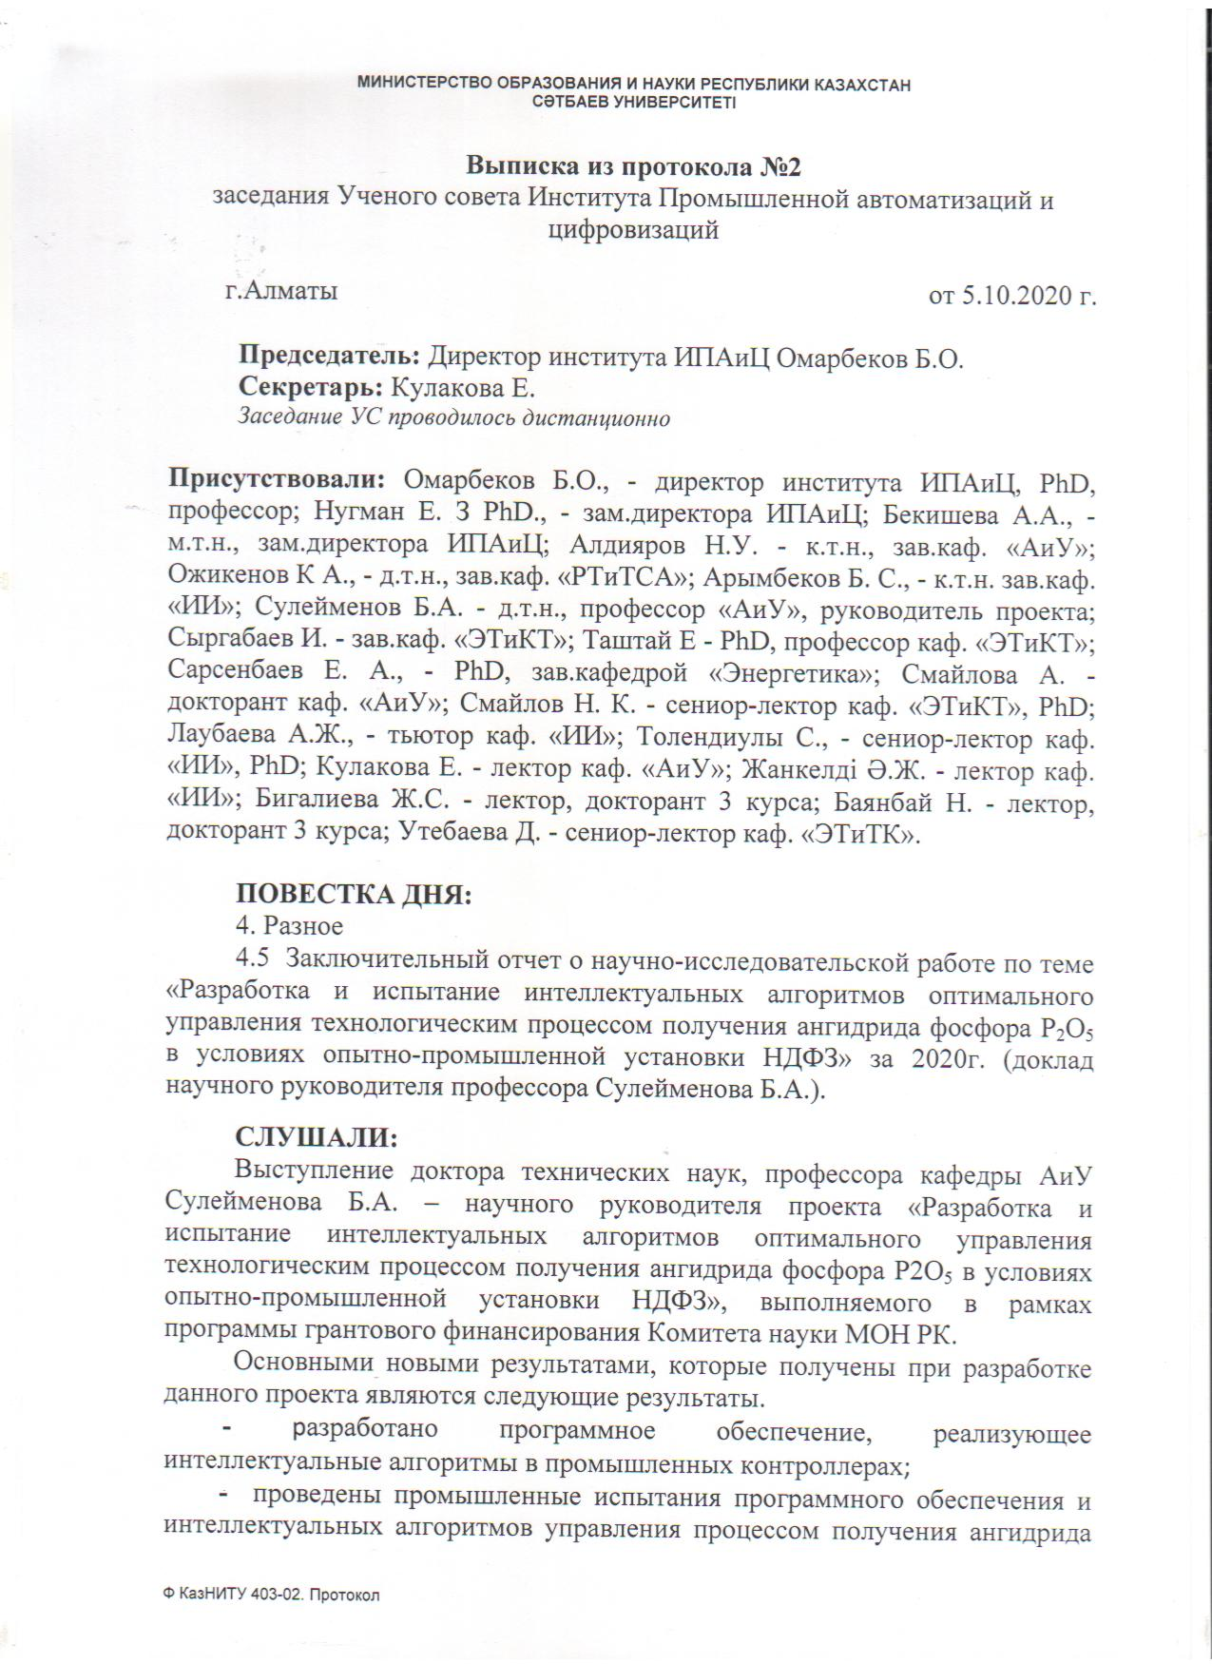

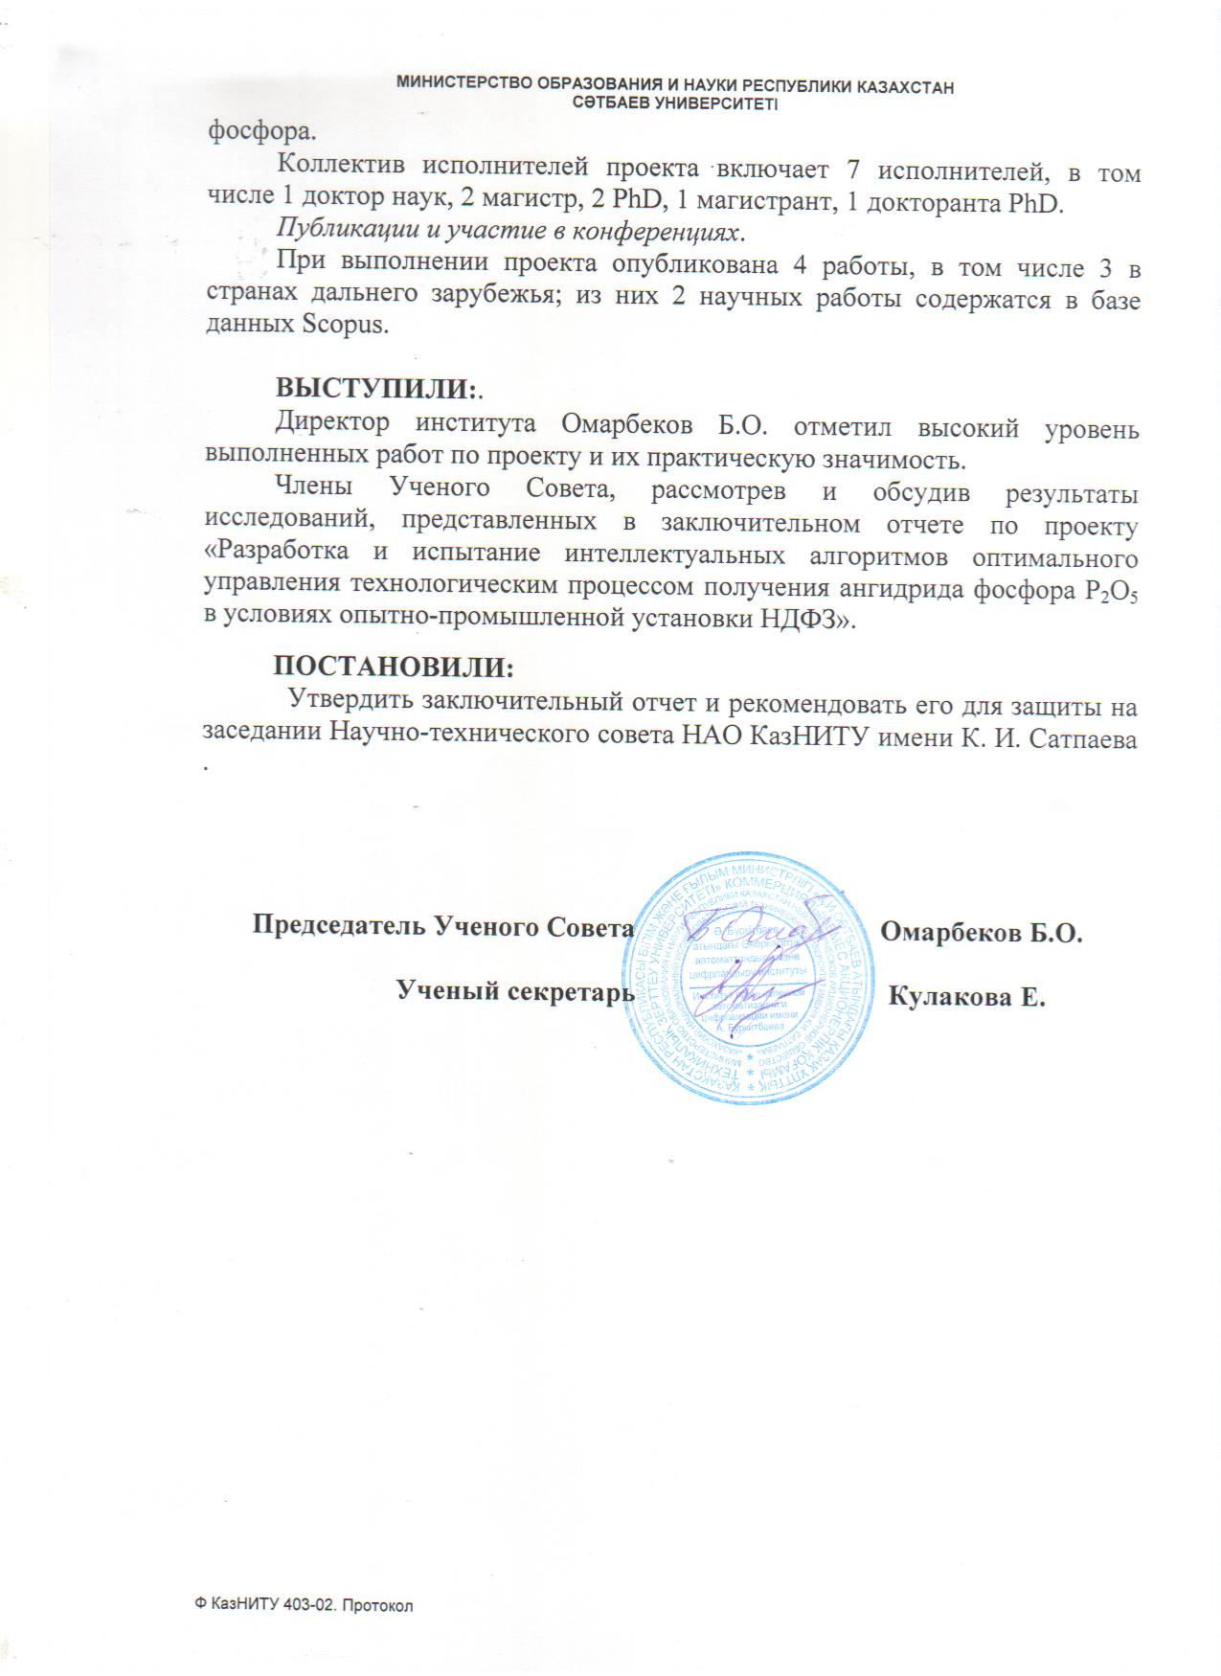

**APPENDIX E**

**Protocol of discussion of the final report on research work for 2020 at a meeting of the Department of automation and control**

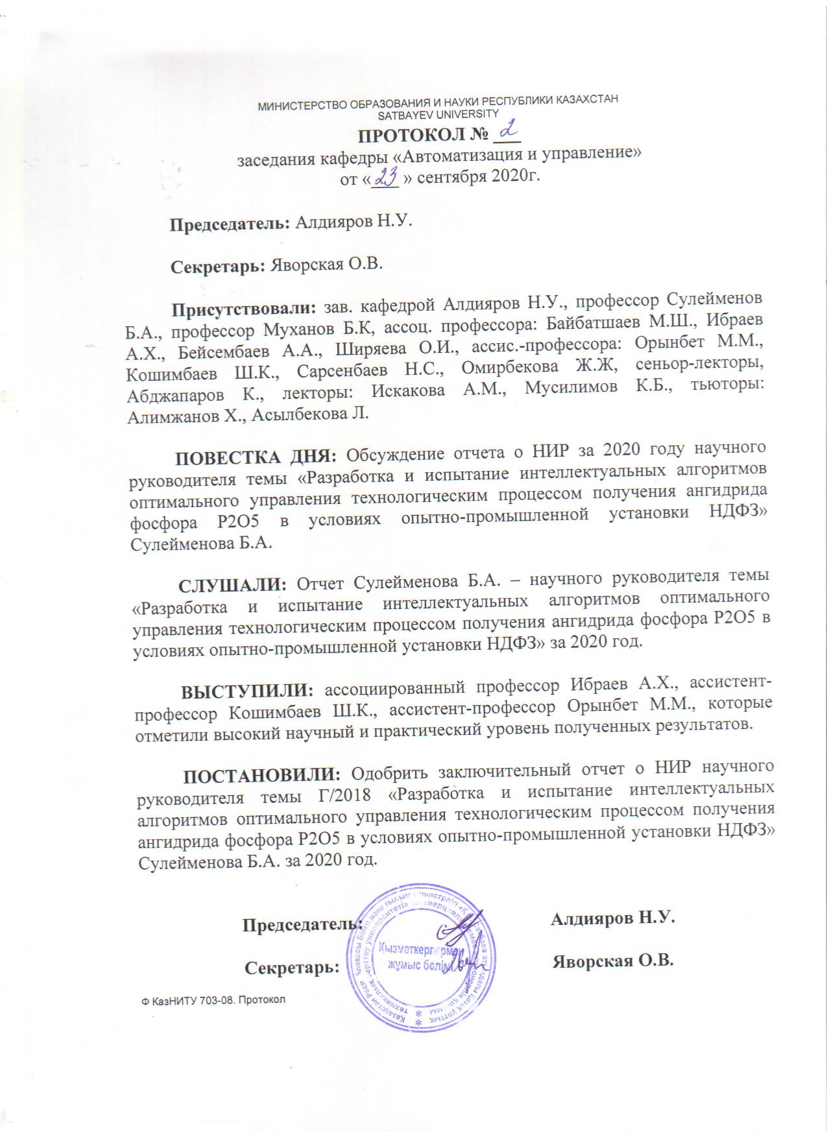

|  |
| --- |
| **APPENDIX F**  **Registration card (kaz., rus.)**  C:\Users\admin\Documents\5321\302-3\Наука\наука2018\P2O5 2018г\ИК.РК.прот\Рег.карта\РКскан каз..jpg  C:\Users\admin\Documents\5321\302-3\Наука\наука2018\P2O5 2018г\ИК.РК.прот\Рег.карта\РКскан каз.1.jpg  C:\Users\admin\Documents\5321\302-3\Наука\наука2018\P2O5 2018г\ИК.РК.прот\Рег.карта\РКскан ру..jpg  C:\Users\admin\Documents\5321\302-3\Наука\наука2018\P2O5 2018г\ИК.РК.прот\Рег.карта\РКскан ру.1.jpg  **APPENDIX G** |

**Intelligent algorithm testing act**

